**Program 1:**

Create a Bank class and declare an instance variable named amount of type double.Create parameterized constructor to initialize variable “amount” with value 10000.Create two methods withdraw(double withdrawalAmount) and deposit(double depositAmount).Calculate withdrawal based on some condition (using ternary operator) like If amount is sufficient then “withdraw successful” message will be printed on the console and amount should be updated after withdraw. Later on, deposit 5000 in the account balance.At the end display total balance on the console.

**Code:**

class Bank{

    // instance variable

    double amount;

    // parameterised constructor

    public Bank(double amount){

        this.amount = amount;

    }

    // Method to withdraw

    public void withdrawAmount(int n){

        String msg = (amount-n)>=2000 ? "Withdraw Successful" : "Insufficient Balance";

        if(amount-n >= 2000){

            amount -= n;

        }

        System.out.println(msg);

    }

    // Method to deposit

    public void depositAmount(int n){

        amount += n;

        System.out.println("Deposited Successfully");

    }

    // Method to display balance

    public void display(){

        System.out.println("Total Balance : "+amount);

    }

}

public class Ques1{

    public static void main(String args[]){

        Bank obj = new Bank(10000);

        obj.withdrawAmount(4000);

        obj.depositAmount(1000);

        obj.display();

    }

}

**Output:**

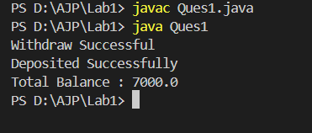

**Program 2:**

Write a program to input two numbers and find the maximum between two numbers using the conditional/ternary operator.

**Code:**

import java.util.*;

public class Ques2{

    public static void main(String args[]){

        Scanner sc = new Scanner(System.in);

        // Taking the first number

        System.out.println("Enter the first number");

        int first = sc.nextInt();

        // Taking the second number

        System.out.println("Enter the second number");

        int sec = sc.nextInt();

        int res = first>sec ? first : sec;

        System.out.println("Greater number is : "+res);

    }

}

**Output:**

