**Program 1:**

Write a program to check whether a number is a Strong number or not. Strong number is a special number whose sum of factorial of digits is equal to the original number. For example: 145 is a strong number. Since, 1! + 4! + 5! = 145

**Code:**

import java.util.*;

public class Ques1{

    // static method can only call static methods only directly and main is static that's why

    static int fact(int n){

        int f = 1;

        for(int i=1; i<=n; i++){

            f *= i;

        }

        return f;

    }

    public static void main(String args[]){

        Scanner sc = new Scanner(System.in);

        // Taking the number

        System.out.println("Enter the number");

        int num = sc.nextInt();

        int r,s=0,temp;

        temp = num;

        // Repeat these steps till the number is greater than 0

        while(num>0){

            r=num%10;

            // Calling the fact method to find its factorial

            int f = fact(r);

            s += f;

            num /= 10;

        }

        if(s==temp)

            System.out.println(temp+ " is a strong number");

        else

            System.out.println(temp+ " is not a strong number");

    }

}

**Output:**

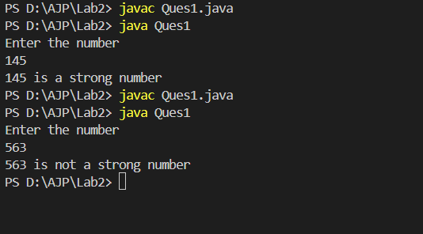

**Program 2:**

Write a program to check leap year using if else. How to check whether a given year is a leap year or not. [Hint:Take an input of any number. Store it in some variable say year. If a year is exactly divisible by 4 and not divisible by 100, then it is a leap year. Or if a year is exactly divisible by 400 then it is a leap year.]

**Code:**

import java.util.*;

public class Ques2 {

    public static void main(String args[]){

        Scanner sc = new Scanner(System.in);

        // Taking the year

        System.out.println("Enter the year");

        int y = sc.nextInt();

        int f = 0;

        // Conditions for leap year

        if(y%4 == 0){

            if(y%100 == 0){

                if(y%400 == 0){

                    f=1;

                }

                else f=0;

            }

            else{

                f=1;

            }

        }

        else{

            f=0;

        }

        if(f==1){

            System.out.println(y+ " is a leap year");

        }

        else

            System.out.println(y+ " is not a leap year");

    }

}

**Output:**

