**Program 1:**

Create one superclass HillStations and three subclasses Manali, Mussoorie, Gulmarg. Subclasses extend the superclass and override its location() and famousFor() method. i.call the location() and famousFor() method by the Parent class’, i.e. Hillstations class. As it refers to the base class object and the base class method overrides the superclass method; the base class method is invoked at runtime. ii.call the location() and famousFor() method by the all subclass’,and print accordingly.

**Code:**

// superclass

class Hillstations{

    void location(){

        System.out.println("Location is");

    }

    void famousfor(){

        System.out.println("Famous for");

    }

}

// sub class

class Manali extends Hillstations{

    // overridden the methods of parent class

    void location(){

        System.out.println("Manali is in Himachal Pradesh");

    }

    void famousfor(){

        System.out.println("It is famous for adventure sports");

    }

}

// sub class

class Mussoorie extends Hillstations{

    // overridden the methods of parent class

    void location(){

        System.out.println("Mussoorie is in Uttarakhand");

    }

    void famousfor(){

        System.out.println("It is famous for educational institutions");

    }

}

// sub class

class Gulmarg extends Hillstations{

    // overridden the methods of parent class

    void location(){

        System.out.println("Gulmarg is in J&K");

    }

    void famousfor(){

        System.out.println("It is famous for skiing");

    }

}

public class Ques1{

    public static void main(String args[]){

        // Creating the objects of the classes

        Hillstations A = new Hillstations();

        Hillstations M = new Manali();

        Hillstations Mu = new Mussoorie();

        Hillstations G = new Gulmarg();

        // Calling the methods using objects

        A.location();

        A.famousfor();

        M.location();

        M.famousfor();

        Mu.location();

        Mu.famousfor();

        G.location();

        G.famousfor();

    }

}

**Output:**

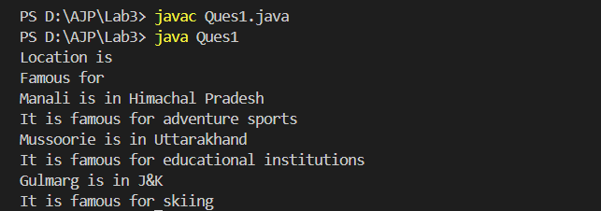

**Program 2:**

Write a Java program that demonstrates method overriding by creating a superclass called Animal and two subclasses called Dog and Cat. ● The Animal class should have a method called makeSound(), which simply prints "The animal makes a sound." ● The Dog and Cat classes should override this method to print "TheCat/The dog meows/barks" respectively. ● The program should allow the user to create and display objects of each class.

**Code:**

// Super class

class Animal{

    public void makeSound(){

        System.out.println("The animal makes a sound");

    }

}

// child class

class Cat extends Animal{

    // overridden the parent class method

    @Override

    public void makeSound(){

        System.out.println("The cat meows");

    }

}

// child class

class Dog extends Animal{

    // overridden the parent class method

    @Override

    public void makeSound(){

        System.out.println("The dog barks");

    }

}

public class Ques2 {

    public static void main(String args[]){

        // making the objects of the classes

        Animal animal = new Animal();

        Cat cat = new Cat();

        Dog dog = new Dog();

        // calling the methods using the objects

        animal.makeSound();

        cat.makeSound();

        dog.makeSound();

    }

}

**Output:**

