**Program 1:**

Create a Book class with bookId, bookName and authorName.Create parameterized constructor to initialize the object. Create an ArrayList of type Book and store all book objects into collections and display all book details. [Hint:Use advanced for loop to display all Books details].

**Code:**

import java.util.*;

// Book class

class Book{

    private int bookId;

    private String bookName;

    private String authorName;

    // parameterized constructor

    public Book(int bookId, String bookName, String authorName){

        super();

        this.bookId = bookId;

        this.bookName = bookName;

        this.authorName = authorName;

    }

    // Overriding to display all the details using toString

    @Override

    public String toString(){

        return "Book [bookId=" + bookId + ", bookName=" + bookName + ",authorname="+ authorName + "]";

    }

}

public class Ques1{

    public static void main(String[] args) {

        // Creating arraylist of objects of type Book

        ArrayList<Book> books = new ArrayList<Book>();

        books.add(new Book(101,"let us c","Yashwant P Kanetkar"));

        books.add(new Book(102,"head first java","Kathy Sierra"));

        // Printing all the details of all the books using enhanced for loop.

        System.out.println("--All Books--");

        for(Book b : books){

            System.out.println(b);

        }

    }

}

**Output:**

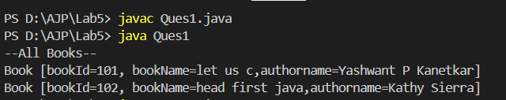

**Program 2:**

Write a Java program that calculates the sum of all even numbers present in an ArrayList of integers.

**Code:**

import java.util.*;

public class Ques2 {

    public static void main(String[] args) {

        // Creating an arraylist of integers

        ArrayList<Integer>nums = new ArrayList<>();

        nums.add(4);

        nums.add(5);

        nums.add(6);

        nums.add(7);

        nums.add(8);

        int ans = 0;

        // Using enhanced for loop.

        for(int n: nums){

            // Checking the condition if number if even or not

            if(n%2 == 0){

                ans += n;

            }

        }

        // Printing the output sum

        System.out.println("Sum of even numbers : "+ans);

    }

}

**Output:**

