**Program 1:**

Write a Java program to append the specified element to the end of a HashSet.

**Code:**

import java.util.HashSet;

public class Ques1{

    public static void main(String [] args){

        // Creating the hashset

        HashSet<String> hashset = new HashSet<>();

        // Adding the initial elements

        hashset.add("apple");

        hashset.add("banana");

        hashset.add("cherry");

        // Display the original hashset

        System.out.println("Original hashset: "+hashset);

        // Element to be appended

        String element = "orange";

        // Appending the element to the hashset

        hashset.add(element);

        // Display the updated hashset

        System.out.println("Updated hashset: "+hashset);

    }

}

**Output:**

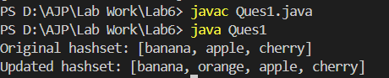

**Program 2:**

Write a program to declare stack. Store 10 elements into it. Remove 4 elements from the stack and display it.

**Code:**

import java.util.*;

public class Ques2 {

    public static void main(String[] args){

        // Creating the stack

        Stack<Integer> stack = new Stack<Integer>();

        // Adding 10 elements in it initially

        stack.push(23);

        stack.push(33);

        stack.push(43);

        stack.push(53);

        stack.push(33);

        stack.push(63);

        stack.push(73);

        stack.push(83);

        stack.push(93);

        stack.push(98);

        // Display the original stack

        System.out.println("---elements---");

        System.out.println(stack);

        // Removing 4 elements from the stack

        stack.pop();

        stack.pop();

        stack.pop();

        stack.pop();

        // Displaying stack after removing 4 elements from it

        System.out.println("Elements after removal");

        System.out.println(stack);

    }

}

**Output:**

