**Program 1:**

Write a Java program to associate the specified value with the specified key in a HashMap.

**Code:**

import java.util.*;

public class Ques1{

    public static void main(String[] args){

        // Creating a hash map having string keys and integer values

        HashMap<String, Integer> mp = new HashMap<>();

        // Adding key-value pairs to the hashmap

        mp.put("Aanya",25);

        mp.put("Doraemon",30);

        mp.put("Nobita",35);

        // Display the original hashmap

        System.out.println("Initial hashmap: "+mp);

        // Associate a new value with the existing key

        mp.put("Doraemon",32);

        // Display the updated hashmap

        System.out.println("Updated hashmap: "+mp);

    }

}

**Output:**

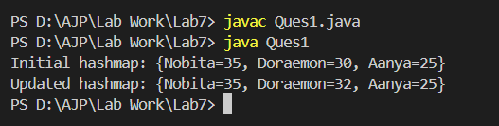

**Program 2:**

Write a Java program to check whether a HashMap contains key-value mappings (empty) or not.

**Code:**

import java.util.*;

public class Ques2 {

    public static void main(String[] args) {

        // Creating a new hashmap

        HashMap<String, Integer> mp = new HashMap<>();

        // Checking if it is empty using isEmpty method

        if(mp.isEmpty()){

            System.out.println("Hashmap is empty");

        }

        else{

            System.out.println("Hashmap is not empty");

        }

        // Add a key value pair, then check empty or not.

        mp.put("Aanya", 25);

        // Checking again to detect if after inserting the file it'll show that it is empty or not

        if(mp.isEmpty()){

            System.out.println("Hashmap is empty");

        }

        else{

            System.out.println("Hashmap is not empty");

        }

    }

}

**Output:**

