**Program 1:**

Write a program to print numbers from 0 to 4 using thread.

**Code:**

public class Ques1{

    public static void main(String[] args) {

        // using the NumberPrinter class, making its object, then using the start method

        NumberPrinter printerThread = new NumberPrinter();

        printerThread.start();

    }

}

class NumberPrinter extends Thread {

    public void run() {

        // printing 0 to 4 with some delay using thread

        for (int i = 0; i <= 4; i++) {

            System.out.println(i);

            try {

                // Sleep for a short period to simulate some delay

                Thread.sleep(500); // 500 milliseconds = 0.5 seconds

            } catch (InterruptedException e) {

                System.out.println("Thread interrupted.");

            }

        }

    }

}

**Output:**

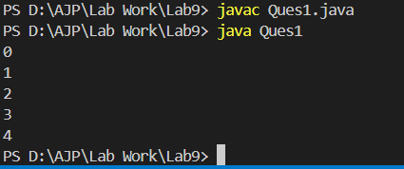

**Program 2:**

Write a program to prints 1 to 10 and sleep for 500ms using thread.

**Code:**

public class Ques2 {

    public static void main(String[] args) {

        // using the NumberPrinter class, making its object, then using the start method

        NumberPrinter printerThread = new NumberPrinter();

        printerThread.start();

    }

}

class NumberPrinter extends Thread {

    public void run() {

        // printing 1 to 10 with some delay using thread

        for (int i = 1; i <= 10; i++) {

            System.out.println(i);

            try {

                // Sleep for 500 milliseconds (0.5 seconds)

                Thread.sleep(500);

            } catch (InterruptedException e) {

                System.out.println("Thread was interrupted.");

            }

        }

    }

}

**Output:**

