**INDEX**

|  |  |  |  |  |  |  |  |
| --- | --- | --- | --- | --- | --- | --- | --- |
|  | **NO** | **TITLE** | | | | **PAGE NO.** |  |
| 1. | **INTRODUCTION** | | | |  |
|  | 1.1 | ORGANIZATION PROFILE | | | 01 |
|  | 1.2 | SYSTEM DETAILS | | | 02 |
|  |  | 1.2.1 | | EXISTING SYSTEM | 02 |
| 1.2.2 | | PROPOSED SYSTEM | 02 |
|  | 1.3 | SCOPE OF SYSTEM | | | 03 |
|  | 1.4 | OBJECTIVE | | | 03 |
| 2 | **PROPOSED SYSTEM REQUIREMENT GATHERING** | | | | 04 |
|  | 2.1 | STAKEHOLDERS OF SYSTEM | | | 05 |
|  | 2.2 | REQUIREMENT GATHERING TECHNIQUES USED | | | 05 |
|  | 2.3 | CONSOLIDATED LIST OF REQUIREMENT | | | 09 |
|  | 2.4 | PROJECT DEFINITION | | | 09 |
| 3 | **SYSTEM MANAGEMENT AND PLANNING** | | | | 11 |
|  | 3.1 | FEASIBILITY STUDY | | | 11 |
|  |  | 3.1.1 | TECHNICAL STUDY | | 12 |
| 3.1.2 | ECONOMICAL STUDY | | 12 |
| 3.1.3 | OPERATIONAL STUDY | | 12 |
|  | 3.2 | HARDWARE-SOFTWARE REQUIREMENT | | | 13 |
|  | 3.3 | SYSTEM PLANNING | | | 13 |
|  |  | 3.3.1 | WORK BREAK DOWN STRUCTURE | | 14 |
| 3.3.2 | GANTT CHART | | 15 |
|  | 3.4 | PROCESS MODEL | | | 15 |

|  |  |  |  |
| --- | --- | --- | --- |
| 4 | **SYSTEM ANALYSIS AND DESIGN** | |  |
|  | 4.1 | UML( UNIFIED MODELING LANGUAGE) | 16 |
|  | 4.2 | SYSTEM FLOW DIAGRAM | 28 |
|  | 4.3 | DATA DICTIONARY | 32 |
|  | 4.4 | USER INTERFACE | 37 |
|  | 4.5 | SYSTEM NAVIGATION | 46 |
| **5** | **INPUT / OUTPUT DESIGN** | | 47 |
| **6** | **TESTING** | | 83 |
| **7** | **SUMMARY** | | 96 |
|  | 7.1 | ASSUMPTION | 96 |
|  | 7.2 | LIMITATION | 96 |
|  | 7.3 | CONCLUSION | 96 |
|  | 7.4 | FUTURE SCOPE | 97 |
|  | 7.5 | BIBILOGRAPHY | 97 |

|  |  |  |
| --- | --- | --- |
| SR NO. | FIGURE NAME | PAGE NO. |
| 01 | USE CASE DIAGRAM | 16 |
| 03 | ACTIVITY DIAGRAM | 20 |

**LIST OF FIGURES**

**LIST OF TABLE :**

|  |  |  |
| --- | --- | --- |
| SR NO. | TABLE NAME | PAGE NO. |
| 01 | USER TABLE | 32 |
| 02 | MEASSAGE TABEL | 33 |
| 03 | CHAT TABLE | 34 |
| 04 | PROJECT | 34 |
| 05 | TASK TABLE | 35 |
| 06 | TIMESHEET TABLE | 35 |

**System Details:-**

This project is all about interaction between senior and junior developers.Senior developer create new project and assigned that project any junior developers and assigned any task .and uses chat with any developers and group of project. Junior developer submit daily timesheet to senior developer.

## Existing System:-

Yes, there is existing system like us. which are given below.

1. **Jira:-**
   * Jira Software launched in 2002 as an issue tracking and project management tool for teams. Since then, 65,000+ companies globally have adopted Jira for its flexibility to support any type of project and extensibility to work with thousands of apps and integrations..
2. **Notion :-**

Notion is an all-in-one, online workspace that helps teams collaborate on content. Using its centralized and customizable platform, users can organize data, switch views, share information, integrate tools, and automate workflow to meet specific project management needs using one application

## proposed system :-

* + - Our current system and proposed system are very different.
    - We are adding new functionality in existing system and add new creativity of our minds
    - Our purposed system gives information through email for any updation like Assigen any project,give any task.
    - Add new chat with project group or any devlopers

## Scope Of System:-

* All project detail in paltform.
* This system platform is very helpful for all company senior and junior devlopers
* This is very helpful to chat with any devlopers

## Objectives Of System :-

* Faster and more accurate retrieval of information.
* Assigned any project to junior developers
* See daily timesheet
* See project progress
* Chat with any developers
* Chat with project group members
* Know about task descripation

# CHAPTER – 2

**PROPOSED SYSTEM REQUIREMENTS GATHERING**

## Stackholder Of System :-

**1)Admin:-**

Admin are handles all project details and all users details and admin

Can add new users delete users and delete any project. See all project details

And which project assigned whom know all details about project. And also see

All project progress repots

## 2)senior developers:-

## senior developers add new project update any project details and assign that project any

## junior developers and assign any task junior developers for complete that task and see all junior developers timesheet.

## 3)junior developers :-

## Receive task from senior developers and start work on particular assigned task . and add

## Daily timesheet

**Requirement gathering techniques used:-**

There are four techniques used for gathering requirements.

* + 1. Questionnaire
    2. Interview
    3. Public opinion
    4. Documentary

We have prepared a list of questions.

## Consolidated List Of Requirement:-

List of Requirements :-

There are different requirement are gathering technique.

* Create or Login account.
* Add project
* Assigned any task
* Track task details
* Search task
* Add timesheet

## Project definition:-

**TITLE** :- **PROJECT MANAGEMENT SYSTEM**

This project is all about interaction between senior and junior developers.Senior developer create new project and assigned that project any junior developers and assigned any task .and uses chat with any developers and group of project. Junior developer submit daily timesheet to senior developer.

# 

# CHAPTER – 3

**SYSTEM MANAGEMENT AND PLANNING**

* + Project planning is part of [project management,](https://en.wikipedia.org/wiki/Project_management) which relates to the use of [schedules](https://en.wikipedia.org/wiki/Schedule_(project_management)) such as [Gantt charts](https://en.wikipedia.org/wiki/Gantt_chart) to plan and subsequently report progress within the project environment.
  + Initially, the [project scope](https://en.wikipedia.org/wiki/Scope_(project_management)) is defined and the appropriate methods for completing the project are determined.
  + Following this step, the [durations](https://en.wikipedia.org/wiki/Duration_(project_management)) for the various [tasks](https://en.wikipedia.org/wiki/Task_(project_management)) necessary to complete the [work](https://en.wikipedia.org/wiki/Work_(project_management)) are listed and grouped into a [work breakdown structure.](https://en.wikipedia.org/wiki/Work_breakdown_structure)
  + The [project schedule](https://en.wikipedia.org/wiki/Schedule_(project_management)) may be optimized to achieve the appropriate balance between [resource usage](https://en.wikipedia.org/wiki/Resource_management) and project duration to comply with the project objectives.

## Feasibility Study :-

* + - A feasibility study is carried out to select the best system that meets performance requirements.
    - The main goal of the feasibility study activity is to determine whether it would be financially and technically feasible to develop the product.
    - The feasibility study activity involves the analysis of the problem and collection of all relevant information relating to the product such as the different data items which would be input to the system, the processing required to be carried out on these data, the output data required to be produced by the system as well as various constraints on the behavior of the system.

## Technical Study :-

* + - * The technical feasibility study compares the level of technology available in the software development company and the level of technology required for the development of the product.
      * Here the level of technology consists of the programming language, the hardware resources, other software tools etc. Internet is required to use the system.

Our system consists of,

* + - * The facility to produce outputs in a given time.
      * Response time under certain conditions.

## Economical study :-

* + - * The economic feasibility study evaluate the cost of the software development against the ultimate income or benefits gets from the developed system. There must be scopes for profit after the successful Completion of the project.
      * Our system is not much costly to develop.
      * It is easy to use and understand therefor there is no need to appoint any operator to use the system.
      * Organization is ready to invest in proposed system because it is being developed in latest technology and will be very fast for the users to transfer or share the information using the system.

## Operational study :-

* + - * Operational feasibility study tests the operational scope of the System to be developed. It is checked that if the system is actually can be useful when implemented. Our system is operationally feasible in the following ways:
      * An effective catalyst for customer feedback is a portion of an operational system.
      * It is very easy to operate. so, that the admin can easily use it.
      * Our system is very easy so user use it without any training.

## Hardware-Software Requirement :-

**Software Specifications :-**

**Front –End Technology :-React **

**Back – End Technology:-**

**Node js ,mongodb**

**Design Tools :-Bootstrap, Html, Css, Angular material**



## Hardware Requirements :-

**Processor :** Pentium microprocessor and above

**Memory :** 2 GB or Higher

**Hard disk :** 300 MB or Higher

## System Planning :-

**Work Break Down Structure :-**



PROJECT MANAGMENT

1.

INTRODUCTION

2.

PROPOSED SYSTEM REQUIREMENT GATHERING

3.

SYSTEM MANAGMENT AND PLANNING

4.SYSTEM ANALYSIS AND PLANNING

1.1

ORGANIZATION PROFILE

2.1

STACKHOLDER OF SYSTEM

3.1

FESIBLITY STUDY

4.1

UML(UNIFIED MODELING LANGUAGE)

1.2

SYSTEM DETAILS

2.2

REQUIREMENT GATHERING TECHNIQUES USED

3.2

HARDWARE-SOFTWARE REQUIREMENT

4.2

SYSTEM FLOW DIAGRAM

1.3

SCOPE OF SYSTEM

2.3

CONSOLIDATED LIST OF REQUIREMENT

3.3

SYSTEM PLANNING

4.3

DATA DICTIONARRY

1.4

OBJECTIVE

2.4

PROJECT DEFINATION

3.4

PROCESS MODEL

4.4

USER ITERFACE

4.5

SYSTEM NAVIGATION

**Gantt chart :-**

|  |  |  |  |  |
| --- | --- | --- | --- | --- |
| Activites | OCT | NOV | DEC | JAN |
| Scope |  |  |  |  |
| Reserch |  |  |  |  |
| Requirement  Gathering |  |  |  |  |
| Analysis |  |  |  |  |
| Planning |  |  |  |  |
| Designing |  |  |  |  |
| Coding |  |  |  |  |
| Testing |  |  |  |  |

**Process Model :-**

* We would be following the incremental model because the nature of this system as the requirements are not concrete. Many features can be added after the development of the system that serves the main purpose.
* The hardware we use is a little costly for prototyping so we go iteration and develop the final product. In this model ONE AFTER THE ANOTHER follows.

**Spiral Model:-**

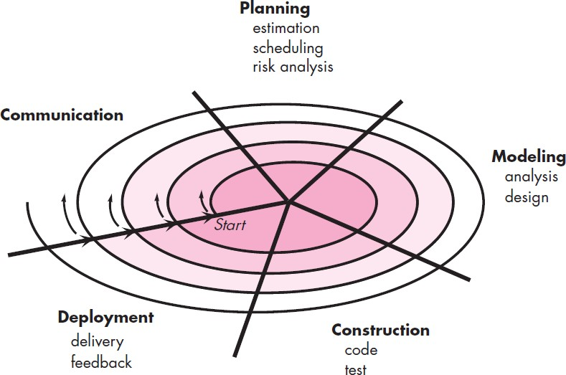

## Why it is suitable for our system?

* Requirement for the complete system are clear.
* There are chances that some details can be evolved with time.
* There is need to get the project in market quickly.
* New technology is being used.
* Multiple independent deliveries are identified.

# CHAPTER – 4

**SYSTEM ANALYSIS AND DESIGN**

## UML (Unified Modeling Language)

**Use-Case Diagram:-**

**1)Admin :-**

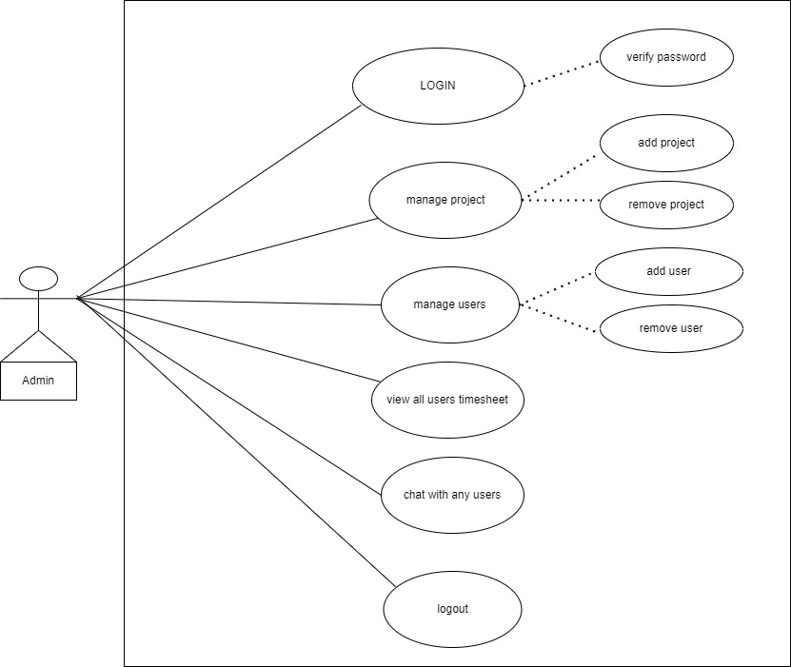

**2)Sr developers:-**

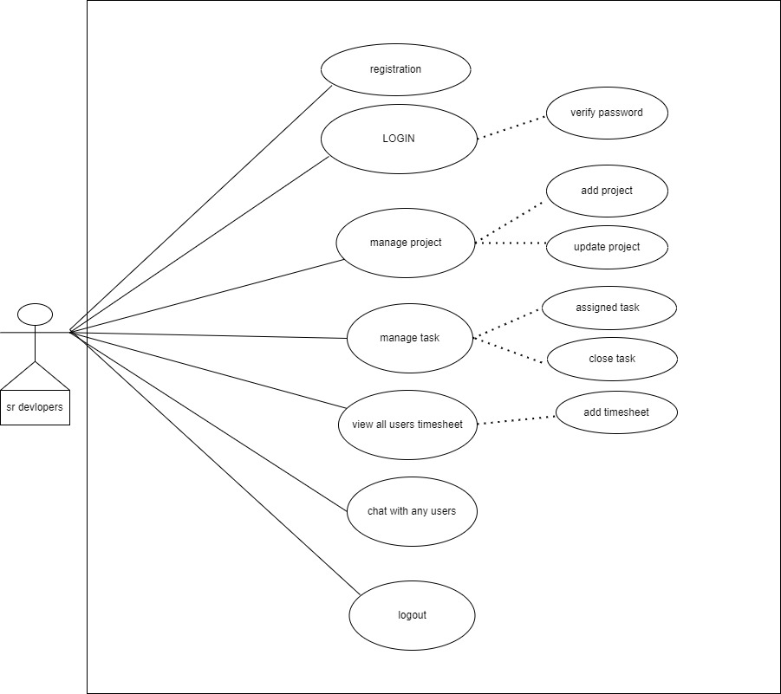

**3)Jr developers:-**

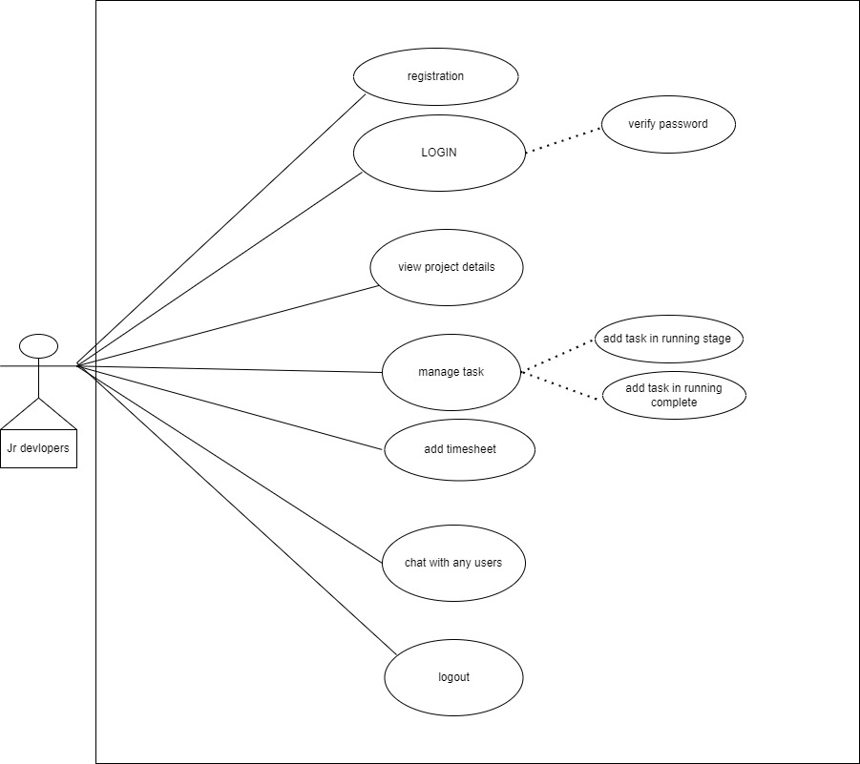

**Activity Diagram :-**

**1)Admin:-**

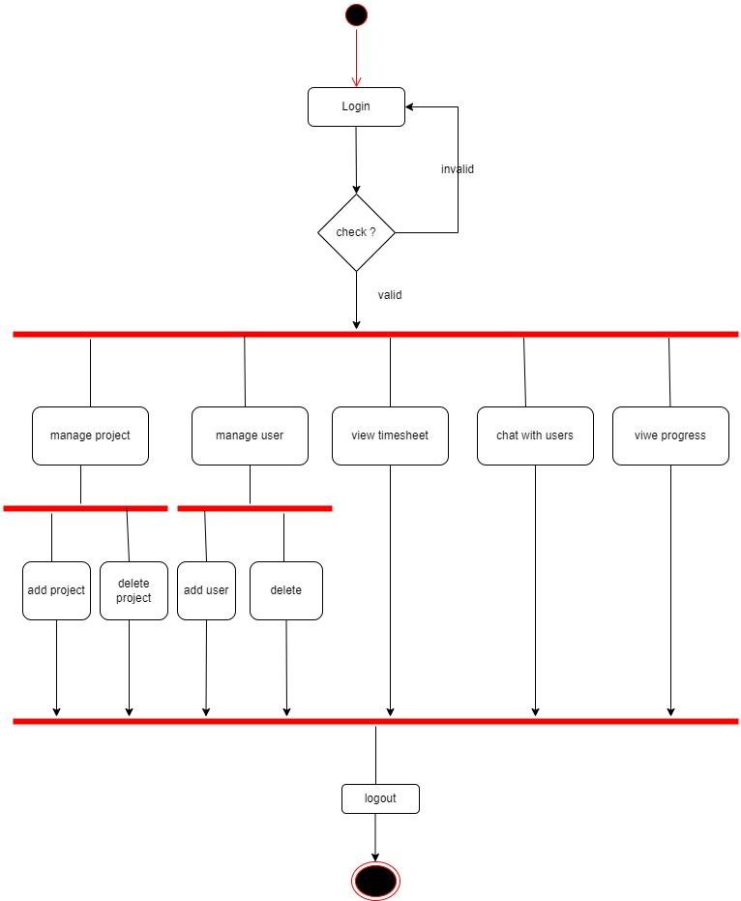

**2) Sr developers:-** 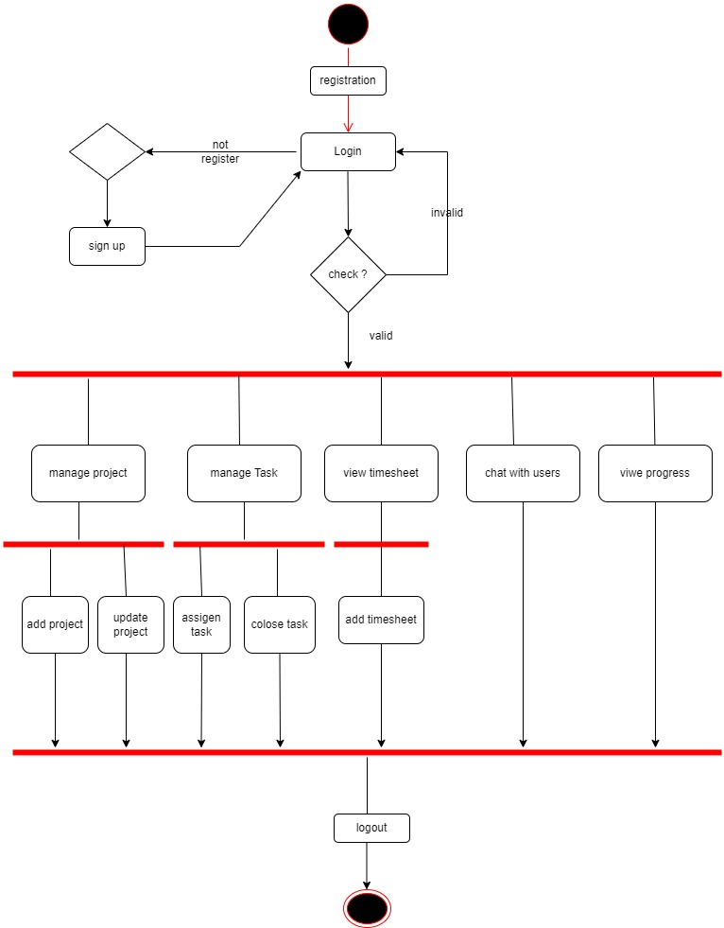

**2)Jr developers:-**

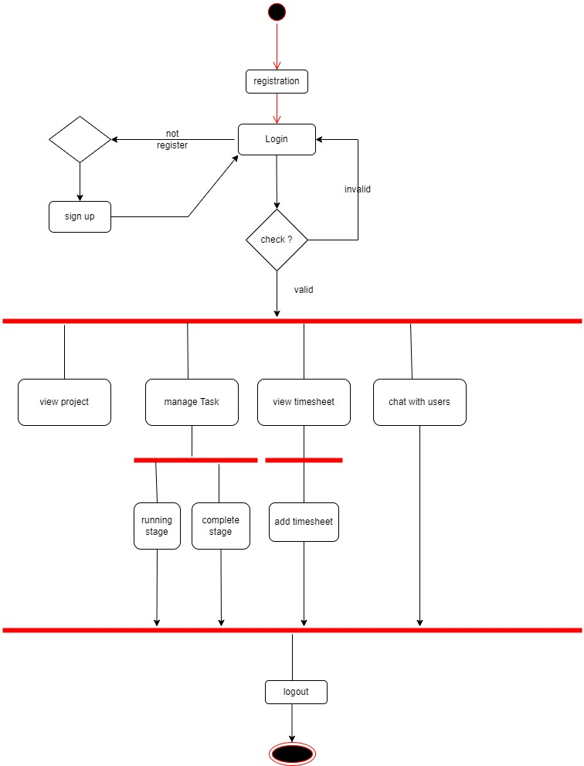

**Data Dictionary:-**

**1)user table**

|  |  |  |  |  |
| --- | --- | --- | --- | --- |
| **NO** | **FILED NAME** | **DATA TYPE** | **CONSTRAINT** | **DESCRIPTION** |
| **1** | id | Integer(3) | Primary key | Unique id of each user |
| **2** | password | String | Not null | Personal password of user |
| **3** | name | String | Not null | Name of The user |
| **4** | email | String | Not null | Email id of user |
| **5** | role_name | String | Not null | role of user |
| **6** | img | String | Not null | User’s image |
| **7** | Contact_number | String | Not null | Mobile no of user |

**2)Message table:-**

|  |  |  |  |  |
| --- | --- | --- | --- | --- |
| **NO** | **FILED NAME** | **DATA TYPE** | **CONSTRAINT** | **DESCRIPTION** |
| **1** | id | Integer(3) | Primary key | Unique id of each massage |
| **2** | User_id | Integer(3) | fk | Identified user |
| **3** | content | String | Not null | Message content |
| **4** | chat | Integer(3) | fk | Identified chat |

**3)chat model:-**

|  |  |  |  |  |
| --- | --- | --- | --- | --- |
| **NO** | **FILED NAME** | **DATA TYPE** | **CONSTRAINT** | **DESCRIPTION** |
| **1** | id | Integer(3) | Primary key | Unique id of each chat |
| **2** | chat Name | string | Not Null | Chat name or  Group chat name |
| **3** | isgroupchat | Boolean | Not null | Message content |
| **4** | users | Integer(3) | fk | Identified user |
| **5** | latestMessage | Integer(3) | fk | Identifid latest Message |
| **6** | groupAdmin | Integer(3) | fk | Identified user |

**4)timesheet:-**

|  |  |  |  |  |
| --- | --- | --- | --- | --- |
| **NO** | **FILED NAME** | **DATA TYPE** | **CONSTRAINT** | **DESCRIPTION** |
| **1** | id | Integer(3) | Primary key | Unique id of each timesheet |
| **2** | user | Integer(3) | fk | Identified user |
| **3** | Date | Date | Not null | Date |
| **4** | works | array | Not null | Identified work |

**5)project table:-**

|  |  |  |  |  |
| --- | --- | --- | --- | --- |
| **NO** | **FILED NAME** | **DATA TYPE** | **CONSTRAINT** | **DESCRIPTION** |
| **1** | id | Integer(3) | Primary key | Unique id of each project |
| **2** | projectName | String | Not null | Project name |
| **3** | description | String | Not null | Project descripation |
| **4** | assigned_date | Date | Not null | date |
| **5** | Deadline | Date | Not null | Date of deadline |
| **6** | completed | Date | Not null | Date of compleate |
| **7** | Is_completed | boolean | Not null | Project complete or not |
| **8** | Lead | Integer(3) | Not null | Identified lead of a project |
| **9** | member | Array | Not null | Identified junior devlopers |
| **10** | satck | Array | Not null | Which Technology |
| **11** | progress | number | Not null | Identified how many % completed project |

**6)Task table**

|  |  |  |  |  |
| --- | --- | --- | --- | --- |
| **NO** | **FILED NAME** | **DATA TYPE** | **CONSTRAINT** | **DESCRIPTION** |
| **1** | id | Integer(3) | Primary key | Unique id of each  **Task** |
| **2** | Project_id | Integer(3) | fk | Identified project |
| **3** | title | string | Not null | Title of task |
| **4** | description | string | Not null | Description of task |
| **5** | Lead_id | Integer(3) | fk | Identified head of project |
| **6** | assigned | Array | Not null | Identified whome assign this task |
| **7** | deadline | Date | Not null | Deadline of task |
| **8** | status | string | Not null | Pending or done |
| **9** | priority | string | Not null | Priority is high or low |

**CHAPTER – 5**

# INPUT/output

# 1)Login page:-

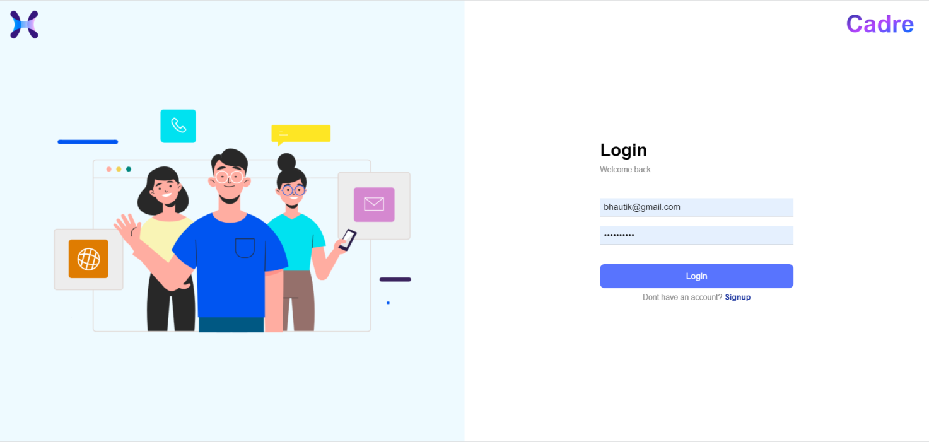

**2)signup page:-**

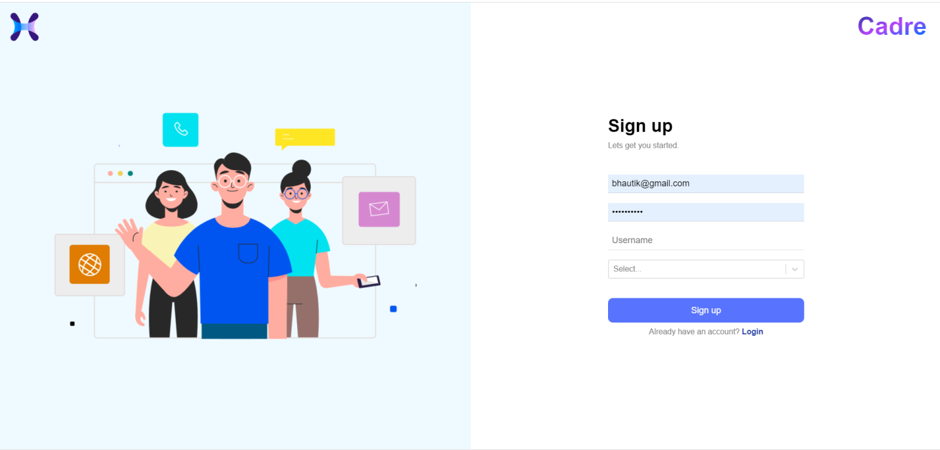

3)dashboard

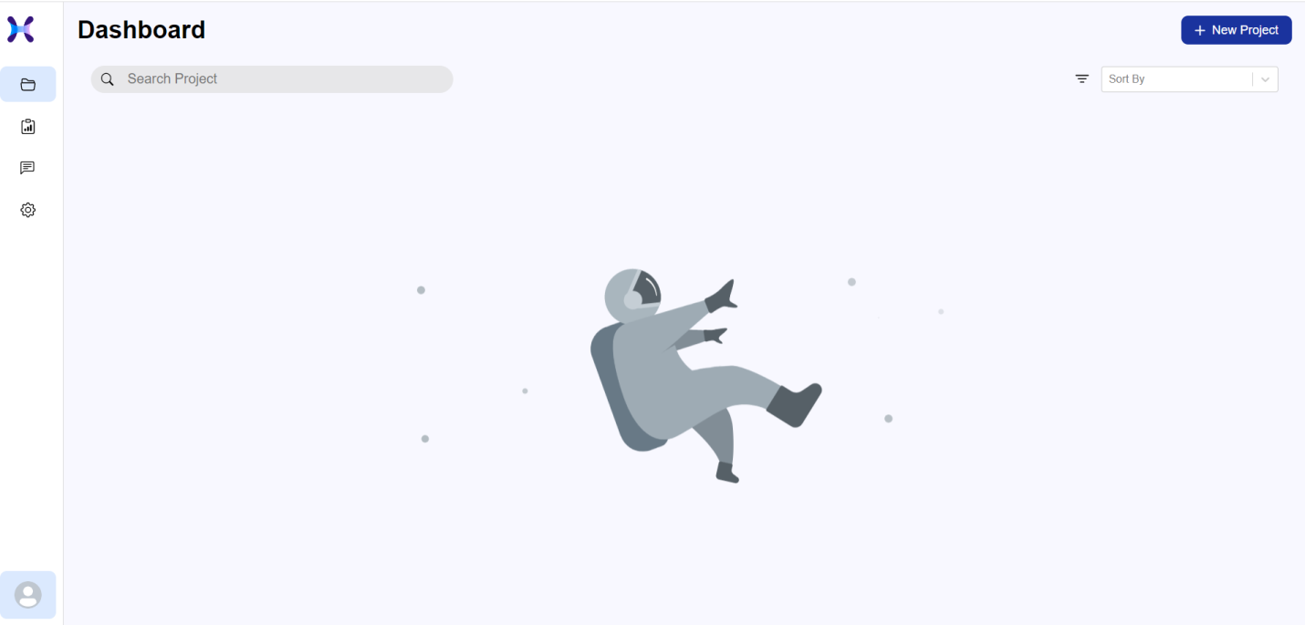

4)create project:-

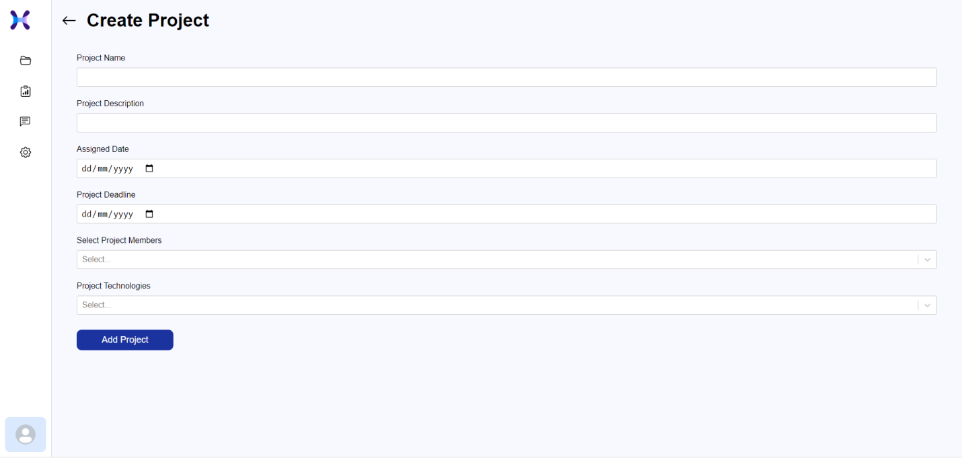

5)dashboard with project

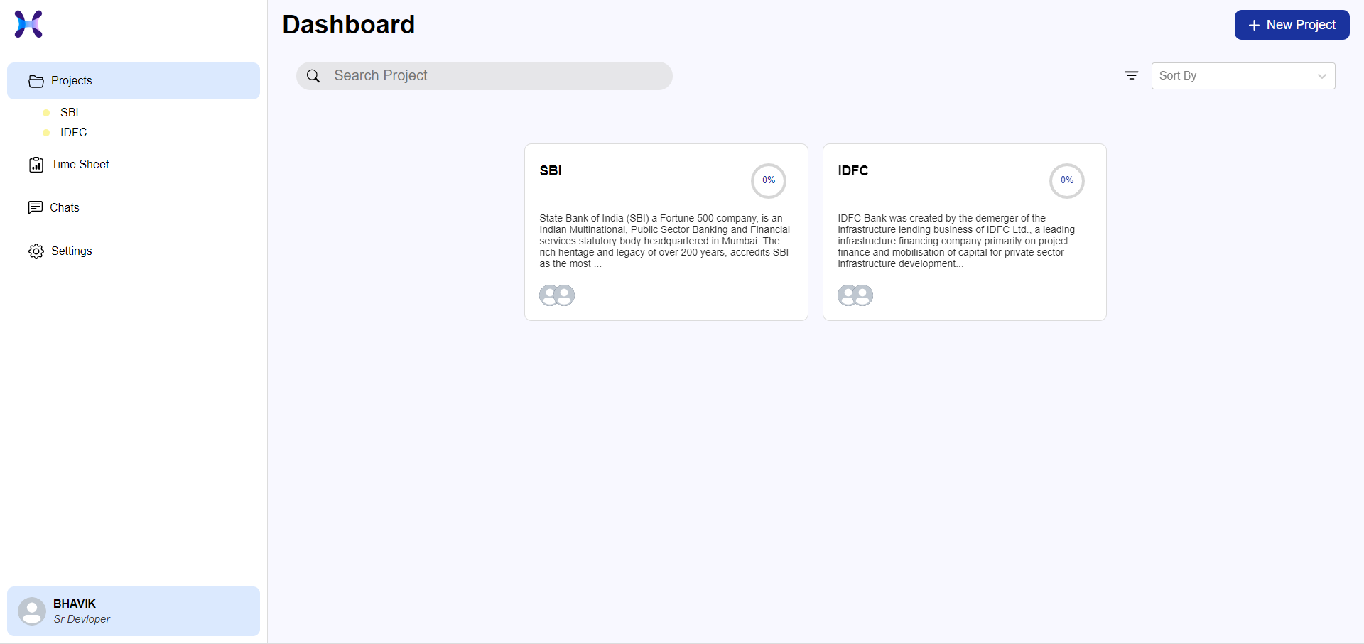

6)create task

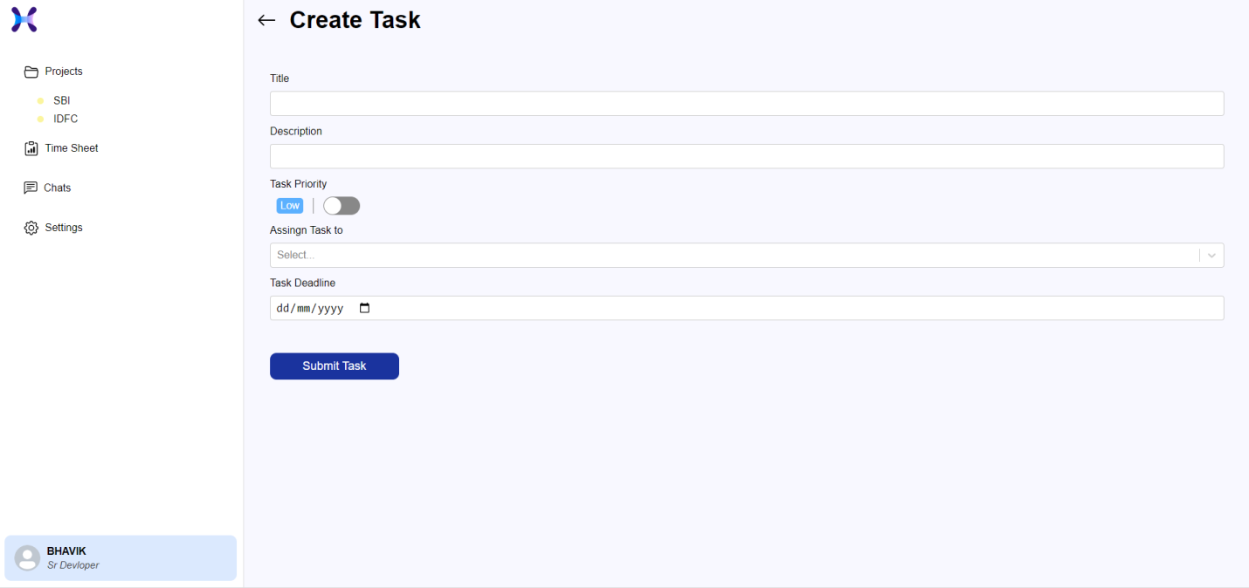

7)project dashboard

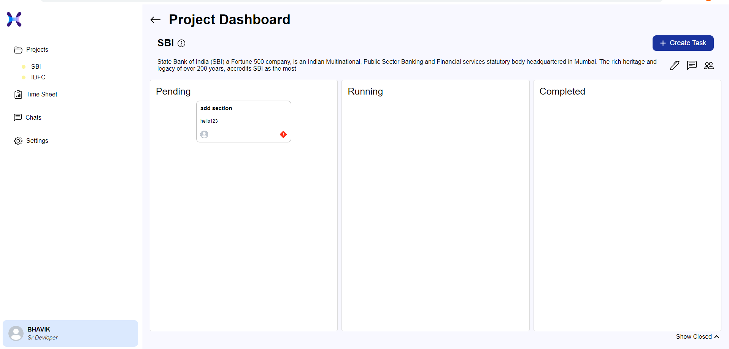

8)update project:-

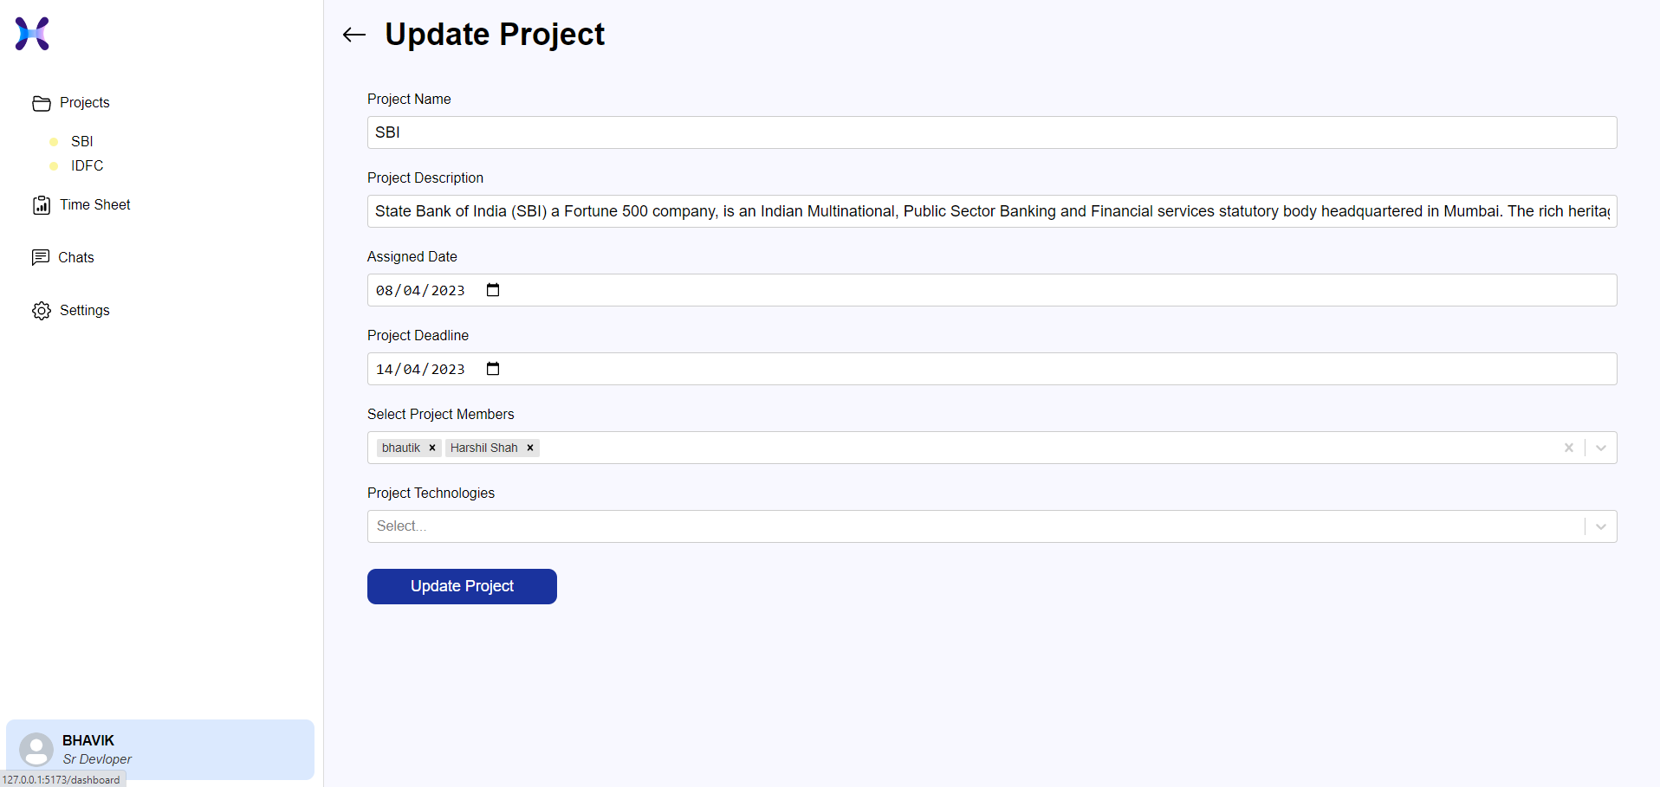

9)Add timesheet

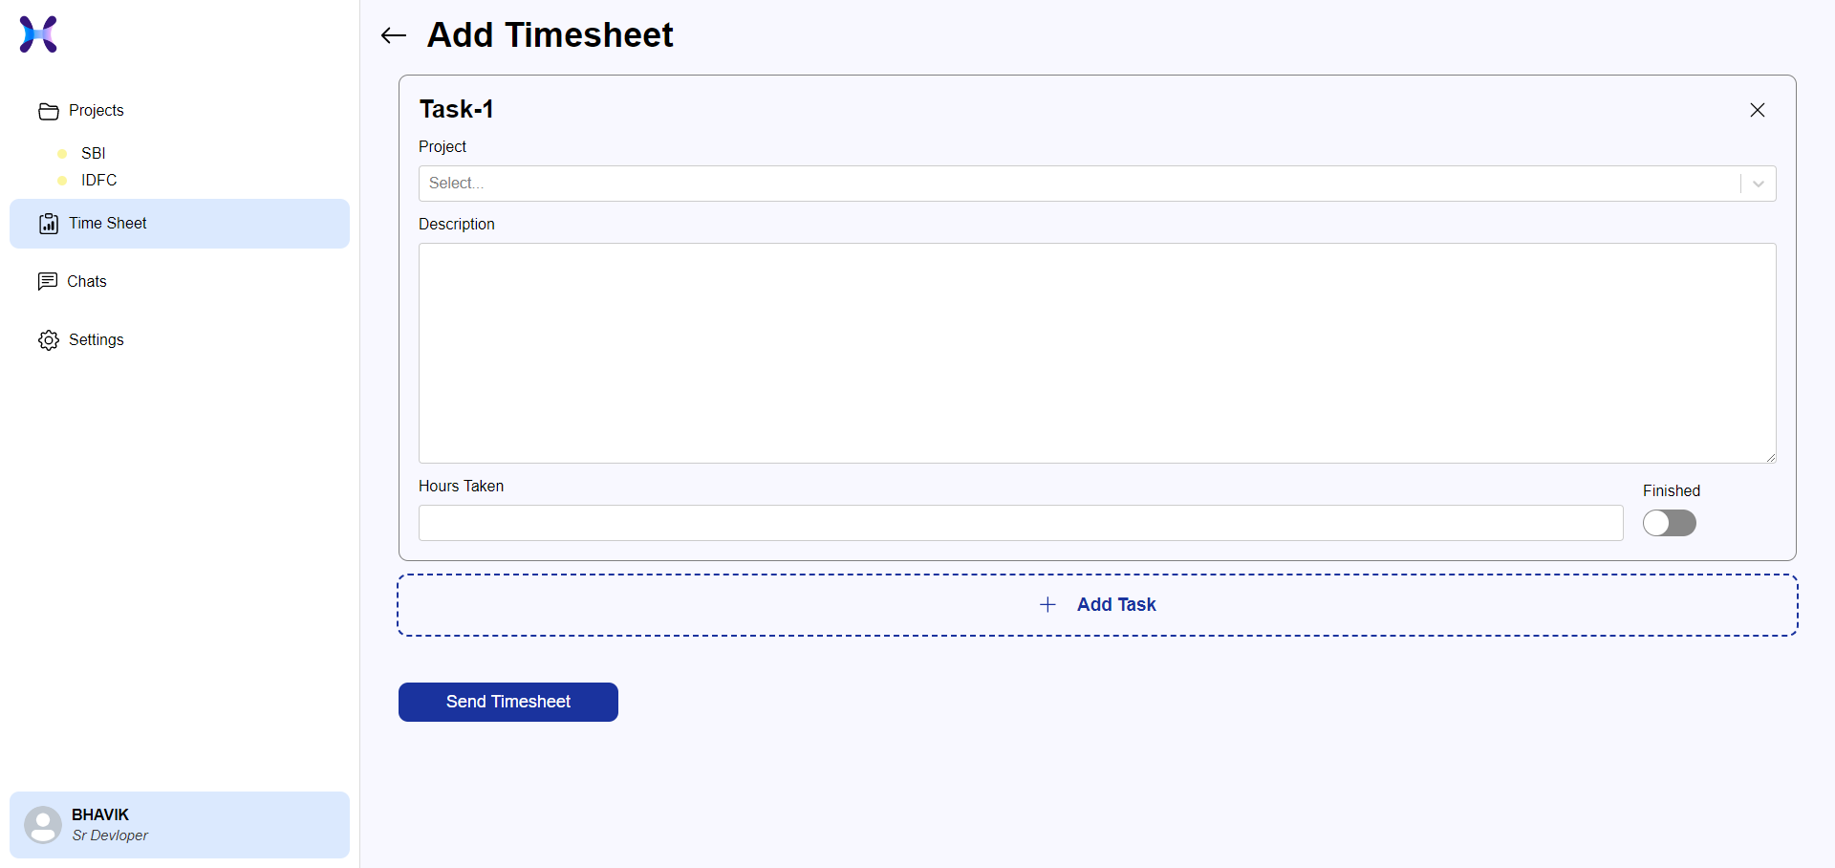

10)view timesheet

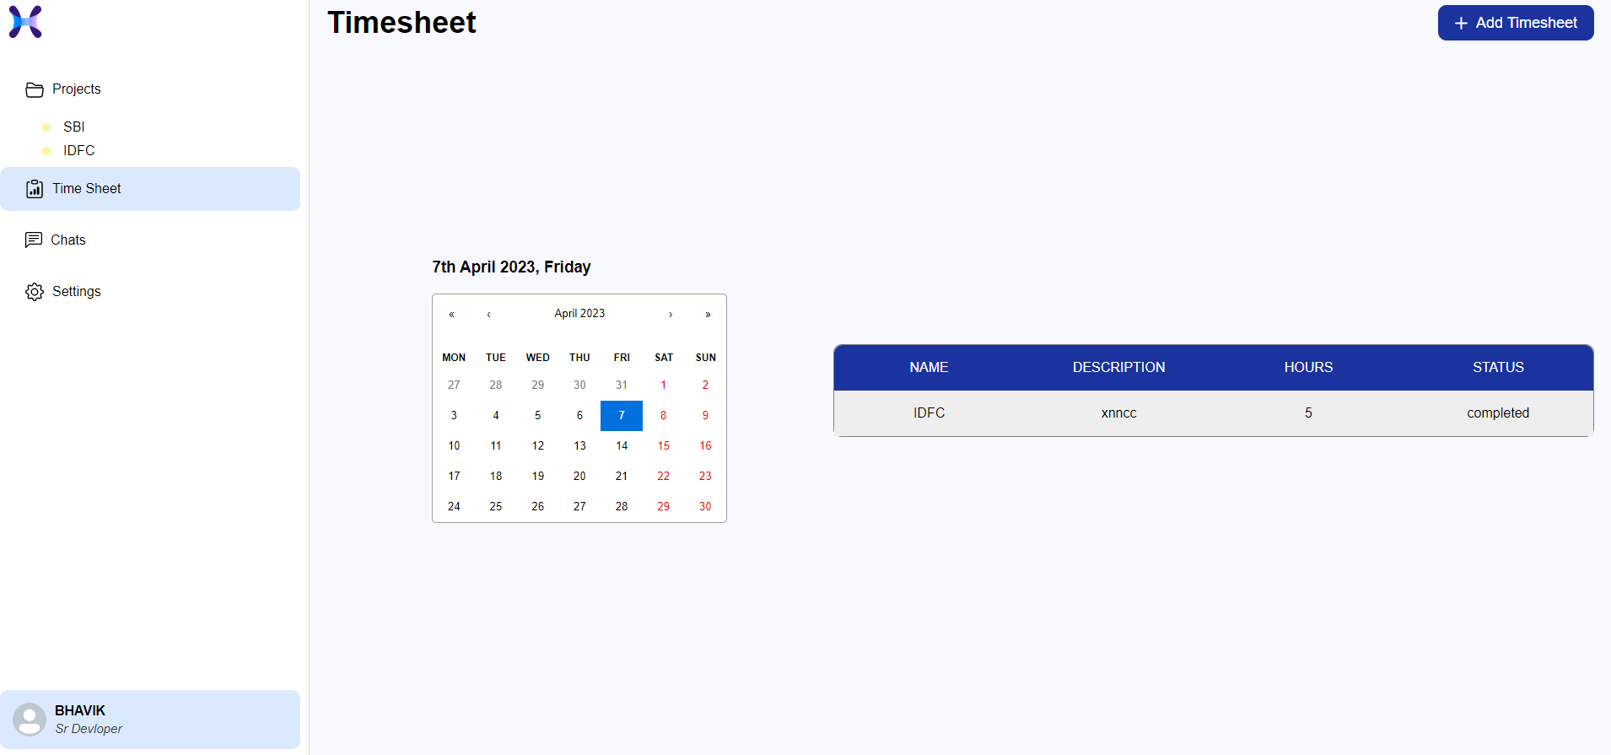

11)setting

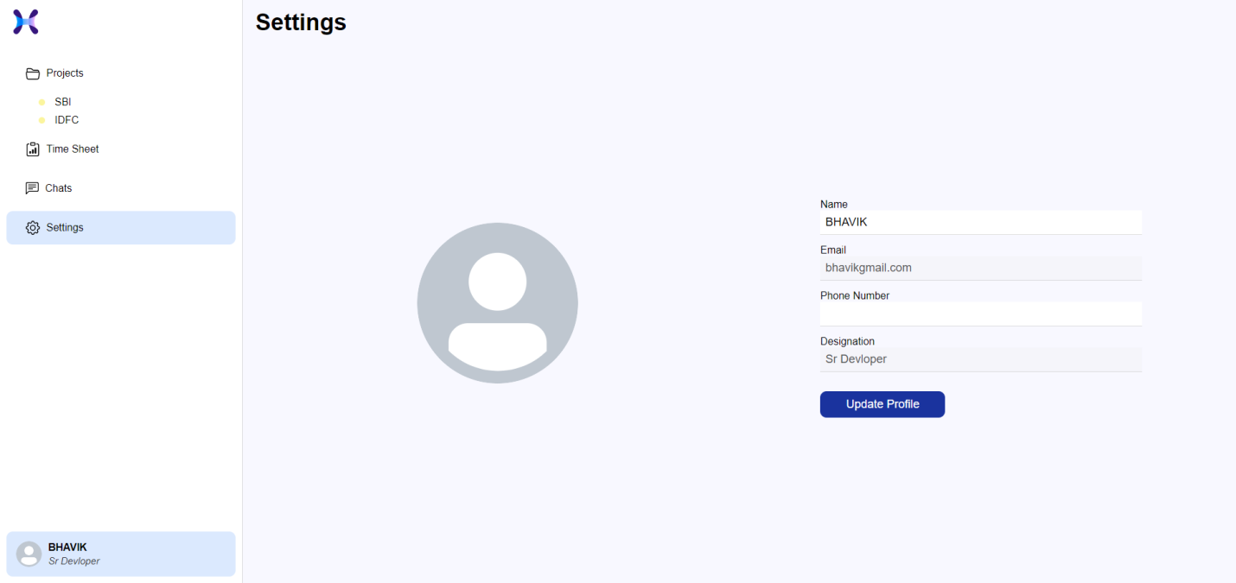

11)chat page:-

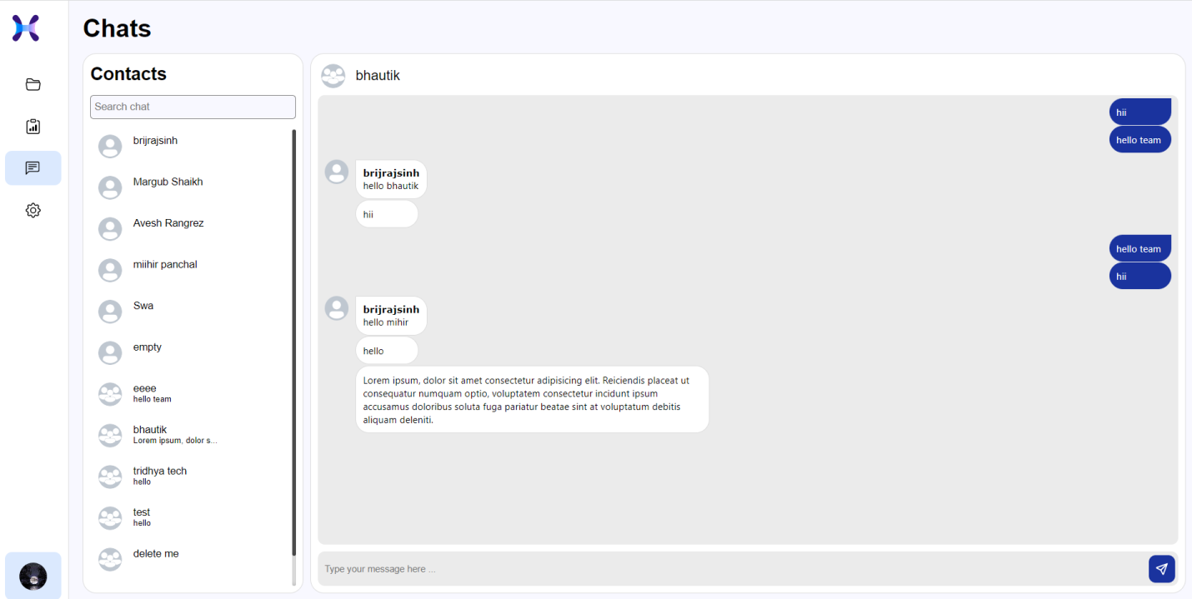

**CHAPTER – 6**

**TESTING**

1)login page:-

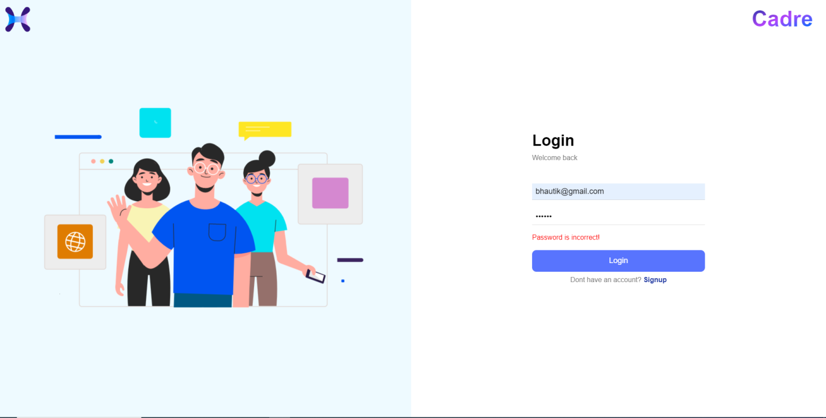

2)signup page:-

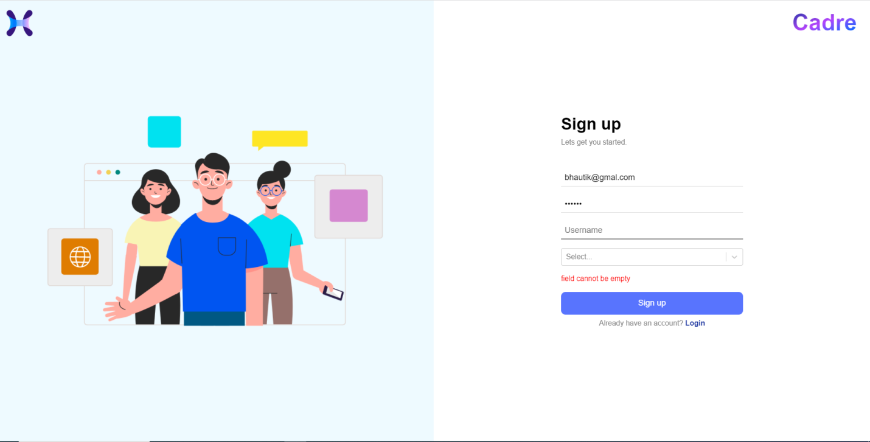

3)create project:-

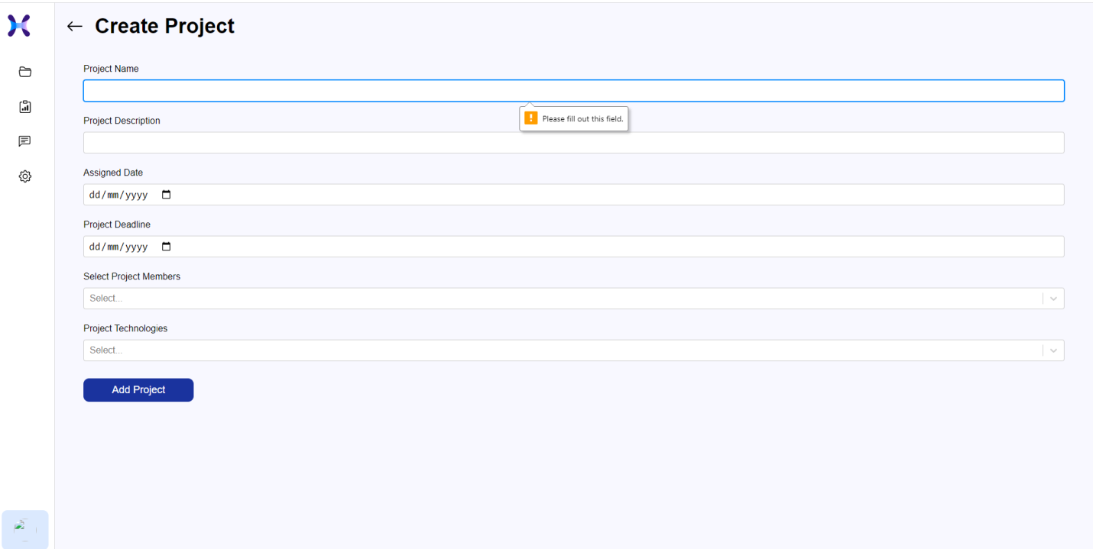

4)create task:-

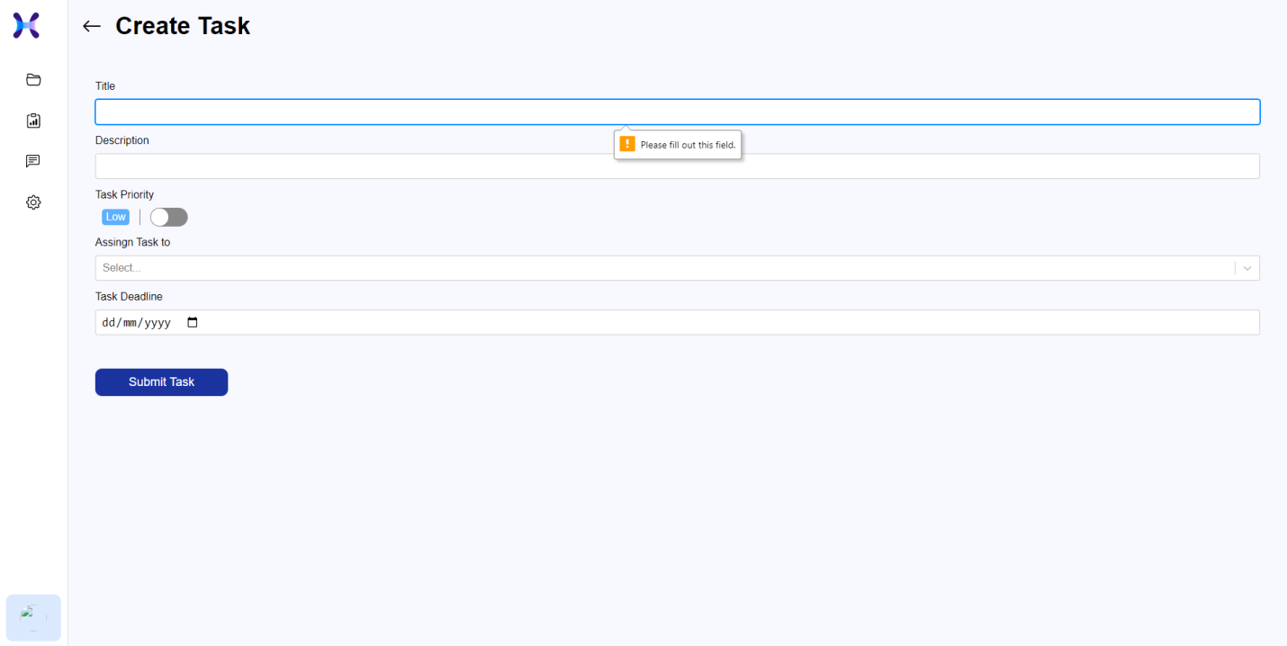

5)update project:-

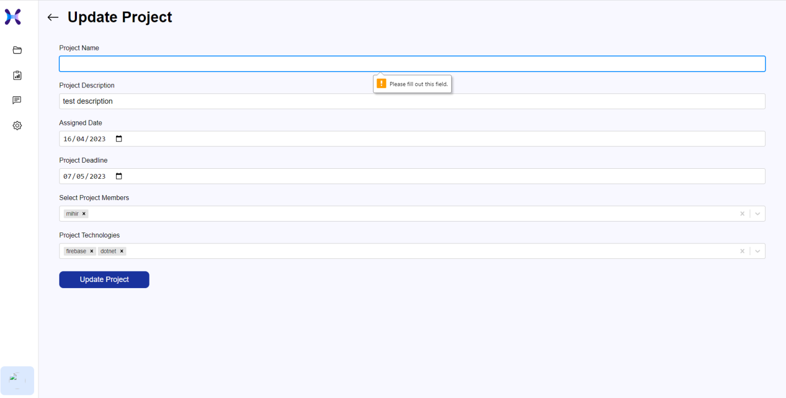

6)Not selected any chat:-

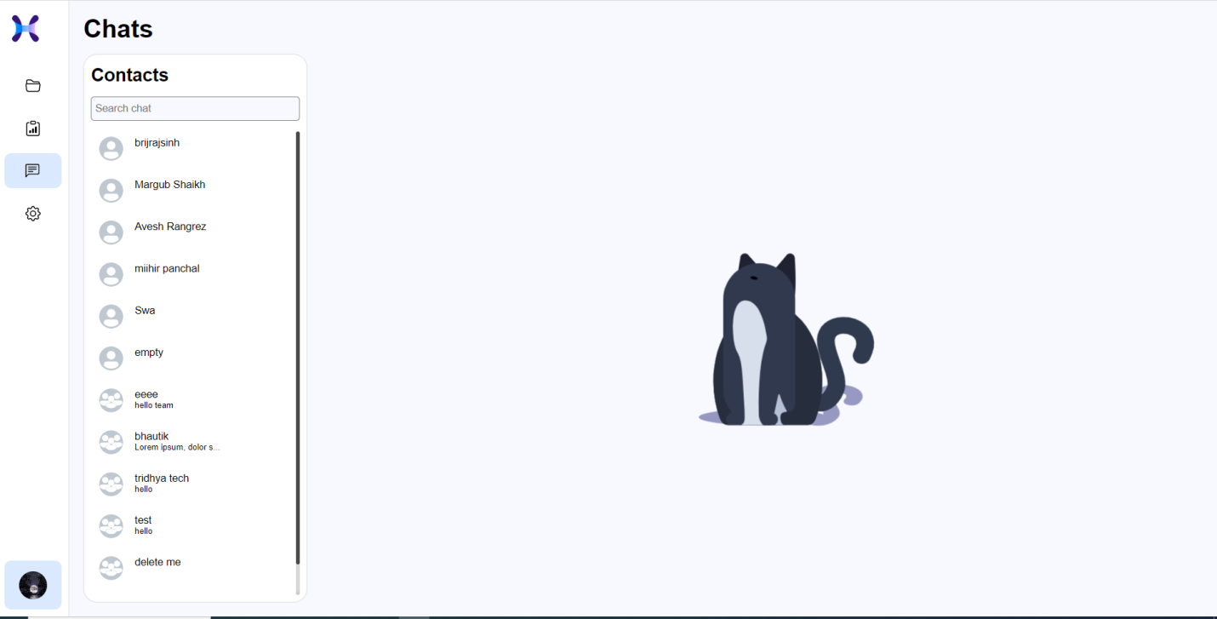

**CHAPTER – 7**

**SUMMARY**

## Assumption:-

* + - This website is supposed to much responsive that it should be easily operated in any size of device.(Smartphones, Laptop and Pc)
    - They must have knowledge of English Language.
    - This website will provide facility of email
    - Profile of every users are visible to all others, but can’t be edited by any other excepting his/her self whose actual profile is.

## Bibliography:-

1. Software Engineering A Practitioner’s Approach

-By Roger S. Pressman

2) System Analysis and Design

-By James A. Senn

3)System Analysis and Design

-By Kendlle & Kendlle