Screenshot

**Header of webpage**

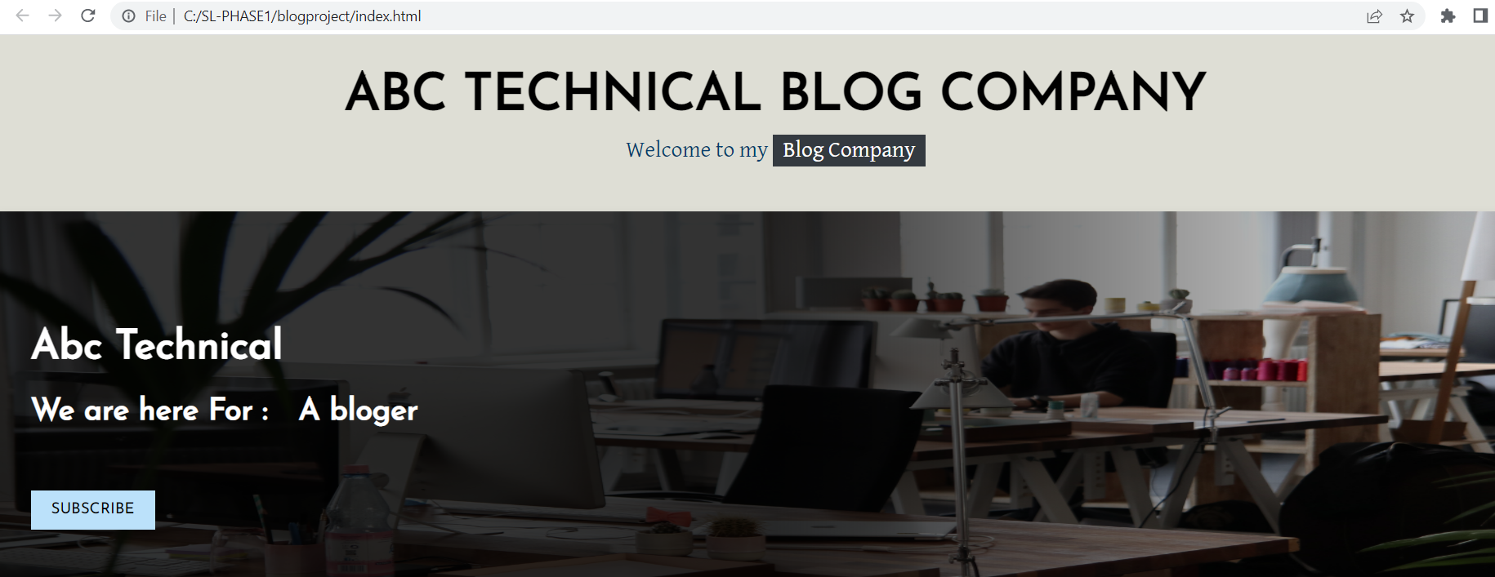

**Body of the web page**

Some Technical blog by company

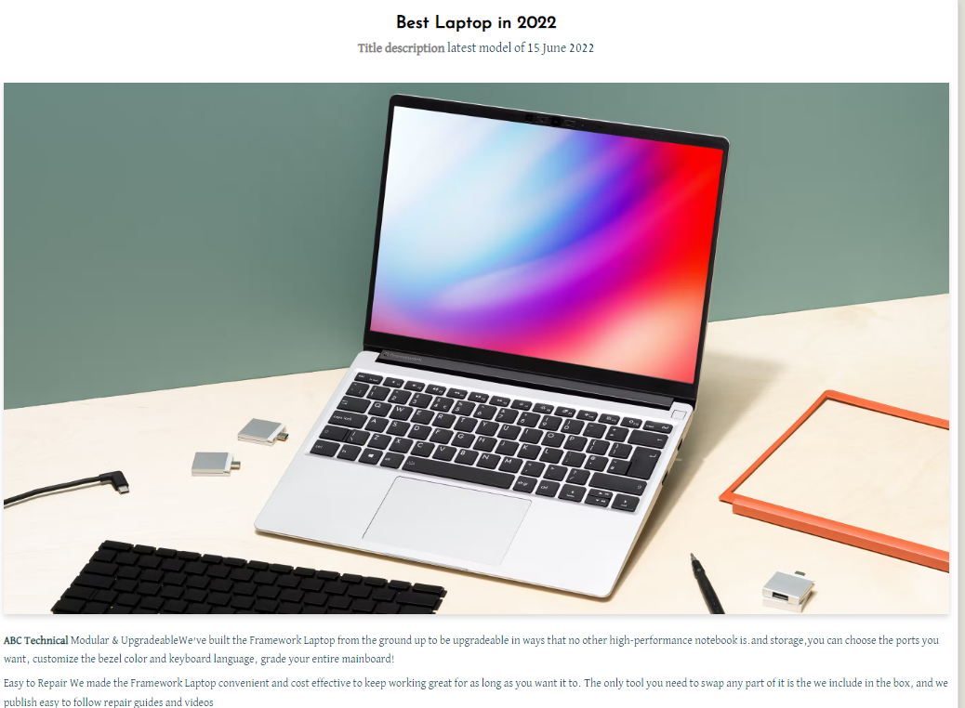



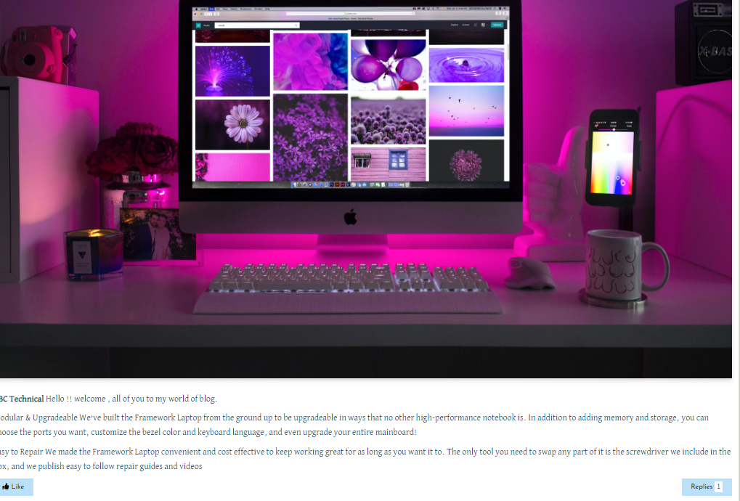



**Footer of Webpage**



**Right Side Division of web page**

**Information About Company of on right side webpage**

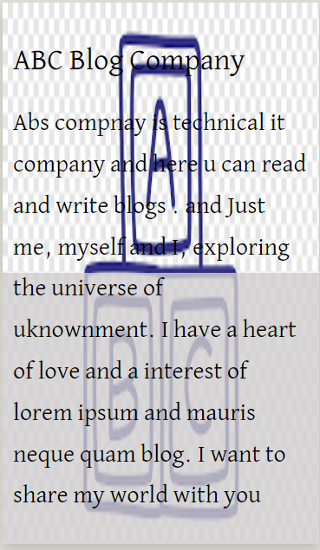

**Customer can read Popular Blogs**



**Advertisement display here**

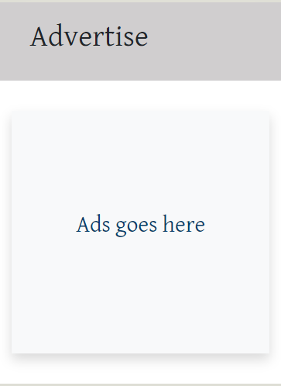

**You Can read related topic**

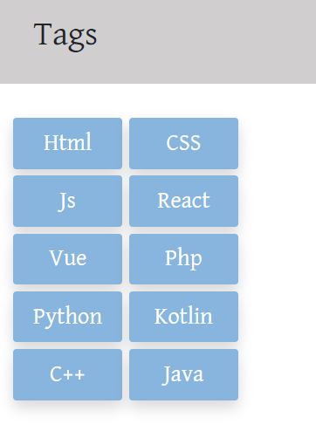

**Inspiration Of different Technical Blog**

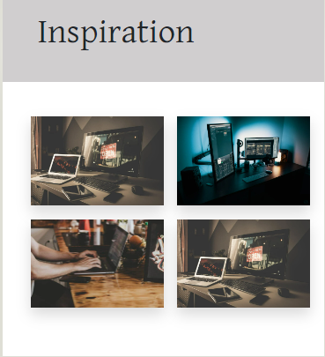

**You can connect this company different Social media**

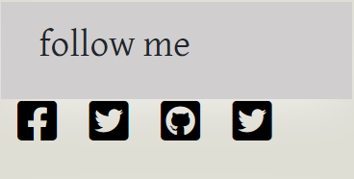

**Blogger can Write blog for this website**

