*ID* : 1

# 1 Feature Analysis

*ID* : 600

***Guidance text is located in separate attribute column*** "Guidelines for using CFAM template"

*ID* : 2

## 1.1 Introduction

*ID* : 4

### 1.1.1 Version History

|  |  |  |  |  |
| --- | --- | --- | --- | --- |
| **Version** | **Date** | **Author** | **Status** | **Comments** |
|  |  |  |  |  |
|  |  |  |  |  |
|  |  |  |  |  |

*ID* : 2062

### 1.1.2 Feature overview

RC0441 “Cloud BTS new hybrid OAM” feature covers all changes in Single BTSOM software architecture required to make cloud deployment possible.

Main changes are

1. RAP side: Introduction of a runtime variability of a functionality provided by Single BTSOM software package. That package will be deployed on physical BTS (RAP - Radio Access Point) in order to maintain same software architecture regardless of Single BTSOM deployment. Single BTSOM software package will be used on both legacy BTS and RAP in cloud. Changeable mode is introduced to mark whether hardware is used for legacy BTS or RAP.
2. VM side: Introduction of modelling and monitoring of available nodes and services in Cloud BTSOM what is required to properly deduce state of the system and enable possibility to build scalability features.

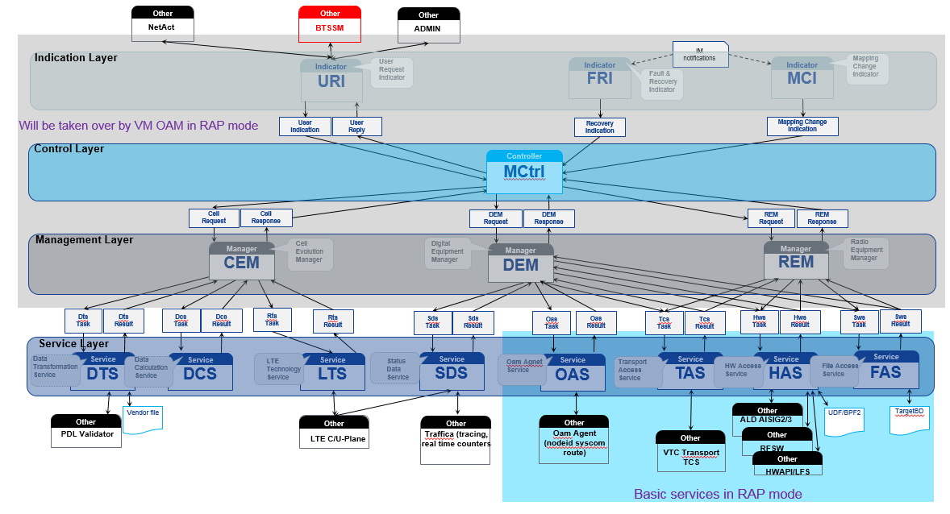

### 1.1.3 Open issues

|  |  |  |  |
| --- | --- | --- | --- |
| **AI number** | **Action item/ Open issue** | **Owner** | **Target date/ Done date** |
|  |  |  |  |
|  |  |  |  |
|  |  |  |  |

*ID* : 52

### 1.1.4 Decisions

|  |  |
| --- | --- |
| **Date** | **Description & reference (if any)** |
|  |  |
|  |  |
|  |  |

*ID* : 64

### 1.1.5 Common Feature analysis Module (CFAM) Phase1 team members and their roles

*ID* : 66

These are CFAM team mebers for Phase1. Phase 2 team members are defined per Network Element in Chapters 7, 8, 9 and 10

*ID* : 1661

**CFAM Team Members**

|  |  |
| --- | --- |
| **Role** | **Person** |
| End to End Feature Owner | Wang, Zijing 1. (Nokia - CN/Hangzhou) |
| Moderator/Approver | Yang, Yuming (Nokia - CN/Hangzhou) |
| SFS authors | Tomczak, Piotr |
| BTS E2E FO |  |
| RNC E2E FO |  |
| OMS main EFS author |  |
|  |  |
|  |  |

*ID* : 1691

**Key Inspectors**

|  |  |
| --- | --- |
| **Role** | **Person** |
| Product Management | Marko Siiskonen |
| SFS authors | Tomczak, Piotr |
| EFS Authors | Ciastoch, Sebastian (ADMIN) |
| SFS Category leader | Krawiec, Lukasz (BM) |
| SyVe |  |
|  |  |
|  |  |
|  |  |
|  |  |
|  |  |

*ID* : 1735

**Other Inspectors**

|  |  |
| --- | --- |
| **Role** | **Person name** |
| System Program Manager |  |
| Entity program Managers |  |
| Possible NE implementation representatives |  |
| Possible Operations representatives |  |
| NE I&V |  |
| CuDo |  |
| SoC |  |
| Network Engineering |  |
| System Specificaiton Project Manager |  |
|  |  |
|  |  |

*ID* : 100

### 1.1.6 Other stakeholders and their roles (CFAM Phase 1)

*ID* : 1796

**Information provider Stakeholders**

|  |  |
| --- | --- |
| **Role** | **Person name** |
| Product Management |  |
| System Specification Project Manager |  |
| SFS Category Leader |  |
| System Program Manager |  |
| Entity Program Managers |  |
| EFS Authors |  |
| Possible NE implementation representatives |  |
| Possible Operations representatives |  |
| NE I&V |  |
| SyVe |  |
|  |  |

*ID* : 186

### 1.1.7 Terms and abbreviations

*ID* : 197

|  |  |
| --- | --- |
| **Terms or abbreviation** | **Explanation** |
| CFAM | Common Feature Analysis Module |
| FSM | Flexi System Module |
| E2E FO | End to End Feature Owner |
| RAP | Radio Access Point |

|  |  |
| --- | --- |
| RCP | Radio Cloud Platform |
| VM | Virtual Machine |

### 1.1.8 References

|  |  |
| --- | --- |
| **Ref number** | **Reference** |
| 1.FS2 material | https://[sharenet-ims.int.net.nokia.com/Download/D544772086](https://sharenet-ims.int.net.nokia.com/Download/D544772086) |
|  |  |

*ID* : 181

### 1.1.9 IPR Notes

*ID* : 1644

## 1.2 Stakeholder Requirements

*ID* : 2065

### 1.2.1 Stakeholder Requirements (from Stakeholder Requirement module)

*ID* : 2066

### 1.2.2 Additional Stakeholder Requirements (edited here)

*ID* : 185

## 1.3 Feature Description

*ID* : 208

This feature covers all changes in Single BTSOM software architecture required to make cloud deployment possible.

Cloud BTS differentiates RAP in two operation modes:

1. RAP mode - RAP role was assigned to BTS by IMP/PnP server (TBD: depends on LTE3435), only basic services (OAS, HAS, TAS, FAS) are running, services are controlled from Cloud BTSOM; RAP is connected to Cloud BTSOM; controller, indicators and managers are inactive. Admin is available from OAM VM.
2. STANDALONE mode - all Single BTS OM services are running (including controller, indicators and managers), ADMIN service is provided locally, waits for a connection from Cloud BTS OM or commissioning from IMP; RAP *is not* connected to Cloud BTSOM

The switching of the RAP operation modes is illustrated below:

Be noted RAP role and RAP mode are different. RAP role assignment doesn't mean switching to RAP mode. Mode is switched from STANDALONE to RAP only when connection between RAP and Cloud BTS OM is established.

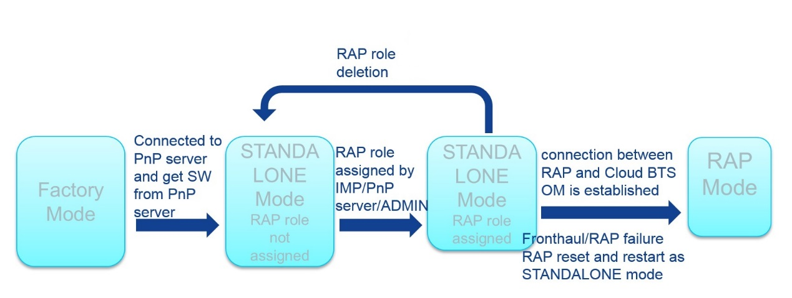

### 1.3.1 Feature Scope

This feature’s scope is the startup of RAP and integration into Cloud BTS. RAP will run differently as in legacy BTS, the control part has been located in cloud side. After that, configuration and commissioning for L3 call is possible.

The IP connection establishment between VMs and RAP is not in the scope of this feature. This feature is scoped to establish IMI connection between VM and RAP.

The RAP auto-integration is not in the scope of this feature. For L3 call, RAP is manually configured to integrate into Cloud BTS.

The startup procedures are listed as below:

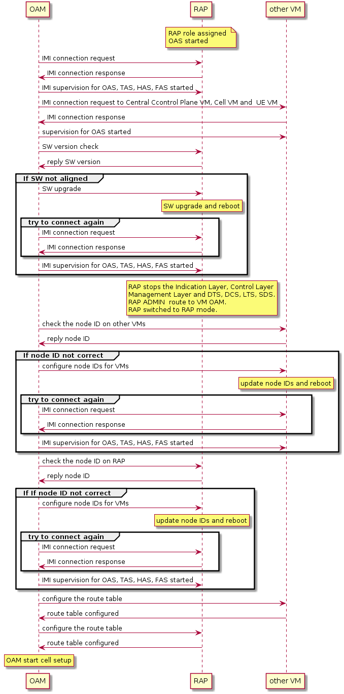

**Scope for ADMIN:**

1. VM status monitoring
   * At least we should know how many Cell VMs and how many UE VMs are there and whether everyone is on-line. Information should be come from OAM.
2. Present cells to VM mapping;
3. In STANDALONE mode, ADMIN is provided locally, in RAP mode RAP ADMIN routed to VM ADMIN
4. Assign RAP role for the BTS by downloading SCF in STANDALONE node. Only commission of TRS is needed, RAP role will be assigned after this procedure.
5. Active CBTS configuration, scf file will be used to commission the site, scf validation is also done by ADMIN.

**Scope for IMI:**

1. IMI on RAP OAM is implemented by BM. IM server should be ported into OAM VM to implement IMI.
2. Allows to access data of services deployed in a distributed cloud architecture over IMI
   * multi-node support
   * handshake between services with proper IMI version verification
   * polling (subscriber - publisher)
   * service discovery
   * SCTP/TCP over IP support
3. Info Model structure change to contain cloud related information such as VMs status, Cell to VM mapping, RAP status.

**Scope for OAS:**

1. OAS is considered as a service in service layer
2. OAS is deployed on below VMs:
   * Central CP VM
   * Cell VM
   * UE VM
   * OAM VM
   * RAP
3. OAS responsibility:
   * Syscom route configuration
   * master/local node IDs assignment

### 1.3.2 Definition on dependencies between features

*ID* : 215

#### 1.3.2.1 Preconditions for this feature

*ID* : 224

1. *RC0189*

* RAP has the corresponding SW version installed
* RAP role assigned
* RAP have IP connections with OAM VM
* The mapping relationship is known in IMP based on SCF.

1. *RC0115*
2. *RC0421*
3. *LTE2866*
4. *LTE3338*

#### 1.3.2.2 Affected features

*ID* : 234

#### 1.3.2.3 Related features

*ID* : 668

### 1.3.3 Alternative Solutions and Selected Solution

*ID* : 257

## 1.4 Definition of User Scenarios

*ID* : 1642

### 1.4.1 Operator Scenarios (Use cases)

*ID* : 1650

**Actors**:

**Preconditions:**

**Hardware requirements:**

**Required features:**

**Description:**

**Configure BTS:**

**Configure RNC:**

**Configure OMS/ NetAct**

**Alarms**:

**Measurements:**

**Post-conditions:**

**Exceptions:**

*ID* : 463

### 1.4.2 Feature Management Scenarios

*ID* : 466

#### 1.4.2.1 Feature Activation Scenarios

*ID* : 467

**Actors**:

**Preconditions:**

**Hardware requirements:**

**Required features:**

**Description:**

**Configure BTS:**

**Configure RNC:**

**Configure OMS/ NetAct**

**Alarms**:

**Measurements:**

**Post-conditions:**

**Exceptions:**

*ID* : 468

#### 1.4.2.2 Feature Deactivation Scenarios (optional)

*ID* : 280

### 1.4.3 Impact on System Performance

*ID* : 296

### 1.4.4 Impact on System Capacity

*ID* : 494

### 1.4.5 Licensing

*ID* : 1647

### 1.4.6 Other User Scenarios

*ID* : 1641

## 1.5 Summary of Feature phasing

Definition of integration steps / phasing

|  |  |  |
| --- | --- | --- |
| **Phase ID** | **Phase description** | Affected Network Elements |
| *use syntax RAN<feature Component ID>_<character>* | *description* |  |

*ID* : 314

## 1.6 SyVe and I&V aspects

*ID* : 496

### 1.6.1 O&M System Performance

*ID* : 497

### 1.6.2 Feature Testability Analysis

*ID* : 499

**HW configuration:**

AirFrame Servers 1+1+1

FSM-r3 + FXFC / FHEB

FSM-r4 + FXFC / FHEB

**VNF configuration:**

Case 1: 1 O&M VM + 1 central CP VM + 1 cell VM + 1 UE VM;

Case 2: 1 O&M VM + 1 central CP VM + 1 cell VM + 2 UE VM;

Case 3: 1 O&M VM + 1 central CP VM + 2 cell VM + 1 UE VM;

**Test equipment requirement:**

Real UE; IPHY

**Test scenario:**

1. CBTS VNF deployment

1 O&M VM + 1 central CP VM + 1 cell VM + 1 UE VM;

1 O&M VM + 1 central CP VM + 1 cell VM + 2 UE VM;

1 O&M VM + 1 central CP VM + 2 cell VM + 1 UE VM;

2. Commissioning with multi configurations

1 cell, 3 cell, 22 cells, more than 22 cells (in case of V3 CPU); 1 cell, 3 cell, 26 cells, more than 26cells (in case of V4 CPU).

1 O&M VM + 1 central CP VM + 1 UE VM + 1 cell VM + FSM-r3 + FXFC

1 O&M VM + 1 central CP VM + 1 UE VM + 1 cell VM + FSM-r4 + FHEB

… …

3. L3 call

1) Cell is on air

2) L3 call establish

3) Paging

### 1.6.3 Define the needed configurations

*ID* : 321

## 1.7 Impact to NE external interfaces

*ID* : 502

### 1.7.1 Interfaces between different NEs

*ID* : 503

#### 1.7.1.1 Interfaces between BTS and RNC

*ID* : 506

#### 1.7.1.2 Interfaces between RNC and OMS

*ID* : 508

#### 1.7.1.3 Interfaces between OMS and NetAct

*ID* : 2067

#### 1.7.1.4 Interfaces between BTS and OMS

*ID* : 2068

#### 1.7.1.5 Interfaces between BTS and NetAct

*ID* : 2069

#### 1.7.1.6 Interfaces between RNC and NetAct

*ID* : 2070

#### 1.7.1.7 Interfaces between OMS and NetAct

*ID* : 2053

### 1.7.2 Layer 1 - Layer 3 interface impacts between UE and RAN

*ID* : 2054

#### 1.7.2.1 RNC - UE interface

*ID* : 2055

#### 1.7.2.2 BTS - UE interface

*ID* : 2052

x

*ID* : 327

# 2 RAN System Level Requirements

*ID* : 329

# 3 BTS High Level Requirements

*ID* : 331

# 4 RNC High Level Requirements

*ID* : 333

# 5 OMS High Level Requirements

*ID* : 666

# 6 RACS High Level Requirements

*ID* : 335

# 7 Impact to BTS design

*ID* : 336

**NOTE: The information in this paragraph is necessarily not up-to-date after implementation of the feature has started. The cumulative BTS design information is kept up-to-date in the documents (formal module paragraphs) stored into the BTS Functional Area Team (FAT) formal modules, located in WCDMA_BTS/BTS_Requirement folder and structured according to separate BTS Document Tree definition available in Sharenet-IMS.**

***Add the comment and date which after the content of this chapter is not updated anymore.***

*ID* : 1653

## 7.1 Impact BTS design phase participants

*ID* : 1654

**Impact BTS design phase team members**

|  |  |
| --- | --- |
| **Role** | **Person name** |
| BTS E2E FO |  |
| Moderator / Approver |  |
| EFS Author |  |
|  |  |
|  |  |

*ID* : 1890

**Impact BTS design phase key inspectors**

|  |  |
| --- | --- |
| **Role** | **Person name** |
| EFS Author |  |
| SA E2E FO |  |
| NE implementation |  |
| NE I&V |  |
|  |  |

*ID* : 1910

**Impact BTS design phase other inspectors**

|  |  |
| --- | --- |
| **Role** | **Person name** |
| SFS Author |  |
|  |  |
|  |  |
|  |  |
|  |  |

*ID* : 338

## 7.2 References

*ID* : 340

## 7.3 Static Models (Optional)

*ID* : 344

### 7.3.1 Architecture impact diagram

*ID* : 348

#### 7.3.1.1 Diagram explanation

*ID* : 350

### 7.3.2 Description of impacts and impacted system and subsystem components

*ID* : 363

## 7.4 Dynamic models (Optional)

*ID* : 501

## 7.5 Capacity and performance

*ID* : 370

## 7.6 Impact to Black Box Modules

*ID* : 372

## 7.7 Impact to BTS HW architecture

*ID* : 374

## 7.8 Impact to BTS SW architecture

*ID* : 2051

## 7.9 Radio Platform User Stories and Requirements

*ID* : 376

## 7.10 Impact to Radio Platform SW

*ID* : 378

## 7.11 Impact to Application SW

*ID* : 380

## 7.12 Testability

*ID* : 388

## 7.13 Impact to Interfaces

*ID* : 389

### 7.13.1 External Interfaces

*ID* : 391

### 7.13.2 Internal Interfaces

*ID* : 393

## 7.14 Impact to BTS EFS Documents

*ID* : 395

## 7.15 Feature splitting in BTS

*ID* : 397

# 8 Impact to RNC Design

*ID* : 398

**NOTE: The information in this paragraph is necessarily not up-to-date after the implementation for the feature has been started. The cumulative RNC detailed level requirements are kept up-to-date in the RNC EFSes stored into the RNC EFS formal modules, located in WCDMA_RNC/EFS folder.**

***Add the comment and date which after the content of this chapter is not updated anymore.***

*ID* : 1657

## 8.1 CFAM Phase 2 RNC participants

*ID* : 1930

**CFAM Phase 2 RNC team members**

|  |  |
| --- | --- |
| RNC E2E FO |  |
| Moderator / Approver |  |
| EFS Author |  |
|  |  |
|  |  |
|  |  |

*ID* : 1950

**CFAM Phase 2 RNC key inspectors**

|  |  |
| --- | --- |
| EFS Author |  |
| SA E2E FO |  |
| NE implementation |  |
| NE I&V |  |
|  |  |
|  |  |

*ID* : 1970

**CFAM Phase 2 RNC key inspectors**

|  |  |
| --- | --- |
| SFS Author |  |
|  |  |
|  |  |
|  |  |
|  |  |
|  |  |

*ID* : 400

## 8.2 References

*ID* : 402

## 8.3 Impact to RNC System Domains

*ID* : 404

### 8.3.1 Capacity and performance

*ID* : 415

### 8.3.2 E2E performance

*ID* : 425

### 8.3.3 Testability

*ID* : 433

### 8.3.4 Connectivity

*ID* : 435

### 8.3.5 Upgradeability

*ID* : 438

### 8.3.6 Availability

*ID* : 616

### 8.3.7 Operability

*ID* : 617

### 8.3.8 Traffic

*ID* : 618

### 8.3.9 Security

*ID* : 440

## 8.4 Impact to HW architecture

*ID* : 442

## 8.5 Impact to SW architecture

*ID* : 2056

## 8.6 Impact to Interfaces

*ID* : 2057

### 8.6.1 External Interfaces

*ID* : 2058

### 8.6.2 Internal Interfaces

*ID* : 444

## 8.7 Feature integration steps/phasing in RNC

*ID* : 446

# 9 Impact to OMS Design

*ID* : 510

**NOTE: The information in this paragraph is necessarily not up-to-date after the implementation for the feature has been started. The OMS detailed level requirements are kept up-to-date in the OMS EFSes stored into the OMS EFS formal modules, located in** [**RA_OMS/EFS folder**](doors://fiesdoorsp01.emea.nsn-net.net:36655/?version=2&prodID=0&urn=urn:telelogic:68a6beb0-29bd-11df-bcd9-cd506bb8bf5d:1-4017b9fe29051a61-F-00013180)**.**

***Add the comment and date which after the content of this chapter is not updated anymore.***

***Optionally short description of the feature from OMS point of view***

*ID* : 1658

## 9.1 CFAM phase 2 OMS participants

*ID* : 1990

**CFAM Phase 2 OMS team members**

|  |  |
| --- | --- |
| OMS E2E FO |  |
| Moderator / Approver |  |
| EFS Author |  |
|  |  |
|  |  |
|  |  |

*ID* : 1991

**CFAM Phase 2 OMS key inspectors**

|  |  |
| --- | --- |
| EFS Author |  |
| SA E2E FO |  |
| NE Implementation |  |
| NE I&V |  |
|  |  |
|  |  |

*ID* : 1992

**CFAM Phase 2 OMS other inspectors**

|  |  |
| --- | --- |
| SFS Author |  |
|  |  |
|  |  |
|  |  |
|  |  |
|  |  |

*ID* : 449

## 9.2 References

*ID* : 451

## 9.3 Impact to domains

*ID* : 511

### 9.3.1 OMS functional domains

*ID* : 513

### 9.3.2 OMS non-functional domains

*ID* : 619

## 9.4 Impact to Flexiplatform

*ID* : 621

## 9.5 Impact to Testing

*ID* : 623

## 9.6 Impact to Customer Documentation

*ID* : 625

## 9.7 Impact to 3rd party SW

*ID* : 452

## 9.8 Impact to External Interfaces

*ID* : 453

### 9.8.1 NWI3

*ID* : 627

### 9.8.2 BTSOM

*ID* : 629

### 9.8.3 Other external interfaces

*ID* : 455

## 9.9 Feature phasing in OMS

*ID* : 1505

# 10 Impact to RACS Design

*ID* : 1506

**NOTE: For RACS there is no separate EFS created. All feature specification is found in this document and EFS' Detailed level requirements are in this folder.**

*ID* : 1507

## 10.1 References

*ID* : 1509

## 10.2 Impact to RACS System Domains

*ID* : 1511

### 10.2.1 Capacity and performance

*ID* : 1522

### 10.2.2 E2E performance

*ID* : 1532

### 10.2.3 Testability

*ID* : 1540

### 10.2.4 Connectivity

*ID* : 1542

### 10.2.5 Upgradeability

*ID* : 1545

### 10.2.6 Availability

*ID* : 1547

### 10.2.7 Operability

*ID* : 1548

### 10.2.8 Traffic

*ID* : 1549

### 10.2.9 Security

*ID* : 1550

## 10.3 Impact to HW architecture

*ID* : 1552

## 10.4 Impact to SW architecture

*ID* : 2059

## 10.5 Impact to Interfaces

*ID* : 2060

### 10.5.1 External Interfaces

*ID* : 2061

### 10.5.2 Internal Interfaces

*ID* : 1559

## 10.6 Feature integration steps/phasing in RACS

*ID* : 1564

## 10.7 RSM EFS

*ID* : 631

# 11 NetAct Impact to Design

*ID* : 632

**NOTE: The information on update dates and CFAM writers in this paragraph should be kept updated once the feature has been started. The idea is also that all NetAct related requirements are linked to this chapter and can be analyzed and traced during feature implementation.**

* *Feature name and short description of NetAct areas*
* *Authors on NetAct for differentent areas*
* *Dates for target reviews and changes*

|  |  |  |  |
| --- | --- | --- | --- |
|  |  |  |  |
|  |  |  |  |
|  |  |  |  |
|  |  |  |  |

*ID* : 633

## 11.1 References

*ID* : 635

## 11.2 Impact to System domains in NetAct

*ID* : 636

### 11.2.1 NetAct Configurator impact

*ID* : 637

### 11.2.2 NetAct Performance Management impact

*ID* : 638

### 11.2.3 NetAct Fault Management impact

*ID* : 639

### 11.2.4 NetAct Traffica impact

*ID* : 640

### 11.2.5 Other NetAct system area impacts

*ID* : 642

## 11.3 Impact to Interfaces

*ID* : 643

### 11.3.1 External Interfaces

*ID* : 645

## 11.4 Feature splitting in OMS and Network Elements

*ID* : 647

## 11.5 NetAct requirements to Network Element implementation

*ID* : 648

### 11.5.1 NetAct Configurator impact

*ID* : 649

### 11.5.2 NetAct Performance Management impact

*ID* : 650

### 11.5.3 NetAct Fault Management impact

*ID* : 651

### 11.5.4 NetAct Traffica impact

*ID* : 652

### 11.5.5 Other NetAct system area impacts