**PROJECT PLAN**

**STOCK PRICE PREDICTOR**

**Team Details:**

**MIHIR JAYAPRKASH PES2UG20CS196**

**MITUL JOBY PES2UG20CS199**

**NAVYAE GOYAL PES2UG20CS219**

**NOEL JACOB ABRAHAM PES2UG20CS234**

**1. Identify the lifecycle to be followed for the execution of your project and justify why you have chosen the model.**

The life cycle followed for the execution of our project is the Agile Scrum. This methodology involves multiple iterations of certain steps and a daily scrum to update each other on the progress.

These iterations are the sprints and are pre decided before starting the project. We follow a continuous deliverable format which verifies tasks for the day and if the sprint completion is up to date.

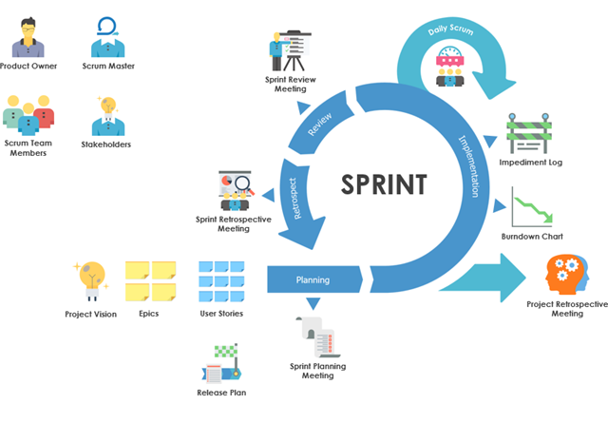

**2. Identify the tools which you want to use throughout the life cycle like planning tool, design tool, version control, development tool, bug tracking and testing.**

Planning tool: JIRA

Design Tools: PowerPoint, Canva

Version Control: git

Development Tool: VS Code, Python

Bug Tracking: JIRA

Testing: Selenium

**3. Determine all the deliverables and categorize them as reuse/build components and justify the same**

* Login Page (Client, Admin): Reuse

There are many existing login page components that we can use and change to our requirements.

* Update the databases with companies’ stock: Build
* Try to add as many companies’ stock prices to the database: Build

A simple process of adding data to an existing database and connecting them

* Generate plots for historical stock prices: Build

Deliverable that takes care of generating historical data such as closing price, opening price, high and low and then based on that prints the stock prices.

* Generate future prices of the stock: Build

Generating the future prices of the stock using machine learning.

**4. Create a WBS for the entire functionalities in detail**

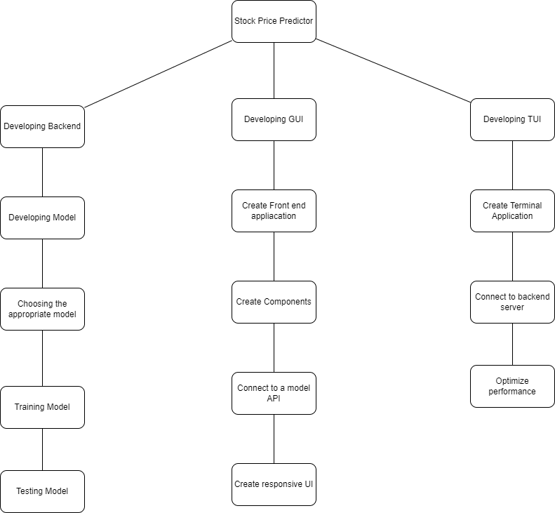

# Rough estimate of effort required

Organic models are used when the problem statement is well understood and have been used in the past, and works well with small teams.

KLOC = 2

a = 2.4

b = 1.05

Effort = a*(KLOC)^b = 4.96

**Gantt chart**

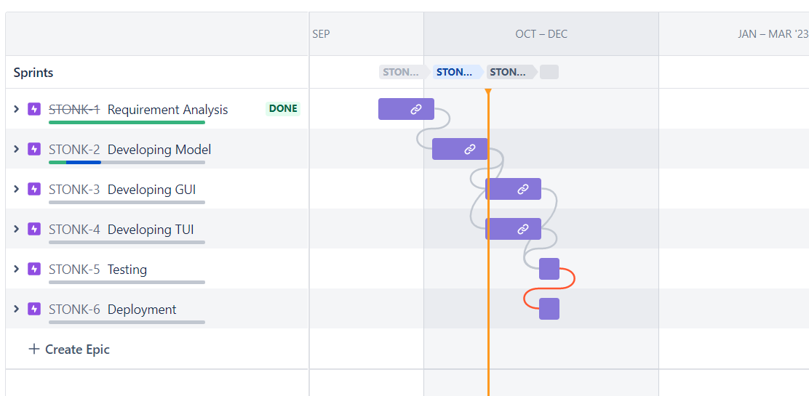

**Sprints**

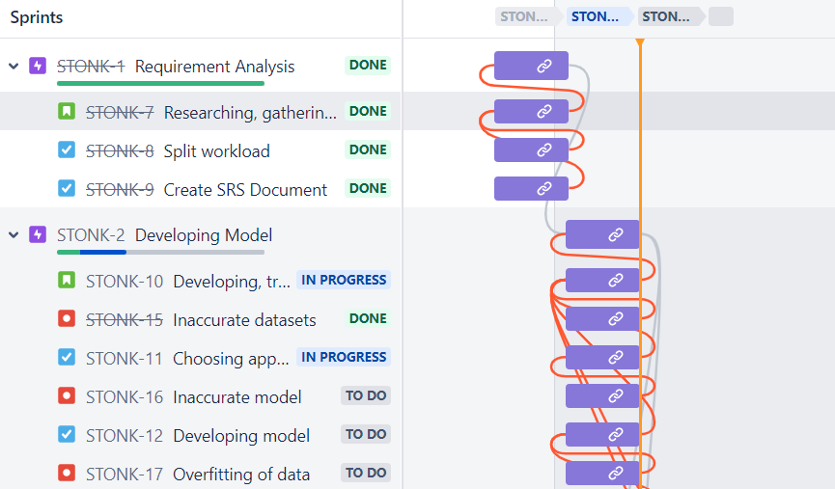

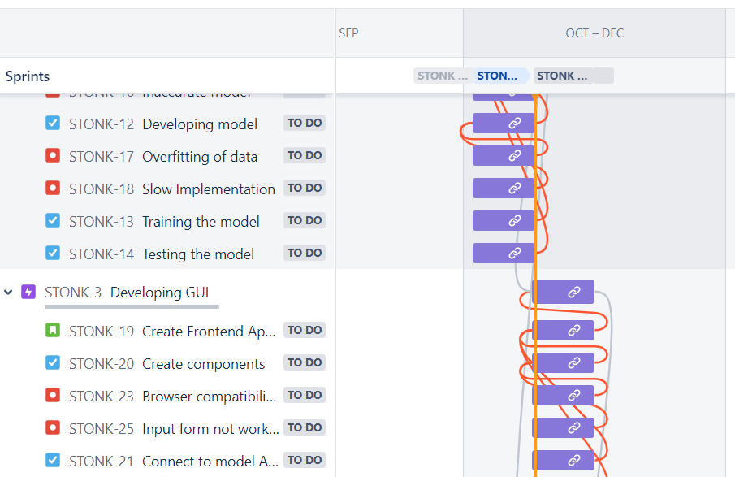

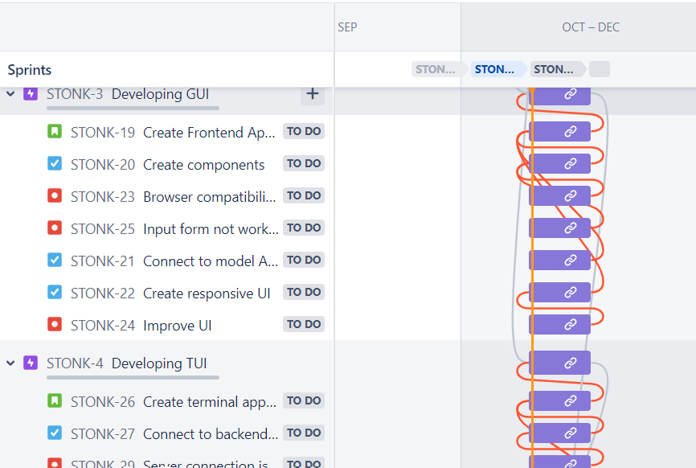

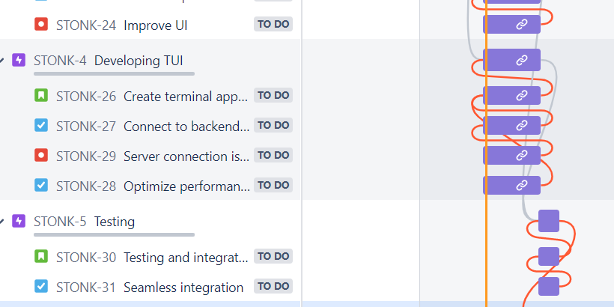

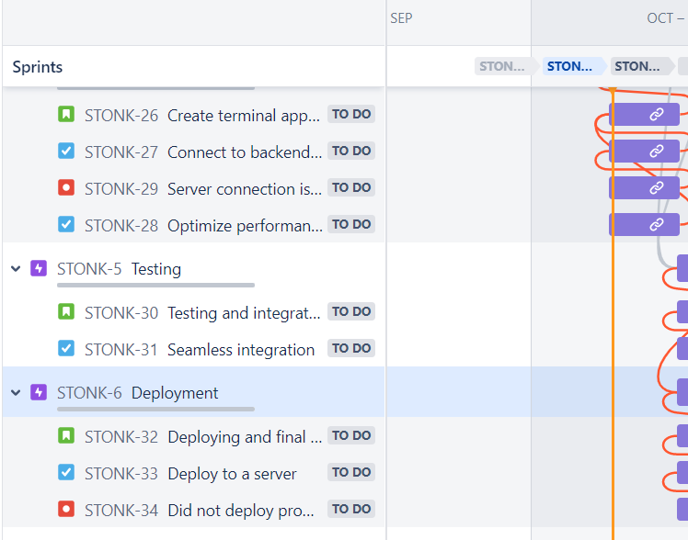

**Product Backlog**

