**PES UNIVERSITY**

**AUGUST – DECEMBER 2022 SEMESTER 5**

**SOFTWARE ENGINEERING LAB TASKS**

**UNIT 2 LAB TASK**

**SUBMITTED BY**

**Mihir Jayaprakash PES2UG20CS196**

**Mitul Joby PES2UG20CS199**

**Navyae Goyal PES2UG20CS219**

**Noel Jacob Abraham PES2UG20CS234**

**PROBLEM STATEMENT 1:**

Your new software project is a product delivery platform. As a part of project initiation and approval you are required to perform and note down a thorough competitor analysis. (Some companies with a product delivery platform are Unbxd, Algolia etc.) After your analysis, you are expected to do the following exercise as a part of risk management. On the digital document or paper, add columns with the following headers:

* What could cause amiss in your deadline?
* Lack of Proper Planning
* Poor communication:
* Poor Performance
* Wrong choice of Technology
* Project Management and Planning Issues
* Improper Estimation -Shifting Project Requirements
* What will keep your project on time?
* Determine the Project’s Scope and Objectives
* Coordinate and Communicate
* Reserve Time for Unexpected Issues
* Break Down the Project into Smaller Tasks
* Review the Project’s Progress Frequently
* What does this project need that you don’t have?
* AI-powered search
* personalized recommendations
* What do you already have that this project needs?
* Site Search
* Merchandizing
* Product Information Management
* What are you worried about?
* smooth implementation of the AI- powered search
* compatibility of the personalized recommendations with the previous software
* What are you excited about?
* implementation of this new software can be a big success and can bring huge profits to the company
* What could go wrong with this project?
* if the implementation of the new software isn't as good as our competitors, then the company's market share will reduce and it can lead to downward spiral
* What could go right with this project?
* If the addition of the new software is well and good then the company will be the market leader.

**PROBLEM STATEMENT 3:**

Explore the MakeMyTrip website https://www.makemytrip.com/.Write the minispecs and draw the top level DFD, first level decomposition and second level composition for the MakeMyTrip website.

**MINISPECS**

**Functional**

1. ADMIN

Login:

* Invalid:  No permissions are granted.
* Valid: Some permissions to change or modify the website and database access and can also monitor the website's traffic.

1. VISITORS

Registration:

* Gather visitor data
* Register as a user
* Visit the website and check for trips, accommodations, modes of transportation, prices, etc. User must log in or register in order to book or use services.

1. USER

After entering the username and password and confirming, the website will redirect to the main page.

* Can view their past reservations and trips.
* Can organize a trip.
* Reservations for flights, hotels, buses, railroads, and vacations (domestic and foreign packages)
* Complete payments
* Purchase the tickets.
* Commit the cancellation of the excursions or tickets. ii. Cancel the tickets.
* Status of refunds
* Cards, gift
* Live specials and bargains.
* Refer and profit

1. TICKET VENDOR

* Purchases tickets on your behalf.
* Discounts and promotions.
* A planner.
* Authentication and verification.

**Non-functional**

* Reliable: The system needs to be synced periodically to prevent scheduling conflicts and other problems, 24/7 usability.
* Integrity and maintainability.
* Versatile: The website ought to function on any OS or browser.
* Safe payment processing.
* The ability to occasionally withstand a lot of incoming traffic.
* Flexible and simple to modify without triggering a shutdown.
* Constraints include memory requirements, language requirements, and implementation restrictions.

**TOP LEVEL DATA FLOW DIAGRAM**

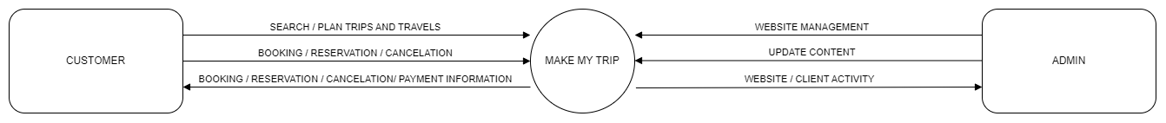

**LEVEL 1 DECOMPOSITION**

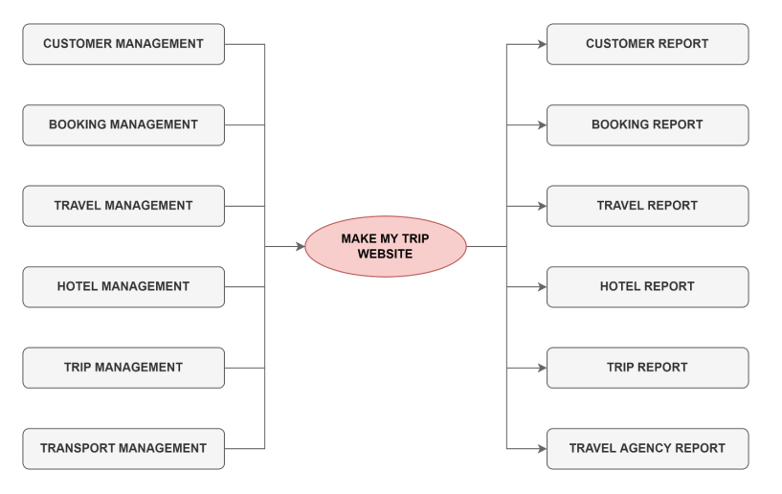

**LEVEL 2 DECOMPOSITION**

