**PES UNIVERSITY**

**AUGUST – DECEMBER 2022 SEMESTER 5**

**SOFTWARE ENGINEERING LAB TASKS**

**UNIT 5 LAB TASK**

**SUBMITTED BY**

**Mihir Jayaprakash PES2UG20CS196**

**Mitul Joby PES2UG20CS199**

**Navyae Goyal PES2UG20CS219**

**Noel Jacob Abraham PES2UG20CS234**

**PROBLEM STATEMENT – 1:**

**You are a manager at a large MNC. You and your team have been working closely with a client to develop their product. Through this project you have developed a good business relationship and friendship with the client. On the eve of the product release, your team notifies you about a major bug in the code that had been overlooked before. Your client asks you if the product is defect free.**

**Keeping in mind personal, business & professional ethics, how would you tackle this situation as a manager? Brainstorm ideas which would lead to a defect free product release without jeopardizing the good relationship with your client. Make use of ethical frameworks and principles in your answer.**

The bug is first observed and checked on how serious the bug is and check the consequences, then the upon studying the bug, we shall inform the client on the procedure on how to fix the bug.

If not, the client should be informed about the bug as it is important to be open, clear and honest to the client as the bug not being informed to the client can lead to dire consequences as client is not ready for such scenarios. It would also lead to loss in trust and money for company.

Then we check if there is sufficient time for the development team to fix the bug, compensating them for working extra hours. If this doesn't fix the defect, that particular feature is pushed to the next release and testing is prioritized a couple of days before the feature is released to avoid a similar situation in the future.

We handle this situation with utmost professionalism and respectfulness. We will be accountable and maintain the transparency throughout which will lead to client being understanding and co-operative.

**PROBLEM STATEMENT – 2:**

**In line with the four pillars of DevOps – Collaboration, Tools, Scaling and Affinity, your team has to come up with innovative solutions to tackle social issues such as child safety for example (each team is free to choose their own topic based on social issues). This will be done using techniques such as Crazy 4s and S.C.A.M.P.E.R. You are then required to provide a list of tools for an end-to-end technical solution for the best idea you generated. You are also required to provide information regarding scaling in terms of teams, Infrastructure, workload, organization and complexity.**

**Crazy 4s:**

**Open a new text editing document.**

**Set a timer for four minutes.**

**In these four minutes each participant is required to come up with four rough ideas as solutions for the problem. You can note your ideas down as small points instead of entire sentences.**

**At the end of four minutes, you are required to discuss your ideas with your teammates to come up with the best possible solution.**

**NOTE: This can be extended to Crazy 6s or Crazy 8s with six minutes for six ideas or eight minutes for eight ideas depending on team size.**

Crazy 4s:

An app which lets combines all streaming services in one platform, this helps customers to avoid the headaches caused by fragmented streaming landscape

A website which lets user with common interest find each other, people with common interest can join their respective forums and discuss about their passions.

An app to collaborate food donation collection from different housing colonies. People in an apartment can all prepare food which is collected by an NGO.

An app where people below poverty line can request for small amounts of money to help purchase their daily food. The money can by the general public.

The best possible solution we have chosen is No.2. An app to collaborate food donation collection from different housing colonies.

We can let people have interest tags when they join the website

We can use user’s cookies to see what they are interested in.

We can create a directory of interested topics and then put links to it

We can recommend groups to users based on geographical location.

S.C.A.M.P.E.R:

In order to further improve your ideas ideated using Crazy 4s, use this technique. Answer these following questions as a team to improve your idea.

Substitute:

Instead of people with different interest go searching for different platforms for each interest, we can have a platform where we can serve people with different interest on the same platform which will have each unique forum for their interest.

Combine:

We can combine two aspects of different forums for different topics with one common platform, which results in users able to navigate easily, using concepts of user-based modeling.

Adapt:

We can find user’s common interest by using their profile, hobbies and geographical location to recommend forums

Modify:

We can increase the exposure of the user and its interest to another user’s. We can also use the exposure of the user to find other forums as well.

Put to another use:

It can also be used to for advertisers to give targeted ads.

Eliminate: If this element is removed then the website shall breakdown since the very core of the website is for helping people find forums for interested topics and find like-minded people. Without using the common interest then the platform would lose its meaning

Reverse/rearrange:

rearranging the steps of the improved solution doesn’t actually affect any of the parameters, but reversing would not work because process cannot be started with forums, since the finding of forums is the last step in this process.

**PROBLEM STATEMENT – 3:**

**For your SE projects, convert your software architecture into a business roadmap and devise a Service strategy by including service value definition, business case development, service assets, market analysis and service provider types.**

**SE project: Stock Price Prediction Website**

Business roadmap:

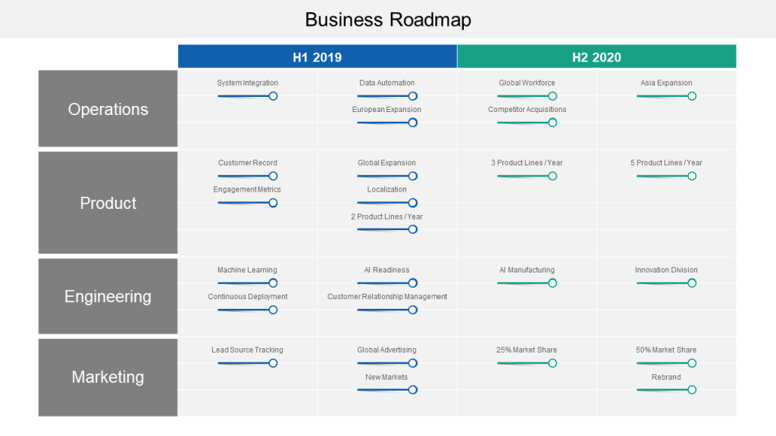

Service Strategy:

**Service Value Definition:**

Creating value for customers by providing them the platform to find information and predictions of stock market and helping them to improve them financially by helping them predict stocks and find profit.

**Business Case Development:**

There is a huge need to predict future prices of stocks since it is a volatile and unpredictable field. Everything changes very quickly; people find it comfortable to use a platform to help them know the future prices of the stocks. The need for domain knowledge decreases. It helps people to generate more money.

**Service Assets:**

ML model

IP related to predicting stock

Engineering team

ML team

Front end team

Backend team

Marketing team

**Market Analysis:**

The market that we are targeting are investors, VC companies, hedge fund like BlackRock Advisors, AQR Capital Management, Sequoia Capital, Blume Ventures, Accel etc.

The common man can also use this platform to generate more money.

This helps them to easily decide which stock to invest in and generate more income. This platform tells which stock is on the up and which stock is down. This helps in their decision making.