A Project Report

on

Cooling Equipment Sensor Fault Detection

carried out as part of the Project Based Learning-3 (DSE3170)
Submitted

by

Rishabh Srivastava (2430010149)
Mitul Seth (2430010099)
Madhav Mittal (2430010096)

in partial fulfilment for the award of the degree of

Bachelor of Technology

in

Computer Science and Engineering (Data Science)

Under the Guidance of
Dr. Neha V Sharma



School of Computer Science and Engineering
Department of Data Science and Engineering

MANIPAL UNIVERSITY JAIPUR, JAIPUR
RAJASTHAN, INDIA

October 2026
CERTIFICATE
This is to certify that the project-based learning project titled Cooling Equipment Sensor Fault Detection is a record of the bonafide work done by Rishabh Srivastava (2430010149), Mitul Seth (2430010099) and Madhav Mittal (2430010096), submitted in partial fulfilment of the requirements for the award of the Degree of Bachelor of Technology in Computer Science and Engineering (Data Science) of Manipal University Jaipur, Jaipur during the academic year 2026-27.

Dr. Neha V Sharma
Assistant Professor (Selection Grade)
Project Guide, Department of Data Science and Engineering
Manipal University Jaipur, Jaipur

Mr. Santosh Rajak
Assistant Professor
Class instructor, Department of Data Science and Engineering
Manipal University Jaipur, Jaipur

Abstract
Reliable sensor readings support cooling control, but fault detectors can generate nuisance alarms when label meaning, operating mode and decision thresholds are poorly matched. This project develops a supervised long short-term memory classifier for outdoor-air temperature sensor-bias detection in an occupied, running simulated air-handling unit. The public AFDD collection supplies native condition labels and documented bias scenarios. A 30-minute history of thirteen sensor/control inputs, six consistency features and thirteen missing indicators forms 32 input channels. Winter and spring are used for training, summer for validation and autumn for final evaluation. Whole source days and scenario blocks remain separated, and all preprocessing statistics come from normal active training data. Three LSTM training seeds are compared with a gradient-boosted classifier on the same histories.
The predeclared seed-42 LSTM achieves 92.82% accuracy, 99.74% precision, 91.86% recall and 95.64% F1 on 33,432 eligible autumn endpoints. Its 1.44% false-positive rate exceeds the original 1% goal; 69 false readings form one alarm burst. It detects 35 of 36 observable fault days and 35 of all 42 raw fault days. The baseline has zero test false positives with lower recall of 72.05%. The study contributes a reproducible evaluation, saved models, a dashboard, retained failure cases and a documented investigation of the earlier M100 label mismatch. Evidence is limited to one simulated unit and one fault family with experimental fault prevalence of 85.71%. No real-equipment deployment reliability or future-fault prediction is claimed.
Keywords Deep learning LSTM AHU Sensor bias False alarms Time series
Table of Contents
1 Introduction 1
1.1 Problem context 1
1.2 Problem statement 1
1.3 Project objectives 1
1.4 Scope and deliverables 1
2 Background and Technical Foundation 2
2.1 Cooling equipment and sensor consistency 2
2.2 Sequence learning with an LSTM 2
2.3 A matched machine learning baseline 2
2.4 Scores and alarm decisions 2
3 Dataset and Experimental Design 3
3.1 Source data and native labels 3
3.2 Partitions and eligibility 3
3.3 Leakage prevention and prevalence 4
4 Proposed Methodology 5
4.1 Measurement cleaning and features 5
4.2 LSTM architecture and loss 5
4.3 Baseline training 6
4.4 Policy search and freeze 6
4.5 Evaluation measures 7
5 System Implementation and Demonstration 8
5.1 Software organization 8
5.2 Dashboard workflow 8
5.3 Reproducibility and testing 8
6 Experimental Results and Analysis 9
6.1 Summer validation results 9
6.2 Reserved autumn performance 9
6.3 Ranking and model comparison 11
6.4 Severity coverage and delay 12
6.5 Detected fault example 13
6.6 Missed fault example 13
6.7 False alarm example 14
6.8 Assessment against the project targets 14
7 Discussion and Project Learning 15
7.1 Why the dataset and scope changed 15
7.2 Interpretation and limitations 15
7.3 PBL outcomes 15
8 Conclusion and Future Scope 16
References 17
Appendix A Reproduction and Demonstration 18
Run the demonstration 18
Verify the frozen experiment 18
Demonstration sequence 18
Appendix B Evidence and Input Contract 19

List of Tables

Table 3.1 Dataset definition 3
Table 3.2 Whole-season partitions 3
Table 4.1 Input feature groups 5
Table 4.2 Fixed training configuration 6
Table 4.3 Validation targets 6
Table 5.1 Implementation components 8
Table 6.1 Validation performance at each selected policy 9
Table 6.2 Primary frozen test performance 9
Table 6.3 Autumn model comparison 11
Table 6.4 Primary performance by imposed sensor bias 12
Table B.1 Principal evidence files 19
List of Figures

Figure 2.1 Source multi-zone AHU schematic from the AFDD inventory page 4 2
Figure 6.1 Autumn confusion matrix for the primary frozen LSTM 10
Figure 6.2 Autumn precision recall curves from raw model scores 11
Figure 6.3 Detected source fault on 2017-11-06 13
Figure 6.4 Missed observable fault day on 2017-11-27 13
Figure 6.5 Healthy source day with a false alarm on 2017-11-02 14

- Introduction
  - Problem context
An air-handling unit conditions and circulates air using fans, dampers and heating or cooling coils. Control decisions depend on measurements such as outdoor-air temperature, supply-air temperature and duct pressure. A biased sensor can produce readings that appear plausible in isolation while disagreeing with related measurements and control commands. This motivates a detector that uses recent sensor relationships rather than a single temperature threshold.
The project addresses current sensor-fault detection during a specified operating mode. It uses the public building fault-detection collection distributed through the Open Energy Data Initiative [1]. The selected MZVAV-1 dataset and its inventory describe one simulated multi-zone AHU, including healthy operation and imposed outdoor-air temperature sensor biases [2]. Although the repository began with a datacenter anomaly-detection study, the final benchmark has a more specific equipment and label definition.
  - Problem statement
Given thirty consecutive one-minute observations from an occupied AHU with its supply fan running, classify whether the current endpoint belongs to the source-defined outdoor-air sensor-bias condition. Apply a validation-selected persistence rule to the sequence of scores and measure both missed fault readings and nuisance alarms. The source label is the reference condition; it is never generated from the same features used for prediction.
  - Project objectives
Audit the dataset labels, scenario dates, operating-mode eligibility and train/validation/test separation.
Clean measurements causally and construct sensor-consistency features without using future observations or test statistics.
Train a compact LSTM and compare three seeds with a matched-history gradient-boosted baseline.
Freeze the model and alarm policy before the autumn test, then report reading metrics, fault-day coverage, delays and retained failures.
Provide reproducible scripts, saved artifacts, a notebook and a dashboard suitable for an academic demonstration.
  - Scope and deliverables
The output is a course prototype for one simulated unit and one fault family. It does not forecast future faults or establish diagnosis of all cooling-system failures. The report, presentation, executable code, trained models and demonstration form the project deliverables. The results section evaluates the actual frozen policy, including the missed false-positive target.
- Background and Technical Foundation
  - Cooling equipment and sensor consistency
The source AHU mixes outdoor and return air before conditioning it for occupied zones. Related temperatures provide complementary information, while fan, damper and valve commands describe the control state. Commands are not direct airflow or heat-transfer measurements. Figure 2.1 reproduces the source equipment schematic [2].
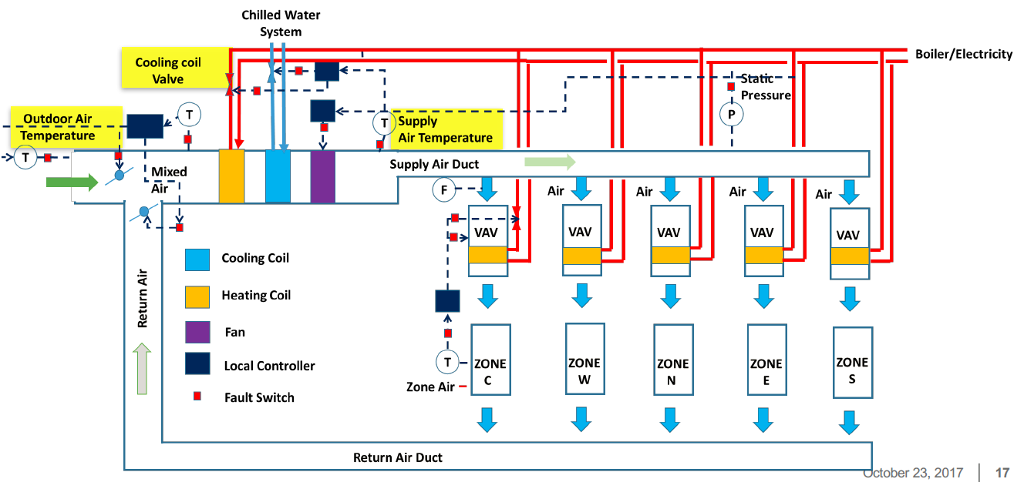
Figure 2.1 Source multi-zone AHU schematic from the AFDD inventory page 4
A command-weighted mixing residual summarizes temperature/control disagreement. Since damper command is not a measured airflow fraction, the residual is a predictive heuristic rather than a validated physical balance.
  - Sequence learning with an LSTM
Hochreiter and Schmidhuber introduced long short-term memory to address recurrent-network limitations in learning long dependencies [3]. An LSTM maintains an internal state while processing a sequence. Here, thirty observations provide operating history before the current endpoint is scored.
The implemented PyTorch LSTM uses input, forget and output gates and a cell state [4]. Its final hidden representation feeds a classification head. The contribution is a controlled application and evaluation of established methods for the stated task.
  - A matched machine learning baseline
Histogram-based gradient boosting provides a supervised baseline [5]. It receives the latest value, mean, standard deviation and slope of the same 32 channels over thirty minutes. Both models use identical endpoint labels and available sensor history.
  - Scores and alarm decisions
A threshold converts scores into positive labels and should be selected on validation data, independently of the final test [6]. Persistence rules additionally suppress isolated highs. AP measures raw-score ranking, while reported precision, recall and FPR describe confirmed decisions. The logit is not a calibrated probability.
- Dataset and Experimental Design
  - Source data and native labels
The selected MZVAV-1 member contains 272,160 one-minute records across 189 source days. Its original Fault Detection Ground Truth column defines 0 as healthy and 1 as faulted. The inventory describes EnergyPlus-Dymola co-simulation of one AHU in a modeled Chicago office building, with outdoor-air temperature sensor biases of plus or minus 1, 2 and 4 degrees Celsius [2]. Measurement temperatures in the CSV are degrees Fahrenheit; the bias-intensity unit must not be confused with the input unit.
Table 3.1 Dataset definition
Attribute | Value
Selected member | MZVAV-1.csv
Raw observations / source days | 272,160 / 189
Native labels | Healthy 0 and faulted 1
Fault family | Outdoor-air temperature sensor bias
Imposed bias | -4, -2, -1, +1, +2, +4 degrees Celsius
Measurement unit | Degrees Fahrenheit
Sampling / timezone | One minute / source local time unspecified

All native daily labels were checked against the documented scenario dates before training. The archive and inventory are preserved unchanged, and their SHA-256 fingerprints are recorded in the experiment plan. Other collection members were reviewed for label availability and independent source-day coverage. The rooftop-unit member contains no healthy native examples in the supplied file; the selected multi-zone dataset provides substantially more scenario days. Selection occurred before model performance was measured.
  - Partitions and eligibility
Table 3.2 Whole-season partitions
Partition | Seasons | Raw days | Scored days | Endpoints | Faults
Train | Winter and spring | 91 | 77 | 61,187 | 52,446
Validation | Summer | 49 | 42 | 33,432 | 28,656
Test | Autumn | 49 | 42 | 33,432 | 28,656

Whole seasons, scenario blocks and source days stay in one partition. A history cannot cross a source day, equipment boundary or timestamp gap. Eligibility requires all thirty preceding observations to have occupied mode and supply-fan-on status. These rules were fixed before fitting. Nights, nonoperating Sundays and history warmup are outside the scoring task, while their raw fault days remain in the coverage denominator.
There are 42 raw autumn fault days. Thirty-six contain eligible windows, and six have no eligible operating history. The primary model detects 35 of the 36 observable days. Reporting only that denominator would hide six unobservable fault days, so coverage of all 42 days is reported separately.
  - Leakage prevention and prevalence
Dates, seasons, day identifiers, scenario identity, imposed bias intensity and reference labels are metadata only. They do not enter the numerical feature vector. Medians and scaling parameters use normal active winter/spring observations. The final model, preprocessing and alarm policy were hashed before test evaluation; the autumn data were not used for model, threshold or seed selection.
Validation and test each have 28,656 fault endpoints and 4,776 healthy endpoints, corresponding to experimental fault prevalence of 85.71%. This is a scenario design rather than a field failure frequency. An analytical all-fault predictor would achieve 85.71% accuracy and 100% FPR, demonstrating why accuracy alone is an inadequate project outcome.
- Proposed Methodology
  - Measurement cleaning and features
Nonfinite input values become missing. Negative outdoor temperatures in Fahrenheit remain valid. Missing values are forward-filled using at most five preceding minutes, with resets at source days and time gaps. Remaining values use medians fitted to normal active training observations. Thirteen missing indicators preserve whether an original measurement was absent, even when a previous value or median supplies the numerical input.
Table 4.1 Input feature groups
Group | Channels | Definition
Temperatures | 5 | Supply, supply setpoint, outdoor, mixed and return
Control commands | 6 | Supply/return fan speed, outdoor/return dampers, cooling/heating valves
Pressure | 2 | Duct pressure and pressure setpoint
Consistency features | 6 | Supply error, three temperature differences, pressure error and command-weighted mixing residual
Missing indicators | 13 | One flag for each original measurement

Standard scaling uses normal active training observations, followed by clipping at ten training standard deviations. The resulting vector has 32 channels. Related sensor measurements are retained because their disagreement can carry fault information. PCA was not applied to this final benchmark; no PCA improvement is claimed. The source-label audit and the operational task definition were more important changes than arbitrary attribute removal.
  - LSTM architecture and loss
Each example is a 30 by 32 tensor. A single LSTM layer with hidden size 32 produces the final hidden state. The head applies a 32-to-16 linear layer, ReLU, dropout 0.2 and a 16-to-1 linear output. The network has 8,993 trainable parameters and produces one logit for the current endpoint.
Training uses binary cross-entropy with logits. PyTorch combines the logit transformation and binary loss, and its positive-class weight changes the contribution of positive examples [7]. Here the weight equals the training healthy/fault endpoint ratio, approximately one-sixth. Fault examples are the majority, so a weight below one balances the loss toward healthy observations. Validation and test retain their original prevalence; no evaluation rows are duplicated or removed for class balancing.
Table 4.2 Fixed training configuration
Setting | Value
Optimizer / learning rate | Adam / 0.001
Batch size | 512
Gradient norm clipping | 1
Maximum epochs / patience | 30 / 6
Checkpoint criterion | Highest summer validation average precision
Training seeds | 7, 42 and 123
Primary seed | 42 declared before final evaluation
Execution device | CPU with four PyTorch threads

  - Baseline training
The gradient-boosted classifier uses learning rate 0.05, at most 15 leaves per tree, minimum leaf size 30 and L2 regularization 1. The candidate iteration counts are 50, 100 and 200, selected using summer validation AP. Random internal early-stopping validation is disabled. Class weights are based on training endpoint counts, and all models use the same frozen cohorts.
  - Policy search and freeze
Each model is assessed using ten global threshold methods and three persistence rules, giving 120 validation policies across the four models. Threshold candidates include normal-validation score percentiles, precision-recall thresholds and default scores. Rules are immediate high, two consecutive highs and two highs among three complete consecutive scored minutes. Alarm history resets at source-day, unit or gap boundaries.
Table 4.3 Validation targets
Measure | Required value
Precision | At least 30%
Reading recall | At least 40%
False-positive rate | At most 1%
False bursts per scored device-day | At most 0.1
Observable fault-day recall | At least 60%

Among feasible policies, selection maximizes precision, then F0.5, then minimizes false-burst rate and finally maximizes recall. All three neural seeds must pass the validation gate before a primary pipeline is frozen. Seed 42 remains the predeclared primary, while the other seeds characterize training variation. The selected primary threshold is logit 6.967112 with a two-of-three rule. A high is strictly greater than the threshold, and the rule requires a complete three-score history.
  - Evaluation measures
True positives and false negatives are confirmed decisions on source-fault endpoints. False positives and true negatives are decisions on healthy endpoints. Accuracy is (TP+TN)/N, precision is TP/(TP+FP), recall is TP/(TP+FN), F1 is 2PR/(P+R), FPR is FP/(FP+TN), and false discovery ratio is FP/(TP+FP). The last two ratios answer different questions and are not interchangeable.
Average precision and ROC-AUC use raw model scores, while the confusion counts use the frozen alarm rule. Adjacent confirmed positives form alarm bursts. Burst frequency is normalized by scored exposure: the 33,432 scored minutes equal 23.2167 device-days, rather than all 49 calendar days. Fault-day detection reports both observable and all source fault days. Delay is reported from the source midnight condition and separately from the first eligible score, so downtime and warmup remain visible.
- System Implementation and Demonstration
  - Software organization
The project separates source preparation, model training, policy evaluation, fresh inference and dashboard presentation. The hvac module defines raw aliases, derived features, causal cleaning and eligibility. Training uses the shared LSTM classifier and alarm-policy implementation. The saved model and preprocessing are loaded directly for fresh CSV scoring, while recorded decisions support a reproducible test replay.
Table 5.1 Implementation components
Component | Purpose
prepare_hvac.py | Validate source labels and create frozen season/day cohorts
train_hvac.py | Fit three LSTM seeds and the tree; select validation policies
evaluate_hvac.py | Evaluate frozen artifacts on autumn once and retain the result
verify_hvac.py | Reproduce transformations, scores, policies and fresh CSV examples
build_hvac_evidence.py | Prepare replay, severity, delay and failure-case evidence
dashboard/app.py | Recorded replay, fresh-window scoring, comparisons and documents

  - Dashboard workflow
The dashboard opens with the held-out primary metrics and a statement of simulation scope. The recorded demonstration selects an autumn source day and replay position, then displays temperatures, model logits, threshold and confirmed alarm points. Ground truth is shown separately as a source condition for evaluating the replay. A quiet score during a faulted scenario remains visible as a possible miss.
The upload tab accepts thirty consecutive one-minute rows from one occupied, running unit. A downloadable CSV demonstrates the expected column names. The scorer validates cadence, source-day consistency and operating mode, applies the saved transforms and returns one logit. A single uploaded history provides only one endpoint score; it cannot establish a two-of-three persistence alarm or an independently validated probability.
  - Reproducibility and testing
The exact Python environment, source checksums, cohort hashes, training histories, preprocessing, model tensors, validation policies and final decisions are retained. Verification reproduces all four complete validation and test score arrays, all 120 validation policies, source-label/scenario alignment, training-only transforms and four fresh CSV examples. Thirty-nine unit tests pass, including gap/day resets, missing-input behaviour and preservation of valid negative Fahrenheit readings.
Packaged replay checks passed in the existing environment; physical-equipment generalization and a clean dependency installation were not tested.
- Experimental Results and Analysis
  - Summer validation results
Table 6.1 Validation performance at each selected policy
Model | AP | Precision | Recall | FPR | Days
LSTM 7 | 0.9836 | 100.00% | 64.42% | 0.00% | 36/36
LSTM 42 | 0.9834 | 100.00% | 48.66% | 0.00% | 36/36
LSTM 123 | 0.9789 | 100.00% | 42.10% | 0.00% | 36/36
boosting | 0.9613 | 100.00% | 57.78% | 0.00% | 32/36

All three LSTM seeds meet the validation policy gate. Validation AP mean is 0.9820 with sample standard deviation 0.0027. The primary has 100% empirical precision and 48.66% reading recall at its selected policy, with zero false-positive readings. Its conservative operating point does not imply that every fault reading is detected. These figures are validation observations, not guarantees for another season.
  - Reserved autumn performance
Table 6.2 Primary frozen test performance
Measure | Result
Accuracy / F1 | 92.82% / 95.64%
Precision / recall | 99.74% / 91.86%
AP / ROC-AUC | 0.9962 / 0.9852
FPR / false discovery ratio | 1.44% / 0.26%
False readings / false bursts | 69 / 1
False bursts per scored device-day | 0.0431
Observable / all fault days detected | 35 of 36 / 35 of 42

The primary reaches 92.82% accuracy, 99.74% precision and 91.86% recall. Its 1.44% FPR exceeds the original 1% target. The single false burst meets the stated false-burst budget, but meeting one nuisance-alarm measure does not erase the missed reading-level target. The validation-frozen threshold remains unchanged after this result.
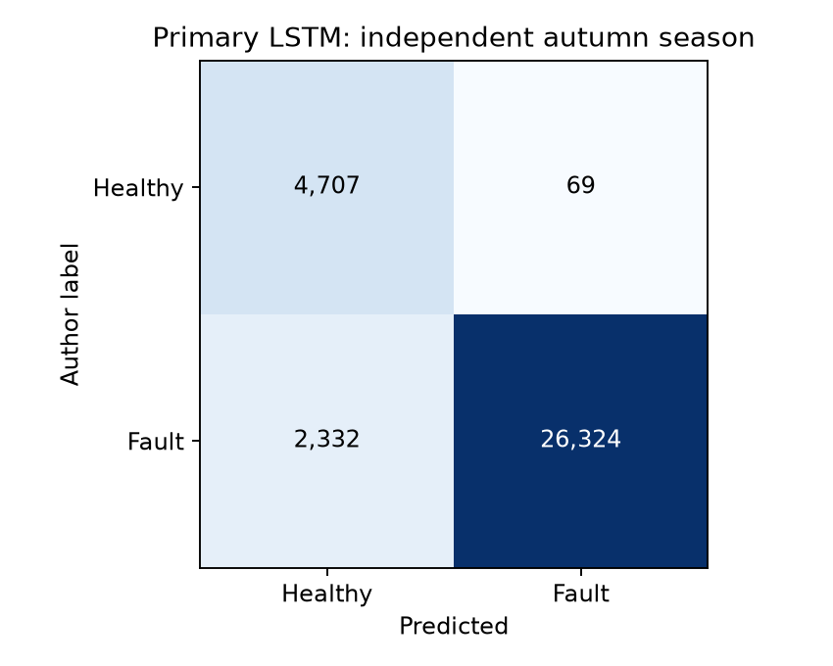
Figure 6.1 Autumn confusion matrix for the primary frozen LSTM
The counts are TP 26,324, FP 69, FN 2,332 and TN 4,707. Thus 69 of 4,776 healthy endpoints are falsely flagged, while only 69 of 26,393 positive alarm decisions are false. This accounts for the different FPR of 1.44% and false discovery ratio of 0.26%.
  - Ranking and model comparison
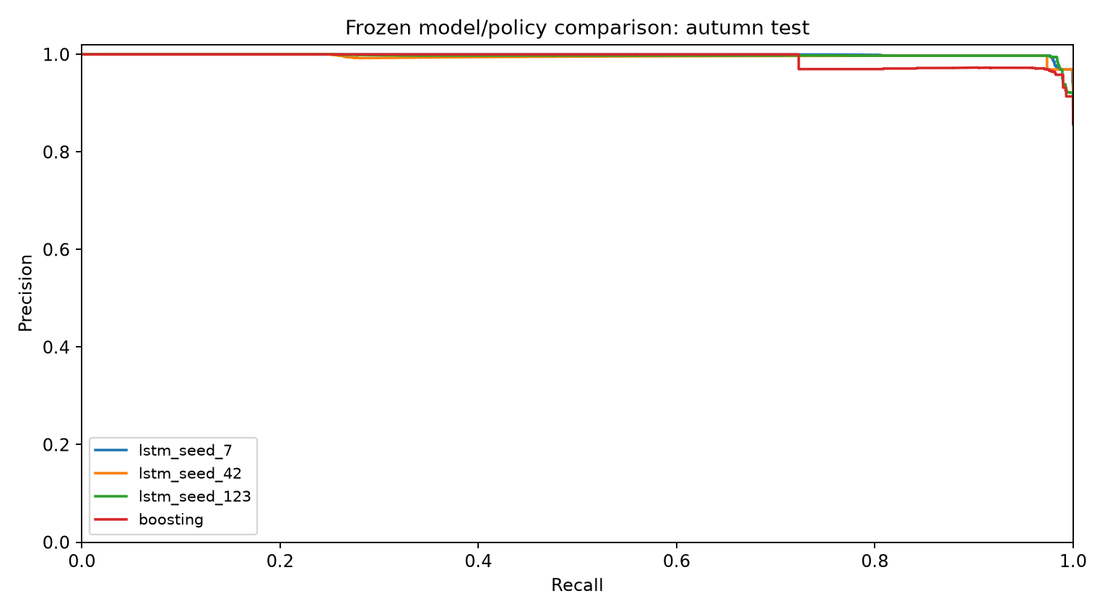
Figure 6.2 Autumn precision recall curves from raw model scores
The precision-recall curves describe score ranking across possible thresholds. They do not authorize selecting a new operating threshold from the test season. The reported decision metrics below use each policy frozen on validation; the primary remains seed 42 even though seed 7 scores higher on the final test.
Table 6.3 Autumn model comparison
Model | Accuracy | Precision | Recall | FPR
LSTM 7 | 96.66% | 99.73% | 96.36% | 1.55%
LSTM 42 | 92.82% | 99.74% | 91.86% | 1.44%
LSTM 123 | 85.55% | 99.71% | 83.39% | 1.47%
boosting | 76.04% | 100.00% | 72.05% | 0.00%

The tree reports zero test false positives and 72.05% reading recall. The primary LSTM gains 19.81 percentage points of reading recall with 69 additional false-positive readings. The three neural seeds have mean test accuracy 91.68% and sample standard deviation 5.64 percentage points. This is variation over three optimization seeds, not a confidence interval for field performance.
  - Severity coverage and delay
Table 6.4 Primary performance by imposed sensor bias
Bias C | Scored days | Recall | Detected days
-4 | 6 | 99.75% | 6
-2 | 6 | 96.11% | 6
-1 | 6 | 78.50% | 5
+0 | 6 | Healthy | 0
+1 | 6 | 87.44% | 6
+2 | 6 | 90.75% | 6
+4 | 6 | 98.64% | 6

The minus-one-degree cases have the lowest recall, 78.50%, and contain the one missed observable day. Larger magnitude biases are generally easier in this test, but the table is not proof of universal severity monotonicity or causal feature attribution. Median delay is 392 minutes from midnight fault imposition and two minutes from the first eligible score. The first measure includes nonoperation and history warmup; neither measure establishes prediction before the fault occurs.
  - Detected fault example
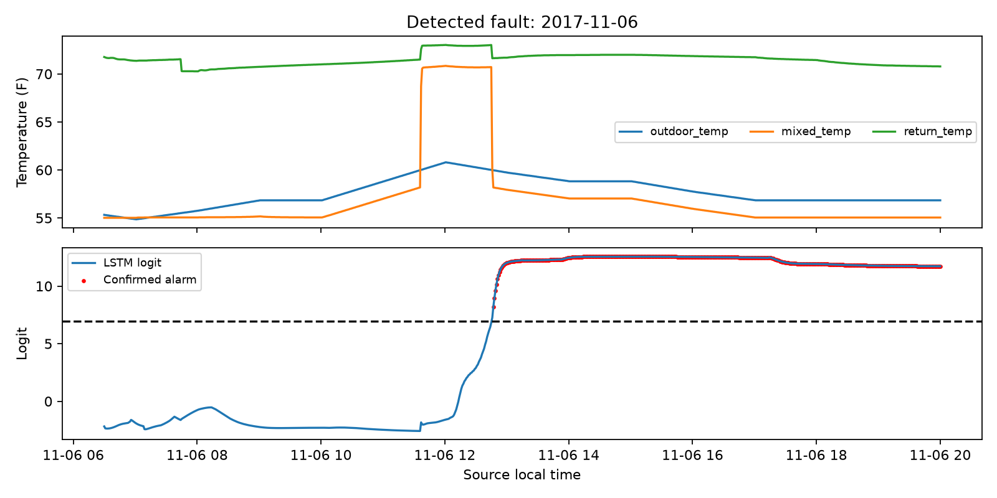
Figure 6.3 Detected source fault on 2017-11-06
The detected example contains an imposed bias of +1 degrees Celsius. Its raw outdoor, mixed and return temperatures provide context for the logit trace. Red markers identify confirmed decisions after the frozen persistence rule; a high score alone and a confirmed alarm are distinct outputs. This individual example illustrates the workflow rather than the median delay across all detected fault days.
  - Missed fault example
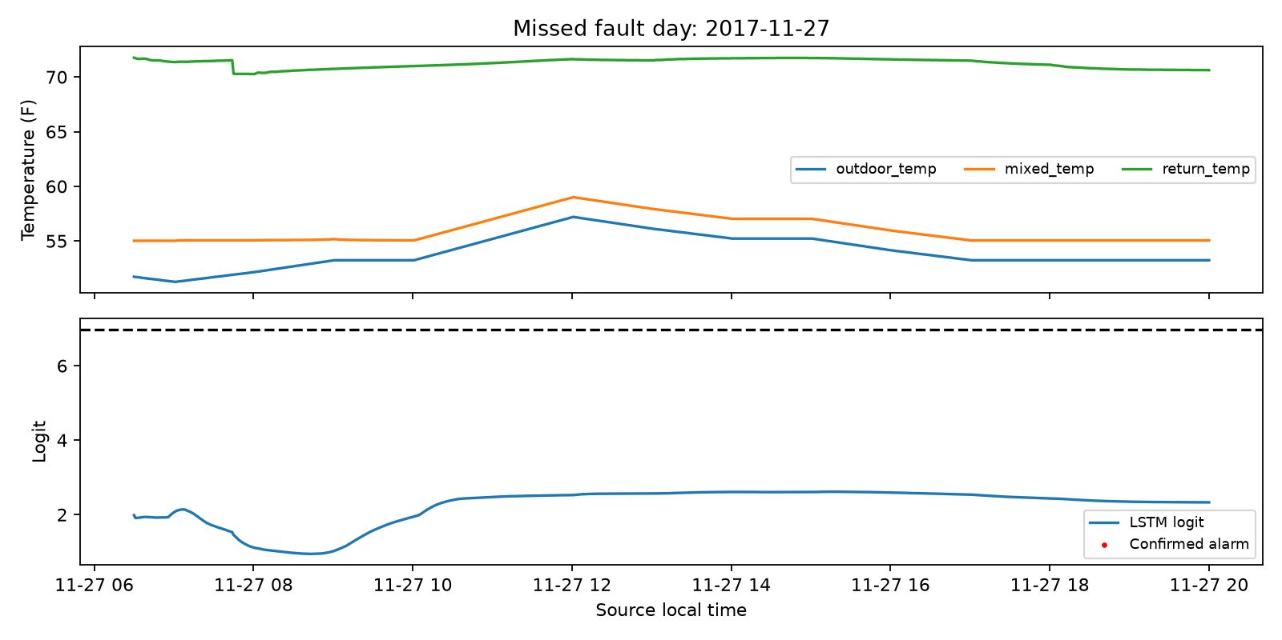
Figure 6.4 Missed observable fault day on 2017-11-27
The retained missed case has a bias of -1 degrees Celsius. The entire source fault day remains in the evaluation. It was not deleted because the signal was difficult or because the confirmed scores failed to cross the selected policy. Its failure contributes to both missed readings and fault-day coverage.
  - False alarm example
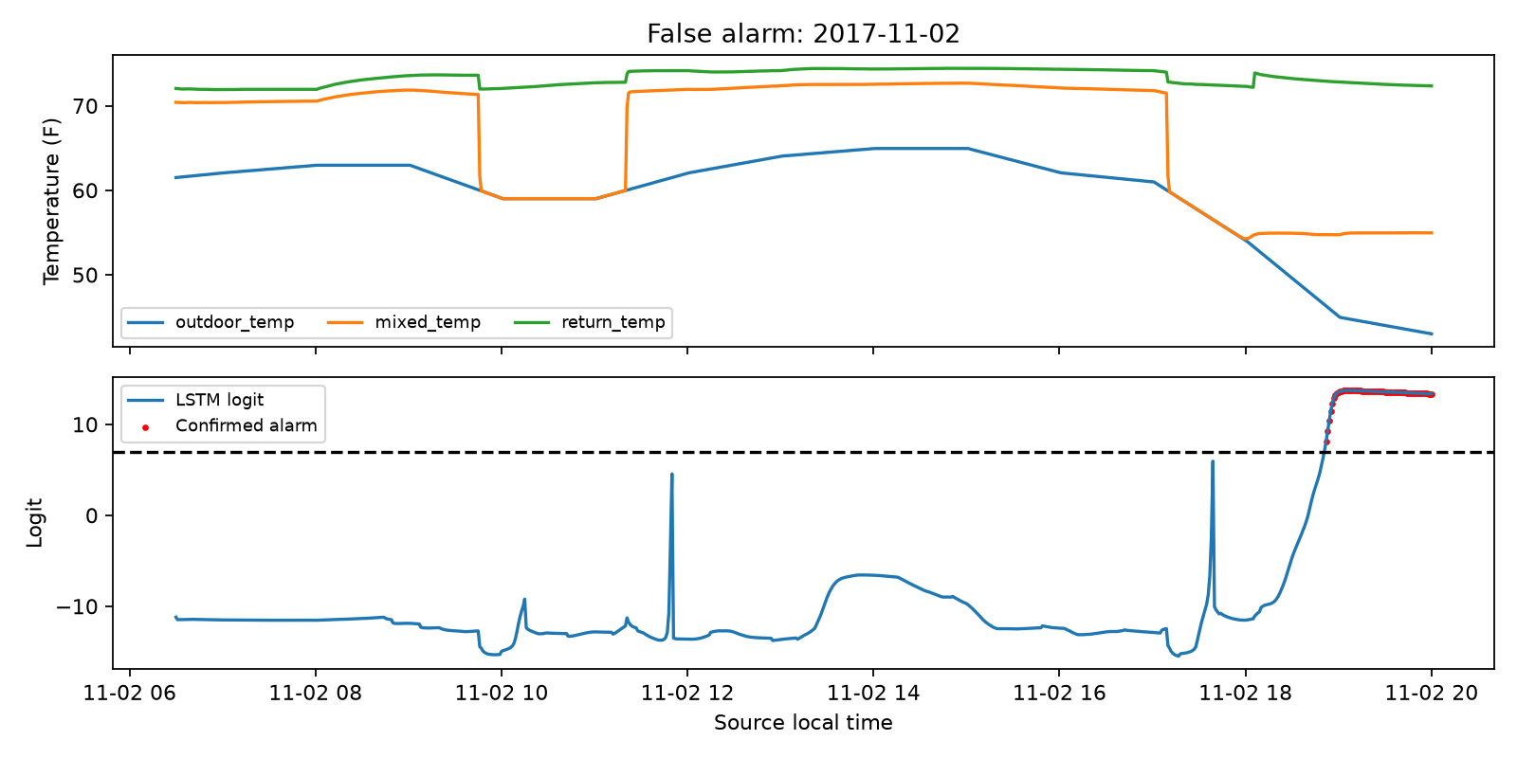
Figure 6.5 Healthy source day with a false alarm on 2017-11-02
The healthy example contains 69 false-positive readings grouped into one continuous burst. It demonstrates a sustained failure mode that persistence alone does not remove. The report retains the healthy label and the original measurements. Raising the threshold after reviewing this test case would invalidate the held-out policy assessment, so no such adjustment was made.
  - Assessment against the project targets
The final primary satisfies the original minimum precision, minimum recall, false-burst exposure budget and observable fault-day coverage targets. It misses the 1% FPR target. The model is therefore an evaluated academic prototype with a documented sensitivity/false-alarm tradeoff, rather than a system that meets every proposed engineering condition. No claim is made that the much higher precision compared with the earlier M100 study is an improvement on the same dataset or label population.
- Discussion and Project Learning
  - Why the dataset and scope changed
The initial M100 investigation evaluated server telemetry with autoencoding, supervised classifiers, threshold rules, feature reduction, quality flags, three-seed repetition and a bounded feature-recovery experiment. None met the unchanged validation gate. The source preparation was then audited: its selected Nagios batch-client state concerns scheduler readiness, which did not establish a cooling-specific failure label. The published preparation is linked in the supporting label audit [8].
This evidence led to the approved change to a separately versioned equipment dataset with author-defined fault scenarios. The M100 negative results, scripts and original artifacts remain preserved, and seven reserved M100 servers remain unscored. The change is documented as a change of task and population. It is not presented as a controlled accuracy improvement caused only by a new model or fewer attributes.
  - Interpretation and limitations
The final benchmark evaluates seasonal transfer within one simulated AHU. It contains one sensor-fault family and an experimental fault-heavy prevalence. Normal validation and test each cover one scenario week, and neighbouring minutes and days share conditions. Thousands of overlapping windows do not create thousands of independent fault incidents. A binomial interval over these readings would overstate independence, so seed variation and day-level coverage are reported without a precise deployment-reliability interval.
The operating-mode restriction excludes nights, nonoperating Sundays and the initial thirty-minute history period. Coverage denominators expose the resulting unobservable fault days. The benchmark also does not validate severe outages, widespread missing inputs, different physical units or genuinely unseen fault mechanisms. A command-weighted mixing residual may be useful to a classifier but does not establish a physical causal explanation.
  - PBL outcomes
The completed work demonstrates dataset auditing, hypothesis revision, causal preprocessing, sequence modeling, baseline comparison, validation-only policy selection, artifact integrity checks and reproducible communication. A concrete lesson is that attribute reduction cannot repair an unsuitable reference label. Another is that a high ranking score or high accuracy does not guarantee an acceptable nuisance-alarm rate. These lessons are supported by both the unsuccessful M100 investigation and the retained limitations of the new benchmark.
- Conclusion and Future Scope
The project delivers a reproducible LSTM-based detector for outdoor-air temperature sensor bias in an operating simulated AHU. Its frozen autumn evaluation yields 92.82% accuracy, 99.74% precision, 91.86% recall and 95.64% F1. It detects 35 of 36 observable fault days. The false-positive rate is 1.44%, above the original 1% goal, and all results retain the policy selected on summer validation.
A matched-history tree offers a different tradeoff: zero test false positives with 72.05% recall. The three-seed experiment shows measurable neural training variability and avoids choosing the best seed after seeing test performance. Source labels, scenario dates, transforms, model weights and final decisions remain auditable through the accompanying notebook and scripts.
Future evaluation should reserve new data from separate physical units, additional fault families and a realistic operating prevalence. It should assess startup coverage, missing-data conditions, probability calibration and the operational cost of persistent false alarms. Threshold or architecture development must use new development data and leave another independent evaluation period untouched. The already-inspected autumn season must not become an iterative tuning target.

References
[1] G. Lin and R. Mitchell, Data Sets for Evaluation of Building Fault Detection and Diagnostics Algorithms, Lawrence Berkeley National Laboratory, OEDI, 2019, doi: 10.25984/1824861. https://data.openei.org/submissions/910. Accessed 15 October 2026.
[2] J. Granderson and G. Lin, Inventory of Data Sets for AFDD Evaluation, documentation supplied with the collection, 2019, pp. 3-7. Local source: data/hvac_benchmark/source_inventory.pdf.
[3] S. Hochreiter and J. Schmidhuber, Long Short-Term Memory, Neural Computation, vol. 9, no. 8, pp. 1735-1780, 1997, doi: 10.1162/neco.1997.9.8.1735.
[4] PyTorch contributors, LSTM, PyTorch documentation. https://docs.pytorch.org/docs/2.14/generated/torch.nn.LSTM.html. Accessed 15 October 2026.
[5] Scikit-learn developers, HistGradientBoostingClassifier, API reference. https://scikit-learn.org/stable/modules/generated/sklearn.ensemble.HistGradientBoostingClassifier.html. Accessed 15 October 2026. The experiment uses the saved scikit-learn 1.9.0 environment.
[6] Scikit-learn developers, Tuning the decision threshold for class prediction, User Guide. https://scikit-learn.org/stable/modules/classification_threshold.html. Accessed 15 October 2026.
[7] PyTorch contributors, BCEWithLogitsLoss, PyTorch documentation. https://docs.pytorch.org/docs/2.14/generated/torch.nn.BCEWithLogitsLoss.html. Accessed 15 October 2026.
[8] M100 dataset authors, ExaData preparation pipeline, node_aggregated_data/step2.py. https://gitlab.com/ecs-lab/exadata/-/blob/main/parquet_dataset/node_aggregated_data/step2.py. The local source-label analysis is preserved in results/task5_recovery_v1/LABEL_AND_SENSOR_AUDIT.md.

Appendix A Reproduction and Demonstration
The GitHub repository is https://github.com/Mitul-dev/DataCenter-Cooling-Anomaly-Detection. Use Python 3.11 and the pinned requirements-tested.txt environment. Source data, trained models and replay data are supplied; the large original M100 archive is not needed to run the primary AHU demonstration.

Run the demonstration
python -m venv .venv
.\.venv\Scripts\python.exe -m pip install -r requirements-tested.txt
.\.venv\Scripts\python.exe -m streamlit run dashboard\app.py
If port 8501 is occupied, add --server.port 8502 to the final command. Open the local URL printed by Streamlit. Start Dashboard.bat also launches the app when dependencies are installed.

Verify the frozen experiment
python scripts/prepare_hvac.py
python scripts/train_hvac.py
python scripts/verify_hvac.py --validation-only
python scripts/evaluate_hvac.py
python scripts/verify_hvac.py
python scripts/run_tests.py
Completed saved training runs and evaluation are reused after integrity checks. A new investigation requires a new experiment version and independent evaluation design. The executed HVAC_submission.ipynb explains the same evidence without automatically retraining against the final test.

Demonstration sequence
Show the problem and scope, explain the season split, replay one detected day, show the missed day and healthy false alarm, and compare the tree with the primary LSTM. Conclude by stating the 1.44% FPR limitation and the need for independent physical-equipment data. Download the example CSV to demonstrate the input contract; explain why one uploaded window cannot confirm a persistence alarm.

Appendix B Evidence and Input Contract
Table B.1 Principal evidence files
Location | Evidence
data/hvac_benchmark | Original archive, inventory and source attribution
results/hvac_v1/experiment_plan.json | Frozen task, cohorts and search budget
results/hvac_v1/evaluation_freeze.json | Pre-test model and policy hashes
results/hvac_v1/lstm_seed_42 | Primary tensors, preprocessing, policies and scores
results/hvac_v1/test_summary.json | Final primary metrics
results/hvac_v1/verification.json | Reproduced transformations, policies and scores
results/hvac_v1/primary_fault_day_delay_analysis.csv | Delay denominators and source-day coverage
results/task1_audit through task5_recovery_v1 | Preserved M100 investigation

A fresh input window contains timestamp, occupied and supply_fan_on columns, plus thirteen raw numerical inputs: supply_temp, supply_setpoint, outdoor_temp, mixed_temp, return_temp, supply_fan_speed, return_fan_speed, outdoor_damper, return_damper, cooling_valve, heating_valve, duct_pressure_setpoint and duct_pressure. The app supplies an example with the exact expected names and units. Labels may be included for reference but are ignored by the scorer.
The checker requires one source day and exact one-minute cadence over thirty rows; occupied and supply_fan_on must remain one throughout. Multiple equipment units cannot be mixed into a single history. Dates, source labels and imposed bias are excluded from the feature vector. The source mapping, derived-feature definitions and saved transformations determine the 32 numerical channels used by inference.

