**DCAN HOME ASSIGNMENT**

**CONTRAST AND COMPARE NETWORK TOPOLOGIES**

**DESIGN ON DIFFERNET TOPOLOGIES**

**(STAR, MESH, BUS, TREE, RING, HYBRID)**

Guided by: - **Prof. Dipak Badgujar**

**Team Members:**

Snehal Mane - 58 | 11911200

Manik Dogra - 59 | 1191005

Mitul Koul - 65 | 11910388

Gauravi More - 69 | 11910801

Khushboo Mundada - 79 | 11910137

|  |  |
| --- | --- |
| **Contents** | **Page No.** |
| Introduction | 2 |
| Objective | 2 |
| Bus | 3 |
| MESH | 4 |
| Ring | 6 |
| Star | 8 |
| Tree | 9 |
| Hybrid | 10 |
| Select a Network Topology | 11 |
| Comparison | 12 |

**Introduction:**

Computer networking has been around for several decades, which is the backbone of what we all know as the Internet today. The Internet is simply a network of networks, which means there is no such thing as a standalone computer on a network. Using topologies to discuss networks simply helps us better visualize them.

This paper presents an introduction to Computer Network Topology. Introduction to each topology is provided in detail. This is followed by a comparison between all topologies and its analysis. A discussion of analysis examples follows with a design and working. This report focuses to underscore the importance of topological design when constructing a new computer network, or adding to an existing one.

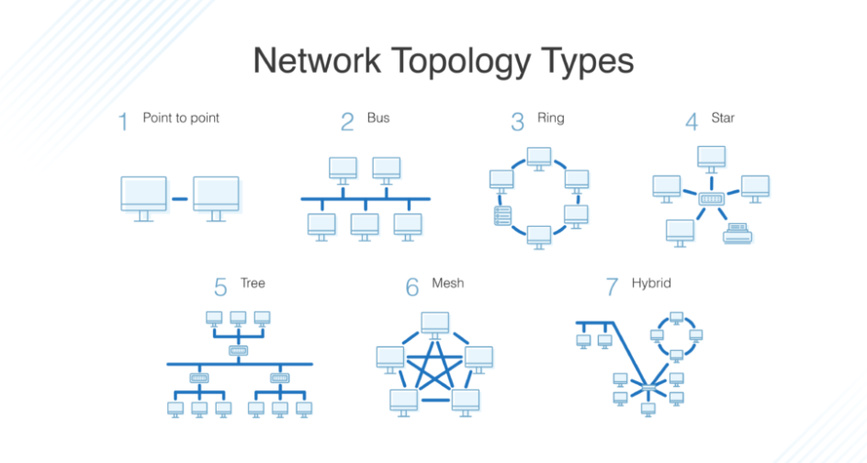

*Keywords:* Network Topology, Bus Network Topology, Ring Network Topology, Star Network Topology, Tree Network Topology, Mesh Network Topology, Hybrid Topology, Design

# Objective

We know configuration or topology of a network is key to determining its performance. There are numerous ways a network can be arranged, all with different pros and cons, and some are more useful in certain circumstances than others. Admins have a range of options when it comes to choosing a network topology, and this decision must account for the size and scale of their business, its goals, and budget. Several tasks go into effective network topology management, including configuration management, visual mapping, and general performance monitoring. The key is to understand user’s requirements to create and manage the network topology in the right way.

Following an in-depth network topology definition, this article will look at the main types of network topologies, their benefits and drawbacks, and considerations for determining which one is best for your business. Network topology is the way a network is arranged, description of how links and nodes are set up to relate to each other.

**TOPOLOGIES:**

* **BUS** - In Bus Network Topology a single cable is used to connect all devices on the net. This cable is often referred to as the network Backbone. When communication occurs between nodes the device sending the message broadcasts to all nodes on the network, but only the desired recipient digests the message. Also, messages from one node can be seen near simultaneously by all other nodes on the network. Figure 1 shows an example of Bus Network Topology.

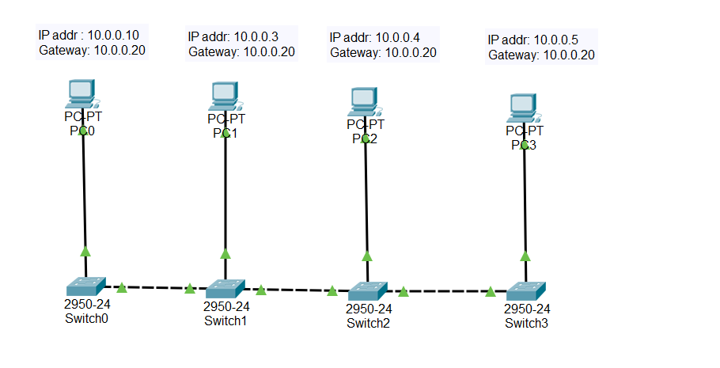

Fig. 1

### Advantages:

* Cost of the cable is very less as compared to other topology, so it is widely used to build small networks.
* Famous for LAN network because they are inexpensive and easy to install.
* It is widely used when a network installation is small, simple, or temporary.
* It is one of the passive topologies. So, computers on the bus only listen for data being sent, that are not responsible for moving the data from one computer to others.

### Disadvantages:

* In case if the common cable fails, then the entire system will crash down.
* When network traffic is heavy, it develops collisions in the network.
* Whenever network traffic is heavy, or nodes are too many, the performance time of the network significantly decreases.
* Cables are always of a limited length.

Applications:

* Small workgroup local area networks (LANs) whose computers are connected using a thin net cable
* Trunk cables connecting hubs or switches of departmental LANs to form a larger LAN
* Back-boning, by joining switches and routers to form campus-wide networks
* **MESH** - Mesh Network Topologies capitalize on path redundancy. This Topology is preferred when traffic volume between nodes is large. A proportion of nodes in this type of network have multiple paths to another destination node. Thus, the probability of single point network failure is greatly minimized with Mesh Network Topology. A full mesh is described as each node being directly connected to every other node in the network. This type of topology is usually restricted to networks with a small number of nodes. A partial mesh is described as having some nodes in the network being indirectly connected to others in the network. The internet employs Mesh Network Topology. Figure 2 shows an example of Mesh Network Topology.

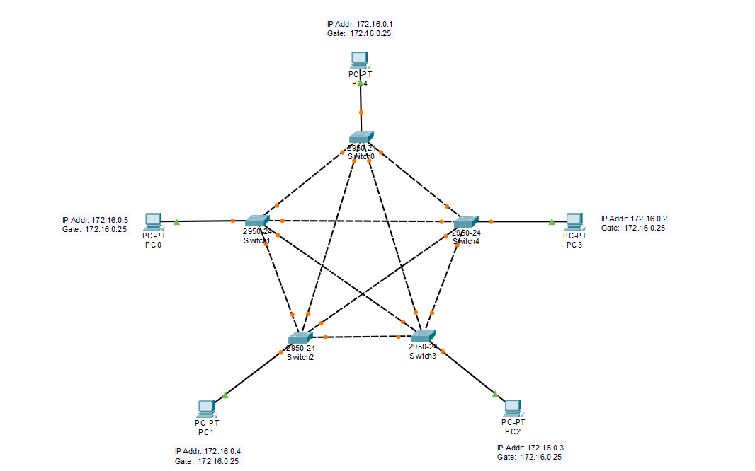Fig. 2

### Advantages:

* The network can be expanded without disrupting current users.
* Need extra capable compared with other LAN topologies.
* Complicated implementation.
* No traffic problem as nodes has dedicated links.
* It has multiple links, so if any single route is blocked, then other routes should be used for data communication.
* P2P links make the fault identification isolation process easy.
* It helps you to avoid the chances of network failure by connecting all the systems to a central node.

### Disadvantages:

* Installation is complex because every node is connected to every node.
* Dedicated links help you to eliminate the traffic problem.
* A mesh topology is robust.
* Every system has its privacy and security
* It is expensive due to the use of more cables. No proper utilization of systems.
* It requires more space for dedicated links.
* Because of the amount of cabling and the number of input-outputs, it is expensive to implement.
* It requires a large space to run the cables.

**Applications:**

Mesh topology is commonly used in the WAN network for backup purposes. This topology is not used in the LAN network implementations. Some of mesh topology examples are:

* Zigbee
* Google Home
* Z-wave
* Google Wi-Fi
* Google On-Hub
* Data-centric fabric
* Networks in military devices
* **RING:** Ring Network Topology has each node in a network connected to two other nodes in the network in conjunction with the first and last nodes being connected. Messages from one node to another then travel from originator to destination via the set of intermediate nodes. The intermediate nodes serve as active repeaters for messages intended for other nodes. Some forms of Ring Network Topology have messages traveling in a common direction about the ring (either clockwise or counterclockwise) while other forms of this type of configuration (called Bi-directional Rings) have messages flowing in either direction with the help of two cables between each connected node. Ring Network Topology is typically employed in networks where inter node traffic volume is small. Ring Network Topologies do have unique disadvantages relative to other topologies concerning expansion or reconfiguration. If a node is added new cabling is required to connect the node to its two neighbors. Networks are not often constructed with pre-wired positions to account for expansion. Figure 3 shows examples of Ring Network Topology.

### Fig. 3

### Advantages:

* Easy to install and reconfigure.
* Adding or deleting a device in-ring topology needs you to move only two connections.
* Offers equal access to all the computers of the networks
* Faster error checking and acknowledgment.

### Disadvantages:

* Unidirectional traffic.
* The troubleshooting process is difficult in a ring topology
* Break in a single ring can risk the breaking of the entire network
* Modern days high-speed LANs made this topology less popular.
* In the ring, topology signals are circulating at all times, which develops unwanted power consumption.
* It is very difficult to troubleshoot the ring network.
* Adding or removing the computers can disturb the network activity.

Applications:

* One of the common examples that still exists is SONET Rings. SONET stands for Synchronous Optical Networking. It uses Fiber Optic Cables for heavy load data transfers for long distances. You can simply think SONET to be Fiber Optic Cable Ring Topology. It is highly reliable Computer Network for synchronizing various branch offices of a multi-national company. Due to the use of Fiber Optic Cable, it provides the best data transfer speeds. SONET is one of the most popular Applications of Ring Topology.
* **STAR:** Star Network Topology requires the use of a central top-level node to which all other nodes are connected. This top-level node may be a computer, or a simple switch, or just a common connection point. Messages received by the top- level node can either be broadcast to all subordinate nodes, or if the top-level device is of high enough fidelity, sent only to the desired subordinate node. Inter node messaging delays are reduced with this configuration. An important advantage of the Star Network Topology comes from the localization of cabling failures inherent in this configuration. Failure in the connection between the top -level node and any subordinate node, or failure in a subordinate node will not disrupt the entire network, because Star Network Topologies are commonly used in LANs spanning a larger geometric area than Bus or Ring Network Topologies. Figure 4 shows an example of Star Network Topology.

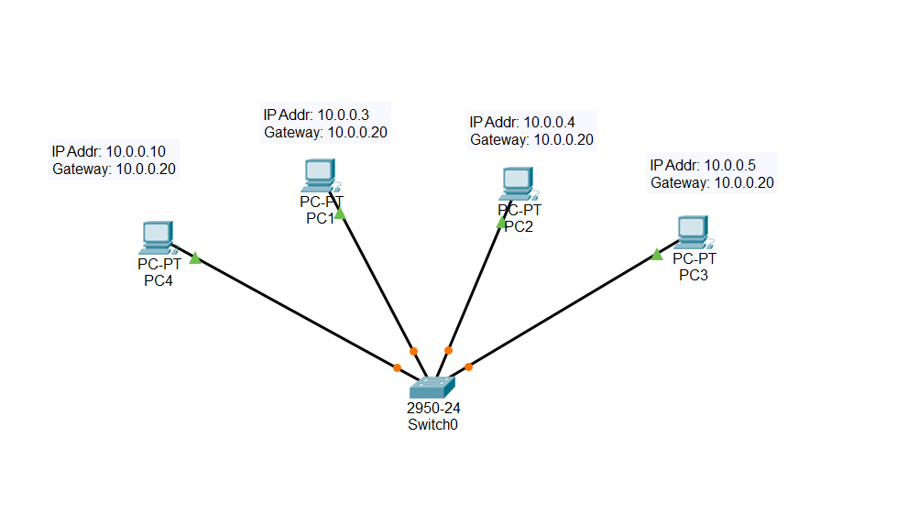

Fig. 4

Advantages:

* Easy to troubleshoot, set up, and modify.
* Only those nodes are affected, that has failed. Other nodes still work.
* Fast performance with few nodes and very low network traffic.
* In Star topology, addition, deletion, and moving of the devices are easy.

### Disadvantages:

* If the hub or concentrator fails, attached nodes are disabled.
* Cost of installation of star topology is costly.
* Heavy network traffic can sometimes slow the bus considerably.
* Performance depends on the hub's capacity
* A damaged cable or lack of proper termination may bring the network down.

Application:

1. Most of computer labs in educational institutes use star topology for connecting Nodes in the lab
2. In banks, there are a variety of banking users present. All of these are connected with each other using star Type of Topology
3. Our home networks are obviously configured in star Network Topology

* 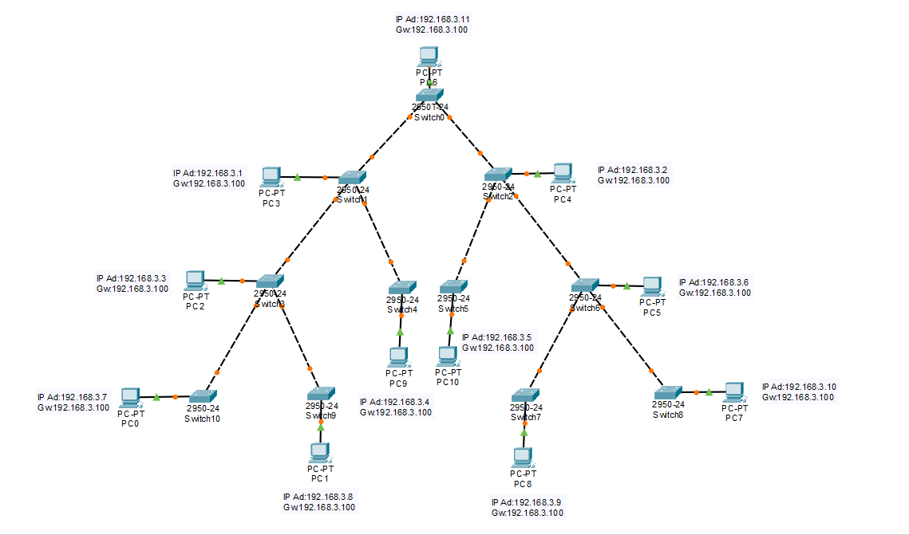**TREE:** Tree Network Topology is constructed from either making a set of Star Network Topologies subordinate to a central node, or by linking a set of Star Network Topologies together directly via a bus, thereby distributing the functionality of the central node among several Star Network Topology top level nodes. Figure 5 provides an example of tree configuration. The top-level nodes from each Star Network are the elements linked via a bus in the second arrangement. In simple Tree Network Topology, no Star Network Topology subordinate nodes are connected to the bus. Messages in a Tree Network Topology can be either broadcast from the central node to all interconnected Star Networks, or targeted to select Star Networks.

Fig. 5

### Advantages:

* Failure of one node never affects the rest of the network.
* Node expansion is fast and easy.
* Detection of error is an easy process
* It is easy to manage and maintain

### Disadvantages:

* It is heavily cabled topology
* If more nodes are added, then its maintenance is difficult
* If the hub or concentrator fails, attached nodes are also disabled.

Applications:

* This topology is very useful for your organizations if you have small departments and even sub-departments
* Tree topologies are frequently used to organize the computers in a corporate network, or the information in a database.
* **HYBRID:** A hybrid topology is a type of network topology that uses two or more differing network [topologies](https://www.computerhope.com/jargon/t/topology.htm). These topologies can include a mix of [bus topology](https://www.computerhope.com/jargon/b/bustopol.htm), [mesh topology](https://www.computerhope.com/jargon/m/mesh.htm), [ring topology](https://www.computerhope.com/jargon/r/ringtopo.htm), [star topology](https://www.computerhope.com/jargon/s/startopo.htm), and [tree topology](https://www.computerhope.com/jargon/t/treetopo.htm). Figure 6 shows an example of Hybrid Topology.

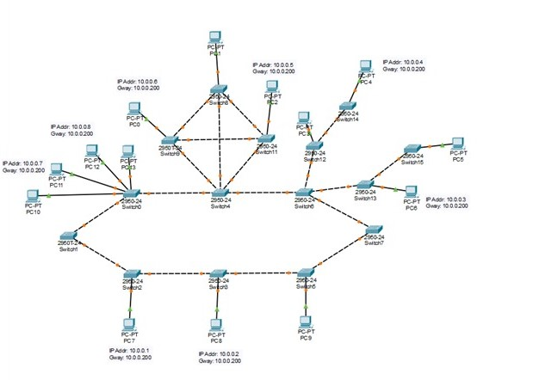

Fig. 6

### Advantages:

* Offers the easiest method for error detecting and troubleshooting
* Highly effective and flexible networking topology
* It is scalable so you can increase your network size

### Disadvantages:

* The design of hybrid topology is complex
* It is one of the costliest processes.
* How to select a Network Topology?

Here are some important considerations for selecting the best topology to create a network in your organization:

* Bus topology is surely least expensive to install a network.
* If you want to use a shorter cable or you planning to expand the network is future, then star topology is the best choice for you.
* Fully mesh topology is theoretically an ideal choice as every device is connected to every other device.
* If you want to use twisted pair cable for networking, then you should build star topologies.
* **COMPARISON BETWEEN DIFFERENT TOPOLOGIES:**

|  |  |  |  |  |
| --- | --- | --- | --- | --- |
| **N= (number of nodes, devices)** | BUS | STAR | RING | MESH |
| **No. of cables** | N+1 | N | N+1 | [N*(N-1)]/2 |
| **No. of ports**  **(Per node)** | 1 | 1 | 1 | N-1 |
| **Reliability** | NO | NO | NO | YES |
| **Security** | NO | NO | NO | YES |

**Conclusion:**

Computer Network Topology brings inherent advantages and disadvantages to any system under study. Description of some of these advantages and disadvantages for several standard physical topologies has been provided in this paper. Through different topology layouts, there’s an abundance of potential for different variations of device coupling. Effective network topology in a LAN isn’t just a matter of sticking devices together, but doing so in a manner that both facilitates the full data demand of the network and mitigates the chance of overload.

**References:**

1. <https://www.cse.wustl.edu/~jain/cse567/08/ftp/topology/index.html#introduction>
2. <https://www.guru99.com/type-of-network-topology.html>
3. <http://compnetworking.about.com/od/networkingdesign/a/topologies.htm>
4. <https://www.itrelease.com/2019/09/what-is-mesh-topology-with-example/>

Link of Live Demonstration: <https://drive.google.com/drive/folders/1wpzUWFw7oHJq7J0146rtHZqocpOZsLT5?usp=sharing>