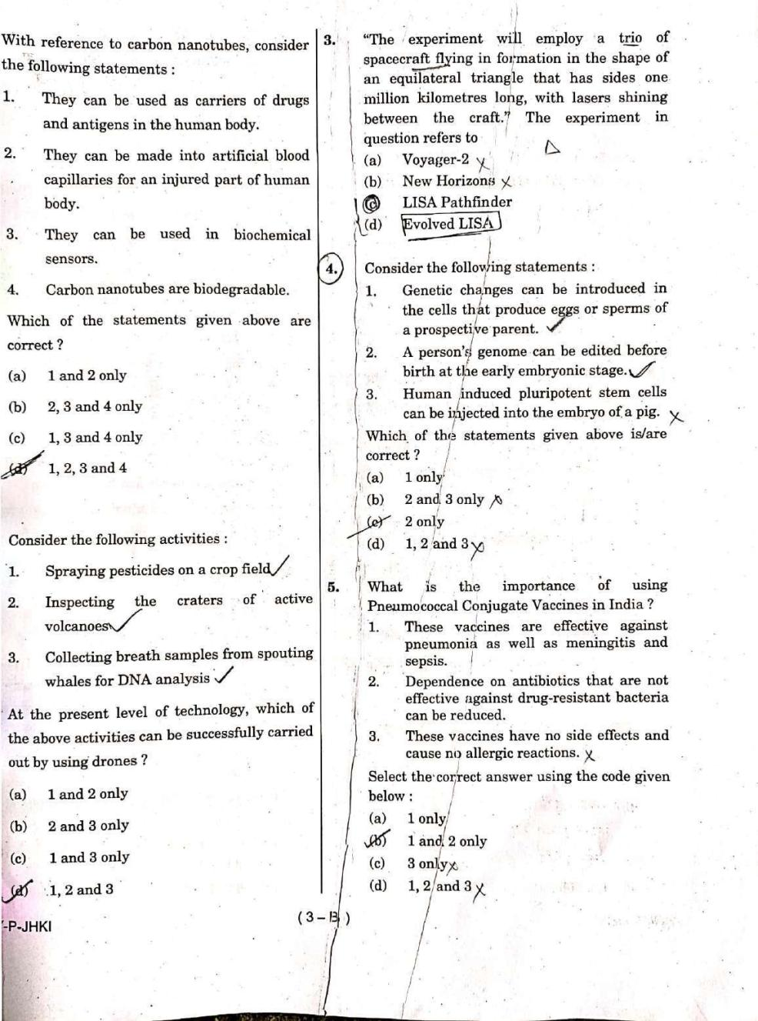

[www.visionias.net](http://www.visionias.net/)

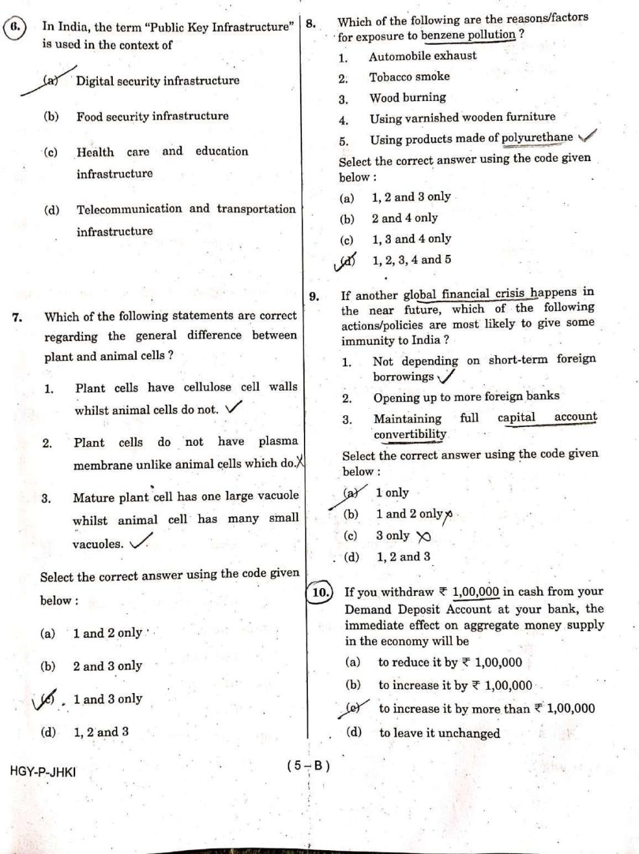

[www.visionias.net](http://www.visionias.net/)

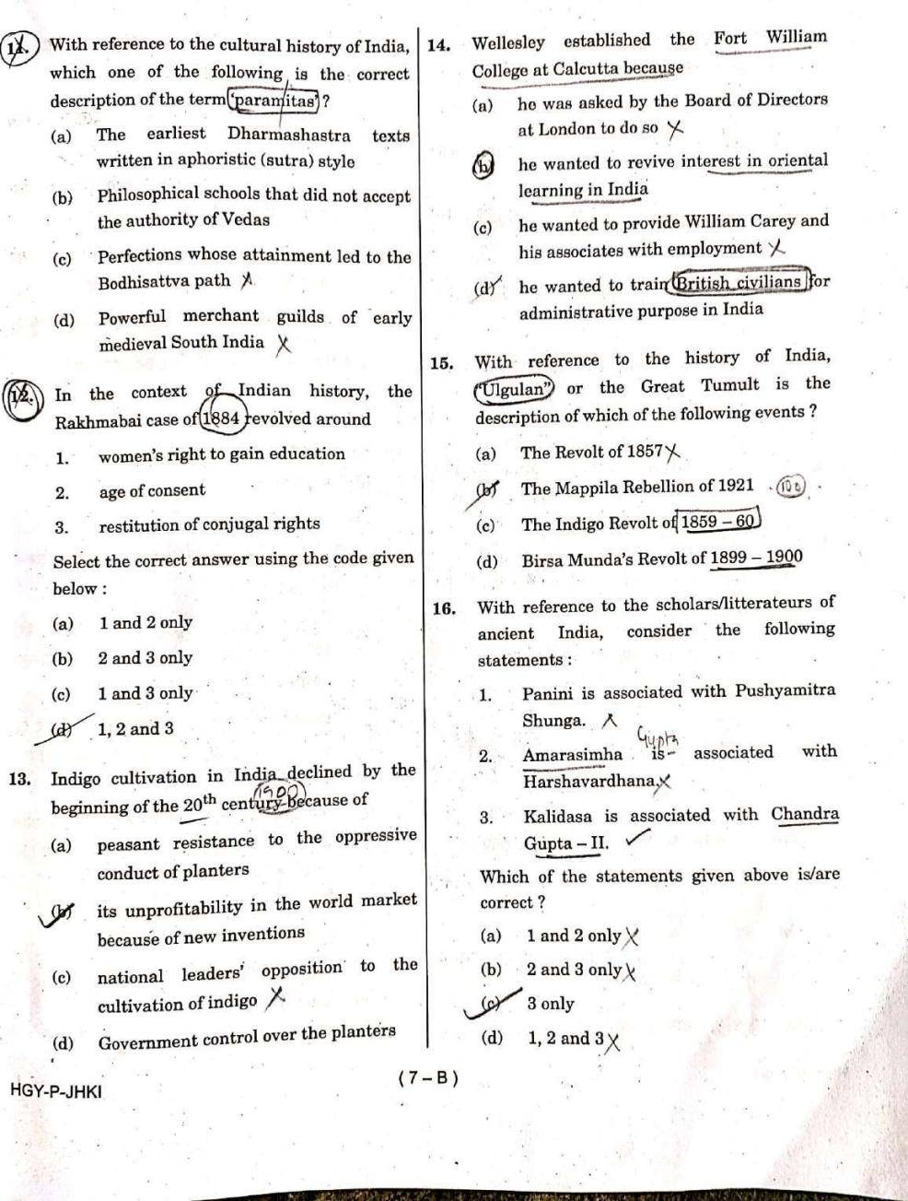

[www.visionias.net](http://www.visionias.net/)