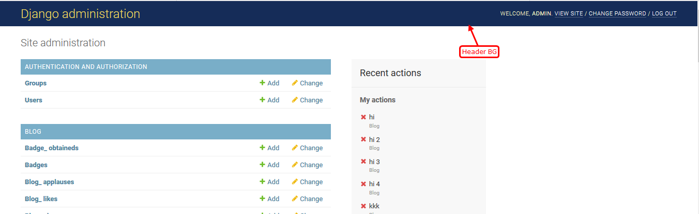

Line No: 830

#header{background: #152c58;}



Line No: 862

#branding h1, #branding h1 a:link, #branding h1 a{color:#fff;}



Line No: 862

#branding h1, #branding h1 a:link, #branding h1 a:visited {

color: #3699FF;

}

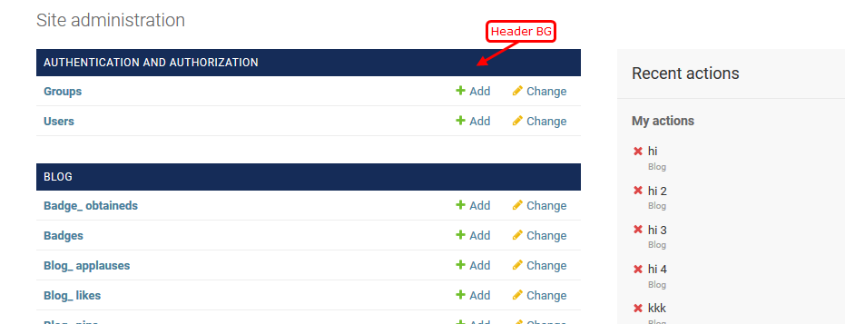

Line No : 519

.module h2, .module caption, .inline-group h2{ background: #152c58;}

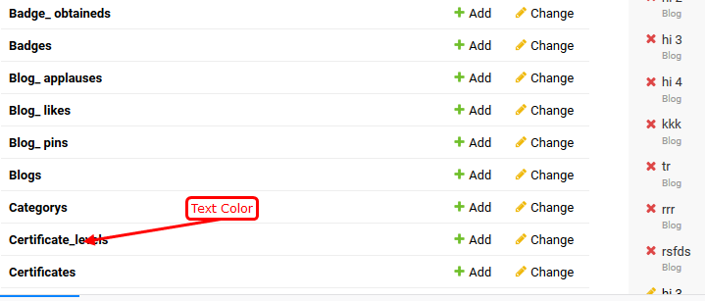

Line No :18

a:link, a:visited { color: #000;}

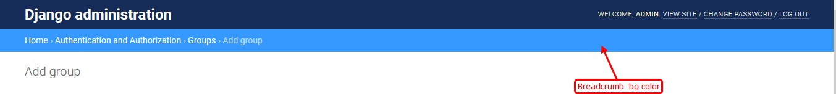

Line No: 648

div.breadcrumbs { background: #3699FF;}

Line No: 425

input[type="text"], input[type="password"], input[type="email"], input[type="url"], input[type="number"], input[type="tel"], textarea, select, .vTextField{

background: #F3F6F9;

border: 1px solid #F3F6F9;}

Line No :475

.button.default, input[type="submit"].default, .submit-row input.default{background: #010142;}

Line No: 452

.button, input[type="submit"], input[type="button"], .submit-row input, a.button{background: #a6252e;}

Changelist.css

Line No:173

#changelist-filter li.selected{

border-left: 5px solid #1BC5BD;

}

Line No:86

changelist #toolbar form #searchbar{border: 1px solid #3699FF;}

line no :99

#changelist #toolbar form input[type="submit"]{

padding: 4px 10px;

background: #a6252e;

color: #fff;

}

table thead th .text a:focus, table thead th .text a{color: #152c58:}