
EEDG/CE 6370
Due Date: Sunday September 1, 11:59pm
38
Design and Analysis or Reconfigurable Systems
Homework 1
Design of Combinational Logic Designs using Schematic entry and Verilog/VHDL using Intel Quartus Prime

Student Name: Mark Ivey
Student email: MXI240020@utdallas.edu
Part I: Schematic Entry (1-bit adder)
a.) Follow the instructions in the homework sheet and design a 1-bit full adder using schematic entry show here the generated schematic (screenshot of the circuit)
(4 marks)
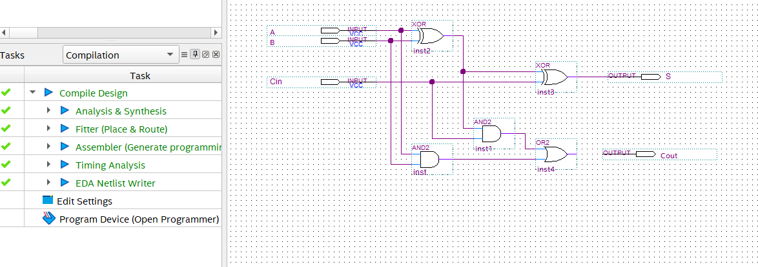

b.) Simulate the 1-bit full adder showing that it works. Include here the test vectors used and the simulation results (waveform). Clearly indicate why it is working.
(4 marks)

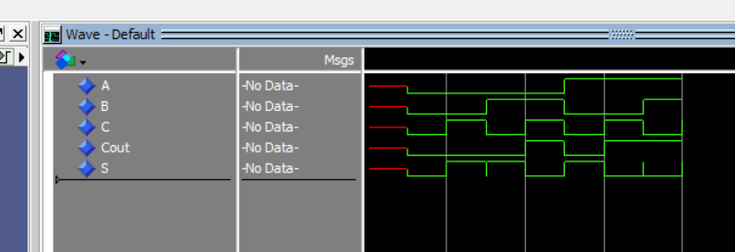
I verified that this works using the following code:
for i in 0 to 7 loop
wait for 1 ns;
(A,B,C) <= std_logic_vector(to_unsigned(i, 3));
end loop;
WAIT;

This code applies all 8 logic combinations. The simulator shows the inputs and how the outputs change based on the input changes.

c.) What test vectors would you use in the case of having to test a 4-bit adder and an 8-bit adder? Do you foresee any problems verifying larger adders?
(2 marks)
The fulladder.vhd can be instantiated into a n-bit adder. Each instantiation would make up one bit in an n-bit slv input and output declaration. The testbench for the full adder could have something like the following:
for i in 0 to 2 ** A'length - 1 loop
for j in 0 to 2 ** B'length - 1 loop
for k in 0 to 2 ** C'length - 1 loop
wait for 1 ns;
A <= std_logic_vector(to_unsigned(i, A'length));
B <= std_logic_vector(to_unsigned(j, B'length));
C <= std_logic_vector(to_unsigned(k, C'length));
end loop;
end loop;
end loop;
WAIT;

The main issue would be verification of each and every answer. This can be done by generating the inputs to be tested and the expected outputs and having more advanced tools or scripts verify the correct outputs.

d.) Report the number of ALMs, ALUTs and critical path of the design from the synthesis report. Compute the maximum frequency.
(2 marks)
 | ALMS/ALUTs | FFs | IOs | DSPs | BRAM
1-bit adder schematic | 2 | 0 | 5 | 0 | 0

I struggled with this, but I think the propagation delay table under “Report Datasheet” has the info you’re asking for:
A | Cout | 6.374 |  |  | 6.640
A | S | 6.193 | 6.225 | 6.253 | 6.290
B | Cout | 6.179 |  |  | 6.354
B | S | 5.834 | 5.924 | 6.042 | 6.056
C | Cout | 6.118 |  |  | 6.325
C | S | 5.820 | 5.868 | 5.928 | 5.958
F_{max} = (6.640 ns) ⁻¹ = 150 MHz

Part II : RTL Entry (Verilog/VHDL) (1-bit adder)
- Re-do the full adder example specifying the 1-bit adder directly in Verilog or VHDL. Enter here the clean source code with comments.
(4 marks)
library ieee;
use ieee.std_logic_1164.all;
use ieee.numeric_std.all;

entity fulladder is
port (
A : in std_logic;
B : in std_logic;
Cin : in std_logic;
Cout : out std_logic;
S : out std_logic
);
end entity;

architecture rtl of fulladder is
begin
-- This is the implementation of the full adder using a pair of truth tables
-- The when/else statements here operate like a case statement (which can
-- only be used inside of a process)
S <= '0' when (A = '0' and B = '0' and Cin = '0') else
'1' when (A = '0' and B = '0' and Cin = '1') else
'1' when (A = '0' and B = '1' and Cin = '0') else
'0' when (A = '0' and B = '1' and Cin = '1') else
'1' when (A = '1' and B = '0' and Cin = '0') else
'0' when (A = '1' and B = '0' and Cin = '1') else
'0' when (A = '1' and B = '1' and Cin = '0') else
'1' when (A = '1' and B = '1' and Cin = '1') else
'U'; -- to account for when the SL variable is not set at first

Cout <= '0' when (A = '0' and B = '0' and Cin = '0') else
'0' when (A = '0' and B = '0' and Cin = '1') else
'0' when (A = '0' and B = '1' and Cin = '0') else
'1' when (A = '0' and B = '1' and Cin = '1') else
'0' when (A = '1' and B = '0' and Cin = '0') else
'1' when (A = '1' and B = '0' and Cin = '1') else
'1' when (A = '1' and B = '1' and Cin = '0') else
'1' when (A = '1' and B = '1' and Cin = '1') else
'U';
end architecture rtl;

- Show the simulation results of the working adder.
(4 marks)
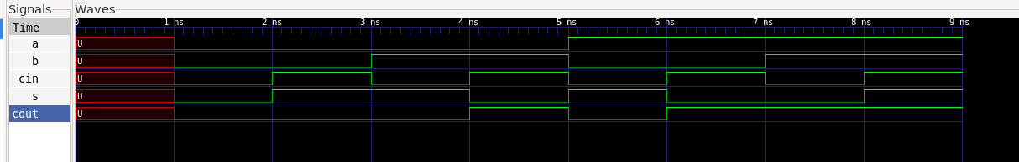

- Report the number of ALMs, ALUTs and critical path of the design from the synthesis report. Compute the maximum frequency.
(2 marks)
 | ALMs/ALUTs | FFs | IOs | DSPs | BRAM
1-bit adder RTL | 2 | 0 | 5 | 0 | 0

A | Cout | 6.118 |  |  | 6.325
A | S | 5.820 | 5.868 | 5.928 | 5.958
B | Cout | 6.374 |  |  | 6.640
B | S | 6.193 | 6.225 | 6.253 | 6.290
Cin | Cout | 6.179 |  |  | 6.354
Cin | S | 5.834 | 5.924 | 6.042 | 6.056
F_{max} = (6.640 ns) ⁻¹ = 150 MHz
- Compare the ALUT usage and critical path delay from the schematic adder and RTL adder do the results match? Yes/no? Explain why?
(2 marks)

 | ALMs/ALUTs | FFs | IOs | DSPs | BRAM | Delay
Schematic | 2 | 0 | 5 | 0 | 0 | 6.64 ns
RTL | 2 | 0 | 5 | 0 | 0 | 6.64 ns
They do. They both do the same thing and are implemented in the FPGA the same way – as a pair of LUT’s.

Part III : RTL Entry (Verilog/VHDL) (4-bit adder)
- Create a 4-bit adder using structural and behavioral RTL (Verilog or VHDL). Annotate their resource usage and critical path in the table below:”
(4 marks)

 | ALMs/ALUTs | Critical path
Structural | 4 | 7.985
Behavioral | 4 | 7.985

- Discuss if the results obtained are what you expected and why yes or no.
(2 marks)
Not quite. Again, the logic inside the LUT’s are created the same regardless of how the hardware is described, so the number of ALM’s being the same was expected. I did think that the critical path would be two to four times as large as the single bit adder. But this can be explained if there was a large constant factor that causes delay before/after the LUT’s, like the tool adding delay to and from the physical pins on the FPGA.

Part IV: Homework reflection
(4 marks)
What do you think were the objectives of this homework?
The main objectives must be the easter egg hunt for the propagation delay table, of which I’m still not 100% convinced I found the right information, and to show off the fact that the lite edition is using the latest VHDL ’19 standard ’08 standard ’93 standard.
The secondary objectives are to give an idea of how fast (for it’s time?) the FPGA can run combinational logic, learn about the various methods of schematic/rtl capture, demonstrate how verification works, and getting familiar with how to synthesize code.

What conclusions have you extracted from the results obtained?
Timing analysis is far more complex than I thought, and finding the information I need.

Part V: Create a short YouTube video that shows that the designs work and the results obtained. Include the link to the video here.
(4 marks)
YouTube Video

Attachments
Include the Verilog/VHDL code here. Make sure it is well formatted and include comments. Marks might get deducted if not.

Fulladder_b_tb.vhd
library ieee;
use ieee.std_logic_1164.all;
use ieee.numeric_std.all;

entity fulladder_b_tb is
end;

architecture bench of fulladder_b_tb is
-- Generics
constant n : integer := 4;
-- Ports
signal A : std_logic_vector(n - 1 downto 0):= (others => '0');
signal B : std_logic_vector(n - 1 downto 0):= (others => '0');
signal S : std_logic_vector(n - 1 downto 0);
signal Cin : std_logic := '0';
signal cout : std_logic;
begin

fulladder_b_inst : entity work.fulladder_b
generic map (
n => n
)
port map (
A => A,
B => B,
S => S,
Cin => Cin,
cout => cout
);
process is
variable temp : std_logic_vector(2 * n + 1 - 1 downto 0);
begin
for i in 0 to 2 ** (2 * n + 1) - 1 loop
wait for 1 ns;
temp := std_logic_vector(to_unsigned(i, 2 * n + 1));
A <= temp(2 * n - 1 downto n);
B <= temp(n - 1 downto 0);
Cin <= temp(2 * n);
-- (A(0),B(0),Cin) <= std_logic_vector(to_unsigned(i, 3));
end loop;
wait for 1 ns;
WAIT;
end process;
end;

Fulladder_i.vhd:
library ieee;
use ieee.std_logic_1164.all;
use ieee.numeric_std.all;
use ieee.math_real.all;

entity fulladder_i is
generic (
n : integer := 4
);
port (
-- clk : in std_logic;
-- reset : in std_logic;
A : in std_logic_vector(n - 1 downto 0);
B : in std_logic_vector(n - 1 downto 0);
S : out std_logic_vector(n - 1 downto 0);
Cin : in std_logic;
cout : out std_logic
);
end entity;

architecture rtl of fulladder_i is

signal tempcarry : std_logic_vector(n downto 0);

begin
loop_inst : for i in 0 to n - 1 generate
fulladder_inst : entity work.fulladder
port map (
A => A(i),
B => B(i),
Cin => tempcarry(i),
Cout => tempcarry(i + 1),
S => S(i)
);
end generate;

tempcarry(0) <= Cin;
cout <= tempcarry(n);

end architecture;

Fulladder.vhd
library ieee;
use ieee.std_logic_1164.all;
use ieee.numeric_std.all;
use ieee.math_real.all;

entity fulladder is
port (
A : in std_logic;
B : in std_logic;
Cin : in std_logic;
Cout : out std_logic;
S : out std_logic
);
end entity;

architecture rtl of fulladder is

begin
-- This is the implementation of the full adder using a pair of truth tables
-- The when/else statemetns here operate similar to a case statement (which can
-- only be used inside of a process)
S <= '0' when (A = '0' and B = '0' and Cin = '0') else
'1' when (A = '0' and B = '0' and Cin = '1') else
'1' when (A = '0' and B = '1' and Cin = '0') else
'0' when (A = '0' and B = '1' and Cin = '1') else
'1' when (A = '1' and B = '0' and Cin = '0') else
'0' when (A = '1' and B = '0' and Cin = '1') else
'0' when (A = '1' and B = '1' and Cin = '0') else
'1' when (A = '1' and B = '1' and Cin = '1') else
'U'; -- to account for when the SL variable is not set at first

Cout <= '0' when (A = '0' and B = '0' and Cin = '0') else
'0' when (A = '0' and B = '0' and Cin = '1') else
'0' when (A = '0' and B = '1' and Cin = '0') else
'1' when (A = '0' and B = '1' and Cin = '1') else
'0' when (A = '1' and B = '0' and Cin = '0') else
'1' when (A = '1' and B = '0' and Cin = '1') else
'1' when (A = '1' and B = '1' and Cin = '0') else
'1' when (A = '1' and B = '1' and Cin = '1') else
'U';

end architecture rtl;

Fulladder_b.vhd:
library ieee;
use ieee.std_logic_1164.all;
use ieee.numeric_std.all;
use ieee.math_real.all;

entity fulladder is
port (
A : in std_logic;
B : in std_logic;
Cin : in std_logic;
Cout : out std_logic;
S : out std_logic
);
end entity;

architecture rtl of fulladder is

begin
-- This is the implementation of the full adder using a pair of truth tables
-- The when/else statemetns here operate similar to a case statement (which can
-- only be used inside of a process)
S <= '0' when (A = '0' and B = '0' and Cin = '0') else
'1' when (A = '0' and B = '0' and Cin = '1') else
'1' when (A = '0' and B = '1' and Cin = '0') else
'0' when (A = '0' and B = '1' and Cin = '1') else
'1' when (A = '1' and B = '0' and Cin = '0') else
'0' when (A = '1' and B = '0' and Cin = '1') else
'0' when (A = '1' and B = '1' and Cin = '0') else
'1' when (A = '1' and B = '1' and Cin = '1') else
'U'; -- to account for when the SL variable is not set at first

Cout <= '0' when (A = '0' and B = '0' and Cin = '0') else
'0' when (A = '0' and B = '0' and Cin = '1') else
'0' when (A = '0' and B = '1' and Cin = '0') else
'1' when (A = '0' and B = '1' and Cin = '1') else
'0' when (A = '1' and B = '0' and Cin = '0') else
'1' when (A = '1' and B = '0' and Cin = '1') else
'1' when (A = '1' and B = '1' and Cin = '0') else
'1' when (A = '1' and B = '1' and Cin = '1') else
'U';

end architecture rtl;

