
Due Date: Sunday October 8, 11:59pm
18
EEDG/CE 6370
Design and Analysis of Reconfigurable Systems
Homework 2
Prototyping on the Terasic DE1-SoC board

Student Names (group of 2): Mark Ivey
Students Emails: Mxi240020@utdallas.edu

Part I: FPGA prototyping
a.) Follow the instructions in the lab sheet and implement the led counter example on the Terasic DE1-SoC board. Create a video and upload it to a shared folder or YouTube showing the it works (counting upwards and downwards). Include the link of the video here.
Marks
4

YouTube Link

b.) Report the number of ALMs and critical path of the design from the synthesis report. Compute the maximum frequency.
Marks
2
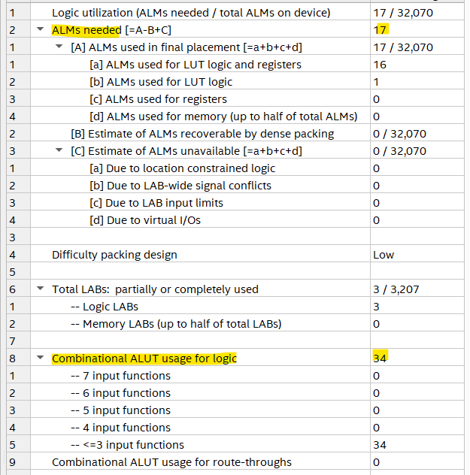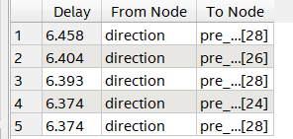
Computed Fmax @ 3.3V = 154.8 MHz
Fmax given under the Slow 1.1V 85C Model: 377.316 MHz

c.) Modify the program such that the 10 MSB of the counter are now assigned to the 10 LEDs in the DE1-SoC board. From the board’s data sheet we can find the pin assignments of the two pins. Create a new video and share it showing that the design works. Append here also the source code.
Marks
6

YouTube Link

Source Code:
library IEEE;
use IEEE.STD_LOGIC_1164.ALL;
use IEEE.STD_LOGIC_UNSIGNED.ALL; -- NEEDED to USE +/- for STD_LOGIC data types

entity ledcounter is
port( clk: in std_logic;
reset: in std_logic;
direction: in std_logic;
count: out std_logic_vector(9 downto 0)
);
end ledcounter;

architecture Behavioral of ledcounter is
signal pre_count: std_logic_vector(31 downto 0);
begin
process(clk, reset)
begin
if (reset = '0') then
pre_count <= (others => '0');
elsif (clk='1' and clk'event) then
if (direction = '1') then
pre_count <= pre_count + '1';
else
pre_count <= pre_count - '1';
end if;
end if;
end process;
count(9 downto 0) <= pre_count(31 downto 22);
-- count(9 downto 4) <= (others => '0');
end Behavioral;

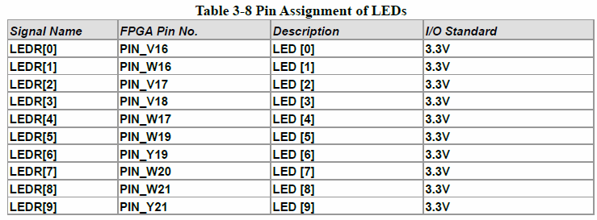
d.) Report the number of ALMs and critical path of the design from the synthesis report. Compute the maximum frequency.
Marks
2
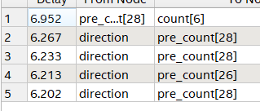
Computed Fmax @ 3.3V = 143.85 MHz
Fmax given under the Slow 1.1V 85C Model: 391 MHz

Part II: Homework reflection
Marks
4
What do you think were the objectives of this homework?

Besides showing off its use of synopsys’ outdated std_logic_unsigned library, I’d say the main objectives were learning about how to program the different aspects of the device, such as directly via JTAG or by first uploading the file to the flash storage device.

What conclusions have you extracted from the results obtained?

I was a bit confused, honestly, when it came to calculating the Fmax of the device. Three different methods gave three different answers. In this, I elected to show two answers, but I believe the computed answer is correct.
I did try to mess with the SDC file to try and increase or decrease the speed of the counter, but though the results and looking online, I realized that that file does not control the PLL. Later that week, the professor said as much during lectures.
That aside, we do see how counters work, and we created one of many applications for them. One other thing I could have done was to use a counter to debounce the switches, which I’m pretty confident would get rid of the glitches I saw when switching between counting direction.

