
EEDG/CE 6370
Due Date: Sunday September 22, 11:59pm – Submit this editable Word document NOT pdf
su
0
16
Design and Analysis of Reconfigurable Systems
Homework 3 – IP generator

Name: Mark Ivey
Email: mxi240020@utdallas.edu
Part I – CORDIC IP
a.) Follow the instructions in the lab sheet. Show the simulation result of the CORDIC IP clearly indicating that the circuit works
Marks
4

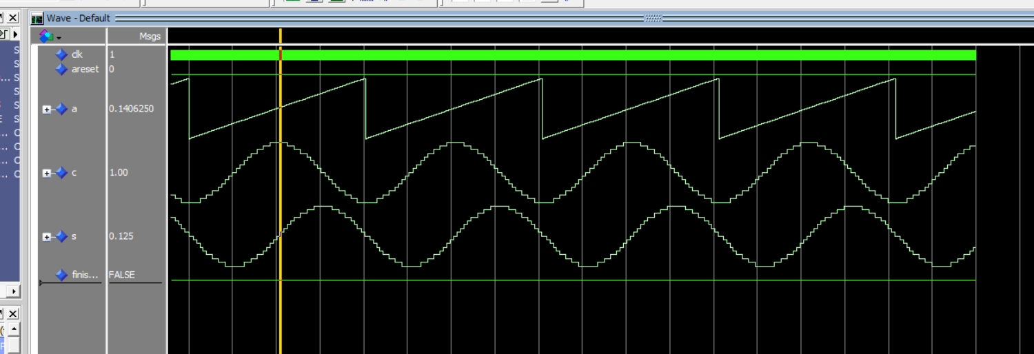
b.) Report the number of ALMs and critical path of the design from the synthesis report. Compute the maximum frequency.
Marks
2
F_{max} = 1/14.171 ns = 70.566 MHz
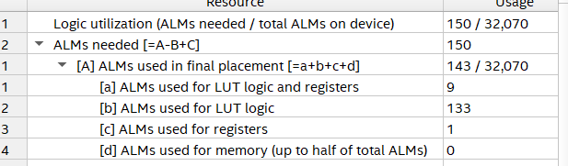

c.) Create a short video showing that the system is successfully prototyped on the DE1-SoC Board
Marks
2

YouTube Link

Part II – CORDIC IP Output Modification (7-segment display)
- Modify the program such that the value of the sin OR cosine are output on the 7-segment display instead of the LEDs.
- The indicated push-button will toggle between displaying the sine or cosine
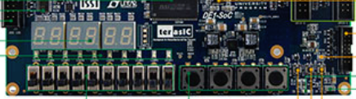

- As shown below the first 7-segment display should show the sign (+ or -) and the rest should display the value
Cosine OR sine

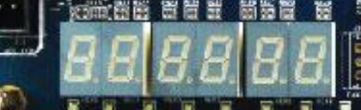
value [+1,-1]
sign

Include here your code and a short video showing that it works. Report also the number of resources used and the critical path
Marks
8
YouTube Link

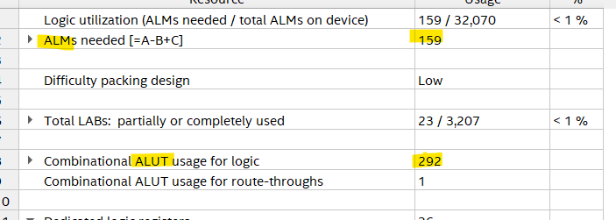

Delay was 13.773 ns
F_{max} = 72.606 MHz

Sincos_disp_top.vhd
library ieee;
use ieee.std_logic_1164.all;

entity sincos_disp_top is
port (
clk : in std_logic;
reset : in std_logic;
cd_button : in std_logic;
cordic_data_s : in std_logic_vector(4 downto 0);
cordic_data_c : in std_logic_vector(4 downto 0);
sev_seg_0_o : out std_logic_vector(6 downto 0);
sev_seg_1_o : out std_logic_vector(6 downto 0);
sev_seg_2_o : out std_logic_vector(6 downto 0);
sev_seg_3_o : out std_logic_vector(6 downto 0);
sev_seg_4_o : out std_logic_vector(6 downto 0);
sev_seg_5_o : out std_logic_vector(6 downto 0)
);
end entity;

architecture rtl of sincos_disp_top is
component seven_seg
port (
data : in std_logic_vector(4 downto 0);
led : out std_logic_vector(6 downto 0)
);
end component;

signal s_sev_seg_0_data : std_logic_vector(4 downto 0);
signal s_sev_seg_1_data : std_logic_vector(4 downto 0);
signal s_sev_seg_2_data : std_logic_vector(4 downto 0);
signal s_sev_seg_3_data : std_logic_vector(4 downto 0);
signal s_sev_seg_4_data : std_logic_vector(4 downto 0);
signal s_sev_seg_5_data : std_logic_vector(4 downto 0);
signal ip_data : std_logic_vector(4 downto 0);

begin

seven_seg_0_inst : entity work.seven_seg
port map (
data => s_sev_seg_0_data,
led => sev_seg_0_o
);
seven_seg_1_inst : entity work.seven_seg
port map (
data => s_sev_seg_1_data,
led => sev_seg_1_o
);

seven_seg_2_inst : entity work.seven_seg
port map (
data => s_sev_seg_2_data,
led => sev_seg_2_o
);

seven_seg_3_inst : entity work.seven_seg
port map (
data => s_sev_seg_3_data,
led => sev_seg_3_o
);

seven_seg_4_inst : entity work.seven_seg
port map (
data => s_sev_seg_4_data,
led => sev_seg_4_o
);

seven_seg_5_inst : entity work.seven_seg
port map (
data => s_sev_seg_5_data,
led => sev_seg_5_o
);

-- in keeping with the spirit of avoiding multiplication
-- this case statement will map all 16 possibilities
-- "if foo == 1; Printf “odd!”, if foo == 2; printf “even!”, etc"

process (clk)
begin
if rising_edge(clk) then
if (reset /= '0') then

s_sev_seg_5_data <= "01001";
s_sev_seg_4_data <= "11110";
s_sev_seg_3_data <= "00100";
s_sev_seg_2_data <= "11110";
s_sev_seg_1_data <= "01010";
s_sev_seg_0_data <= "00000";
elsif (reset = '0') then

if (cd_button = '1') then
ip_data <= cordic_data_c;
else
ip_data <= cordic_data_s;
end if;
case ip_data is
when "11000" => -- -1
s_sev_seg_5_data <= "01000";
s_sev_seg_4_data <= "10001";
s_sev_seg_3_data <= "00001";
s_sev_seg_2_data <= "10000";
s_sev_seg_1_data <= "10000";
s_sev_seg_0_data <= "10000";

when "11001" => -- -0.875
s_sev_seg_5_data <= "01000";
s_sev_seg_4_data <= "10000";
s_sev_seg_3_data <= "00001";
s_sev_seg_2_data <= "11000";
s_sev_seg_1_data <= "10111";
s_sev_seg_0_data <= "10101";

when "11010" => -- -0.750
s_sev_seg_5_data <= "01000";
s_sev_seg_4_data <= "10000";
s_sev_seg_3_data <= "00001";
s_sev_seg_2_data <= "10111";
s_sev_seg_1_data <= "10101";
s_sev_seg_0_data <= "10000";

when "11011" => -- -0.625
s_sev_seg_5_data <= "01000";
s_sev_seg_4_data <= "10000";
s_sev_seg_3_data <= "00001";
s_sev_seg_2_data <= "10110";
s_sev_seg_1_data <= "10010";
s_sev_seg_0_data <= "10101";

when "11100" => -- -0.500
s_sev_seg_5_data <= "01000";
s_sev_seg_4_data <= "10000";
s_sev_seg_3_data <= "00001";
s_sev_seg_2_data <= "10101";
s_sev_seg_1_data <= "10000";
s_sev_seg_0_data <= "10000";

when "11101" => -- -0.375
s_sev_seg_5_data <= "01000";
s_sev_seg_4_data <= "10000";
s_sev_seg_3_data <= "00001";
s_sev_seg_2_data <= "10011";
s_sev_seg_1_data <= "10111";
s_sev_seg_0_data <= "10101";

when "11110" => -- -0.250
s_sev_seg_5_data <= "01000";
s_sev_seg_4_data <= "10000";
s_sev_seg_3_data <= "00001";
s_sev_seg_2_data <= "10010";
s_sev_seg_1_data <= "10101";
s_sev_seg_0_data <= "10000";

when "11111" => -- -0.125
s_sev_seg_5_data <= "01000";
s_sev_seg_4_data <= "10000";
s_sev_seg_3_data <= "00001";
s_sev_seg_2_data <= "10001";
s_sev_seg_1_data <= "10010";
s_sev_seg_0_data <= "10101";

when "00000" => -- 0.000
s_sev_seg_5_data <= "00000";
s_sev_seg_4_data <= "10000";
s_sev_seg_3_data <= "00001";
s_sev_seg_2_data <= "10000";
s_sev_seg_1_data <= "10000";
s_sev_seg_0_data <= "10000";

when "00001" => -- 0.125
s_sev_seg_5_data <= "00000";
s_sev_seg_4_data <= "10000";
s_sev_seg_3_data <= "00001";
s_sev_seg_2_data <= "10001";
s_sev_seg_1_data <= "10010";
s_sev_seg_0_data <= "10101";

when "00010" => -- 0.250
s_sev_seg_5_data <= "00000";
s_sev_seg_4_data <= "10000";
s_sev_seg_3_data <= "00001";
s_sev_seg_2_data <= "10010";
s_sev_seg_1_data <= "10101";
s_sev_seg_0_data <= "10000";

when "00011" => -- 0.375
s_sev_seg_5_data <= "00000";
s_sev_seg_4_data <= "10000";
s_sev_seg_3_data <= "00001";
s_sev_seg_2_data <= "10011";
s_sev_seg_1_data <= "10111";
s_sev_seg_0_data <= "10101";

when "00100" => -- 0.500
s_sev_seg_5_data <= "00000";
s_sev_seg_4_data <= "10000";
s_sev_seg_3_data <= "00001";
s_sev_seg_2_data <= "10101";
s_sev_seg_1_data <= "10000";
s_sev_seg_0_data <= "10000";

when "00101" => -- 0.625
s_sev_seg_5_data <= "00000";
s_sev_seg_4_data <= "10000";
s_sev_seg_3_data <= "00001";
s_sev_seg_2_data <= "10110";
s_sev_seg_1_data <= "10010";
s_sev_seg_0_data <= "10101";

when "00110" => -- 0.750
s_sev_seg_5_data <= "00000";
s_sev_seg_4_data <= "10000";
s_sev_seg_3_data <= "00001";
s_sev_seg_2_data <= "10111";
s_sev_seg_1_data <= "10101";
s_sev_seg_0_data <= "10000";

when "00111" => -- 0.875
s_sev_seg_5_data <= "00000";
s_sev_seg_4_data <= "10000";
s_sev_seg_3_data <= "00001";
s_sev_seg_2_data <= "11000";
s_sev_seg_1_data <= "10111";
s_sev_seg_0_data <= "10101";

when "01000" => -- 1.000
s_sev_seg_5_data <= "00000";
s_sev_seg_4_data <= "10001";
s_sev_seg_3_data <= "00001";
s_sev_seg_2_data <= "10000";
s_sev_seg_1_data <= "10000";
s_sev_seg_0_data <= "10000";

when others =>
null;
end case;

end if;
end if;
end process;

end architecture;

seven_seg.vhd

library ieee;
use ieee.std_logic_1164.all;

entity seven_seg is
port (
data : in std_logic_vector(4 downto 0);
led : out std_logic_vector(6 downto 0)
);
end entity;

architecture rtl of seven_seg is
begin

led <= "1000000" when (data = "10000") else -- "0"
"1111001" when (data = "10001") else -- "1"
"0100100" when (data = "10010") else -- "2"
"0110000" when (data = "10011") else -- "3"
"0011001" when (data = "10100") else -- "4"
"0010010" when (data = "10101") else -- "5"
"0000010" when (data = "10110") else -- "6"
"1111000" when (data = "10111") else -- "7"
"0000000" when (data = "11000") else -- "8"
"0010000" when (data = "11001") else -- "9"
"0001000" when (data = "11010") else -- "A"
"0000011" when (data = "11011") else -- "b"
"0100111" when (data = "11100") else -- "c"
"0100001" when (data = "11101") else -- "d"
"0000110" when (data = "11110") else -- "E"
"0001110" when (data = "11111") else -- "F"
"1111111" when (data = "00000") else -- "blank"
"1110111" when (data = "00001") else -- "_"
"1000110" when (data = "00010") else -- "C"
"0100011" when (data = "00011") else -- "o"
"0010010" when (data = "00100") else -- "S"
"1111011" when (data = "00101") else -- "i"
"0101011" when (data = "00110") else -- "n"
"0001100" when (data = "00111") else -- "P"
"0111111" when (data = "01000") else -- "-"
"0101111" when (data = "01001") else -- "r"
"0000111" when (data = "01010") else -- "t"
"1111111";
end architecture;
Sincos_top.vhd

library IEEE;
use IEEE.std_logic_1164.all;

entity sincos_top is
port (
clk: in std_logic;-- Input clock
areset : in std_logic;
a: in std_logic_vector(9 downto 0) := (others => '0');
sev_seg_0_o : out std_logic_vector(6 downto 0);
sev_seg_1_o : out std_logic_vector(6 downto 0);
sev_seg_2_o : out std_logic_vector(6 downto 0);
sev_seg_3_o : out std_logic_vector(6 downto 0);
sev_seg_4_o : out std_logic_vector(6 downto 0);
sev_seg_5_o : out std_logic_vector(6 downto 0);
cd_button : in std_logic
);
end;

architecture arch of sincos_top is

component sincos is
port (
clk : in std_logic := 'X'; -- clk
areset : in std_logic := 'X'; -- reset
a : in std_logic_vector(9 downto 0) := (others => 'X'); -- a
c : out std_logic_vector(4 downto 0); -- c
s : out std_logic_vector(4 downto 0) -- s
);
end component sincos;
signal cordic_data_s : std_logic_vector(4 downto 0);
signal cordic_data_c : std_logic_vector(4 downto 0);

begin

u0 : component sincos
port map (
clk => clk, -- clk.clk
areset => not areset, -- areset.reset
a => a, -- a.a
c => cordic_data_c, -- c.c
s => cordic_data_s -- s.s
);

sincos_disp_top_inst : entity work.sincos_disp_top
port map (
clk => clk,
reset => not areset,
cd_button => cd_button,
cordic_data_s => cordic_data_s,
cordic_data_c => cordic_data_c,
sev_seg_0_o => sev_seg_0_o,
sev_seg_1_o => sev_seg_1_o,
sev_seg_2_o => sev_seg_2_o,
sev_seg_3_o => sev_seg_3_o,
sev_seg_4_o => sev_seg_4_o,
sev_seg_5_o => sev_seg_5_o
);
end;

sincos_tb.vhd

library ieee;
use ieee.std_logic_1164.all;
-- use ieee.std_logic_unsigned.all;
use ieee.numeric_std.all;

entity sincos_top_tb is
end;

architecture bench of sincos_top_tb is
-- Clock period
constant clk_period : time := 5 ns;
constant pos_pi : signed := "0110010010";
constant neg_pi : signed := "1001101110";
constant phase_inc : signed := "00100";
-- Generics
-- Ports
signal clk : std_logic := '0';
signal areset : std_logic := '0';
signal a : std_logic_vector(9 downto 0) := (others => '1');
signal c : std_logic_vector(4 downto 0);
signal s : std_logic_vector(4 downto 0);
signal finished : boolean := false;
signal cd_button : std_logic := '0';
begin

sincos_inst : entity work.sincos_top
port map (
clk => clk,
areset => areset,
a => a,
c => c,
s => s,
cd_button => cd_button
);

process is
begin
clk <= '1';
wait for clk_period;
clk <= '0';
wait for clk_period;
if finished then
wait;
end if;
end process;

process is
variable cnt : integer := 0;
begin
if ((phase_inc + signed(a) ) > pos_pi) then
a <= std_logic_vector( neg_pi) ;
else
a <= std_logic_vector( phase_inc + signed(a));
end if;
wait for clk_period * 2;
if (cnt > 2000) then
finished <= true;
wait for clk_period;
wait for clk_period;
wait for clk_period;
else
cnt := cnt + 1;

end if;
end process;

end;

