
EEDG/CE 6370
Due Date: Sunday September 29, 11:59pm– Submit this editable Word document NOT pdf
0
20
Design and Analysis of Reconfigurable Systems
Homework 4 – Physical design

Student Name: Mark Ivey
Student email: mxi240020@utdallas.edu

Part I – Design Implementation and timing analysis
a.) Follow the instructions in the lab sheet and synthesize the design without replacing any LUT in Chip Planner. Report the logic utilization (ALMs/ALUTs), total registers, pins, block memory, DSP blocks and DLLs used using the fitter report. Include a screenshot of the report too.
Marks
2

ALMs/ALUTs | FFs | IOs | DSPs | BRAM | DLLs
49/84 | 79 | 241 | 0 | 0 | 0

b.) Open the Timing analyzer and report the maximum frequency. Include screenshot.
Marks
2
F_{max} = 227.84 MHz
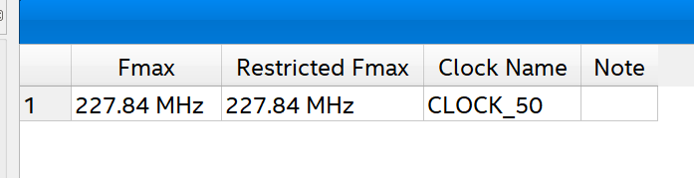

c.) Annotate here the 5 longest critical paths from Timing analyzer and annotate here their delay and slack. Include screenshot.
Marks
2

Critical Path | Slack | Delay
1 | 15.611 | 3.908
2 | 15.684 | 3.749
3 | 16.050 | 3.378
4 | 16.095 | 3.333
5 | 16.106 | 3.324

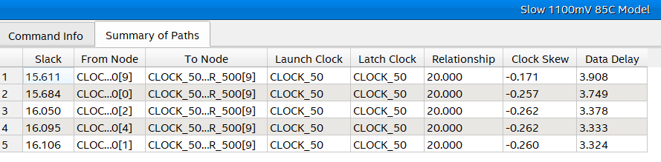
e.) Change the sdc constraint file setting the clock constraint to a period of 2ns (500Mhz) instead of 20ns (50Mhz). Reopen the Timing analyzer and report the 5 longest critical paths and their slack. Compare with the results in c). What did you notice? (include screenshot of the delays)
Marks
2

Critical Path | Slack | Delay
1 | -1.472 | 2.402
2 | -1.281 | 2.208
3 | -1.236 | 2.163
4 | -1.225 | 2.154
5 | -1.191 | 2.118
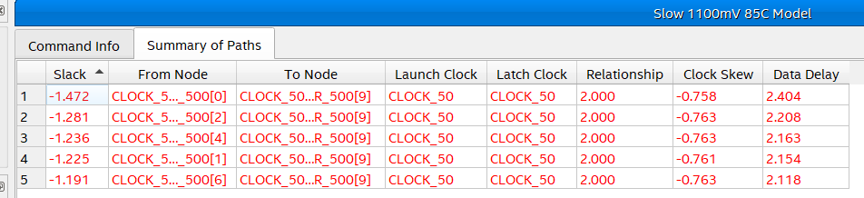
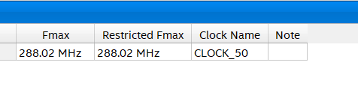
We can see that the place and route tool did try to optimize to get timing closure, but was unable to do so on multiple flip-flops.

Part II – Chip Planner
- Change back the sdc clock constraint to 20ns. Move the resources explained in the lab sheet (top and bottom left) using the Chip planner and re-compile the program.
Report the 5 longest critical paths from Timing Analyzer after the replacement. How did this affect the critical path? Compare the results with the original placement results. Explain why.
Marks
6

 | Critical Paths Original | Critical Paths New (moved)
1 | 3.908 | 9.538
2 | 3.749 | 5.707
3 | 3.378 | 5.666
4 | 3.333 | 5.295
5 | 3.324 | 5.250

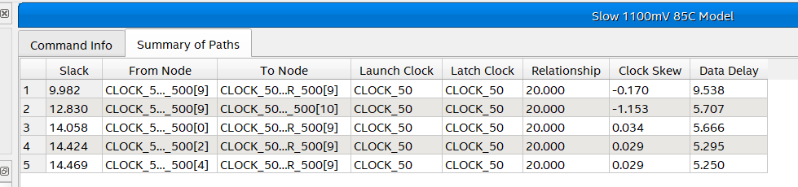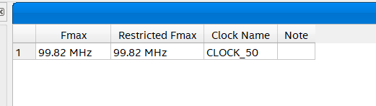

For the new location to work, the place and route tool must set a lot of switches to get from the center of the FPGA to the edge and back. This negatively impacts timing as these long ‘wires’ have a large impact on the time it takes for the information to travel across the chip.

b.) Create a YouTube video showing the working designs and showing how you measured the information reported int this homework
Marks
6

https://www.youtube.com/watch?v=z11qRIoI2fk

