
EEDG/CE 6370
Due Date: Sunday October 6, 11:59pm– Submit this editable Word document NOT pdf
0
32
Design and Analysis or Reconfigurable Systems
Homework 7
VGA-FPGA Interface

Name:
Email
Part I – VGA implementation with DCM IP to set clock
a.) Follow the instructions in the lab sheet and implement the design which draws two squares of different color to the screen using Altera’s IP catalogue to create a clock of different frequency (based on screen size and resolution). Create a short video demonstrating the working design.
Marks
4

https://www.youtube.com/watch?v=4WJT3sCox2M

b.) Report the number of ALMs, ALUTs and critical path of the design from the synthesis report. Compute the maximum frequency. Include the screenshots generated by Quartus.
Marks
2

F_{max} = 225.33 MHz
ALM = 41
ALUT = 57
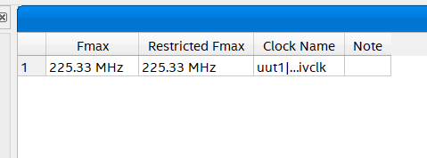
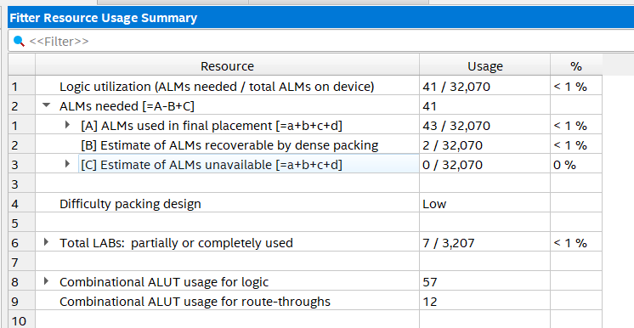

Part II – Timing analysis
c.) Open TimeQuest. 1) Netlist Create Timing netlist. 2.) Read .sdc file from VGA project (Constraints read sdc file). 3.) Update timing netlist (Netlist Update Timing netlist)
Report the slack of the circuit. Is it positive or negative? Explain what that means (Reports slack Report setup summary and Report hold summary.
Marks
2

The worst case slack is 2.298 ns and is positive. This means that the data reached 2.298 ns before it was required to meet the setup constraints. The hold time was also positive at 0.383 ns, which means the data for all inputs and outputs was constant for the required data acquisition time.
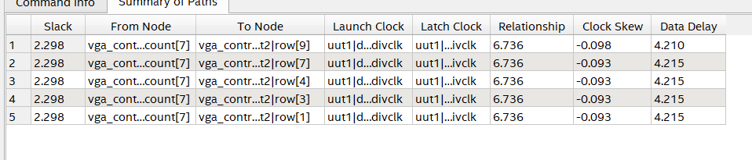

e.) Reporting the skew. Task pane Custom reports report skew. Edit “From clock” and “To clock” combo boxes. Which clock should you choose? Explain why.
Marks
2

“To” and “From” are set to the “PLL_OUTPUT_COUNTER” clock, as it is the main clock used in the design. The sys_clk goes to the PLL only and is not used in any sort of multi-clock domain scenario.

f.) Is the slack positive or negative? What does the slack result obtained suggests?
Marks
2

The worst case slack is 2.298 ns and is positive. This means that the data reached 2.298 ns before it was required to meet the setup constraints.

Part III – Power Estimation
- Use the PowerPlay Excel sheet to estimate the total power of the design. Enter manually the resources used. Let the toggle rate at its default value. Annotate the estimated dynamic and static power, with the following values. Discuss the results.

Marks
6

Configs | Frequency  [MHz] | Temperature [ºC] | Toggle rate [%] | Static power (Quiescent) [W] | Dynamic Power [W] | Total Power [W]
Config 1 | 50 | 50 | 12.5 | 0.325 | 0.035 | 0.36
Config 2 | 60 | 50 | 12.5 | 0.325 | 0.036 | 0.361
Config 3 | 70 | 50 | 12.5 | 0.325 | 0.037 | 0.362
Config 4 | 50 | 55 | 12.5 | 0.334 | 0.035 | 0.369
Config 5 | 50 | 60 | 12.5 | 0.344 | 0.035 | 0.379
Config 6 | 50 | 65 | 12.5 | 0.355 | 0.035 | 0.39
Config 7 | 50 | 50 | 15 | 0.325 | 0.036 | 0.361
Config 8 | 50 | 50 | 20 | 0.325 | 0.038 | 0.363
Config 9 | 50 | 50 | 25 | 0.325 | 0.04 | 0.365

The results show that the static power increases only when the temperature increases. I also noticed that the dynamic power increases when the frequency, temperature or toggle rate changes, which shows that the formulas we discussed in class are in fact the ones they are using to create this estimation. These increases in dynamic power can be mainly attributed to the IO switching speeds increasing. I did wonder if I should also use the HPS portion of the PowerPlay tool, but decided against it, as it’s not what we’re concerned about at the moment. It is still something we should consider, as portions of that system must be on.

- Compare the results obtained from Power Play Early Power Estimator (Excel spreadsheet) with the results obtained from Power Play Power Analyzer (Quartus II power estimation tool). Do the results match? Explain why yes/no.
Marks
4

Power dissipation from the PowerPlay Analyzer had config 1 at 0.459/0.083/0.574 watts vs the values that are one to two hundred mW less from the excel spreadsheet. These values also only seemed to change when I changed the ambient temperature; changing the IO toggle rate did not change the power output like how the excel spreadsheet did.

Part IV – Re-doing VGA Output
Re-do the design and display one of the following messages (choose one) on the center of the screen in UTD green or orange:
- I love FPGAs
- UT Dallas
- HW > SW
The screen background should be white background (full display). Write down the RTL code that generates this image from the ‘hw_image_generator’ module. Only the code snippet. Adjust the monitor size parameters (porch values and horizontal and vertical pixels, etc..). Include the parameters settings here. Finally create a YouTube video showing that this works
Marks
10
https://www.youtube.com/watch?v=uQLZViZarGg
Porch values, blanking times and all other default values were all the same, only the clock speed was changed from 108 MHz to 148.5 MHz, as previously described in the first video.

HW_image_generator Modifications
LIBRARY ieee;
USE ieee.std_logic_1164.all;
use IEEE.STD_LOGIC_UNSIGNED.ALL;

ENTITY hw_image_generator IS
---------- Here I added two extra generics, and highlight a 250x250 square
GENERIC(
pixels_y0 : INTEGER := 415;
pixels_y1 : INTEGER := 665;
pixels_x0 : INTEGER := 835;
pixels_x1 : INTEGER := 1085);
PORT(
pixel_clk : IN STD_LOGIC; -- added pixel clock
disp_ena : IN STD_LOGIC;
row : IN INTEGER;
column : IN INTEGER;
red : OUT STD_LOGIC_VECTOR(7 DOWNTO 0) := (OTHERS => '0');
green : OUT STD_LOGIC_VECTOR(7 DOWNTO 0) := (OTHERS => '0');
blue : OUT STD_LOGIC_VECTOR(7 DOWNTO 0) := (OTHERS => '0'));
END hw_image_generator;

ARCHITECTURE behavior OF hw_image_generator IS
signal rom_output : STD_LOGIC_VECTOR (23 downto 0);
signal address : STD_LOGIC_VECTOR(15 DOWNTO 0);
signal temp : std_logic_vector(rom_output'range);

component rom_test
PORT -- created the ROM that will hold the data.
( -- Mem init file linked to in MegaWizard
address : IN STD_LOGIC_VECTOR (15 DOWNTO 0);
clock : IN STD_LOGIC := '1';
q : OUT STD_LOGIC_VECTOR (23 DOWNTO 0)
);
end component;
BEGIN

myrom : rom_test PORT MAP (
-- Instantitated a ROM
address => address,
clock => pixel_clk,
q => rom_output
);
process (pixel_clk, row, column)
begin -- This process changes the data on 'q'
if (rising_edge(pixel_clk)) then
if (row > pixels_y0 and row <= pixels_y1) then
if (column > pixels_x0 - 1 and column <= pixels_x1 - 1) then
address <= address + '1';
temp <= rom_output;
end if;
elsif (row = 1) then
address <= (others => '0');
else
address <= address;
end if;
end if;

end process;

PROCESS(disp_ena, row, column)
BEGIN

IF(disp_ena = '1') THEN --display time
-- IF(row < pixels_y AND column < pixels_x) THEN
-- red <= (OTHERS => '0');
-- green <= (OTHERS => '0');
-- blue <= (OTHERS => '1');
if (row > pixels_y0 and row <= pixels_y1) then
if (column > pixels_x0 and column <= pixels_x1) then
-- red <= rom_output(23 DOWNTO 16);
-- green <= rom_output(15 DOWNTO 8);
-- blue <= rom_output(7 DOWNTO 0);
-- send data to VGA DAC's
(red, green, blue) <= rom_output(23 downto 0);
else
red <= (others => '1');
green <= (others => '1');
blue <= (others => '1');
end if;
ELSE
red <= (OTHERS => '1');
green <= (OTHERS => '1');
blue <= (OTHERS => '1');
END IF;
ELSE --blanking time
red <= (OTHERS => '0');
green <= (OTHERS => '0');
blue <= (OTHERS => '0');
END IF;

END PROCESS;
END behavior;

