
EEDG/CE 6370
Due Date: Sunday October 27, 11:59pm– Submit this editable Word document NOT pdf
0

32
Design and Analysis of Reconfigurable Systems
Homework 6
High-Level Synthesis with CyberWorkBench

Student Names

PART 1 – ave8.c Synthesis
- Synthesize the ave8.c design. Annotate from the resource constraint file (FCNT) the number and type of Functional Units (FUs) used (include screenshots from the reports). Explain what type and why these FUs are needed. Create a short YouTube video showing the process of creating the CWB project and synthesis.
Marks
6

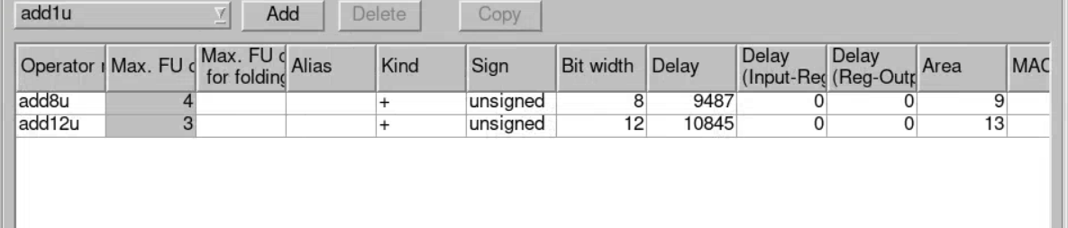
These two functional units are an eight-bit adder and a twelve-bit adder. There’s a max of 4, which allows for four additions to be done in parallel. The three 12-bit adders allow for the 4 intermediate answers to be done in parallel (two) and then the remaining addition can be done immediately after that. The eight-bit adders are needed as the input is 8 bits, and after adding all 8 terms, the final answer can be as many as 11-bits long, From there, we assign [10:3] to the output for our final average.

https://www.youtube.com/watch?v=oaPDH75XEq0

- Report from the QoR file the size of the circuit in terms of number of LUTs and registers. Report also the latency of the synthesized circuit and the critical path and maximum frequency. Include screenshot.
Marks
2

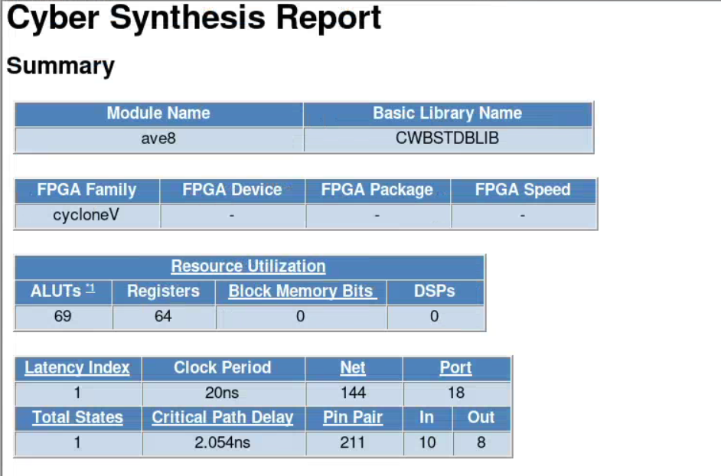
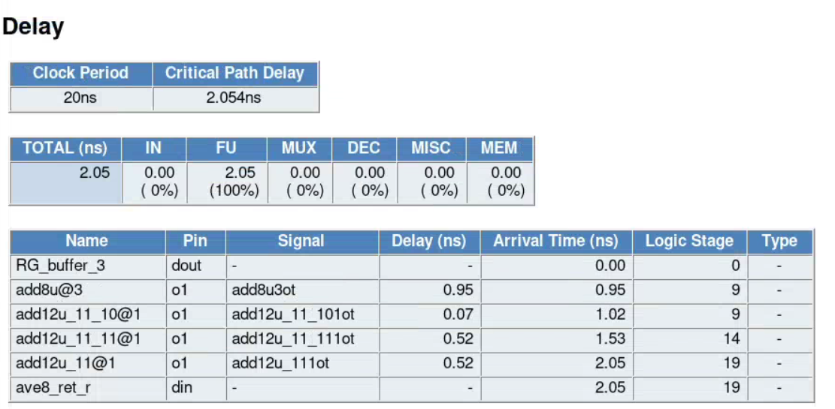
F_{max} = 237.95 MHz
LUT’s = 69
Registers = 64

- Perform Logic synthesis using Quartus Prime and compare the area results in terms of LUTs. You might call Quartus from within CWB as shown in the lab sheet or manually create a project in Quartus and include the RTL file generated by CWB, and an SDC file. Discuss if they match or not and why they do/don’t. Shown Quartus results screenshots.
Marks
4
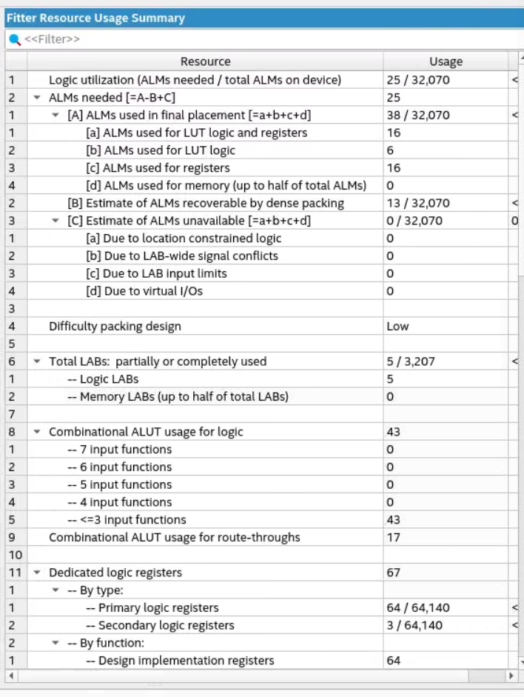
Quartus was able to lower the amount of ALUT’s from 69 to 60 [combinational ALUT usage for logic (43) and route-throughs (17)] and used 3 more secondary registers than CWB. The main reason for why they don’t match is the CWB does not do fitting and placement. It just estimates how much registers and ALUT’s each functional unit requires and adds them together, where as Quartus will do logic packing to reduce ALM utilization.

- What is the latency (in clock cycles) if you set the target synthesis frequency to 500 MHz (in project properties). Include screenshot. Explain why.
Marks
2

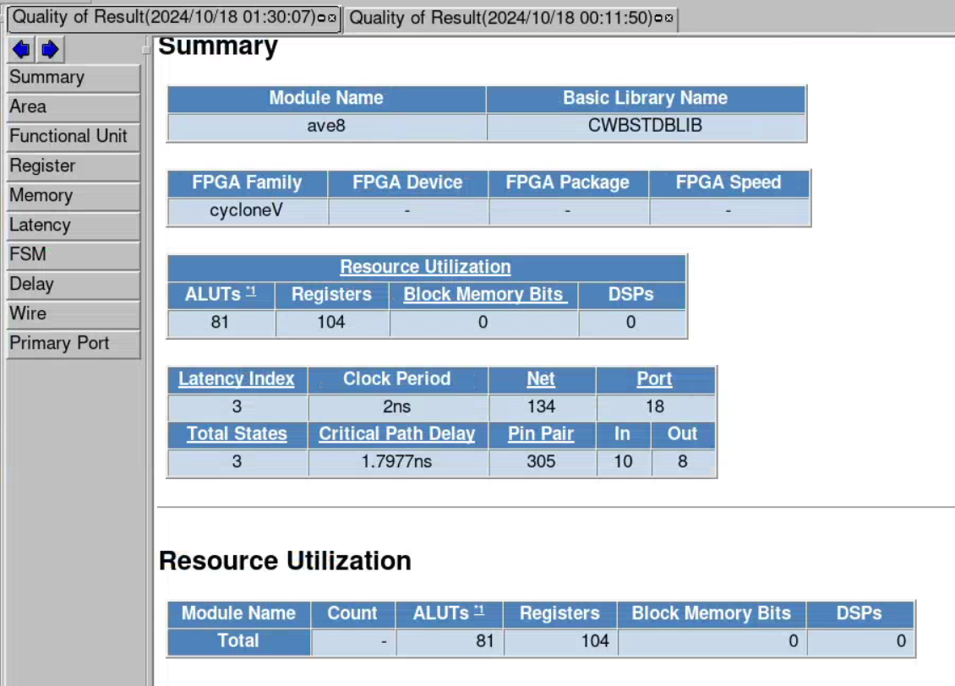
The critical path delay at first was 2.05 ns, which would violate the timing of 2 ns. Before, when looking at the data path, all 7 additions were done in a single clock cycle. However, the new datapath graph shows the addition of three intermediate registers to store the data, with the created FSM doing the addition in 3 clock cycles.

PART 2 – ave8.c Verification
- Perform a cycle-accurate simulation using the untimed test vectors used for the software simulation and make sure that the simulation outputs match for the two versions with HLS frequency 100MHz and 500Mhz. Show the result (paste console window)
Marks
4

PART 3 ave8.c Design Space Exploration
a.) Reduce the number of FUs in the Resource Constraint file (FCNT) from the maximum number obtained in the initial design (50Mhz) to half that number and to only 1 FU. Annotate the area in terms if LUTs and the latency of each of the 3 designs in a table. Plot the graph of area vs. latency of the 3 designs (y-axis area, x-axis latency). Discuss the results. Are they what you expected? (Yes/No)
Marks
6

Design | ALUTs | Latency | Critical path
Max FUs | 69 | 1 | 2.054 ns
Half FUs | 93 | 2 | 4.0816 ns
One single FU | 74 | 7 | 4.4595 ns

My first thoughts on this would be that I’d see the ALUT’s increase when I changed the FU to just one (the 12 bit adder), but was genuinely surprised to see the number of ALUT’s fall. This makes sense when you think about it adding one number at a time, which explains why it took 7 cycles to complete.

FPGA Prototyping
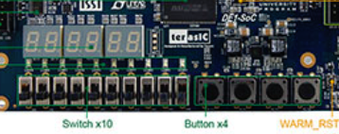
Prototype the design on the DE1-SoC board such that the switches act as a new unsigned 8-bit value to be read into the circuit each time that a button is pressed. The average of the last 8 values is displayed on the 7-segment displays as shown. Add, to the report the new synthesizable C code and create a YouTube video showing that the design works.
Display ave8 result on LCD
Marks
8

Read the value when button is pressed
New unsigned 8-bit value

https://www.youtube.com/watch?v=XW08jOBLMTk
Include the modified ave8.c file that follows the specifications indicated and that displays the results on the LCD display and a video showing that the design is working.
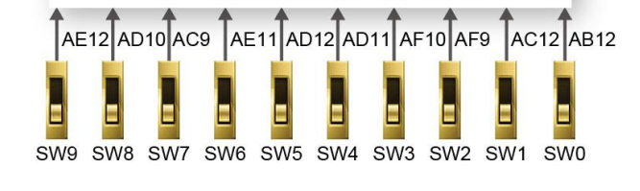
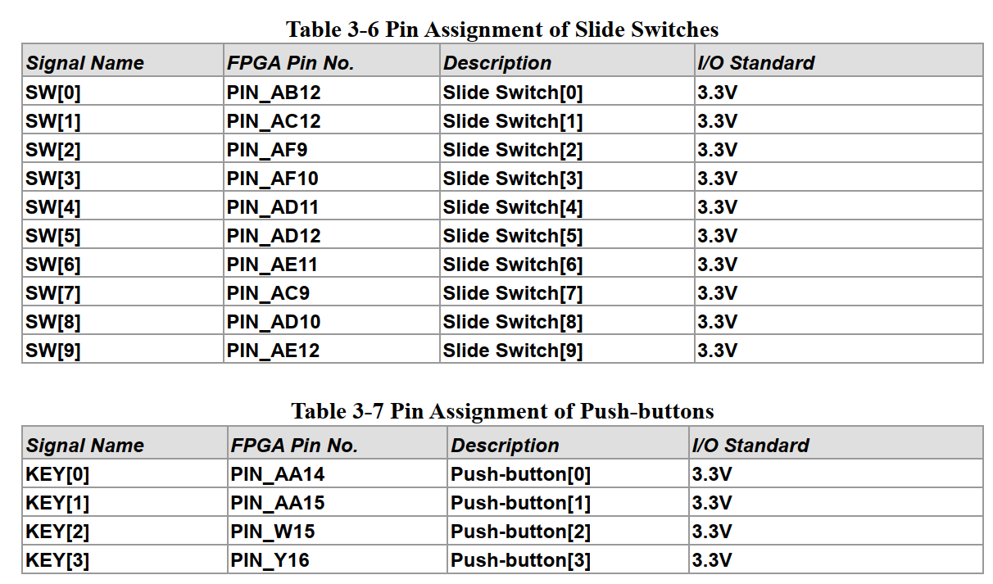
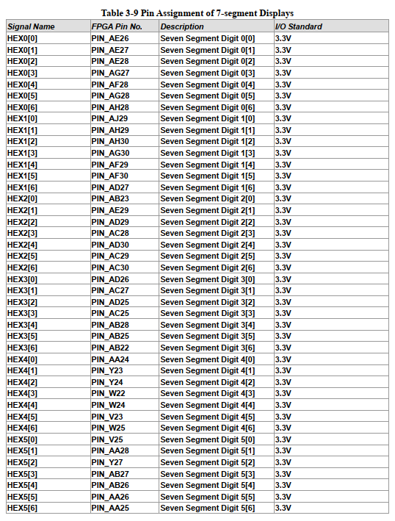

Ave8_E.vhd

-- vhdlgen version : 6.84.1 Thu Feb 15 14:35:44 JST 2018 (BIF version 3.41z)
-- options: /proj/cad/cwb-6.1/linux_x86_64/bin/vhdlgen -EE ave8_E.IFF
-- bdlpars options: -EE -I../.. -I/proj/cad/cwb-6.1/linux_x86_64/include -info_base_name ave8_sw ../../ave8_sw.c -process=ave8
-- bdltran options: -EE -c2000 -s -Zresource_fcnt=GENERATE -Zresource_mcnt=GENERATE -Zdup_reset=YES -Zfolding_sharing=inter_stage -Zcdfgdraw -EE -lb /proj/cad/cwb-6.1/packages/cycloneV.BLIB -lfl /proj/cad/cwb-6.1/packages/cycloneV.FLIB +lfl ave8-auto.FLIB +lfl ave8-amacro-auto.FLIB -lfc ave8-auto.FCNT +lfc ave8-amacro-auto.FCNT -lml ave8-auto.MLIB -lmc ave8-auto.MCNT ave8.IFF
-- timestamp_0: 20241018000232_06646_63121
-- timestamp_5: 20241018001115_14065_00483
-- timestamp_9: 20241018001149_14065_64526
-- timestamp_C: 20241018001116_14065_87210
-- timestamp_E: 20241018001149_14065_31694
-- timestamp_V: 20241018004437_07037_92034
--Command Option Status
-- FU mapping style[std_package]
-- DFF mapping style[std_package]
-- 80 characters in each line
-- Datapath module name [ave8]
-- Output file[ave8_E.vhd]
-- Sample Configuration File is not generating
-- dontcare value--> 0
--end of Command Option Status

library IEEE;
use IEEE.std_logic_1164.all;
use IEEE.std_logic_unsigned.all;
entity ave8_add12u_11_10 is
port (
i1 : IN std_logic_vector(0 to 8);
i2 : IN std_logic_vector(0 to 8);
o1 : OUT std_logic_vector(0 to 9)
);
end ave8_add12u_11_10;
architecture RTL of ave8_add12u_11_10 is
begin
o1 <= ('0'&i1) + ('0'&i2);
end RTL;

library IEEE;
use IEEE.std_logic_1164.all;
use IEEE.std_logic_unsigned.all;
entity ave8_add12u_11_11 is
port (
i1 : IN std_logic_vector(0 to 9);
i2 : IN std_logic_vector(0 to 8);
o1 : OUT std_logic_vector(0 to 10)
);
end ave8_add12u_11_11;
architecture RTL of ave8_add12u_11_11 is
signal i2_10bit : std_logic_vector(0 to 9);
begin
i2_10bit <= '0'&i2 ;
o1 <= ('0'&i1) + ('0'&i2_10bit);
end RTL;

library IEEE;
use IEEE.std_logic_1164.all;
use IEEE.std_logic_unsigned.all;
entity ave8_add12u_11 is
port (
i1 : IN std_logic_vector(0 to 10);
i2 : IN std_logic_vector(0 to 8);
o1 : OUT std_logic_vector(0 to 10)
);
end ave8_add12u_11;
architecture RTL of ave8_add12u_11 is
signal i2_11bit : std_logic_vector(0 to 10);
begin
i2_11bit <= "00"&i2 ;
o1 <= i1 + i2_11bit;
end RTL;

library IEEE;
use IEEE.std_logic_1164.all;
use IEEE.std_logic_unsigned.all;
entity ave8_add8u is
port (
i1 : IN std_logic_vector(0 to 7);
i2 : IN std_logic_vector(0 to 7);
o1 : OUT std_logic_vector(0 to 8)
);
end ave8_add8u;
architecture RTL of ave8_add8u is
begin
o1 <= ('0'&i1) + ('0'&i2);
end RTL;

library IEEE;
use IEEE.std_logic_1164.all;
entity ave8 is
port (
in0 : IN std_logic_vector(0 to 7); -- line#=../../ave8_sw.c:20
ave8_ret : OUT std_logic_vector(0 to 7); -- line#=../../ave8_sw.c:20
CLOCK : IN std_logic;
RESET : IN std_logic
);
end ave8;
architecture RTL of ave8 is
signal add12u_11_101i2 : std_logic_vector (0 to 8);
signal add12u_11_101i1 : std_logic_vector (0 to 8);
signal add12u_11_101ot : std_logic_vector (0 to 9);
signal add12u_11_111i2 : std_logic_vector (0 to 8);
signal add12u_11_111i1 : std_logic_vector (0 to 9);
signal add12u_11_111ot : std_logic_vector (0 to 10);
signal add12u_111i2 : std_logic_vector (0 to 8);
signal add12u_111i1 : std_logic_vector (0 to 10);
signal add12u_111ot : std_logic_vector (0 to 10);
signal add8u4i2 : std_logic_vector (0 to 7);
signal add8u4i1 : std_logic_vector (0 to 7);
signal add8u4ot : std_logic_vector (0 to 8);
signal add8u3i2 : std_logic_vector (0 to 7);
signal add8u3i1 : std_logic_vector (0 to 7);
signal add8u3ot : std_logic_vector (0 to 8);
signal add8u2i2 : std_logic_vector (0 to 7);
signal add8u2i1 : std_logic_vector (0 to 7);
signal add8u2ot : std_logic_vector (0 to 8);
signal add8u1i2 : std_logic_vector (0 to 7);
signal add8u1i1 : std_logic_vector (0 to 7);
signal add8u1ot : std_logic_vector (0 to 8);
signal RG_buffer : std_logic_vector (0 to 7); -- line#=../../ave8_sw.c:16
signal RG_buffer_1 : std_logic_vector (0 to 7); -- line#=../../ave8_sw.c:16
signal RG_buffer_2 : std_logic_vector (0 to 7); -- line#=../../ave8_sw.c:16
signal RG_buffer_3 : std_logic_vector (0 to 7); -- line#=../../ave8_sw.c:16
signal RG_buffer_4 : std_logic_vector (0 to 7); -- line#=../../ave8_sw.c:16
signal RG_buffer_5 : std_logic_vector (0 to 7); -- line#=../../ave8_sw.c:16
signal RG_buffer_6 : std_logic_vector (0 to 7); -- line#=../../ave8_sw.c:16
signal ave8_ret_r : std_logic_vector (0 to 7); -- line#=../../ave8_sw.c:20
component ave8_add12u_11_10
port (
i1 : IN std_logic_vector(0 to 8);
i2 : IN std_logic_vector(0 to 8);
o1 : OUT std_logic_vector(0 to 9)
);
end component;
component ave8_add12u_11_11
port (
i1 : IN std_logic_vector(0 to 9);
i2 : IN std_logic_vector(0 to 8);
o1 : OUT std_logic_vector(0 to 10)
);
end component;
component ave8_add12u_11
port (
i1 : IN std_logic_vector(0 to 10);
i2 : IN std_logic_vector(0 to 8);
o1 : OUT std_logic_vector(0 to 10)
);
end component;
component ave8_add8u
port (
i1 : IN std_logic_vector(0 to 7);
i2 : IN std_logic_vector(0 to 7);
o1 : OUT std_logic_vector(0 to 8)
);
end component;
begin
INST_add12u_11_10_1 : ave8_add12u_11_10 port map(i1=>add12u_11_101i1,i2=>add12u_11_101i2,
o1=>add12u_11_101ot); -- line#=../../ave8_sw.c:39
INST_add12u_11_11_1 : ave8_add12u_11_11 port map(i1=>add12u_11_111i1,i2=>add12u_11_111i2,
o1=>add12u_11_111ot); -- line#=../../ave8_sw.c:39
INST_add12u_11_1 : ave8_add12u_11 port map(i1=>add12u_111i1,i2=>add12u_111i2,
o1=>add12u_111ot); -- line#=../../ave8_sw.c:28,35,39
INST_add8u_1 : ave8_add8u port map(i1=>add8u1i1,i2=>add8u1i2,o1=>add8u1ot); -- line#=../../ave8_sw.c:28,35,39
INST_add8u_2 : ave8_add8u port map(i1=>add8u2i1,i2=>add8u2i2,o1=>add8u2ot); -- line#=../../ave8_sw.c:39
INST_add8u_3 : ave8_add8u port map(i1=>add8u3i1,i2=>add8u3i2,o1=>add8u3ot); -- line#=../../ave8_sw.c:39
INST_add8u_4 : ave8_add8u port map(i1=>add8u4i1,i2=>add8u4i2,o1=>add8u4ot); -- line#=../../ave8_sw.c:39
ave8_ret <= ave8_ret_r; -- line#=../../ave8_sw.c:20
add8u2i1 <= RG_buffer_4; -- line#=../../ave8_sw.c:28,39
add8u2i2 <= RG_buffer_5; -- line#=../../ave8_sw.c:28,39
add12u_11_111i1 <= add12u_11_101ot; -- line#=../../ave8_sw.c:39
add12u_11_111i2 <= add8u2ot; -- line#=../../ave8_sw.c:39
VHDLgen_Label1002 :process(CLOCK, RESET)
begin
if ( RESET = '1' ) then
ave8_ret_r <= "00000000";
elsif ( CLOCK'event and CLOCK = '1' ) then
ave8_ret_r <= add12u_111ot(0 to 7); -- line#=../../ave8_sw.c:28,35,39,43,46
end if;
end process;
VHDLgen_Label1003 :process(CLOCK, RESET)
begin
if ( RESET = '1' ) then
RG_buffer <= "00000000";
elsif ( CLOCK'event and CLOCK = '1' ) then
RG_buffer <= in0; -- line#=../../ave8_sw.c:32
end if;
end process;
VHDLgen_Label1004 :process(CLOCK, RESET)
begin
if ( RESET = '1' ) then
RG_buffer_1 <= "00000000";
elsif ( CLOCK'event and CLOCK = '1' ) then
RG_buffer_1 <= RG_buffer; -- line#=../../ave8_sw.c:28
end if;
end process;
VHDLgen_Label1005 :process(CLOCK, RESET)
begin
if ( RESET = '1' ) then
RG_buffer_2 <= "00000000";
elsif ( CLOCK'event and CLOCK = '1' ) then
RG_buffer_2 <= RG_buffer_1; -- line#=../../ave8_sw.c:28
end if;
end process;
VHDLgen_Label1006 :process(CLOCK, RESET)
begin
if ( RESET = '1' ) then
RG_buffer_3 <= "00000000";
elsif ( CLOCK'event and CLOCK = '1' ) then
RG_buffer_3 <= RG_buffer_2; -- line#=../../ave8_sw.c:28
end if;
end process;
VHDLgen_Label1007 :process(CLOCK, RESET)
begin
if ( RESET = '1' ) then
RG_buffer_4 <= "00000000";
elsif ( CLOCK'event and CLOCK = '1' ) then
RG_buffer_4 <= RG_buffer_3; -- line#=../../ave8_sw.c:28
end if;
end process;
VHDLgen_Label1008 :process(CLOCK, RESET)
begin
if ( RESET = '1' ) then
RG_buffer_5 <= "00000000";
elsif ( CLOCK'event and CLOCK = '1' ) then
RG_buffer_5 <= RG_buffer_4; -- line#=../../ave8_sw.c:28
end if;
end process;
VHDLgen_Label1009 :process(CLOCK, RESET)
begin
if ( RESET = '1' ) then
RG_buffer_6 <= "00000000";
elsif ( CLOCK'event and CLOCK = '1' ) then
RG_buffer_6 <= RG_buffer_5; -- line#=../../ave8_sw.c:28
end if;
end process;
add8u1i1 <= RG_buffer_6; -- line#=../../ave8_sw.c:28,35,39
add8u1i2 <= in0; -- line#=../../ave8_sw.c:28,35,39
add12u_111i1 <= add12u_11_111ot; -- line#=../../ave8_sw.c:28,35,39
add12u_111i2 <= add8u1ot; -- line#=../../ave8_sw.c:28,35,39
add8u3i1 <= RG_buffer_2; -- line#=../../ave8_sw.c:28,39
add8u3i2 <= RG_buffer_3; -- line#=../../ave8_sw.c:28,39
add8u4i1 <= RG_buffer; -- line#=../../ave8_sw.c:28,39
add8u4i2 <= RG_buffer_1; -- line#=../../ave8_sw.c:28,39
add12u_11_101i1 <= add8u4ot; -- line#=../../ave8_sw.c:39
add12u_11_101i2 <= add8u3ot; -- line#=../../ave8_sw.c:39
end RTL;

AVE8.c Part 4 Modification
/**************************************************
**
** ave8.c
**
** Description: The following program computes the average
** of the 8 numbers being read
**
****************************************************/
#ifdef C
#include "stdio.h"
#include "stdlib.h"
#endif

/* Global variables */
unsigned char buffer[8] = {0, 0, 0, 0, 0, 0, 0, 0};
var (3..0) par_out_0;
var (3..0) par_out_1;
var (3..0) par_out_2;
var (3..0) par_out_3;
reg (27..0) sevseg_0;
int count = 0;
int state = 0;

// Cyber func=process
unsigned int ave8(unsigned char in0, var button ) {
var (13 .. 0) temp1, temp2, temp3, temp4;

/* Local variables declaration */
int out0_v, sum, i;
par_out_2 = 0b0101;

switch (state) {
case 0: // no button pressed, nothing happening
$
par_out_3 = 0b0000;
if (button == 1) {// active low
$
state = 0;

}
else { // button == 0
$
state = 1;
count = 0;
}

break; // numbers stay in the same place, do nothing
// and let the machine add the same numbers over and over
case 1: // button pressed, no debounce
$
par_out_3 = 0b0001;
while (count < 5000000)
{
$ //wait 0.1 seconds and check if button is still 0
count++;
$
}
$
if (button == 0){
$
for (i = 7; i > 0; i--) {
buffer[i] = buffer[i- 1];
}
buffer[0] = in0;
$
state = 2;
}
else // button was actually not pressed
{
$
state = 0;
$
}
break;
case 2: // button pressed, debounced. Wait for release
$
par_out_3 = 0b0010;
if (button == 0) {// active low
$
state = 2;

}
else { // button == 1
$
state = 3;
count = 0;
}

break; // nothing happens, wait
case 3: // button released, debounce it
$
par_out_3 = 0b0011;

while (count < 5000000)
{
$ //wait 0.1 seconds and check if button is still 0
count++;
$
}
$
if (button == 1){
$
state = 0;
}
else // button was actually not pressed
{
$
state = 2;
$
}
break;
default:
$
par_out_3 = 0b0100;
}
/* Set first element of sum to compute the average => can save 1 loop iteration */
$
sum= buffer[0];

/* Add up all the numbers in the buffer */
for (i= 1; i< 8; i++) {
sum += buffer[i];
}

/* Compute the average by dividing by 8 -> In HW a divide by 8 (/8) = shift 3 times */
out0_v= sum / 8;
par_out_0 = out0_v % 16;
out0_v = out0_v / 16;
par_out_1 = out0_v % 16;
//work = 1;
// seg_0 = SevSeg(par_out_0);
// seg_1 = SevSeg(par_out_1);
// Dont know how to create the function, and why the numbers have to be in binary
// ... though maybe "var" treats the declaration as a collection of bits, like how SLV does.

switch (par_out_0) {
case 0b0000:
temp1 = 0b1000000;
break;
case 0b0001:
temp1 = 0b1111001;
break;
case 0b0010:
temp1 = 0b0100100;
break;
case 0b0011:
temp1 = 0b0110000;
break;
case 0b0100:
temp1 = 0b0011001;
break;
case 0b0101:
temp1 = 0b0010010;
break;
case 0b0110:
temp1 = 0b0000010;
break;
case 0b0111:
temp1 = 0b1111000;
break;
case 0b1000:
temp1 = 0b0000000;
break;
case 0b1001:
temp1 = 0b0010000;
break;
case 0b1010:
temp1 = 0b0001000;
break;
case 0b1011:
temp1 = 0b0000011;
break;
case 0b1100:
temp1 = 0b0100111;
break;
case 0b1101:
temp1 = 0b0100001;
break;
case 0b1110:
temp1 = 0b0000110;
break;
case 0b1111:
temp1 = 0b0001110;
break;
}
$

switch (par_out_1) {
case 0b0000:
temp2 = 0b1000000;
break;
case 0b0001:
temp2 = 0b1111001;
break;
case 0b0010:
temp2 = 0b0100100;
break;
case 0b0011:
temp2 = 0b0110000;
break;
case 0b0100:
temp2 = 0b0011001;
break;
case 0b0101:
temp2 = 0b0010010;
break;
case 0b0110:
temp2 = 0b0000010;
break;
case 0b0111:
temp2 = 0b1111000;
break;
case 0b1000:
temp2 = 0b0000000;
break;
case 0b1001:
temp2 = 0b0010000;
break;
case 0b1010:
temp2 = 0b0001000;
break;
case 0b1011:
temp2 = 0b0000011;
break;
case 0b1100:
temp2 = 0b0100111;
break;
case 0b1101:
temp2 = 0b0100001;
break;
case 0b1110:
temp2 = 0b0000110;
break;
case 0b1111:
temp2 = 0b0001110;
break;
}
$

switch (par_out_2) {
case 0b0000:
temp3 = 0b1000000;
break;
case 0b0001:
temp3 = 0b1111001;
break;
case 0b0010:
temp3 = 0b0100100;
break;
case 0b0011:
temp3 = 0b0110000;
break;
case 0b0100:
temp3 = 0b0011001;
break;
case 0b0101:
temp3 = 0b0010010;
break;
case 0b0110:
temp3 = 0b0000010;
break;
case 0b0111:
temp3 = 0b1111000;
break;
case 0b1000:
temp3 = 0b0000000;
break;
case 0b1001:
temp3 = 0b0010000;
break;
case 0b1010:
temp3 = 0b0001000;
break;
case 0b1011:
temp3 = 0b0000011;
break;
case 0b1100:
temp3 = 0b0100111;
break;
case 0b1101:
temp3 = 0b0100001;
break;
case 0b1110:
temp3 = 0b0000110;
break;
case 0b1111:
temp3 = 0b0001110;
break;
}
$

switch (par_out_3) {
case 0b0000:
temp4 = 0b1000000;
break;
case 0b0001:
temp4 = 0b1111001;
break;
case 0b0010:
temp4 = 0b0100100;
break;
case 0b0011:
temp4 = 0b0110000;
break;
case 0b0100:
temp4 = 0b0011001;
break;
case 0b0101:
temp4 = 0b0010010;
break;
case 0b0110:
temp4 = 0b0000010;
break;
case 0b0111:
temp4 = 0b1111000;
break;
case 0b1000:
temp4 = 0b0000000;
break;
case 0b1001:
temp4 = 0b0010000;
break;
case 0b1010:
temp4 = 0b0001000;
break;
case 0b1011:
temp4 = 0b0000011;
break;
case 0b1100:
temp4 = 0b0100111;
break;
case 0b1101:
temp4 = 0b0100001;
break;
case 0b1110:
temp4 = 0b0000110;
break;
case 0b1111:
temp4 = 0b0001110;
break;

}
$

sevseg_0 = temp3<<21 | temp4 << 14 | temp2<<7 | temp1;
/* Output the newly computed average to the output port */
//return(out0_v);
//sevseg_0 = seg_1;
//sevseg_0 = sevseg_0 << 7;
//sevseg_0 = sevseg_0 + seg_0;

return(sevseg_0);
//return(seg_1);

}

/*------------------------------------------------------
* ANSI-C test bench
*------------------------------------------------------ */
#ifdef C // ifdef pre-compiler directive to separate SW from HW C
int main(){

FILE *fp_i, *fp_o;
int i;
unsigned char in0
int out0;

if((fp_i = fopen("indata.txt", "r")) == NULL){
printf(" \"indata.txt \" could not be opened.\n");
exit(1);
}
if((fp_o = fopen("outdata.txt", "w")) == NULL){
printf(" \"outdata.txt \" could not be opened.\n");
exit(1);
}

for (;;){

if (fscanf(fp_i, "%c", &in0) == EOF) break;
out0=ave8(in0); // Main computational function
fprintf(fp_o, "%d\n", out0);
}

fclose(fp_i);
fclose(fp_o);
}
#endif

