
EEDG/CE 6370
Due Date: Sunday November 10, 11:59pm– Submit this editable Word document NOT pdf
0

28
Design and Analysis of Reconfigurable Systems
Homework 7
High-Level Synthesis Optimizations

Name:
Email

PART 1 – sobel.c Synthesis and Verification – Use part1 source sobel.zip
- Synthesize the sobel.c design. Report from the QoR file the size of the circuit in terms of number of LUTs and registers. Report also the latency of the synthesized circuit and the critical path and maximum frequency from CWB. . Include screenshots from CWB here.
Marks
4

Number of LUTS: 175
Number of Registers: 32
Latency : 1
Critical Path Delay: 6.289 ns
Calculated max frequency: 159 Mhz
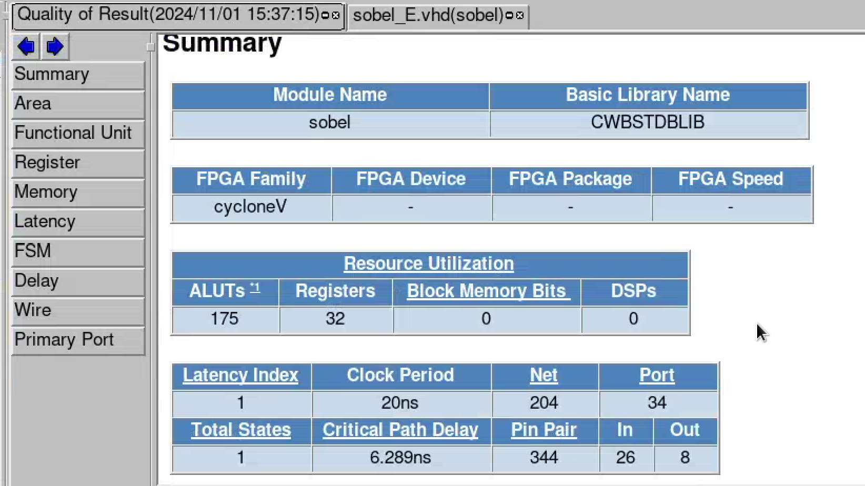

- Annotate from Resource constraint file (FCNT) the number and type of Functional Units (FUs) needed to fully parallelize the description (include screenshots from the reports). Explain why these FUs are needed and why no multipliers are needed
Marks
4

Looking at the Functional constraints, it was a bit perplexing at first for me to understand what was going on. However, looking at the code, specifically the matrix multiplication, the only terms that affect the new data input are -2, -1, 0, and 1.
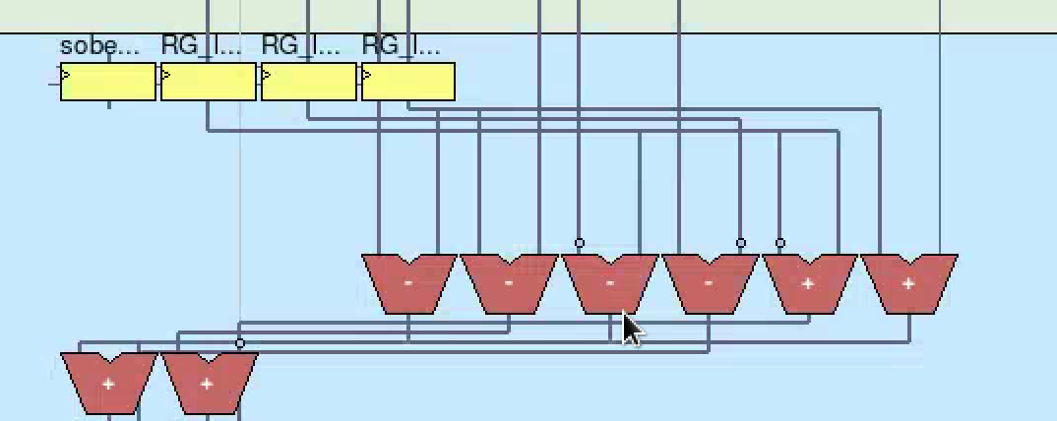
The 6 adders and subtractors on the right correspond to one of 4 options: ±1 and ±2. For both -1 and -2, the code ensures that they are the second term, or i2, in the subtraction block. For ±2, the tool simply concatenates a zero to the end of the term for a multiply by b’10 operation.
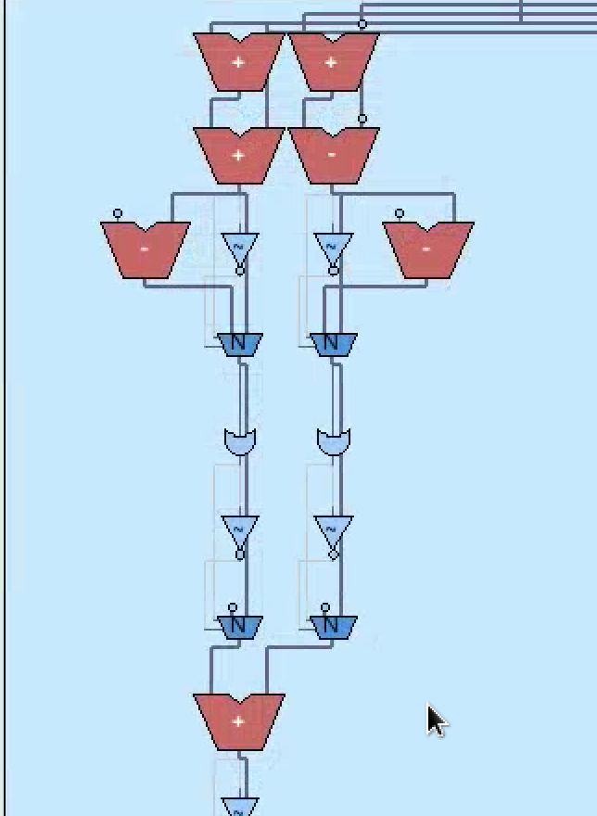
The remaining 7 are there to do the summation described in lines 72 and 73 of the C code (top 6) and the final sumX + sumY and the related logic around checking for 255.
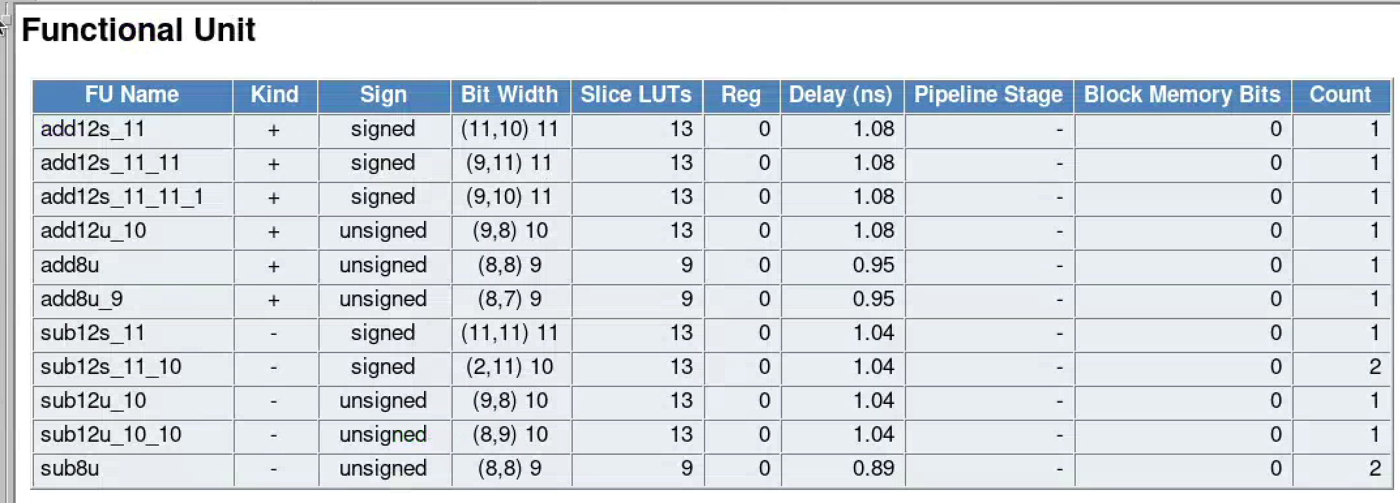
- Perform Logic synthesis using Quartus Prime and compare the area results in terms of ALMS/ALUTs. You might call Quartus from within CWB as shown in the lab sheet or manually create a project in Quartus and include the RTL file generated by CWB, and an SDC file. Discuss if they match or not and why they do/don’t. Add screenshot from Quartus here. Fill out the table given below.
Marks
6

 | CWB | Quartus
ALMS/ALUTs | 175 | 64
Registers | 32 | 32
IOS | 34 | 34
DSP Macros | 0 | 0

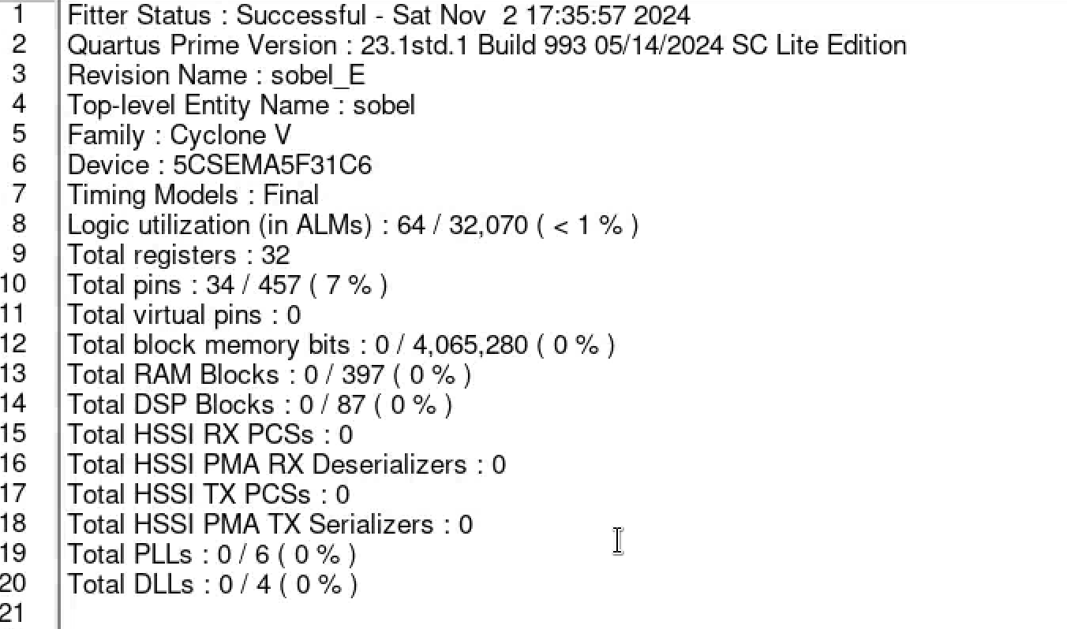
Figure 1: Quartus Output

sobel.c Verification
- Perform a pure SW simulation, a cycle-accurate simulation and an RTL simulation using the untimed test vectors used for the software simulation and make sure that the simulation outputs match for the two versions with HLS. Show the result (paste console window). Past also the pure SW simulation results (.bmp file).
Marks
6

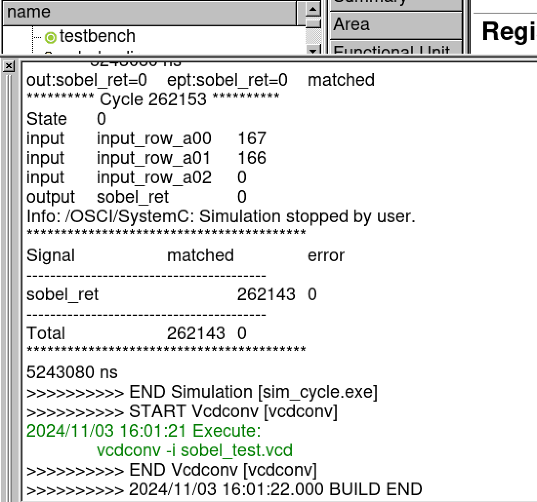
Figure 2: Cycle Accurate simulation
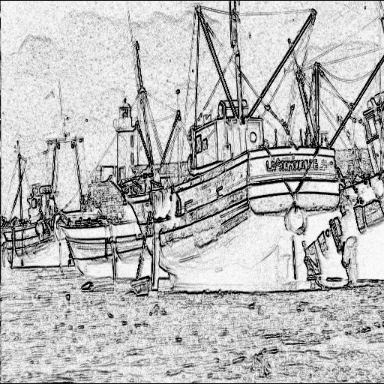
Figure 3: Software Simulation Output
I could not get CWB to run the rtl.

PART 2 sobel.c Design Space Exploration – Use part2 source sobel explorationl.zip
- Open source_sobel_exploration folder and you will find three files:
- Sobel.c
- attrs.h
- lib_sobel.info
- cycloneV.FLIB cycloneV.BLIB

Sobel.c: This new sobel file version has synthesis directives specified as comments in the code ranging from ATTR1 to ATTR2. The actual attributes are specified in attrs.h

Attrs.h: A sample file with the synthesis directives that CWB needs to synthesize the new sobel are given here. E.g.:

#define ATTR1 Cyber array=REG

Substitutes the ATTR1 in the comment in sobel.c by Cyber array=REG

lib_sobel.info: The library with all of the possible synthesis directives for each of the individual operations

cycloneV.FLIB/.BLIB: CWB technology libraries

Create a script that reads in the lib_sobel.info file and creates for each possible attribute combination a unique attrs.h. Every new combination has to be parsed (cpars), and synthesized (bdltran) as follows:

Step 1: Read lib_sobel.info with all attributes for each operation.
Step2: Generate new attrs.h header file with unique attributes combination.
Step3: Parse the new description. Make sure attrs.h is in the same folder as sobel.c:
%cpars sobel.c
Step4: Synthesize design calling HLS (bdltran)
%bdltran -c2000 -s sobel.IFF -lfl cycloneV.FLIB -lb cycloneV.BLIB
Step5: Read the area and latency of the new design and store sobel.QOR file or sobel.csv file and attrs.h file by moving it to either another or renaming the files.
Repeat step2 until all combinations are generated.
Step6: Generate report file with all the results and report optimal designs (area, latency and pragmas that lead to them).

Plot the graph of area vs. latency of all of the designs generated (y-axis=-area, x-axis=latency). Report the pragmas that lead to the Pareto-optimal designs. Discuss the results. Are they what you expected? (Yes/No). Create a short YouTube video showing how your explorer works.
Marks
8

https://www.youtube.com/watch?v=XQMv3Wx7kQI

