
EEDG/CE 6370
Due Date: Sunday November 17, 11:59pm– Submit this editable Word document NOT pdf
0
12
Design and Analysis or Reconfigurable Systems
Homework 8 – Hard Processor System

Name: Mark Ivey Email: mxi240020@utdallas.edu

Part I - Linux
Install any of the Linux versions on the SD card and show that it is working. Include picture.
Marks
2
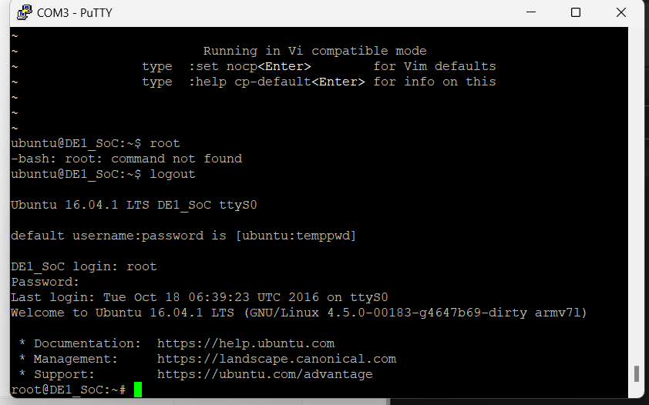

Part II – Simple program
Write a simple “Hello UTD” Program” and compile and run it on the HPS of the FPGA. Report the size of the compiled file. Include a video of the compilation process and working design showing the program runs on the FPGA.
Marks
4

https://www.youtube.com/watch?v=6pjJhUETS_I
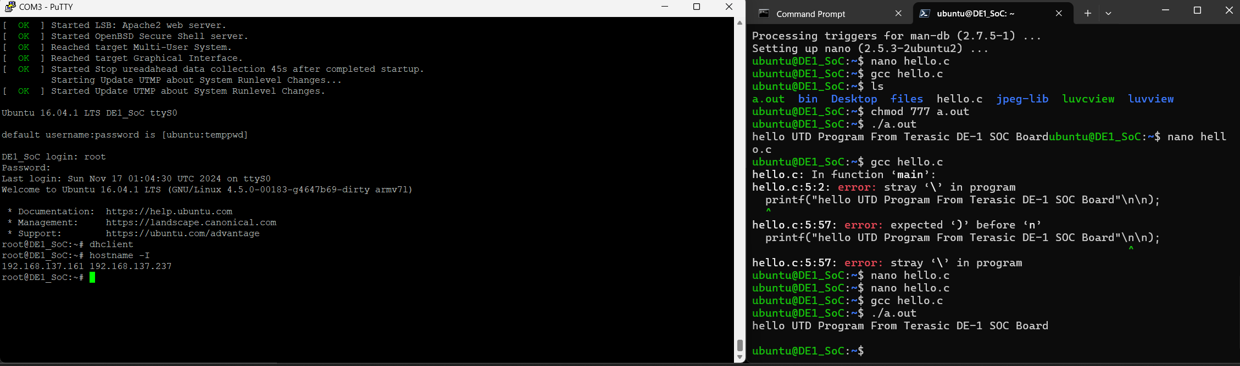

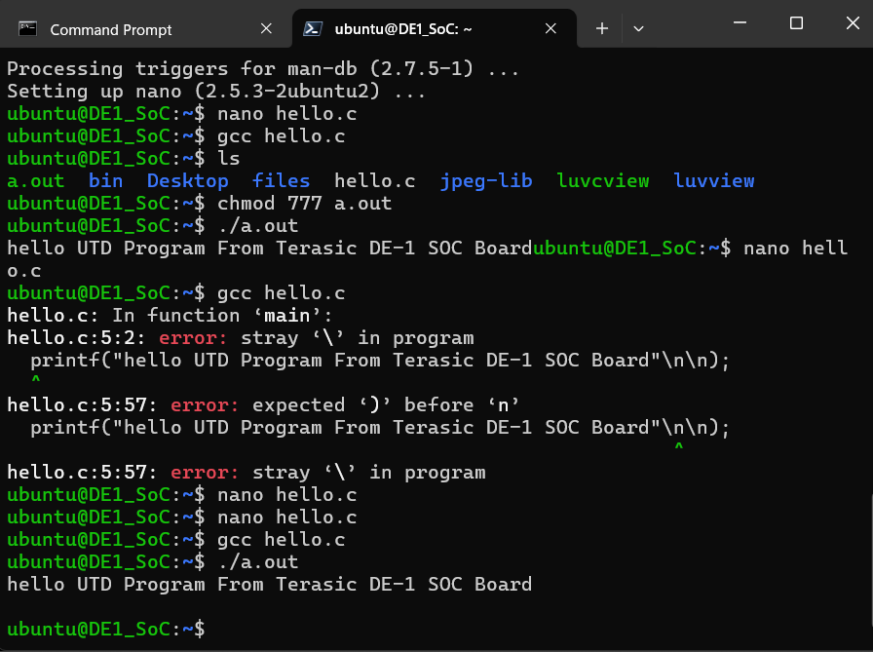
Part III – Controlling Peripherals through HPS
- As you can see from the picture below, the HPS in the Terasic board is ‘connected’ to different peripherals:
Figure 1 Cyclone V SoC in Terasic DE1-SoC board overview

Some of these peripherals include an HPS user button and a HPS user LED. Compile the hps_gpio/main.c program and annotate next to each line what it does through C/C++ comments. Include the size of the compiled program too. Create a YourTube video showing that it works.
Marks
6

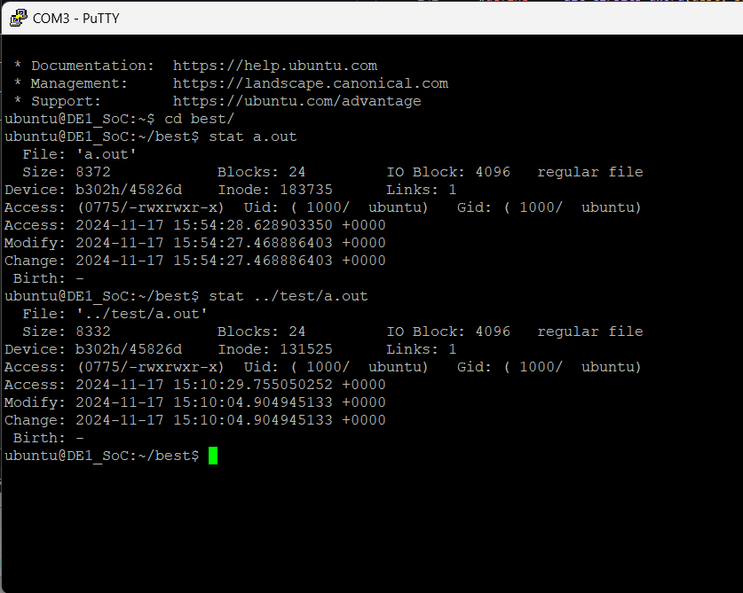
Size of original a.out program: 8332 bytes
https://www.youtube.com/watch?v=SwKurNImsB8

Main.c File
#define soc_cv_av
#include <stdio.h>
#include <unistd.h>
#include <fcntl.h>
#include <sys/mman.h>
#include "hwlib.h"
#include "socal/socal.h"
#include "socal/hps.h"
#include "socal/alt_gpio.h"

#define HW_REGS_BASE ( ALT_STM_OFST )
#define HW_REGS_SPAN ( 0x04000000 )
#define HW_REGS_MASK ( HW_REGS_SPAN - 1 )

#define USER_IO_DIR (0x01000000)
#define BIT_LED (0x01000000)
#define BUTTON_MASK (0x02000000)

int main(int argc, char **argv) {

void *virtual_base;
int fd;
uint32_t scan_input;
int i;
// map the address space for the LED registers into user space so we can interact with them.
// we'll actually map in the entire CSR span of the HPS since we want to access various registers within that span
if( ( fd = open( "/dev/mem", ( O_RDWR | O_SYNC ) ) ) == -1 ) {
// this allows us to read and write directly to memory;
// Requires elevated privileges
printf( "ERROR: could not open \"/dev/mem\"...\n" );
return( 1 );
}

virtual_base = mmap( NULL, HW_REGS_SPAN, ( PROT_READ | PROT_WRITE ), MAP_SHARED, fd, HW_REGS_BASE );
//declare the base address
printf("virtual_base address: %p\n", virtual_base); // returns 0xb2e2f000
if( virtual_base == MAP_FAILED ) {
printf( "ERROR: mmap() failed...\n" );
close( fd );
return( 1 );
}
// initialize the pio controller
// led: set the direction of the HPS GPIO1 bits attached to LEDs to output
//alt_setbits_word
alt_setbits_word( ( virtual_base + ( ( uint32_t )( ALT_GPIO1_SWPORTA_DDR_ADDR ) & ( uint32_t )( HW_REGS_MASK ) ) ), USER_IO_DIR );
printf("Offset added to virtual_base to enable LED GPIO: %p\n", (void *)((uint32_t)(ALT_GPIO1_SWPORTA_DDR_ADDR) & (uint32_t)(HW_REGS_MASK)));
// this offset for LED GPIO is 0x3709004
//printf("virtual_base + offset address: %p\n", ( virtual_base + ( ( uint32_t )( ALT_GPIO1_SWPORTA_DDR_ADDR ) & ( uint32_t )( HW_REGS_MASK ) ) ));
printf("led test\r\n");
printf("the led flash 2 times\r\n");
printf("Offset added to virtual_base to blink LED: %p\n", (void *)( ( uint32_t )( ALT_GPIO1_SWPORTA_DR_ADDR ) & ( uint32_t )( HW_REGS_MASK ) ) );
// this offset is 0x3709000
for(i=0;i<2;i++)
{
alt_setbits_word( ( virtual_base + ( ( uint32_t )( ALT_GPIO1_SWPORTA_DR_ADDR ) & ( uint32_t )( HW_REGS_MASK ) ) ), BIT_LED );
usleep(500*1000);
//alt_write_word(dest, alt_read_word(dest) | (bits))
// Reads the data in the base + offset address
// modifies the data using OR BIT_LED with the value retrieved from the address (0xb2e2f000 + 0x3709000)
// writes the value to the base + offset address
alt_clrbits_word( ( virtual_base + ( ( uint32_t )( ALT_GPIO1_SWPORTA_DR_ADDR ) & ( uint32_t )( HW_REGS_MASK ) ) ), BIT_LED );
usleep(500*1000);
//alt_write_word(dest, alt_read_word(dest) & ~(bits))
// Reads the data in the base + offset address
// modifies the data using INVERT then AND BIT_LED with the value retrieved from the address (0xb2e2f000 + 0x3709000)
// writes the value to the base + offset address
}
printf("user key test \r\n");
printf("press key to control led\r\n");
printf("Offset added to virtual_base for key press: %p\n", (void *)(( uint32_t )( ALT_GPIO1_EXT_PORTA_ADDR ) & ( uint32_t )( HW_REGS_MASK )));
while(1){ // start superloop
scan_input = alt_read_word( ( virtual_base + ( ( uint32_t )( ALT_GPIO1_EXT_PORTA_ADDR ) & ( uint32_t )( HW_REGS_MASK ) ) ) );
// poll offset address for the button...
//usleep(1000*1000);
if(~scan_input&BUTTON_MASK) //... and check if it is being pressed
alt_setbits_word( ( virtual_base + ( ( uint32_t )( ALT_GPIO1_SWPORTA_DR_ADDR ) & ( uint32_t )( HW_REGS_MASK ) ) ), BIT_LED );
// if pressed, turn the LED on
else alt_clrbits_word( ( virtual_base + ( ( uint32_t )( ALT_GPIO1_SWPORTA_DR_ADDR ) & ( uint32_t )( HW_REGS_MASK ) ) ), BIT_LED );
// if not pressed, turn the LED off
}
// clean up our memory mapping and exit
if( munmap( virtual_base, HW_REGS_SPAN ) != 0 ) {
printf( "ERROR: munmap() failed...\n" );
close( fd );
return( 1 );
} // if we never enter the superloop (ie, no root acesss to read/write to /dev/mem/) then close fd and exit
close( fd );
return( 0 );
}

