
EEDG/CE 6370
0
18
Design and Analysis or Reconfigurable Systems
Homework 9 – HPS+FPGA

Student Name: Mark Ivey

Part I –Simple HPS+FPGA System
a.) Follow the instructions in the My_First_HPW_FPGA.pdf document provided by Terasic and show that the system is working. In this example the SW running on the HPS does:
- The LED on DE1-SoC will be expected to perform 60 times of LED light shift operation, and then the program is terminated.
Deliverables:
- Report the number of FPGA resources used, and the maximum frequency achieved.
  - 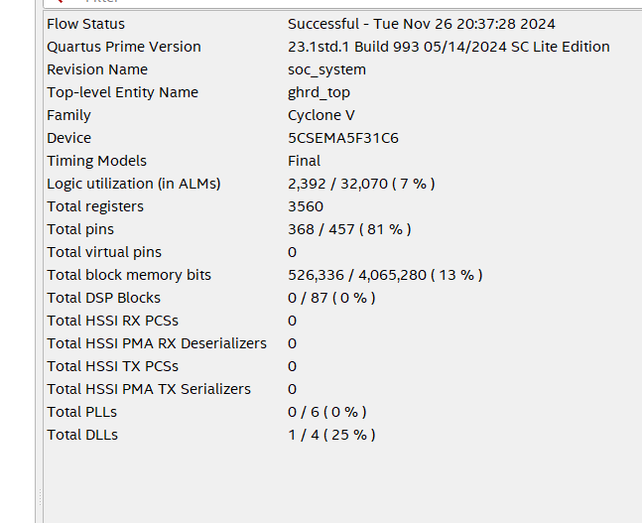
  - 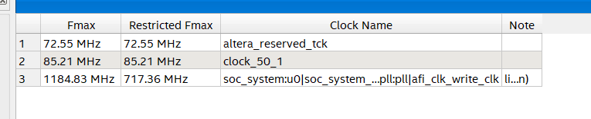
- Report the size of the compiled SW program
  - 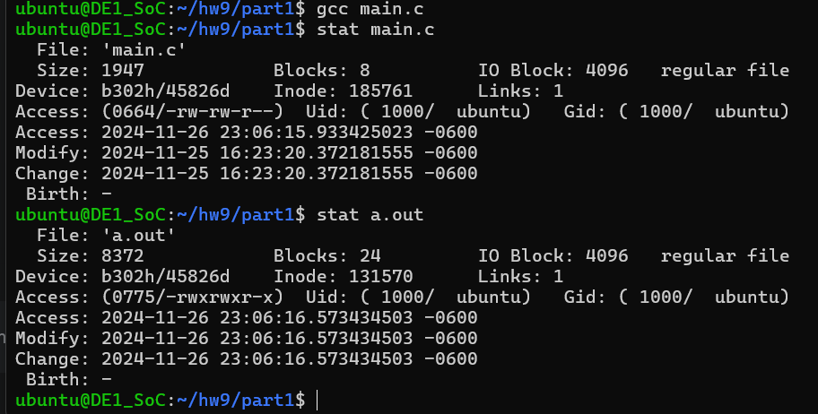
  - 8.4 kilobytes.
- A YouTube video showing that the system works.
  - https://www.youtube.com/watch?v=3dJk2sKDsrA
Marks
6
0

Part II – Modifying the HPS+FPGA System
- Modifed the system so that the 7-segment displays on the board will display a running counter generated by the HPS which counts, seconds, minutes and hours. Every 1 second until 60 seconds and then wraps around incrementing the minutes, which in turn wrap around when 60 minutes is reached by incrementing the hours by one, which in turn wrap around when 24 is reached.
Marks
12
0

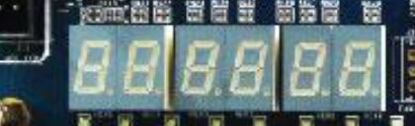
seconds minutes hours

Deliverables:
- Show that your system works by creating a small video (You do not need to wait for the hour to change).
  - https://www.youtube.com/watch?v=HHthV5GfYF0
- Report the FPGA resources used, max frequency, etc.
  - 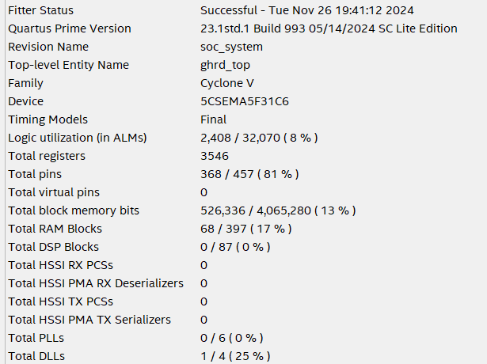
  - 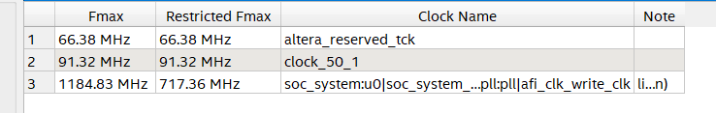
  - 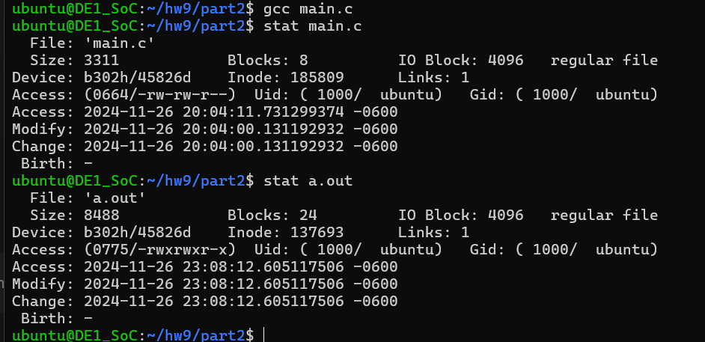
- Attach all of the project files in zipped file.

