

Networking Module Assessment 2

Author : 2503344 -Maxim Vasiliev
Course Title : BSc Computer Science
Module Convenor : Your module tutor / convenor
Date : 30/12/202

Overview

The St. Mary’s University has recently expanded and now consists of five main buildings:
• Building A: Administration, Finance, and IT
• Building B: Classrooms and Engineering Labs
• Building C: Library and Student Services
• Building D: Research Hub with HPC and IoT Labs
• Building E: Student Accommodation and Gym
And I have been asked to implement a modern, secure, and smart network infrastructure to be able to access these buildings in St Mary’s University
Modules / Functionality
To be able to implement this network I will divide the project into 5 sections to be able to tackle each building separately then being able to connect them to function as a network. Each building should be able to send packets to other devices within that building and across other buildings withing the university

Main Module or Sub-System

Building A:
Building A consists of Administration, Finance, and IT and Requires 6 PCs, 3 Laptops and a Printer.
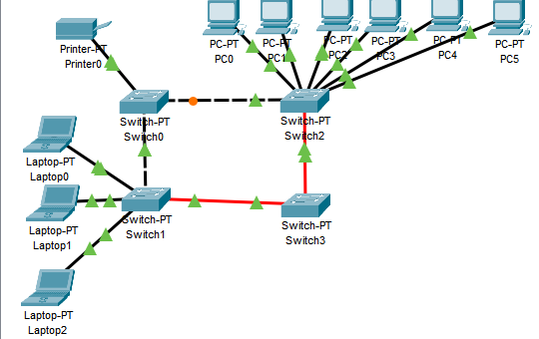
Before assigning Ip addresses for building a I designed a hybrid topology consisting of a ring topology and a star topology. This allowed for a simpler design of the network in building A to be able to understand the network and the devices it can connect to separately i.e. switch 1 is connected to laptops 0-2 and allow for connectivity to other switches which connect to sperate devices.
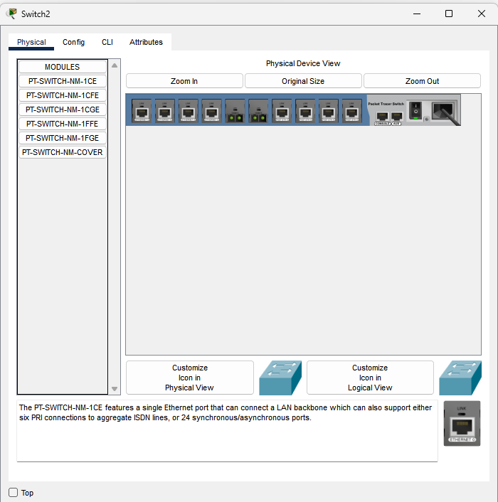
To be able to allow multiple connections through a single switch I added sufficient ports to allow for multiple connections through each switch. As through specifications I creates a subnet mask capable of allowing an additional 20+ devices for each building.
Device Name | Static IPv4 Address | Subnet Mask
PC0 | 192.168.1.111 | 255.255.255.0
PC1 | 192.168.1.112 | 255.255.255.0
PC2 | 192.168.1.113 | 255.255.255.0
PC3 | 192.168.1.114 | 255.255.255.0
PC4 | 192.168.1.115 | 255.255.255.0
PC5 | 192.168.1.116 | 255.255.255.0
Printer0 | 192.168.1.117 | 255.255.255.0
Laptop0 | 192.168.1.118 | 255.255.255.0
Laptop 1 | 192.168.1.119 | 255.255.255.0
Laptop 2 | 192.168.1.121 | 255.255.255.0
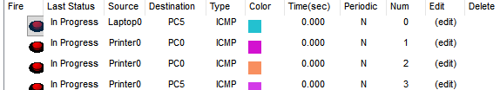
After assigning these IP addresses to these individual devices I tested the connectivity of each device to ensure packets could travel between without Errors

Building B:
Building B compromises of Classrooms and Engineering Labs and requires 6 PCs, 3 Laptops and a Printer.
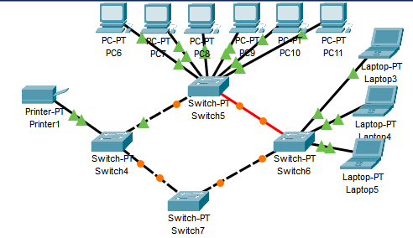
Device Name | Static IPv4 Address | Subnet Mask
PC6 | 192.168.2.111 | 255.255.255.0
PC7 | 192.168.2.112 | 255.255.255.0
PC8 | 192.168.2.113 | 255.255.255.0
PC9 | 192.168.2.114 | 255.255.255.0
PC10 | 192.168.2.115 | 255.255.255.0
PC11 | 192.168.2.116 | 255.255.255.0
Printer1 | 192.168.2.117 | 255.255.255.0
Laptop3 | 192.168.2.118 | 255.255.255.0
Laptop 4 | 192.168.2.119 | 255.255.255.0
Laptop 5 | 192.168.2.121 | 255.255.255.0

When designing the network layout for Building B I decided to use the same topologies as Building A to ensure complexity is not created between the buildings as this would allow for future devices and future implementations for example a DHCP server to be added in the future.
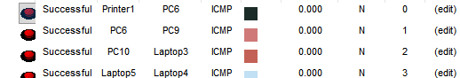
Building C:
Building C Compromises of the Library and Student Services and requires 6 PCs, 3 Laptops and a Printer
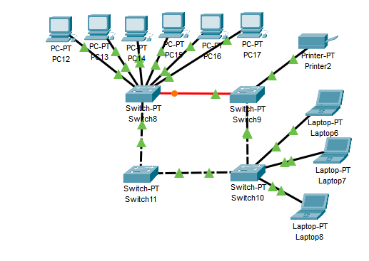
Device Name | Static IPv4 Address | Subnet Mask
PC12 | 192.168.3.111 | 255.255.255.0
PC13 | 192.168.3.112 | 255.255.255.0
PC14 | 192.168.3.113 | 255.255.255.0
PC15 | 192.168.3.114 | 255.255.255.0
PC16 | 192.168.3.115 | 255.255.255.0
PC17 | 192.168.3.116 | 255.255.255.0
Printer3 | 192.168.3.117 | 255.255.255.0
Laptop6 | 192.168.3.118 | 255.255.255.0
Laptop 7 | 192.168.3.119 | 255.255.255.0
Laptop 8 | 192.168.3.121 | 255.255.255.0

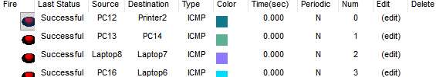
Building D:
Building D compromises of Research Hub with HPC and IoT Labs and requires 6 PCs, 3 Laptops and a Printer
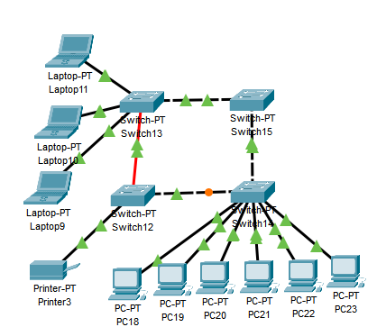
Device Name | Static IPv4 Address | Subnet Mask
PC18 | 192.168.4.111 | 255.255.255.0
PC19 | 192.168.4.112 | 255.255.255.0
PC20 | 192.168.4.113 | 255.255.255.0
PC21 | 192.168.4.114 | 255.255.255.0
PC22 | 192.168.4.115 | 255.255.255.0
PC23 | 192.168.4.116 | 255.255.255.0
Printer3 | 192.168.4.117 | 255.255.255.0
Laptop9 | 192.168.4.118 | 255.255.255.0
Laptop 10 | 192.168.4.119 | 255.255.255.0
Laptop 11 | 192.168.4.121 | 255.255.255.0
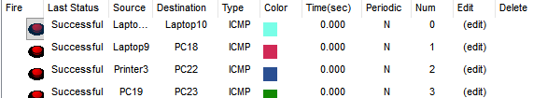
Building E:
Building E compromises of a Student Accommodation and a Gym and requires 6 PCs, 3 Laptops and a Printer
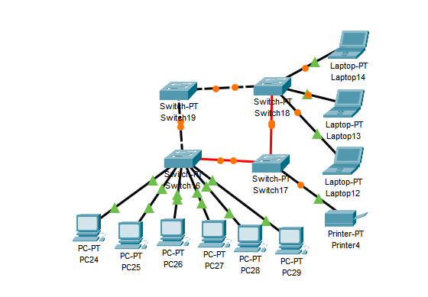
Device Name | Static IPv4 Address | Subnet Mask
PC24 | 192.168.5.111 | 255.255.255.0
PC25 | 192.168.5.112 | 255.255.255.0
PC26 | 192.168.5.113 | 255.255.255.0
PC27 | 192.168.5.114 | 255.255.255.0
PC28 | 192.168.5.115 | 255.255.255.0
PC29 | 192.168.5.116 | 255.255.255.0
Printer4 | 192.168.5.117 | 255.255.255.0
Laptop12 | 192.168.5.118 | 255.255.255.0
Laptop 13 | 192.168.5.119 | 255.255.255.0
Laptop 14 | 192.168.5.121 | 255.255.255.0
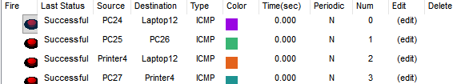
Using a new router Connection after Finishing the Networks of each building I connected Switches 3,7,11,15,19 of each building to router0 creating a star topology connecting each building.
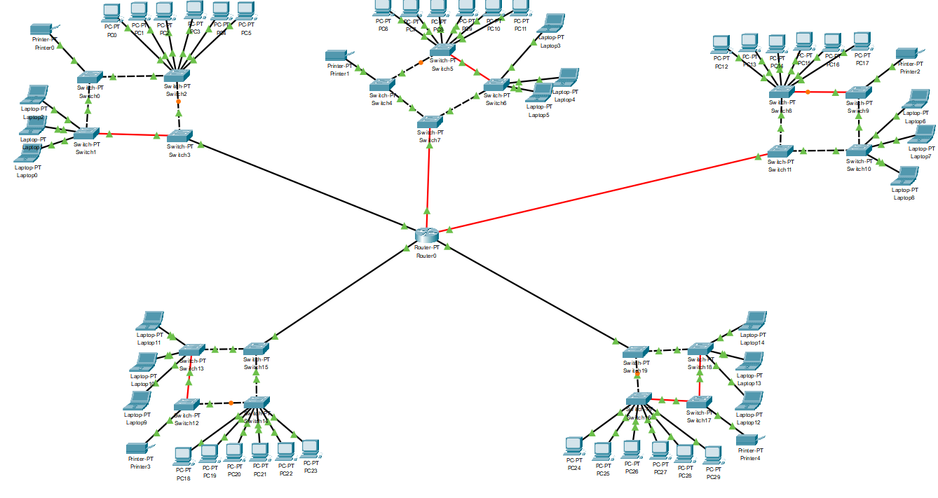
Building A was connected through switch 3 and followed the cable Fa1/0 using the default gateway of 192.168.1.1
Building B was connected through switch 7 and followed the cable Fa 4/0 using the default gateway of 192.168.2.1
Building C was connected through switch 11 and followed the cable Fa 5/0 using the default gateway of 192.168.3.1
Building D was connected through switch 15 and followed the cable Fa 0/0 using the default gateway of 192.168.4.1
Building E was connected through switch 19 and followed the cable Fa 5/0 using the default gateway of 192.168.5.1
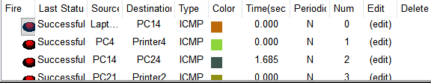
After testing I ensured that all devices could connect to each other on their respective LAN and the other devices on different building’s LAN

Other Module, Sub-System, Or Key Part
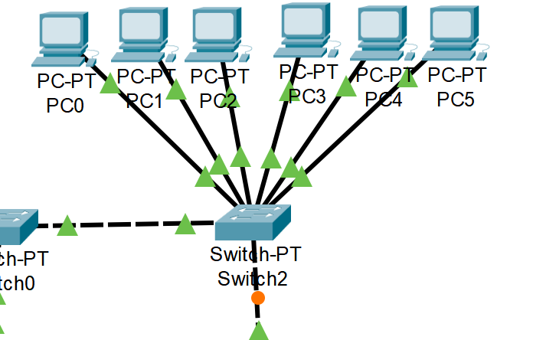
For each type of device (i.e. printer, Laptop, pc) I connected a respective switch creating a star topology as this allowed for easy management and scalability allowing of future devices to be easily added. This also allows for less better performance ad there will be less data collisions resulting in faster transmission speed of packets. However, this creates reliability on a singular cable which can result in a whole network being affected. For example, router0 and switch 7 are connected through cable fa4/0 and should this cable fail for any reason, building B will be unable to connect to any other buildings on the network. Using another topology for instance a mesh or a ring topology, building B will be able to use another path/route to connect to other devices whiles the cable is unavailable.
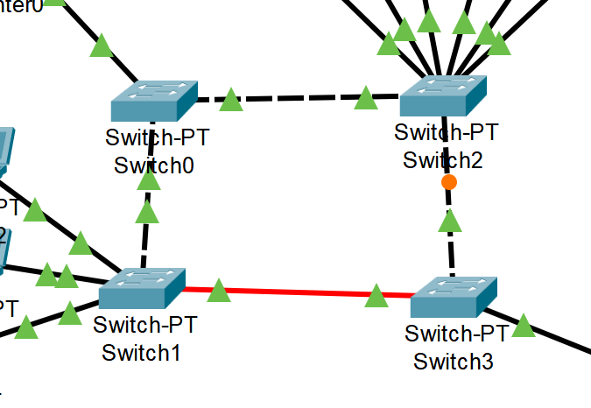
For each Building I designed a ring topology to allow the connections of different device types to allow for easier fault detection and fewer reliance on a singular cable. This can be seen here as switch 2 and 3 have trouble connecting, therefore for a packet to travel through switch 2 form switch 3 it is able to loop around using a different path from switch 1-2 to be able to send packets consistently still. This also allows for other devices to be more easily managed and allows for new devices to be implements easily for example a mobile device using a new switch.

