МИНИСТЕРСТВО НАУКИ И ВЫСШЕГО ОБРАЗОВАНИЯ  
РОССИЙСКОЙ ФЕДЕРАЦИИ

федеральное государственное автономное   
образовательное учреждение высшего образования  
«Самарский национальный исследовательский университет   
имени академика С.П. Королева»

(Самарский университет)

Институт информатики и кибернетики  
Кафедра суперкомпьютеров и общей информатики

**Отчет по лабораторной работе №5**

Дисциплина: «Методы проектирования и поддержки требований к программному обеспечению»

Вариант 14: **«Photo services»**

Тема: **«Class diagram»**

Выполнил: Неженский М.С.

Группа: 6133-010402D

Самара 2023

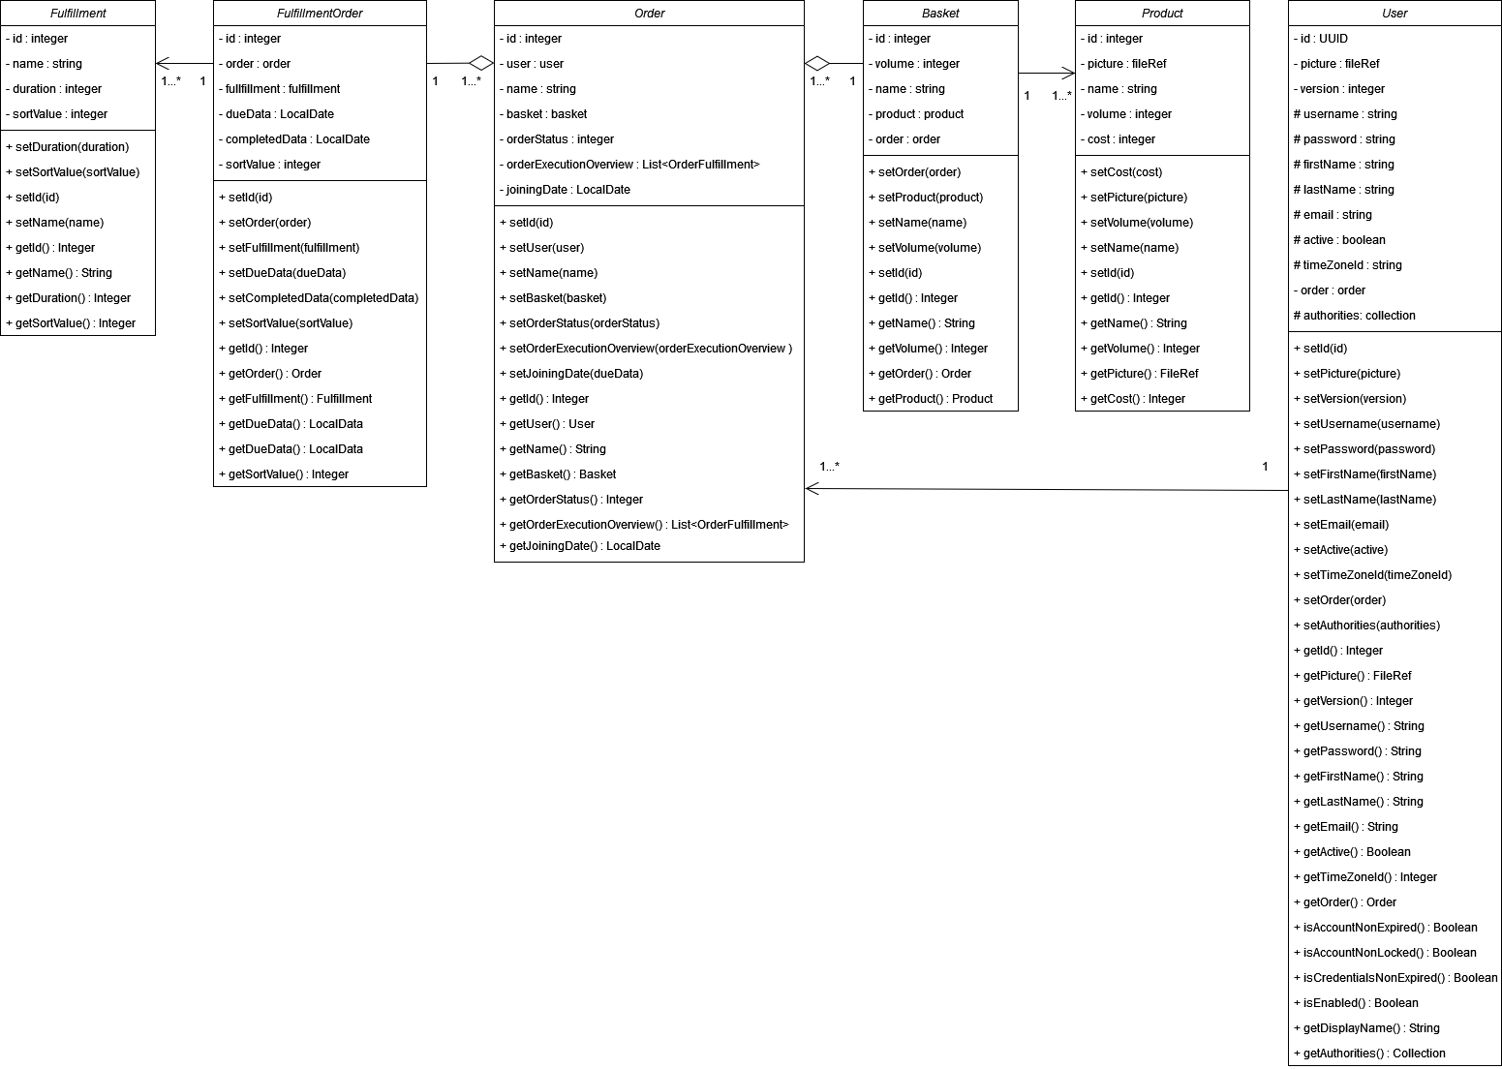

Рисунок 1 – Class diagram 1

Таблица 1- Table with comments

|  |  |  |
| --- | --- | --- |
| Class name | Attributes/Methods | Data type/Comment about method assigment |
| Fulfillment | id | int, fulfillment id |
|  | name | String, fulfillment name |
|  | duration | int, duration of the order fulfillment point |
|  | sortValue | int, attribute for sorting |
| FulfillmentOrder | id | int, fulfillmentOrder id |
|  | order | order, order type element |
|  | dueData | LocalData, approximate order completion time |
|  | completedData | LocalData, real time of order fulfillment |
|  | sortValue | int, attribute for sorting |
| Product | id | int, product id |
|  | picture | fileRef, product picture |
|  | name | String, product name |
|  | volume | int, product volume |
|  | cost | int, cost of the products |
| Basket | id | int, basket id |
|  | volume | int, basket volume |
|  | name | String, basket name |
|  | product | product, product type element |
|  | order | order, order type element |
| User | id | UUID, user id |
|  | picture | fileRef, user picture |
|  | version | int, the original attribute |
|  | username | String, user's login name |
|  | password | String, login password |
|  | firstName | String, real user name |
|  | lastName | String, the user's real last name |
|  | email | String, user's email address |
|  | active | Boolean, indicator whether the account is active |
|  | timeZoneId | String, user's time zone |
|  | order | order, order type element |
|  | authorities | collection, the authorities granted to the user |
|  | isAccountNonExpired() | Indicates whether the user's account has expired. An expired account cannot be authenticated. |
|  | isAccountNonLocked() | Indicates whether the user is locked or unlocked. A locked user cannot be authenticated. |
|  | isCredentialsNonExpired() | Indicates whether the user's credentials (password) has expired. Expired credentials prevent authent |
|  | isEnabled() | Indicates whether the user is enabled or disabled. A disabled user cannot be authenticated. |
|  | getAuthorities() | Returns the authorities granted to the user. Cannot return null. |
|  | getDisplayName() | Used to get the name |
| Order | id | int, order id |
|  | user | user, user type element |
|  | name | String, order name |
|  | basket | basket, basket type element |
|  | orderStatus | int, status order (in process, deliveredand so on) |
|  | orderExecutionOverview | List<OrderFulfillment>, enumeration of the fulfillment of delivery points(collection, delivery and so on) |
|  | joiningDate | LocalDate, date of registration |