Passmanager 2.0
Documentation

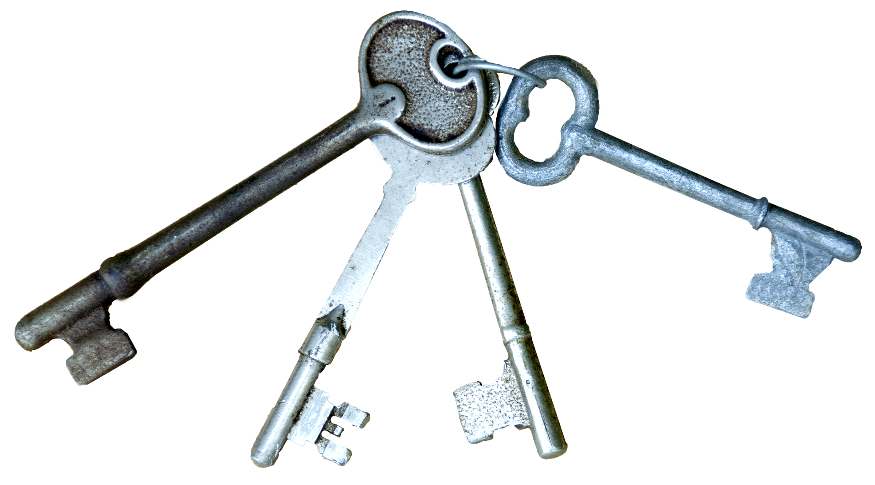


Powered by MIXvoip S.a.
Written by Christophe Laures

General
The Passmanager 2.0 is a tool to manage password via folders and tag's. There are 2 types of folders: The Private and the Shared Folder. Additionally to the folders there are the tag's. Tag's are used to control the users access to the passwords in a folder.

The Folder
As mentioned above there are 2 types of folders.

Private Folder
A private folder is a folder which can never be shared. It's intended to store your private passwords which you don't want to share. Passwords stored here are encrypted with your personal password. Passwords in this folder can also be marked as favorite. If the recovery mechanism is not enabled and you loose or forget your password your password stored here are also lost.

Shared Folder
A shared folder is a folder in which the stored passwords are shared between the user's an every user can decrypt the password by using his login password. The application doesn't allow the recovery of the passwords stored in here but it's possible as long as at least one user in the share knows his password.

The Tags
Tags are used to control the access of the user's to the Password itself. There are 2 methods how tags are evaluated: strict tagging and recursive tagging.

Strict tagging
When strict tagging is enabled the users have only access to passwords tagged with a tag witch they are subscribed to. So you have a linear access structure.

Recursive tagging
When strict tagging is disabled the users have access to all passwords tagged with a tag which they are subscribed to and to every password tagged with a child tag of the subscribed tag. So you have a hierarchical access structure.

User access levels
User have a access level which define which actions a user can do. At the moment there are only 2 access level available:
- 0: Is a simple user who can create folders and passwords. They also can change their own password
- 1: Is the administrator he can do the exact same things as normal user and additionally he has access to the Administration tab which allows him to create, edit, delete, block users. He also can create, edit and delete Tags.

Misc

Tables
The tables are sorted by the ID by default. To change the sorting of the tables simply click on the Header of the Table

Search
The search can be focused using the shortcut ctrl-y. The search also supports Regular expressions. To use the Regular expressions type in /<your regex>/g.
When you use the prefix :: (Default Value) in your search you can limit your search to the folders.

Technical

How to install
- Put all the files from the Application in the webroot of the server.
- To create the go to app/webroot/db and execute the createDatabase.sh script.
- To add the first users execute # sqlite Passmanager.db < firstUser.sql
- Now you can browse to your server and login with the user admin and the password q1w2e3!. Don't forget to change the Password once you logged in!

The Configuration
The configuration can be found in app/Config/core.php. Here you can see the version of the application and the database. You can set the minimum password-length (default: 8); activate, deactivate or edit the entries from the quick access bar.

The Cryptology
For the Cryptology the Passmanager uses the twofish algorithm from the Phpseclib. All cryptographic functions are implemented in the cryptowrapper.php for simple replacement.

