====Virtual Internship====

600 hours

**- Self-Introductory Video**

**- Search for Online Job Portal**

- Rate 20 pts, able to find 10 job portals

- Attach screenshot of registered account. Must show your name and website

**- Creating Comprehensive resume/cover letter**

- in Writing

Fresh cover letter for each job

You can use old cover letter you already have or you may use templates

Include Hiring Manager's Name

Craft an Opening Line

Go Beyond your resume

Think not what the company can do for you

Highlight the Right Experiences

Showcase your skills, sell yourself out

- rated according to originality (original design, not copy paste), format and organization (alignments), content (verified and true contents)

- References, ask the person before putting their contact details

**- Conduct 1 IT webinar/Online Training**

To prepare

Program

Invitation

Participants - Maam Mangmang, and anyone, can be classmate or else

- 20 Participants

- 50 pts, if successfully conducted IT Training.

**- Attend atleast 3 webinars online training with e-copy of certificate of participation**

- 50 pts 3 webinars

- IT related webinars Starting from October 2021

- MS Office Specialist Certificate is accepted

**- Priviledge to be accepted for an online internship job(at least 1 job)**

- Proof certificate of output acknowledgement

-- Sites/Company that accepts online internship

- Creotec Phils. - maghimo ug system

- Accenture

**- Perform the duty as Automated Contact Tracing System (ACTS) encoder**

- trace.southernleyte.org.ph

- Si maam mu create sa account, igu nalang ta change pass.

- Account type = Encoder - Individual

- QR Registration for Walk-ins - Enter info - Check duplicates - if naa, go to search QR - if wala, click register

- Search QR code for existing QR codes - search name - view QR

- Registration Approval - anhi makita pending registration - check duplicate - if none, proceed to View Docs then reject/approve - reject with reason of rejection - if theres duplicate reject and search QR - you can also edit information if there are wrong - approve if all are good

- Mag takenote sa imong activities, ensure report sa daily activity for Journal

- Login time, Approved registrants include time, rejected registrants include time, log out

**- Internship Journal Submission**

Format

- Title Page

- Approval sheet

- Acknowledgement

- Table of contents

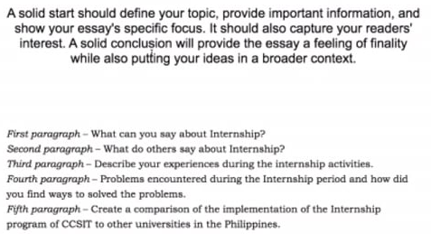 - Introduction

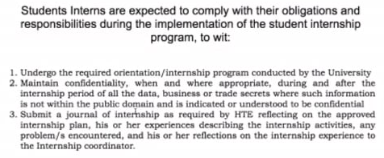 - Internship duties and activities

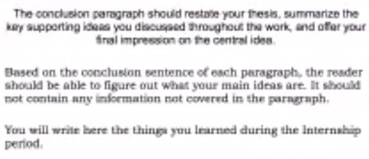 - Conclusion

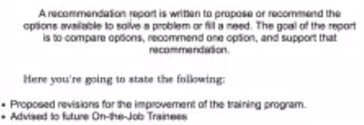 - Recommendation

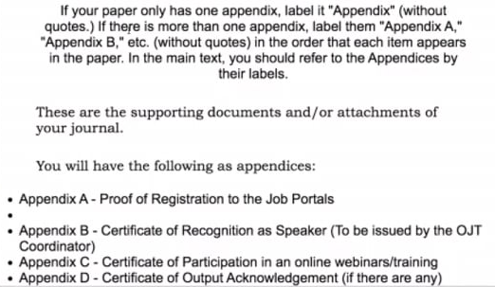 - Appendix/Appendices

- Soft bound yellow, A4, to be posted and other details

- before COC and PRC, submit Soft Bound first