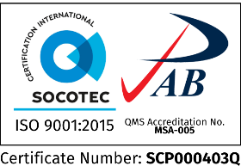Republic of the Philippines

**SOUTHERN LEYTE STATE UNIVERSITY**

Main Campus, Sogod, Southern Leyte

website: www.slsuonline.edu.ph

email: slsumaincampus@gmail.com /

op@slsuonline.edu.ph telefax: (053) 577-8299

***College Computer Studies & Information Technology***

College/Department

**INDIVIDUAL WORK FROM HOME PLAN**

|  |  |  |
| --- | --- | --- |
| **DATE** | **ACTIVITIES/PLANS** | **REMARKS** |
| December 6, 13, 2021 |  |  |
| * Conduct virtual class thru Google Meet. |  |
| * Respond, Accommodate and Cater queries and concerns of students. |  |
| * Check students’ outputs. |  |
|  |  |
|  |  |

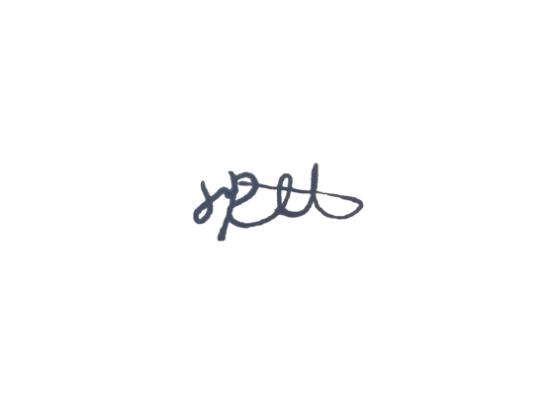

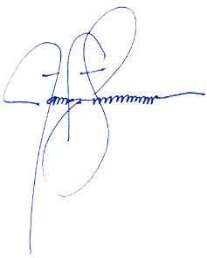Prepared by: Noted:

**JAYVON R. SATUR JAMES BRIAN FLORES, Ph. D. TM.**

Name & Signature of Faculty Name & Signature of Department Head/Dean

Approved by:

**FRANCIS ANN R. SY, PhD**

VPARI