**FIRE DETECTION SYSTEM USING**

**IMAGE PROCESSING**

A Proposal

Presented to the Faculty of the

College of Computer Studies and Information Technology,

Southern Leyte State University

In Partial Fulfillment of the Requirements

for the degree Bachelor of Science in Information Technology

By

Lindy G. Arguelles

Rodmarc L. Bautista

Lyka Mae M. Binongo

Rina Mae G. Escorro

Vanessa Tidalgo

Ms. Jannie Fleur V. Oraño

Adviser

July, 2021

Republic of the Philippines

**SOUTHERN LEYTE STATE UNIVERSITY**

Sogod, Southern Leyte

Website: [www.slsuonline.edu.ph](http://www.slsuonline.edu.ph/)

Email: [slsumaincampus@gmail.com](mailto:slsumaincampus@gmail.com)

[op@slsuonline.edu.ph](mailto:op@slsuonline.edu.ph)

Telefax No. (053) 382-3294

***College of Computer Studies and Information Technology***

## **APPROVAL SHEET**

The Capstone Project Study entitled **Fire Detection System Using Image Processing** prepared and submitted by Arguelles, Bautista, Binongo, Escorro and Tidalgo has been examined and is recommended for approval and acceptance.

RECOMMENDED:

JANNIE FLEUR V. ORAÑO FRANCIS REY PADAO

Adviser ITSO Manager Research Facilitator

=====================================================================

APPROVED by the Committee on Oral Examination with a grade of PASSED on _________ _

ALEX C. BACALLA

Chairman

GERALDINE MANGMANG JAMES BRIAN FLORES

Member Member

=====================================================================

ACCEPTED and APPROVED in partial fulfillment of the requirements in Bachelor of Science in Information Technology.

_____________________________________

Dean, CCSIT

Date: ___________________

**DEDICATON**

Above all, this study is dedicated to our Almighty God for giving us guidance, motivations

and strengths in doing this whole project.

To the Instructors, who guided and prepared us to reach our dreams in the future.

To our parents and relatives, who gave us all the support and helped us in our struggles and

also gave us inspiration in all the good times and bad times.

To the members of this team, who never falter to push through all the challenges that we

have encountered in this college life.

To our Capstone Adviser, who gave her time available just to guide us, teach us and give

us motivation to continue doing this study.

And lastly to our Alma Mater, Southern Leyte State University that sheltered and molded

us to become a person that we are today.

**ACKNOWLEDGEMENT**

This study will not be made possible without the help and guidance of all the persons

behind the proponents back. The proponents wanted to give their sincere gratitude to all of them.

To the very kind and humble Capstone Adviser, Ms. Jannie Fleur V. Oraño who patiently

supported, share her ideas and eagerly taught us everything based on her mastery that we can apply

in our study.

To the Capstone Instructor for always giving us motivation to do the study and patiently

following up for our progress of our study.

And to the friends and classmates who stayed with us day and night easing up our troubles

and problems in doing the study

**TABLE OF CONTENTS**

**Content Page No.**

Title Page 1

Approval Sheet 2

Dedication 3

Acknowledgement 4

Table of Contents 5

List of Figures 7

List of Tables 8

**Chapter I – INTRODUCTION**

1.1 Project Context 9

1.2 Purpose and Description of the Project 9

1.3 Objectives of the Project 10

1.4 Scope and Limitations of the Project 10

**Chapter II – REVIEW OF RELATED LITERATURE**

2.1 Related Literature/ Theoretical Background 11

2.2 Related Studies 12

**Chapter III – TECHNICAL BACKGROUND**

3.1 Technicality of the Project 13

3.2 Details of the Technologies to be Used 14

3.3 How the Project Will Work 15

**Chapter IV – METHODOLOGY**

4.1 Requirements Specification 16

4.1.1 Operational Feasibility 16

Fishbone Diagram 16

Functional Decomposition Diagram 17

4.1.2 Technical Feasibility 18

Compatibility Checking 18

Relevance of the Technologies 18

4.1.3 Schedule Feasibility 18

4.1.3 Economic Feasibility 19

Cost and Benefit Analysis 19

Cost Recovery Scheme 19

4.1.4 Requirements Modeling 20

Object Modeling 20

4.1.5 Risk Assessment/Analysis

4.2 Design

4.2.1 Output and User-Interface Design

4.2.2 Data Design

4.2.3 System Architecture

4.3 Development

4.3.1 Software Specification

4.3.2 Hardware Specification

4.3.3 Program Specification

4.3.4 Programming Environment

4.3.5 Deployment Diagram

4.3.6 Test Plan

4.4 Testing

4.4.1 Unit Testing

4.4.2 Integration Testing

4.4.3 System Testing

4.4.4 Acceptance Testing

**References**

**LIST OF FIGURES**

Figure 1 Fishbone Diagram

Figure 2 Fishbone Diagram

Figure 3 Fishbone Diagram

Figure 4 Functional Decomposition Diagram

Figure 5 Gantt Chart

Figure 6 Requirements Modeling

Figure 7 Use Case Diagram

Figure 8 Sequence Diagram

Figure 9 Activity Diagram

**LIST OF TABLES**

Table 1 Cost Benefit Analysis

Table 2 Cost Recovery Scheme

**Chapter 1**

**INTRODUCTION**

* 1. **Project Context**

Fire is one of the unwanted and sometimes uncontrolled events. Because of its nature which endangers and disrupts people’s lives, fire is categorized as a form of disaster. Fires generally occur due to short-circuiting of electrical wires/devices, leakage on LPG gas cylinder ducts, or due to human negligence itself such as forgetting to turn off the stove fire, burning garbage, or cigarette butts. So to control fire, various system is developed and being developed.

Fire detection systems are among the most important components in surveillance systems used to monitor buildings and the environment. As part of a early warning mechanism, it is preferable that the system has the capacity to report the earliest stage of a fire. Due to rapid developments in digital camera technology and video processing techniques, there is a major trend to replace conventional fire detection methods with computer vision based systems. Computer vision-based fire detection systems employ three major stages: fire pixel classification, moving object segmentation, and analysis of the candidate regions.

Fire Detection Systems in most of our localities is quite limited only to essential buildings like the municipal hall. Other buildings do not even bother to have fire systems and rely only to the Authorities in case of fire. Most system being utilized is the traditional way which incorporates the sensors in the detection of fire. Now using this method is inefficient nowadays in terms of detection. Detecting fires using sensors can trigger false alarms from intentional use of fire and cost too much as to why most buildings don’t have fire detection systems.

The Bureau of Fire Protection (BFP) is the one responsible for ensuring public safety through prevention and/or suppression of all destructive fires on buildings and other structures. They have risked their lives to protect us from these incidents. But there are certain times where the BFPs are late in responding in such crisis, one reason is that the reports are sometimes delayed which also affects their service. This is where the proposed system comes useful, Fire detection using image processing can only not detect fire but can also authorities the fire incident when the moment the system detects a fire.

This will greatly improve the response time of the authorities and therefore lessen the casualties in case fire incident happens.

Fire detection using image processing has the potential to be useful in conditions in which conventional methods cannot be adopted. The application of fire detections as tool has increase to due to the frequent occurrence of extended fire with consequences on human health and security.

* 1. **Purpose and Description of the Project**

The purpose of this study is the develop a system capable of detecting fire incidents through the use of image processing which will help authorities to be respond in time in case of a fire incident. The system also aims to provide fire detection system which are inexpensive and efficient to the community.

* 1. **Objective of the Project**

The objective of the study is to able to produce a system which helps to detect the fire and analyzing certain points in the image using image processing techniques. By doing so, this will help build better Image processing system where the fire can be detected. The following are the sub objectives in doing the project:

* To take a certain feature in the fire detection using image processing techniques.
* To able to implement fire detection deep learning method.
* To measure the accuracy of the fire detection system.
  1. **Scope and Limitations of the Project**

In current set of studies, we aim to address this issue by creating a system that can predict the fire detection using image processing. This study is focused only to areas where there is fire such buildings and facilities. These fire detection systems still require human intelligence to distinguish between real fires and false alarms. This project will be focusing of fire detection using image processing which is to focus only for capable of detection fire outbreaks which would ignore other types of incident such as robbery or other types of disaster.

**CHAPTER II**

**REVIEW OF RELATED LITERATURE**

**2.1 Related Literature/ Theoretical Background**

The advantages of fire detection technology based on the video image can be summarized as the following points: first, detection techniques are very intuitive. Second, due to the speed of light transmission and induction is far higher than the smoke and temperature, such fire detection with high real-time has no delay caused by induction time. Third, the remote surveillance cameras can be adjusted freely and not to be confined to the indoor and outdoor space. So its detection range is larger other methods. Fourth, the image can save more scene information through color and texture, which promotes the diversification of the fire detection method greatly. Fifth, it is convenient for people to verify, record or query the fire with the saved video monitor screen, so this technology has a higher reliability and real-time performance (Li et al., 2013).

In many ways, flame detection is used to provide fast response to growing fires and activation of suppression and safety shut-down systems. Video image flame detectors represent a relatively new technology that has been gaining popularity and using in many applications. The color feature of the flame can be used as a basis for fire detection. (Soe et al., 2011) used the static image characteristics of the light blue flame to detect fires. The image is grabbed in the memory and fire-suspected regions are defined by using the region of interest (ROI) technique. Since the conventional smoke-based fire detectors tend to exhibit high false alarm behavior, Wirth, (M, 2010) explored a simple algorithm for flame detection based on the use of a modified histogram back projection algorithm in YCbCr color space.

(Ti Nguyen et al., 2013) developed a method that extract colour and motion from video sequences to detect fire. The results of this paper was able to produce a method which has the ability to perform the region growing segmentation to identify colour pixels in the scene and then identify fire region. The methodology used are YCBCR colour space model and region growing technique which compares all unallocated neighbouring pixels to the region.

(Govil et al., 2020) proposed a smoke detection system based on machine-learning-based image recognition software and a cloud-based workflow that is capable of scanning hundreds of cameras every minute. The authors further plan to leverage the other existing fire detection algorithms and combine their information with the information obtained from the author’s camera-based detection system to provide a robust and faster and combined system.

**2.2 Related Studies**

Liu et al. (2004) investigated three different models, including spectral, spatial, and temporal, for fire regions in images. However, their method is based on an assumption considering the irregular shape of fire, which is not always the case as moving objects can also change their shape.

Turgey Celik et al. (2009) proposed a generic color model to segment the flame pixel from the background using YCbCr color model. This method segments the flame region except the flame centre. But this method classifies fire pixels only based on color information.

To improve the rate of detection (Torabnezhad et al., 2013), vision-based smoke detection is proposed. In this approach, both vision- and thermal-based information are taken into account in order to improve its efficiency in estimating the smoke detection when compared with other detection approaches.

Celik et al. (2007) proposed a novel model for detection of fire and smoke detection using image processing approach. For fire detection the proposed method uses RGB and YCbCr color space. Few rules are identified to fire pixels, and then given to a Fuzzy Inference System (FIS). A rule table is formed depending on the probability value the pixel is considered to be fire. They report to have 99% accuracy but, this cannot be used for real time monitoring. In case of smoke detection, they have given some threshold values but, this method may fail because the texture of smoke varies depending on the materials which are burned.

In Ollero et al. (2015) a scheme of multi-sensorial integrated systems for early detection of forest fires has been presented. The system presented by the authors employs infrared images, visual images, data from sensors, maps and models in their system. According to their study, to facilitate the reduction of perception errors and the improvement in reliability of the detection process, the integration of sensors, terrain knowledge and expertise is necessary.

A metric based on binary contour difference images is also introduced to measure the degree of burning of fire into classes, such as ‘no fire,’ ‘small,’ ‘medium,’ and ‘big’ fires. They report a 96.94% detection rate including false positives and false negatives for their algorithms. However, there is no attempt to reduce the false positives and false negatives by changing their threshold values. Horng et al. (2005).

Frizzi et al. (2016) proposed a CNN method for detecting fires in video. Tested on real video sequences, the proposed method achieves better classification performance than other related traditional video forest fire detection methods.

Fu et al. (2016) designed different network models to identify the forest fire image in the case of different forest fire backgrounds at night and during the day, and mainly analyze the performance of the network under different parameters. The experimental results show that the CNN-based forest fire flame recognition method has prominent advantages compared with the traditional image processing-based flame detection method.

**Chapter III**

**TECHNICAL BACKGROUND**

**3.1 Technicality of the Project**

The project will be a computer-based software that is intended for detecting fires using image processing method. The program will be using video/image frames acquired through a video acquisition device in detecting fires in the area. The program will be helpful in avoiding false alarms and help secure fire hazard areas using vision-based fire detection algorithm.

**DATA COLLECTION IMPLEMENTATION APPLICATION**

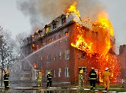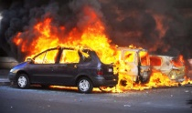

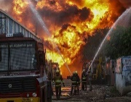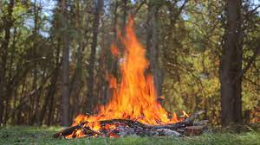

Training Set

CNN Training Model

Dataset of Fire

Images

Split

Data

Hyperparameter

Tuning

Output:

* Classify Fire Incident Images

Validation Set



Validation Results

Testing Set



Trained Model

Classification of fire evaluation

Figure 1. Architecture Design

The figure shows the overall concept of how the system will function. There are three phases for the completion of the system, which are data collection, implementation and application. In data collection process, the proponents are tasked to gather different kinds of fire related incident images which will then establish the dataset to be trained in the system.

The implementation process is divided into three parts, training, validation and testing. During the training, a training set of fire images is taken from the dataset to the train the CNN model and validation set for model validation. In testing, the trained model is used in the system in classifying fire incident images. The application is where the program is utilized in real life scenarios for evaluating the program.

**3.2 Details of the Technologies to be Used**

The following are the tools used in developing the project:

* **Pycharm -**  is an integrated development environment (IDE) used in computer programming, specifically for the Python language.
* **OpenCV -** is a huge open-source library for computer vision, machine learning, and image processing. OpenCV supports a wide variety of programming languages like Python, C++, Java, etc. It can process images and videos to identify objects, faces, or even the handwriting of a human.
* **NumPy** - contains a multi-dimensional array and matrix data structures which is utilized to perform a number of mathematical operations on arrays such as trigonometric, statistical, and algebraic routines.
* **Os -** The OS module in Python provides functions for interacting with the operating system.
* **Tensorflow** – a backend framework for running Keras.
* **PyQt5** – Python bindings for the Qt GUI Framework.
* **Keras** - Keras is an open-source neural network library written in Python. Designed to enable fast experimentation with deep neural networks, it focuses on being user-friendly, modular, and extensible.
* **Matlplotlib** - A plotting library for the Python programming language and its numerical mathematics extension.

**3.3 How the project will Work**

The program will take video/Image frames from a video acquisition device and then analyze the video using image processing algorithms.

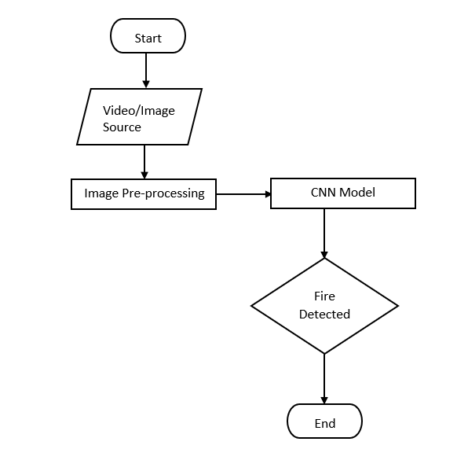

Figure 2. Flowchart

The figure is an overview of how the system will run from start to end. First the system will require an image/video acquisition device as an input to the program. Then the system will segment the image to partition the image into multiple parts base from characteristics of the pixels in the image input. After that, CNN model will be used to detect fire from the image and then evaluate whether a fire is present in the image or not. If the system detects a fire, the system will authorities such as BFP and to its designated personnel.

**Chapter IV**

**METHODOLOGY**

**4.1 Requirements Specifications**

**4.1.1 Operational Feasibility**

***Fishbone Diagram***

Faulty wiring

Cooking equipment

Pots and pans can overheat and cause a fire very easily if the person cooking gets distracted and leaves cooking unattended.

Homes with inadequate wiring can cause fires from electrical hazards.

Caused Fire Outbreak

flammable liquids can give off enough vapor to form burnable mixtures with air. As a result, they can be a serious fire hazard.

Lack of operational readiness of fire-fighting equipment, a centralized chain of command, gaps in training and familiarization of crew are some of the matters that can contribute to delayed response times in actual fire incidents.

Delayed Response

Flammable Liquids

Figure 3. Fishbone Diagram

This diagram is showing the causes and effect on why Fire Outbreaks occurs in certain places.

***Functional Decomposition Diagram***

FIRE DETECTION SYSTEM USING

IMAGE PROCESSING

Identify Fire Incident

Training Model

Video/Image Source

CNN Algorithm

CNN Model

Figure 4. Functional Decomposition Diagram

Function Decomposition diagram contains the whole function or project along with all of the necessary sub-tasks needed to complete it.

Video/Image acquisition is the part where the proponents acquire images or footage of fire incidents for the program to use. In training the model, the system uses CNN algorithm which helps segment and extract features from the video/Image source. The trained model is then used by the system to be able to identify fire incident using image processing.

**4.1.2 Technical Feasibility**

***Compatibility Checking (hardware/software)***

The software needed in this system are all computer-based applications which requires a Microsoft OS such as windows 7, 8, and 10 versions. The software can be executable as long as the computer has power since it is built as an offline system and will run as long as the computer has all the software dependencies of the program installed.

***Relevance of Technologies***

A computer is the main technology needed for the system to function or be implemented in this project. Since the program is a computer-based application, all operations are mostly executed in the computer. A smartphone is also required for the program to provide video/image frames to the system to work out.

**4.1.3 Schedule Feasibility**



Figure 5. Gantt Chart

The graph shows the timeline and the progress of the tasks to be done by the proponents of this project.

**4.1.4 Economic Feasibility**

***Cost and Benefit Analysis***

|  |  |
| --- | --- |
| **EXPENSES** | **AMOUNT** |
| Internet Expenses |  |
| Paper and Photocopy Expenses |  |
| Transportation |  |
| Miscellaneous Expenses |  |
| Total |  |

Table 1. Cost and Benefit Analysis

This table reflects the list of expenses or cost incurred in order to sustain the creation of the project

***Cost Recovery Scheme***

|  |  |  |  |  |  |
| --- | --- | --- | --- | --- | --- |
| **EXPENSES** |  |  |  |  |  |
| Internet Expenses |  |  |  |  |  |
| Paper and Photocopy Expenses |  |  |  |  |  |
| Transportation |  |  |  |  |  |
| Miscellaneous Expenses |  |  |  |  |  |
| Total |  |  |  |  |  |

Table 2. Cost Recovery Scheme

This table reflects the division of expenses in order to gradually pay the cost incurred upon the creation of the project.

**4.1.5 Requirements Modeling**

**PROCESS:** takes video frames from security cameras then analyze the video by frames if it has fires or in a fiery state and then the system will make an alarm and notify its personnel.

**PERFORMANCE:**  Detect Fire Outbreaks (static image or video)

**INPUT:** Video frames from

Video acquisition devices

**OUTPUT:** Notify Authorities and send location in case of fire outbreak

Figure 6. Requirements Modeling

***Object Modeling***



System

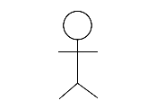

Admin

Figure 7. Use Case Diagram

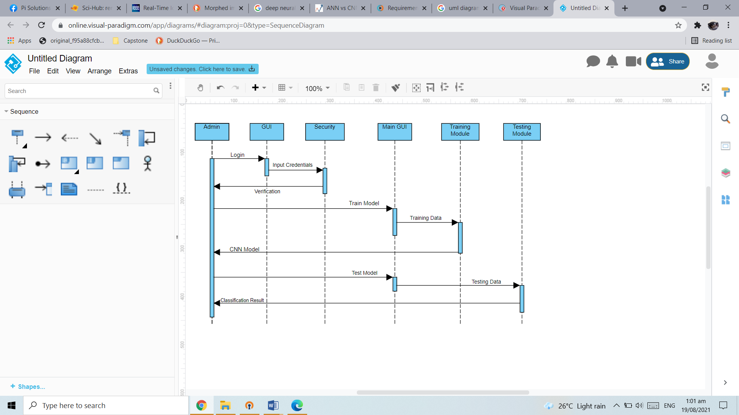

Figure 8. Sequence Diagram

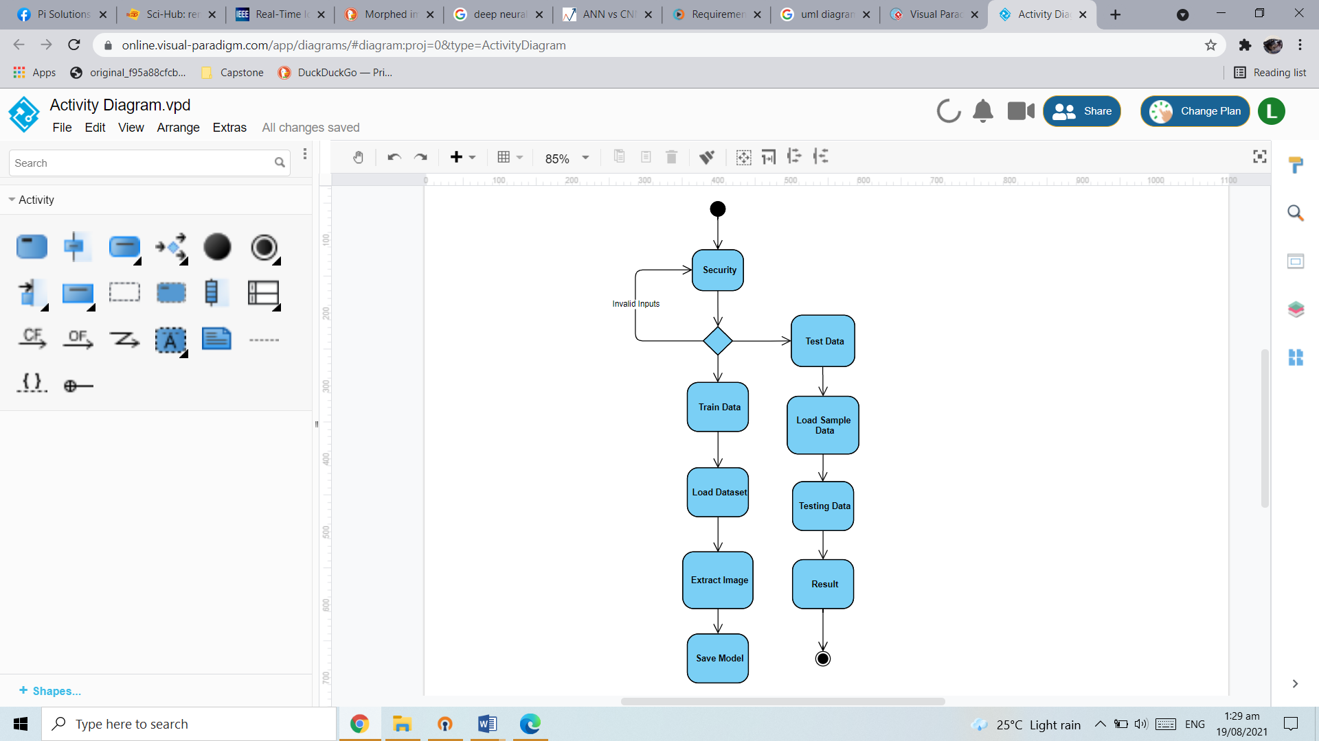

Figure 9. Activity Diagram