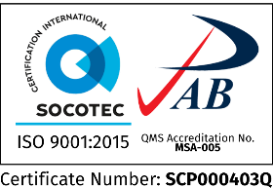Republic of the Philippines

**SOUTHERN LEYTE STATE UNIVERSITY**

Main Campus, Sogod, Southern Leyte

website: www.slsuonline.edu.ph

email: slsumaincampus@gmail.com /

op@slsuonline.edu.ph telefax: (053) 577-8299

***College Computer Studies & Information Technology***

College/Department

**ACCOMPLISHMENT REPORT**

|  |  |  |
| --- | --- | --- |
| **DATE** | **ACTIVITIES/PLANS** | **REMARKS** |
| February 1-15, 2022 | Informed the students and post the learning materials in google class | Done |
| Posted the assessment for Module 1 and Module 2 in google class | Done |
| Attended webinar (Security Skills Enablement) | Done |
|  |  |
|  |  |

Prepared by: Noted:

**JUNE VIC W. CADAYONA JAMES BRIAN FLORES, Ph. D. TM.**

Name & Signature of Faculty Name & Signature of Department Head/Dean

Approved by:

**ANNABELLE M. HUFALAR, EdD**

VPARI

Webinar/s Attended this month

