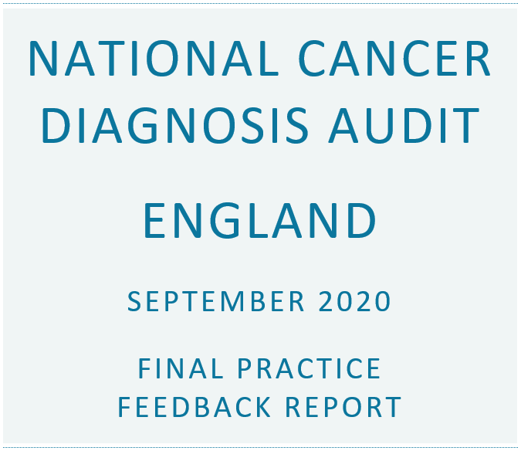

Results for:
- Practice: Woodbrook Medical Centre
- Practice code: C82070
- Cancer Alliance: East Midlands
- Final completion level: 98.1% of eligible cases

Introduction

What is included in the report
This report summarises data submitted to the National Cancer Diagnosis Audit (NCDA) on patients diagnosed with cancer in 2018. Comparators are included for a group of similar practices, Cancer Alliance and the England national data. Please see the glossary for more information on the groupings of the similar practices and other terms. This report is being provided to this practice only and will not be circulated further.

How to use the information
These results provide comparative information for benchmarking and reviewing variations at practice level. They are intended to help practices think about their clinical practice and service delivery in cancer and, in particular, early diagnosis. They are not for the purpose of performance management and there are no 'right or wrong' answers.
At the end of the report the chapter: What to do next outlines follow-up actions you may wish to take and sets out criteria and standards that can help guide review of your audit findings and QI planning.

Caveats
- Results should be interpreted with caution where the number of patients per practice (or per cancer type) is low, as the results may be due to chance alone.
- Although it was not compulsory for practices to submit data on patients who had a screen detected cancer, these data have been included in this report.
- Please note that not all completed data are shown in this report, e.g. symptoms and free text comments, as they would not be meaningful at practice level. However, they will be used in the national analysis.

Further support
You can request a PowerPoint template to help you summarise and present these results from NCDA@cancer.org.uk. Support from Cancer Research UK’s Facilitators and Macmillan GPs is also available. They can discuss your results with you and can provide additional resources. Find out who your local facilitator is at www.cruk.org/facilitators and who your local Macmillan GP is by emailing macdocs@macmillan.org.uk.

In Partnership with:

Summary of results
This summary provides an overview of the data for your practice completed for the NCDA up to September 2020. You can use the summary to identify sections in the report you would like to review in detail.
This is the final report for Woodbrook Medical Centre, based on 51 completed audit cases for patients diagnosed in 2018. A total of 64600 audits were completed by practices taking part in the NCDA in England.
Please follow the links to the individual results sections, the ‘What to do next’ chapter and glossary for more information on your practice’s results:
Cancer type |  |  | Multiple consultations |  | Primary care interval |  | Demographics
Cancer stage |  |  | Investigations |  | Diagnostic interval |  | What to do next
Place of presentation |  |  | Referrals |  | Safety netting
Consultations |  |  | Emergency referral routes |  | Avoidable delays

Demographics summary
The demographics for the patients (for whom data were completed) from this practice are shown below.
Demographic | This practice | England
Male / female | 51.0% / 49.0% | 51.7% / 48.3%
Median age | 73 years | 70 years
White ethnicity | 90.2% | 86.4%

Cancer type summary
The table below shows the number and percentage of records where data were entered for the top four most common cancers.
Cancer type | This practice % (n) | England % (n)
Breast | 27.5% (14) | 15.3% (9863)
Colorectal | 15.7% (8) | 10.9% (7056)
Lung | 15.7% (8) | 12.6% (8138)
Prostate | 7.8% (4) | 15.2% (9850)

Place of presentation summary
The most common place where the patient first presented with symptoms, ultimately considered by the GP to be related to the cancer diagnosis, was the GP Surgery for 66.0% of patients in the England national data, compared to 56.9% of patients at this practice.
The proportion of patients who first presented at Accident and Emergency with symptoms related to the cancer diagnosis was 7.4% of patients in the national data for England and 7.8% of patients at this practice.

Consultations summary
The proportion of patients who had fewer than 3 consultations before referral was 71.5% of patients in the national data for England and 82.4% at this practice.
The median and interquartile range for the number of consultations, prior to referral by any route, was:
- Woodbrook Medical Centre: 1 consultation (min: 0, interquartile range: 1 - 2)
- England: 1 consultation (min: 0, interquartile range: 1 - 2)
In the England national data, the most common reason for multiple consultations was 'Complexity of presentation' for 53.5% of patients. Compared to 46.2% at this practice.

Investigations summary
The proportion of patients in the national data for England who had at least one primary care led investigation prior to referral was 46.5% and 35.3% of patients at this practice.
Of investigations ordered, the most commonly used investigation in the England national data was a blood test for 59.4%. The same test was ordered for 63.2% of investigations at this practice.

Referrals summary
The most common route of referral for patients in the national data for England was TWW for 54.9% of patients, and 52.9% of patients at this practice. There were 13.4% of patients nationally who had an emergency referral. At this practice, 23.5% of patients were referred as an emergency.

Interval summary
The median primary care interval (time from first presentation of symptoms to referral by any route) was:
- Woodbrook Medical Centre: 1 day
- England: 2 days
The median diagnostic interval (time from first presentation of symptoms to diagnosis) was:
- Woodbrook Medical Centre: 16 days
- England: 35 days

Safety netting summary
In the national data for England, the proportion of cases where a safety netting procedure was recorded was 33.9%. At this practice, the proportion was 19.6%.

Avoidable delays summary
In the national data for England, 23.5% of patients were considered by the GP to have had an avoidable delay to their diagnosis. Compared to 27.5% of patients at this practice.

Results Section
The following results section shows more information than given in the above summary on the data submitted to the NCDA for patients diagnosed with cancer in 2018. Results from a group of similar practices, the East Midlands Cancer Alliance and the England national data are provided for benchmarking. The group of similar practices is determined by grouping practices based on ethnicity, deprivation level, age structure, practice size and whether the practice is rural/urban. Please see the glossary for more information on this and other terms.

Cancer Type
The figure below shows the proportion of patients by cancer type, as recorded by Public Health England's National Disease Registration. According to the data completed at Woodbrook Medical Centre, breast cancer was the most common diagnosis (27.5% of diagnoses audited at this practice), compared to 15.3% in the England national data. To compare these data to the cancer incidence figures for England overall and by Cancer Alliance for 2018, please see: www.cancerdata.nhs.uk/incidence/base_numbers
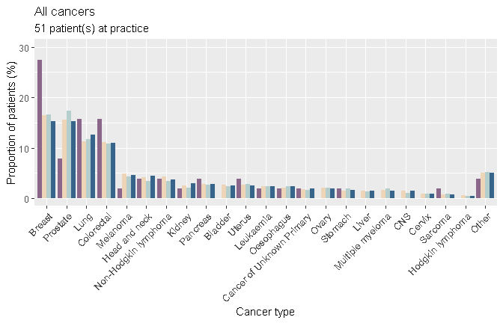
Note
CNS: Central Nervous System (including brain)

The following graphs show the same data as above but focus in on the four most common cancer types. Please interpret these results with caution where there are small numbers at practice level.

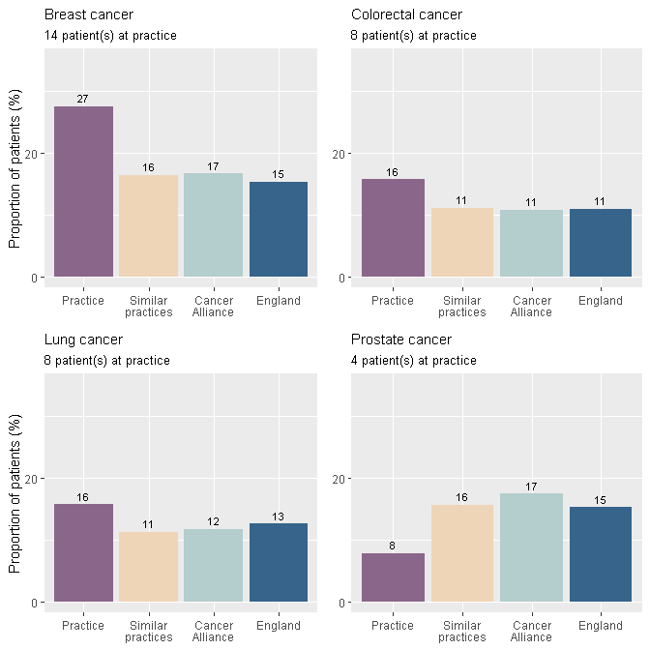
Note
'Similar practices' is a group of equivalent practices that can be used as a comparison to the practice. The similar practice group is determined by grouping practices based on ethnicity, deprivation level, age structure, practice size and whether the practice is rural/urban (please see glossary for more information).

Cancer Stage
The cancer stage at diagnosis, as recorded by Public Health England's National Disease Registration, is shown here. To give more meaningful information due to low numbers, the cancer stages have been combined into 'early' (stages 0/1/2) and 'late' (stage 3/4) (there are a small number of malignant breast cancers that are recorded as stage 0).
At this practice, 49.0% of patients were diagnosed with early stage cancer and 35.3% were diagnosed with late stage cancer. In the England national data, 44.7% of patients were diagnosed with early stage cancer and 37.2% were diagnosed with late stage cancer.

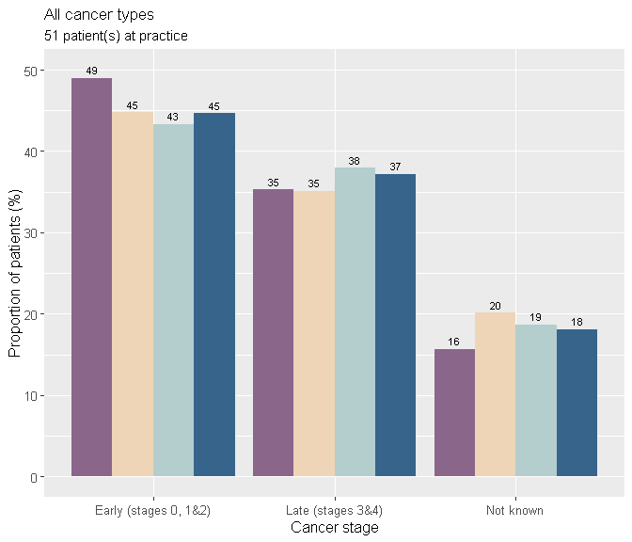

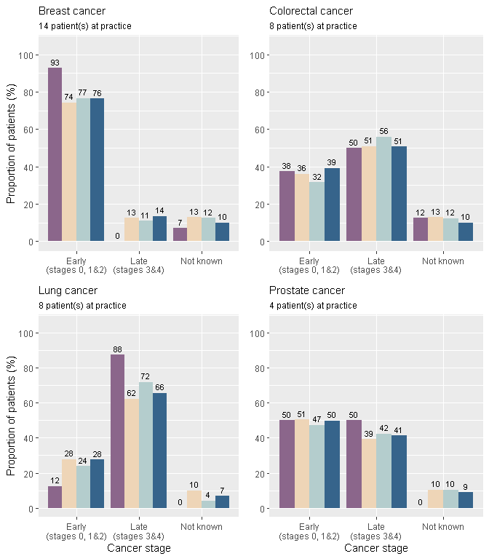

Place of presentation
The following data shows information on the place where the patient first presented with symptoms, ultimately considered by the GP to be related to the cancer diagnosis.
The most common place where the patient first presented was the GP Surgery for 66.0% of patients in the England national data. The proportion of patients who first presented in this way at Woodbrook Medical Centre was 56.9%.
Cases that first presented at A&E have been included as presenting at 'A&E' here. Please note this figure may differ from patients ultimately diagnosed via emergency routes, as patients who first present at A&E are then not necessarily diagnosed via an emergency route, and as patients who first present elsewhere may, ultimately, still get diagnosed through an emergency route.
The following figure shows where patients first presented with symptoms for all cancer types.
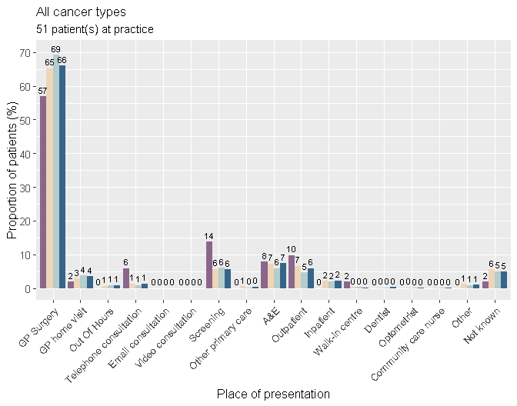

The following graphs show the place of first presentation by the four most common cancer types.

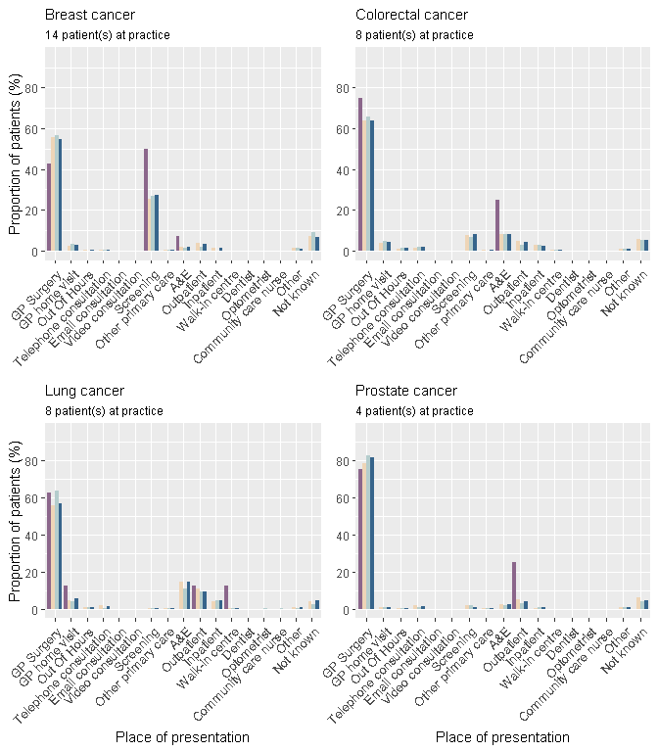

Consultations
The results show the number of consultations for cancer-related symptoms in the year before the referral that led to the cancer diagnosis. This number includes the consultation that led directly to the referral. The definition of a consultation includes email, telephone, nurse practitioner and nurse consultations, in any clinical setting.
The median and interquartile range for the number of consultations, prior to referral by any route, was:
- Woodbrook Medical Centre: 1 consultation (min: 0, interquartile range: 1 - 2)
- Similar practice group: 1 consultation (min: 0, interquartile range: 1 - 2)
- East Midlands Cancer Alliance: 1 consultation (min: 0, interquartile range: 1 - 2)
- England: 1 consultation (min: 0, interquartile range: 1 - 2)
The proportion of patients who had fewer than 3 consultations prior to referral was:
- Woodbrook Medical Centre: 82.4%
- Similar practice group: 72.1%
- East Midlands Cancer Alliance: 68.8%
- England: 71.5%
The consultation numbers have been grouped into 'fewer than 3' and '3 or more consultations'. The graphs below show the proportion of patients in each group.
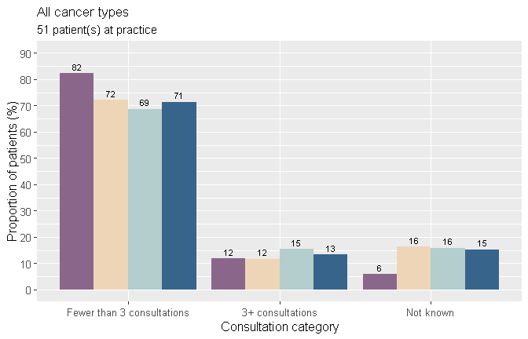

The proportion of patients who had ‘fewer than 3’ and ‘3 or more consultations’ is shown below for the four most common cancer types.
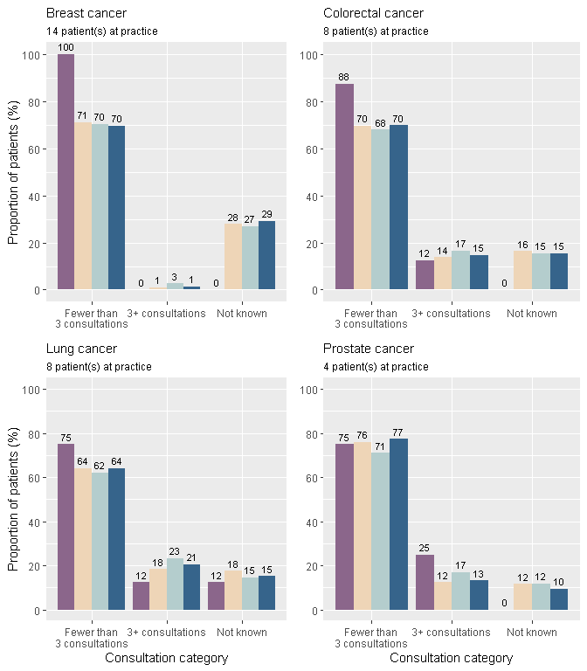

Multiple consultations
The reasons given for why patients had multiple (3 or more) consultations are listed below.
In the England national data, the most common reason for multiple consultations was 'Complexity of presentation' for 53.5% of patients. Compared to 46.2% at this practice for the same reason.
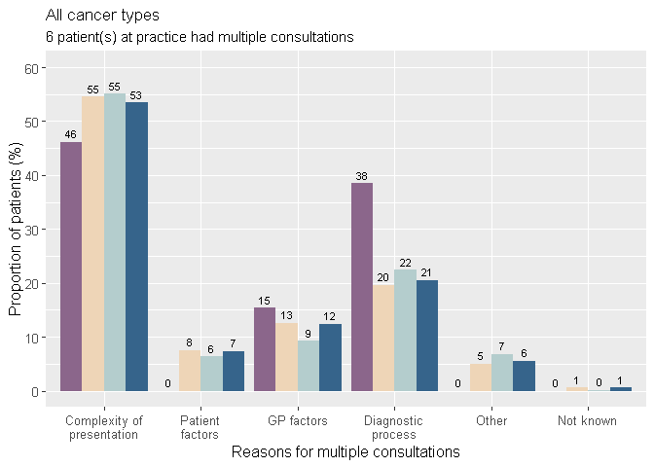
Note
Patients could have had multiple consultations for more than one reason and reasons given have been grouped in the graphs above. Below are examples of reasons included within each group:
- Complexity of Presentation: 'Vague/Non-Specific symptoms', 'Co-morbidity blurring picture', or 'Symptoms suggested different initial diagnosis'
- Patient Factors: 'Patient declined test or referral', or 'Patient did not attend'
- GP Factors: 'Poor communication', 'Inadequate history taken', 'Referred to ‘wrong’ specialty', or 'Seen by multiple health professionals'
- Diagnostic Process: 'Reassurance from negative investigation', or 'Multiple consultations to discuss test results'

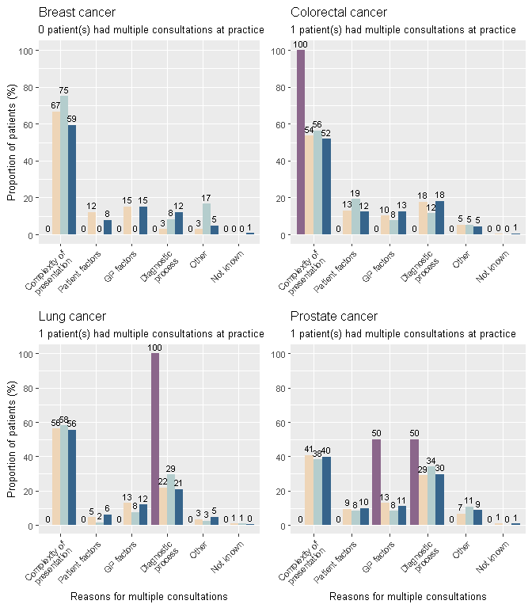

Investigations
The results below show the number of investigations that were ordered in primary care as part of the diagnostic assessment prior to referral and in response to symptoms reported, signs elicited, or abnormal test results. These are investigations where the GP receives the result directly and retains responsibility for acting upon the result.
The proportion of patients who had at least one primary care led investigation prior to referral was 35.3% at this practice and 46.5% of patients in the national data for England. At this practice there were 39.2% of patients who had no investigation, 0.0% not known and 25.5% not applicable. In the national data for England, 37.3% of patients had no investigation prior to referral.
Of primary care led investigations ordered, the most common investigation was a blood test for 59.4% of all investigations nationally. The same test was ordered for 63.2% of all investigations at Woodbrook Medical Centre.
For those patients who had at least one primary care-led investigation, more information on the type of investigations ordered is shown in the graphs below. Only the type of investigation was considered, i.e. the graphs show one blood test per patient even if the patient had more than one blood test.

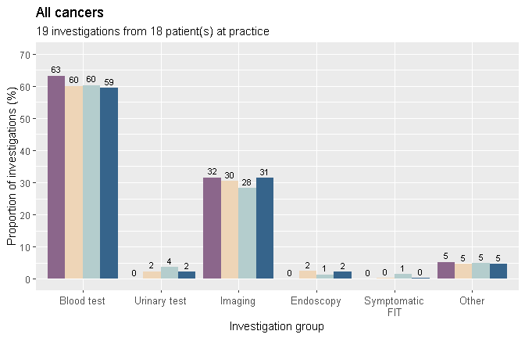

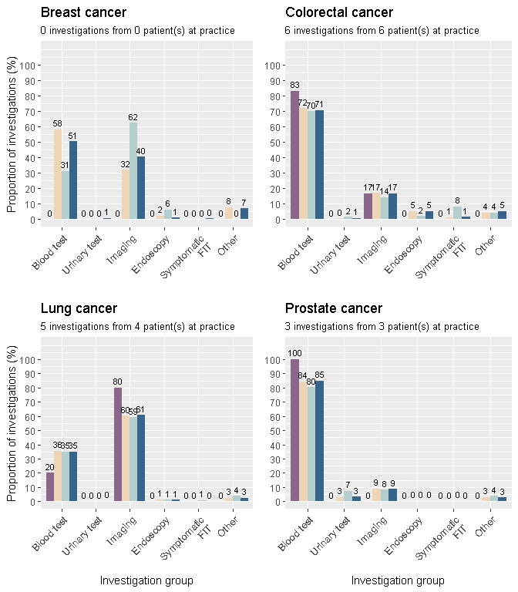

Referrals
This section shows the type of referral that led most directly to a diagnosis of cancer. Where a patient was referred multiple times for reasons attributed to cancer, the closest referral to diagnosis was used.
The proportion of patients referred by Two Week Wait for suspected cancer were:
- Woodbrook Medical Centre: 52.9%
- Similar practice group: 54.7%
- East Midlands Cancer Alliance: 57.5%
- England: 54.9%
The graph below shows the proportion of patients who were referred by each route. Further information is shown in the next section of the report for patients who had an emergency referral.
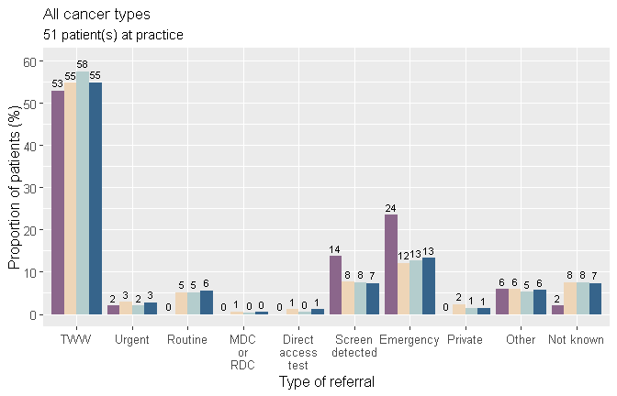
Notes
TWW: Two week wait / urgent referral for suspected cancer
Urgent: Any urgent referral that was not for suspected cancer
MDC or RDC: Multidisciplinary Diagnostic Centre or Rapid Diagnostic Centre - referral pathway for patients with non-specific but concerning symptoms that could indicate cancer
Emergency: All emergency referrals, including patient self referral

The following graphs show the proportion of patients who went through each referral route for the four most common cancer types.
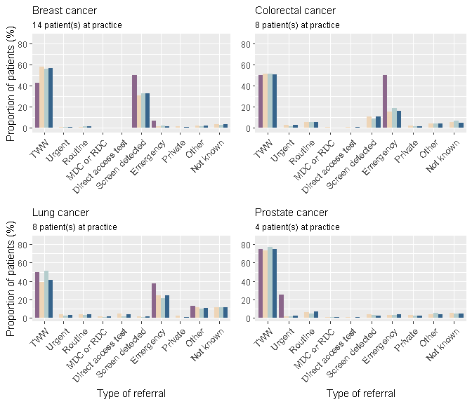

Referral number
The median and interquartile range for the number of referrals made before diagnosis was:
- Woodbrook Medical Centre: 1 referral (min: 0, interquartile range: 0 - 1)
- Similar practice group: 1 referral (min: 0, interquartile range: 1 - 1)
- East Midlands Cancer Alliance: 1 referral (min: 0, interquartile range: 1 - 1)
- England: 1 referral (min: 0, interquartile range: 1 - 1)
(The number of referrals include those to different specialties, or multiple referrals to the same specialty).

Emergency referral routes
This section provides details on emergency referrals, specifically whether or not a patient had contact with the GP before their emergency referral, and whether the GP had already initiated tests or made a referral. Note: this is not the same as the A&E group in the ‘Place of First Presentation’ section above, which provides details on where patients first presented and not on their referral.
Of patients referred by any emergency route nationally (13.4%), the most common route of referral was 'Patient self-referred to A&E / hospital, without any prior relevant GP consultations' for 29.2 % of emergency referred patients. 23.5% of patients at this practice were referred by an emergency route, and 33.3% of these were diagnosed through the most common national route (self-referral without any prior consultation).
The following graphs show the proportion of patients who were referred by the different emergency routes. Note: Only patients who had an emergency referral are shown in the graph below.
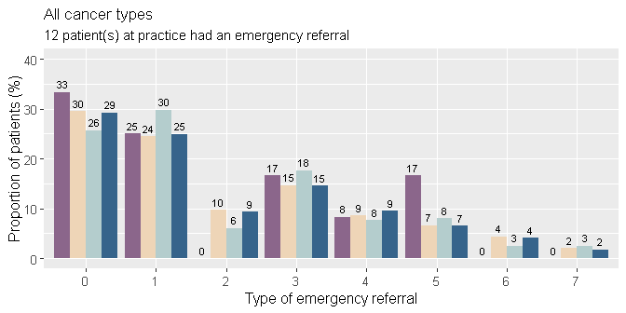

Key of emergency referrals:

0. Patient self-referred to A&E / hospital, without any prior relevant GP consultations

1. Patient was referred to A&E / hospital as an emergency by the GP or OOH service (e.g. emergency A&E or emergency admission to surgical or medical ward) – patient had no prior relevant GP consultations

2. Patient self-referred to A&E / hospital having previously consulted the GP during the same episode of illness but not awaiting a previously arranged test or referral

3. Patient was referred to A&E / hospital as an emergency by the GP or OOH service having previously consulted the GP during the same episode of illness but not awaiting a previously arranged test or referral

4. Patient self-referred to A&E / hospital while waiting for referral / investigation arranged by GP previously (e.g. sudden deterioration of patients’ symptoms while waiting to be assessed in hospital electively)

5. Patient was referred to A&E / hospital as an emergency by the GP or OOH service (e.g. emergency A&E or emergency admission to surgical or medical ward) – patient was awaiting to be assessed in hospital following prior referral

6. Other

7. Not known / circumstances leading to emergency presentation cannot be verified
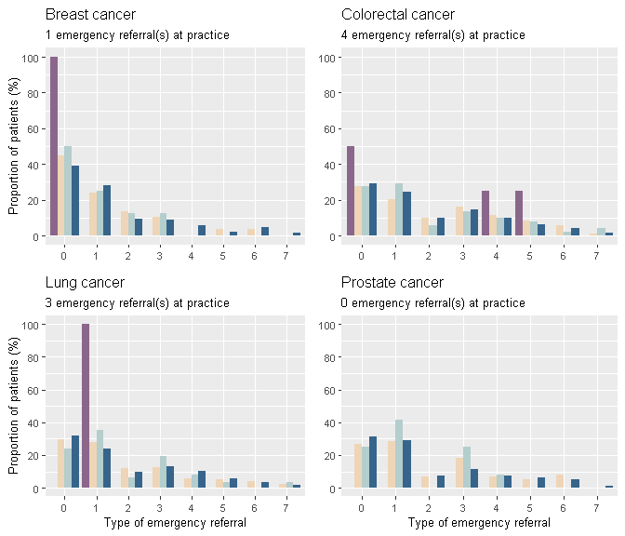

Key of emergency referrals:

0. Patient self-referred to A&E / hospital, without any prior relevant GP consultations

1. Patient was referred to A&E / hospital as an emergency by the GP or OOH service (e.g. emergency A&E or emergency admission to surgical or medical ward) – patient had no prior relevant GP consultations

2. Patient self-referred to A&E / hospital having previously consulted the GP during the same episode of illness but not awaiting a previously arranged test or referral

3. Patient was referred to A&E / hospital as an emergency by the GP or OOH service having previously consulted the GP during the same episode of illness but not awaiting a previously arranged test or referral

4. Patient self-referred to A&E / hospital while waiting for referral / investigation arranged by GP previously (e.g. sudden deterioration of patients’ symptoms while waiting to be assessed in hospital electively)

5. Patient was referred to A&E / hospital as an emergency by the GP or OOH service (e.g. emergency A&E or emergency admission to surgical or medical ward) – patient was awaiting to be assessed in hospital following prior referral

6. Other

7. Not known / circumstances leading to emergency presentation cannot be verified

Primary Care Interval
This section shows the number of days from when the patient first presented with symptoms, ultimately considered by the GP to be related to the cancer diagnosis, to the date of first referral from primary care.
The median time from first presentation to referral was:
- Woodbrook Medical Centre: 1 day
- Similar practice group: 2 days
- East Midlands Cancer Alliance: 3 days
- England: 2 days

The dot in each of the plots below represents one patient and the time (in days) from first presentation of symptoms to referral (x-axis), the further to the right a dot is on the graphs, the longer it took for that patient to be referred. Data are only shown where there was a date for presentation and referral - therefore patients who had no referral recorded are not included in these results.

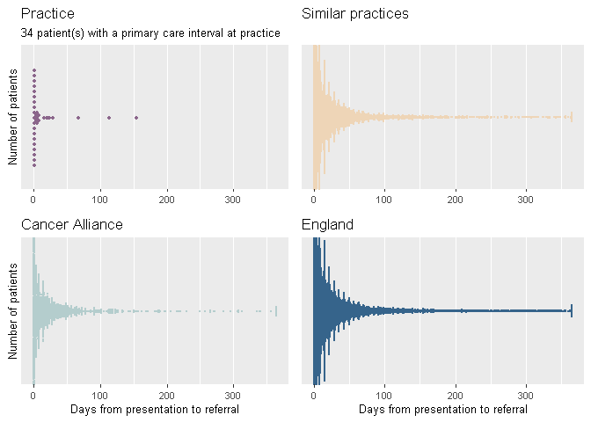

Diagnostic Interval
This section shows the number of days from when the patient first presented with symptoms ultimately considered by the GP to be related to the cancer diagnosis, to the date of cancer diagnosis (as recorded by Public Health England's National Disease Registration).
The median time from first presentation of symptoms to diagnosis was:
- Woodbrook Medical Centre: 16 days
- Similar practice group: 35 days
- East Midlands Cancer Alliance: 32 days
- England: 35 days

The dot in each of the plots below represents one patient and the time (in days) from first presentation of symptoms to diagnosis (x-axis), the further to the right a dot is on the graphs, the longer it took that patient to be diagnosed. Data are only shown where there was a date for presentation and a date of diagnosis recorded.

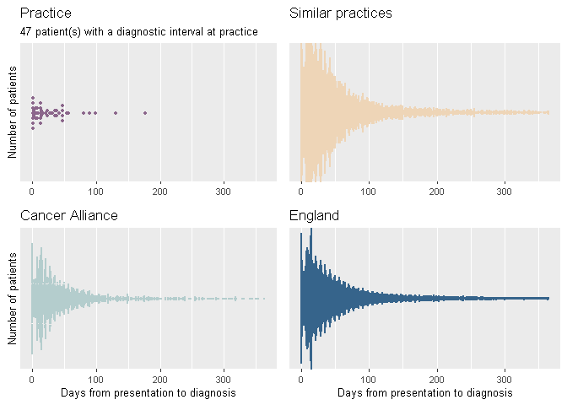

Safety Netting
Information was collected on whether there was evidence in the clinical record that safety netting was used and recorded at any stage of the patient's diagnostic process and the type of safety netting used. The 'not applicable' option was selected if safety netting was not relevant, e.g. the patient self-presented to A&E without having had any prior relevant GP consultations. Screen-detected cases, where data were not entered, are included in the 'not applicable' category.
The proportion of cases where a safety netting procedure was recorded was 19.6% at Woodbrook Medical Centre and 33.9% in the England national data.

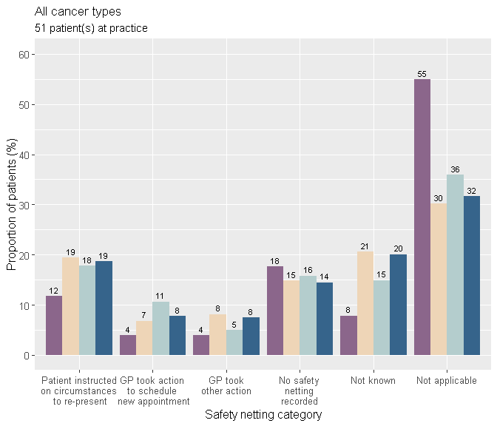
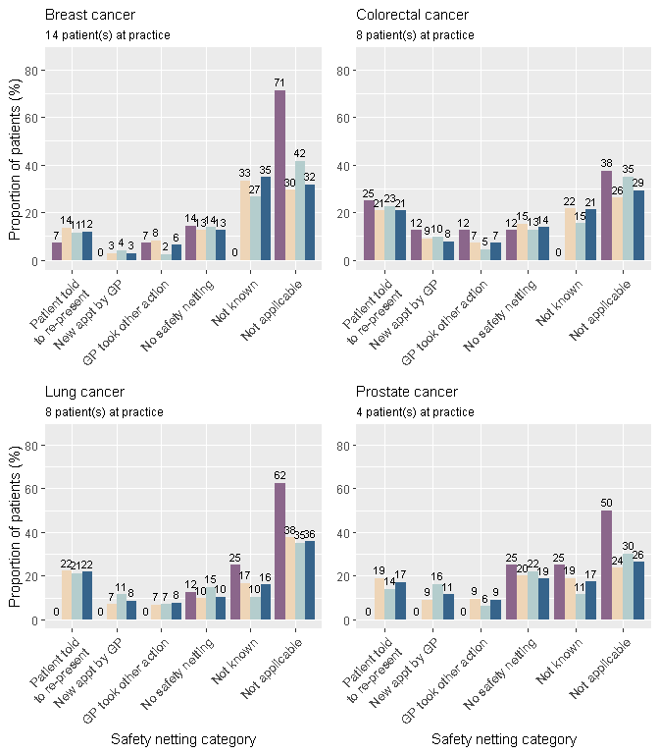

For patients for whom the GP reported that safety netting had been used, the graphs below show whether the GP felt that safety netting had made a positive contribution to the diagnosis, had not made a positive contribution, or where the impact of safety netting was unknown or not applicable.

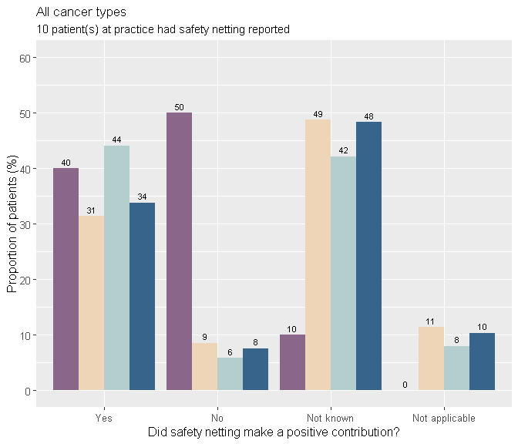
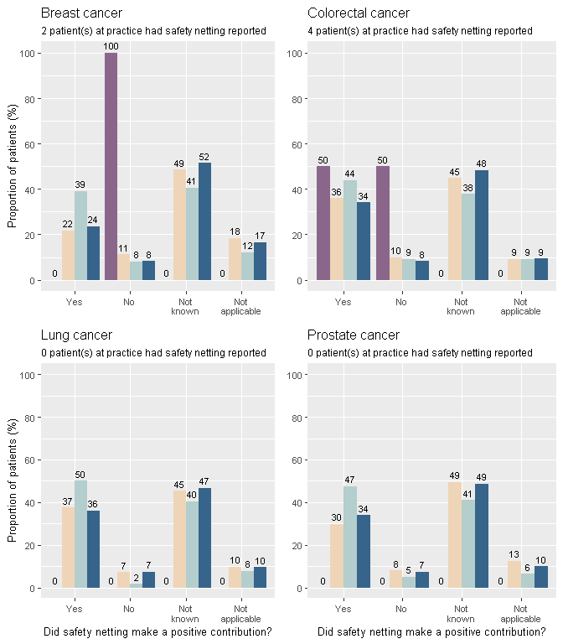

Avoidable delays
This section shows information about cases in which, with hindsight, the GP believed there to have been an avoidable delay in the patient receiving their diagnosis. Overall, the proportion of patients with a GP-assessed avoidable delay was 27.5% at Woodbrook Medical Centre and 23.5% in the England national data.
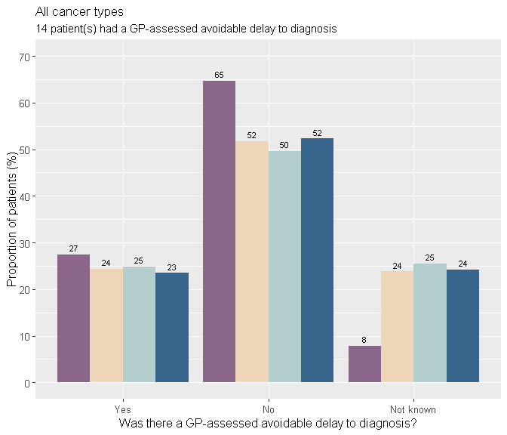

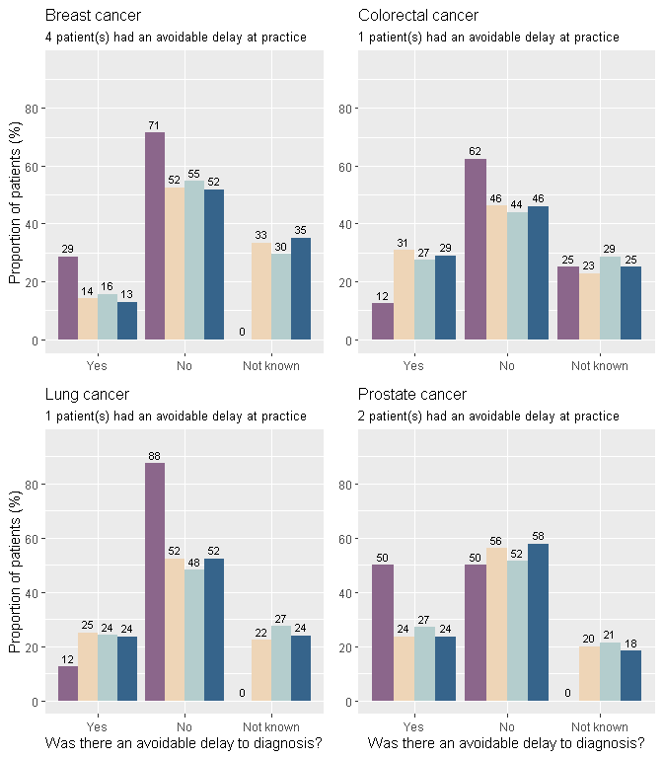

When did avoidable delay occur?
An avoidable delay could have occurred before presentation of symptoms, between presentation and referral, and/or after referral. For patients who were judged by the GP to have experienced an avoidable delay, the table below shows the proportion that experienced an avoidable delay at different stages in the pathway.
Note: each patient who experienced avoidable delay may have experienced this at one or more stage(s) in the pathway and may therefore be included in more than one column. Proportions do not include patients who had a screen-detected cancer.
For patients who experienced an avoidable delay (n=14 / 27.5% of patients audited at this practice):
Region: | Avoidable delay  before presentation | Avoidable delay between  presentation and referral | Avoidable delay  after referral
Practice | 64.3% | 28.6% | 28.6%
Similar practices | 44.5% | 43.2% | 40.6%
Cancer Alliance | 45.6% | 46.1% | 33.5%
England | 43.7% | 43.9% | 39.3%

Demographics
This section provides a summary of the patient demographics for the NCDA data completed at Woodbrook Medical Centre on patients diagnosed with a new primary cancer in 2018. Note: these are the demographics for cancer patients from whom the practice completed this audit and these may not reflect the practice population.

Sex
The patients diagnosed with cancer at this practice were mostly male (51.0%), as recorded by Public Health England's National Disease Registration. The patients diagnosed with cancer in England were mostly male (51.7%). The figures below show the proportion of patients by sex.
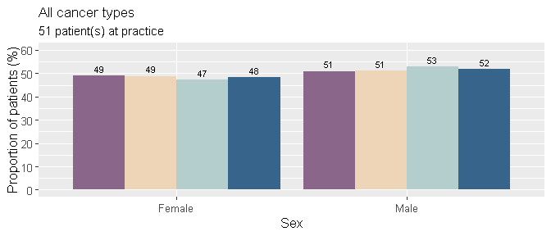
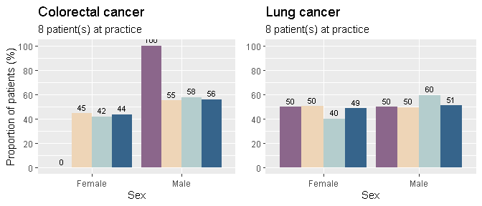

Age
The age group of most patients with cancer at this practice was 75-84 years (33.3%), as recorded by Public Health England's National Disease Registration. The largest proportion of patients diagnosed with cancer in the England national data were in the age group 65-74 (29.7%). The figures below show the proportion of patients by age group.
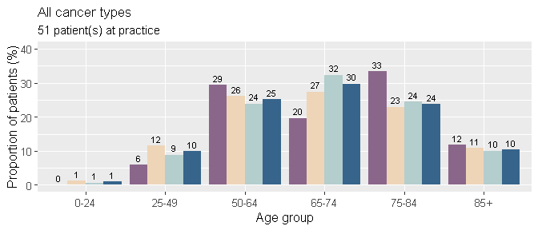
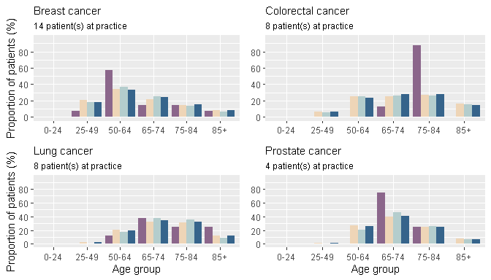

Ethnicity
The patients with cancer at this practice were mostly white ethnicity (90.2%). In the England data the patients were mostly white (86.4)%, as recorded in the cancer registry. The figures below show the proportion of patients by ethnicity.
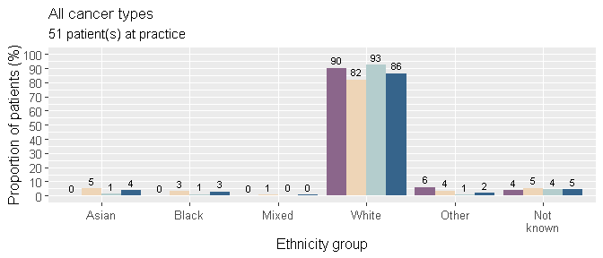
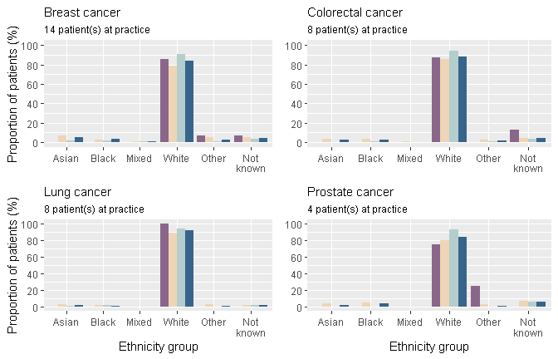

Co-morbidities
The proportion of patients who had at least one co-morbidity present prior to cancer diagnosis was 78.4% at this practice and 71.2% of patients in the national data for England. At this practice, 21.6% of patients had no co-morbidities recorded and 0.0% not known. In the national data for England, 21.8% of patients had no co-morbidities prior to cancer diagnosis.
Co-morbidities present prior to cancer diagnosis were documented and multiple selections could be made. If a patient had more than one co-morbidity reported, they will be counted in multiple groups in the graph below.
The most common co-morbidity reported for patients with cancer in the England national data was hypertension (24.8% of all co-morbidities, compared to 25.8% at this practice).
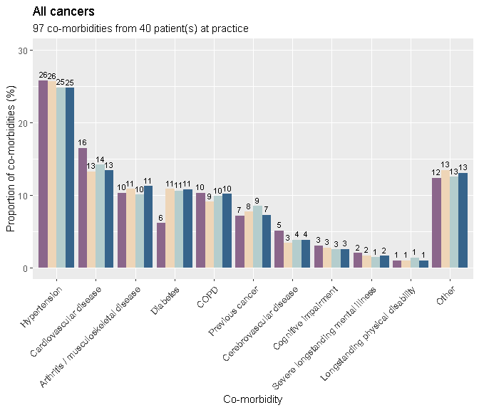
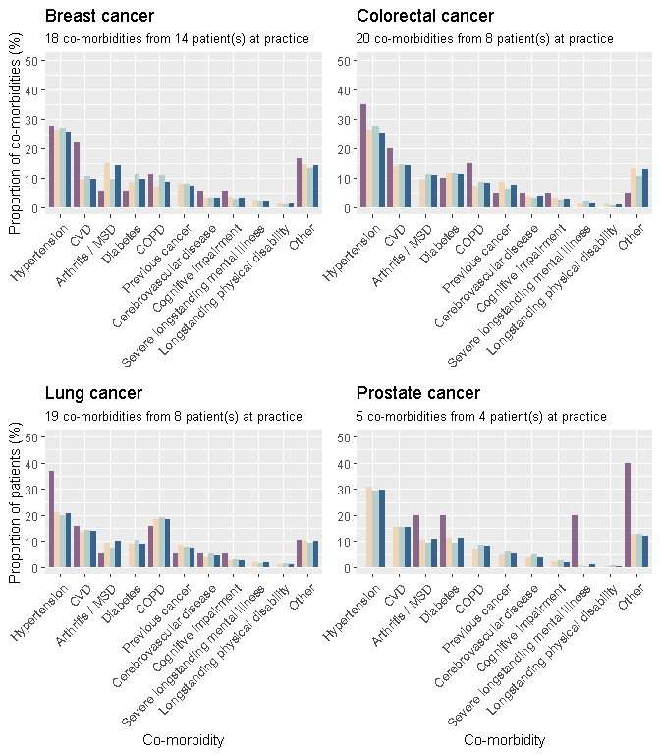
CVD: Cardiovascular disease
MSD: Musculoskeletal disease

What to do next
Support from Cancer Research UK's Facilitators and Macmillan GPs is available. They can discuss your results with you and can provide additional resources you may find helpful. Find out who your local facilitator is at www.cruk.org/facilitators and who your local Macmillan GP is by emailing macdocs@macmillan.org.uk (please note that not all areas in England will have a Facilitator or Macmillan GP).

Recommended next steps

Consider Learning Event Analysis and/or internal audit
You may have already done some Learning Event Analysis (LEA) on patients you were reviewing as part of the audit, but the report may have highlighted additional areas of interest. Consider further LEAs, guided by any issues that have been highlighted in the report (you could carry out these LEAs on patients diagnosed more recently than 2018). Alternatively, or in addition, the report may have highlighted certain pathways or cancer types that need further exploration. A smaller-scale internal follow-up audit could allow you to further examine specific issues, e.g. if you identified colorectal cancer emergency presentations as a potential issue, you may wish to carry out an internal audit of emergency diagnoses of colorectal cancers or bowel screening uptake.
Resources that could be helpful: Early Diagnosis of Cancer Toolkit: www.rcgp.org.uk/clinical-and-research/resources/toolkits/early-diagnosis-of-cancer-significant-event-analysis-toolkit.aspx

Share and discuss your results
Others in your practice will be interested in these results and what they mean for the team. You may consider a reflective practice session to discuss results. We recommend that you use these sessions to highlight good practice, identify areas for improvement and agree actions to take forward.
Your local Cancer Research UK Facilitator or Macmillan GP may be able to help run the session and can share case studies and learnings from other practices. They can also provide certificates for activities relating to the NCDA that they undertake with you and your colleagues, which can count towards your CPD.
Resources that could be helpful: You can request a PowerPoint template from your Cancer Research UK facilitator or Macmillan GP or by emailing ncda@cancer.org.uk that will allow you to add in your practice's results and quickly create a presentation of your key data to stimulate discussion at a practice session.
You could also consider sharing a summary of the audit findings with your Patient Participation Group.

Decide on actions and implement change
Depending on your results, there may be some actions you decide to take forward at your practice. These could include changes to systems and processes, such as referral practices or recording of safety netting, recommendations for further education and training, or other quality improvement activities. It's important to think about how you will monitor changes that have been made and the impact they are having.
Your local Cancer Research UK Facilitator or Macmillan GP can offer advice and support for any actions you decide to take.
Resources that could be helpful: The Quality Improvement Toolkit for the Early Diagnosis of Cancer: www.rcgp.org.uk/-/media/Files/CIRC/Toolkits-2017/Cancer/NCDA-toolkit-110917b.ashx?la=en

Criteria and standards
In the context of cancer care, there are a number of criteria and standards based on evidence and guidelines that can help to guide review of data and quality improvement activity. For the NCDA, a number of criteria and standards have been identified to aid interpretation of the results presented in this report, encourage reflection and planning for improvement by practice teams (with subsequent re-audit).
The criteria and standards outlined below are not intended for the purposes of performance management or making comparisons between practices, but rather to identify where improvement may be required.
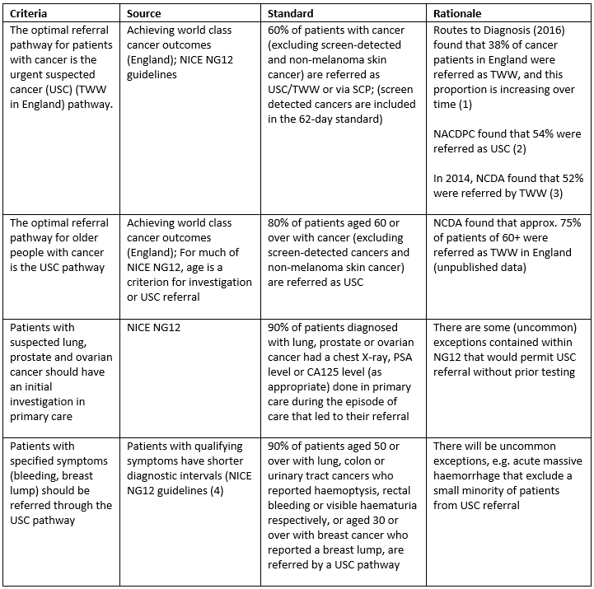

Unexpected events
The following, which are termed 'unexpected events', are events generally associated with poorer outcomes, that may (or may not) have been avoidable. Their occurrence will be highly variable year on year at the practice level and does not in itself reflect the quality of care provided by a practice. However, they can usefully trigger more detailed case review / learning events. Patients who have experienced an unexpected event can be identified through the audit work. The practice could consider LEAs for such cases to better understand what happened in the run-up to the event.
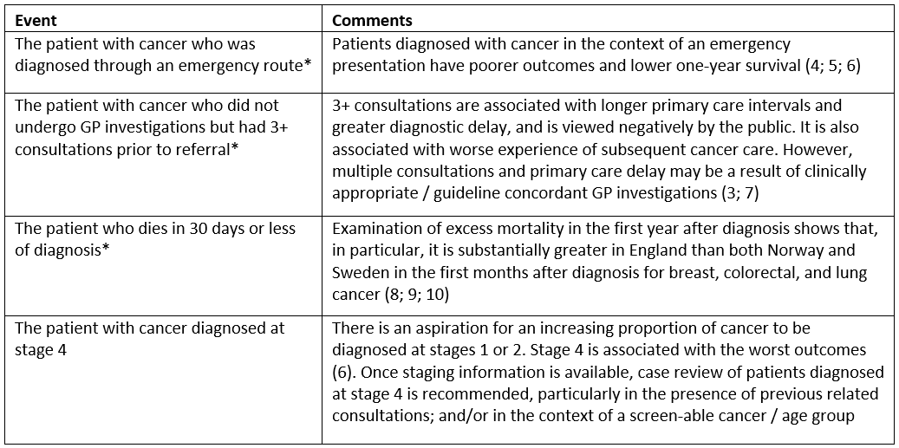
*patients in this group are marked with a blue flag in the patient list on the NCDA portal
References:

1. Public Health England. Routes to Diagnosis. National Cancer Registration and Analysis Service (NCRAS) 2016 http://www.ncin.org.uk/publications/routes_to_diagnosis

2. National Audit of Cancer in Primary Care. Rubin, G, McPhail, S and Elliott, K.: Royal College of General Practitioners, Clinical innovation and Research Centre, 2011

3. Diagnosing cancer in primary care: results from the National Cancer Diagnosis Audit. Swann, R, et al.: Br J Gen Pract, 2018 Vol. 68

4. Comparison of cancer diagnostic intervals before and after implementation of NICE guidelines: analysis of data from the UK General Practice Research Database. Neal RD et al. Br J Cancer. 2014, Vol 110

5. Global surveillance of trends in cancer survival 2000-14 (CONCORD-3): analysis of individual records for 37 513 025 patients diagnosed with one of 18 cancers from 322 population-based registries in 71 countries. Allemani, C, et al. 10125: Lancet, 2018, Vol. 391

6. National Audit of Cancer in Primary Care. Rubin, G, McPhail, S and Elliott, K: Royal College of General Practitioners, Clinical innovation and Research Centre, 2011

7. National Cancer Registration and Analysis Service. Routes to Diagnosis - NCIN Data Briefing. Public Health England. 2018. http://www.ncin.org.uk/publications/data_briefings/routes_to_diagnosis

8. Impact of investigations in general practice on timeliness of referral for patients subsequently diagnosed with cancer: analysis of national primary care audit data. Rubin, GP, et al.: British Journal of Cancer, 2015, Vol. 112

9. Colorectal cancer survival in the Nordic countries and the United Kingdom: excess mortality risk analysis of 5 year relative period survival in the period 1999 to 2000. Engholm, G, et al. : Int J Cancer, 2007, Vol. 121

10. National comparisons of lung cancer survival in England, Norway and Sweden 2001-2004: differences occur early in follow-up. Holmberg, L, et al.: Thorax, 2010, Vol. 65

11. Breast cancer survival in England, Norway and Sweden a population-based comparison. Møller, H, et al.: Int J Cancer, 2010, Vol. 126

Other useful Resources
Depending on your reflections, you may also wish to:
Review your practice-level data at PHE Fingertips - Cancer Services. To view data on cancer screening, Two Week Wait referrals, diagnostic services, emergency presentations and admission with a comparison at practice-level, Cancer Alliance-level and for England: fingertips.phe.org.uk/profile/cancerservices
Review the "NG12 Suspected cancer: recognition and referral guidelines": www.nice.org.uk/guidance/ng12
Access different types of summaries of the "NG12 Suspected cancer: recognition and referral guidelines":
- www.macmillan.org.uk/documents/aboutus/health_professionals/pccl/rapidreferralguidelines.pdf
- www.cancerresearchuk.org/health-professional/learning-and-development-tools/nice-cancer-referral-guidelines
- www.gatewayc.org.uk/gwc-cancer-map/
Learn about the impact of covid-19 on cancer diagnosis: www.cruk.org/hpcovidhub
Find more information and e-learning about cancer: www.cruk.org/hponlinelearning
Join the free online cancer education platform Gateway C: www.gatewayc.org.uk/
Access information, resources and support for quality improvement as part of the GP contract and PCN specification: www.cruk.org/GPcontract
Look at RCGP QI Ready resources: www.rcgp.org.uk/QI-Ready
Refer to NCDA QI case studies from the previous audit on QI Ready Learning Network:
- TWW Safety Netting: qiready.rcgp.org.uk/casestudies/safety-netting-tww-referrals-through-national-cancer-diagnosis-audit/#.XQeZ5Y0h3oo
- PSA testing and Referrals: qiready.rcgp.org.uk/casestudies/improving-cancer-referrals-through-national-cancer-diagnosis-audit/#.XQeZ5I0h3oo
- Bowel Screening: qiready.rcgp.org.uk/casestudies/driving-bowel-screening-uptake-through-national-cancer-diagnosis-audit-2/#.XQeZ4Y0h3oo
Review the RCGP Quality Improvement web pages: www.rcgp.org.uk/clinical-and-research/our-programmes/quality-improvement.aspx
Visit the Primary Care Cancer Toolkit (RCGP, Cancer Research UK): www.rcgp.org.uk/clinical-and-research/resources/toolkits/primary-care-cancer-toolkit.aspx
Complete the best practice toolkits for bowel and cervical screening:
- www.cancerresearchuk.org/health-professional/screening/bowel-screening-evidence-and-resources/bowel-screening-resources
- publications.cancerresearchuk.org/publication/engaging-primary-care-cervical-screening-%E2%80%93-good-practice-guide
Find links to further e-learning, resources, toolkits, infographics and more at www.cruk.org/NCDA

Glossary
- Avoidable delay: Instances where the GP considered there to be an avoidable delay in the patient receiving their diagnosis. The location where the delay was deemed to have occurred could be pre-consultation, primary care, secondary / tertiary care or not known.
- Consultations: The number of consultations for cancer-related symptoms up to one year before the referral that led to the cancer diagnosis, including the consultation that led directly to the referral. This includes email, telephone, nurse practitioner and nurse consultations, in any clinical setting.
- Ethnicity: Patient ethnicity as recorded in the cancer registry at Public Health England's National Disease Registration.
- Interquartile range: When all values are ranked low to high, this is the range of values from the first quartile (25%) to the third quartile (75%), giving the range of values in the middle 50% of data.
- Investigations: The primary care led (ordered) investigations that were ordered as part of the diagnostic assessment decided by the GP and in response to symptoms reported, signs elicited, or abnormal test results. These are investigations that are carried out prior to referral where the GP receives the results directly and retains responsibility for acting upon them. The number of investigation type was counted e.g. the graphs show one blood test per patient even if the patient had more than one blood test.
- MDC: Multidisciplinary Diagnostic Centre - referral pathway for patients with non-specific but concerning symptoms that could indicate cancer
- Median: When all values are ranked low to high, this is the middle value. The median is displayed because the data are skewed and providing the mean average could be misleading.
- Multiple referrals: Number of specialty referrals made by the GP surgery (including referrals to different specialties, or multiple referrals to the same specialty).
- Place of presentation: The place at which the patient first presented with symptoms, which the GP considered to be related to the diagnosis of cancer.
- RDC: Rapid Diagnostic Centre - referral pathway for patients with non-specific but concerning symptoms that could indicate cancer
- Referral: The type of referral that led most directly to a diagnosis of cancer. Where a patient was referred multiple times for reasons attributed to cancer, the closest referral to diagnosis was used. The same applied for emergency referrals.
- Safety netting: Safety netting is a 'diagnostic strategy' or 'consultation technique' to ensure timely re-appraisal of a patient's condition.
- Similar Practices: The 'similar practice' group is determined by grouping practices based on ethnicity, deprivation level, age structure, practice size and whether the practice is rural or urban. Given these variables, a practice could belong to one of 6 groups. This is an approach to enable contextual comparisons between practices in relation to their group; it is not however directly adjusting for the role of chance or the role of case-mix. The analysis was completed with a methodology developed by the Cancer Intelligence team at Cancer Research UK.
Numbers of practices included in each group: Group 1: 308, Group 2: 129, Group 3: 364, Group 4: 344, Group 5: 205, Group 6: 520
- TWW: Two Week Wait, urgent referral by GP for suspected cancer.

Links back to main sections:
- Introduction
- Summary of results

- Results Section
- Cancer type
- Place of presentation
- Consultations
- Multiple consultations
- Investigations
- Referrals
- Primary care interval
- Diagnostic interval
- Safety netting
- Avoidable delays
- Demographics

- What to do next
- Glossary

