GYNAECOLOGICAL URGENT SUSPECTED CANCER REFERRAL FORM
GP name: | Date of GP decision to refer:
Please note this form MU NOTE: This form is NOT for use for patients under 16yrsSNOT e used for under 16yrs
Patient last name: |  | Preferred name:
Gender: |  | DOB: | NHS no.

REFERRAL CRITERIA FOR GYNECOLOGICAL SUSPECTED CANCER (NG12) |  | Tick boxes
PLEASE PROVIDE APPROXIMATE BMI (Important for straight to test):
Hormonal status: Premenopausal Postmenopausal (>1yr since LMP)
Hysterectomy Y N
On HRT
Date of last cervical smear: Result:
 | OVARIAN CANCER: CA125 result MUST accompany referral for it to be accepted - please tick applicable boxes:
 | CA 125 - PLEASE PROVIDE RESULT:
 | Ascites and/or pelvic mass, obviously not fibroidsR5 Result: CA125 must accompany referral for it to be a
 | Suspicious pelvic mass on pelvic ultrasound (attach report)
 | Unexplained persistent or rising CA125 with normal USS post-menopausal woman or aged 50+ years
 | ENDOMETRIAL CANCER – please tick applicable boxes:
 | Pelvic and Speculum examination must be performed as per NICE guidelines, National Best Practice and National Gynae Cancer Society to exclude VULVA/VAGINA AND CERVIX suspected cancer prior to referral
 | Please provide Speculum examination findings:
Premenopausal and aged over 40:
Persistent intermenstrual bleeding over 3 consecutive months not attributable to contraception, cyclical progesterone, HRT or infection
For Information - USS assessment of the endometrium is of little diagnostic benefit in the premenopausal patient.
If concerns are raised on an USS please submit an Advice & Guidance request to the gynaecology service.
Postmenopausal not taking HRT:
Vaginal bleeding (PMB) after 12 months amenorrhoea Suspicious Vaginal discharge
 | Endometrial thickness >4mm on ultrasound scan (attach report)
Unscheduled bleeding on HRT:
HRT type: Continuous combined (cc) Sequential (s)
Date HRT commenced:
Unscheduled Vaginal bleeding > 6 months after starting/changing HRT and not able to assess ET on USS
Unscheduled Vaginal bleeding with one MAJOR risk/ three MINOR risks as per BMS flow chart
(see Appendix 2)
Endometrial thickness of >4mm for ccHRT or >7mm for sHRT on ultrasound scan (attach report)
Bleeding within 6 months of starting or changing HRT does not typically require referral, refer to flow chart
In Appendix 2.
 | Tamoxifen use: Abnormal vaginal bleeding whilst taking Tamoxifen or within 12 months of stopping
 | For Information - Co-incidental findings of thickened endometrium (up to 11mm in the absence of bleeding) - does not require referral. If there are risk factors for endometrial cancer please refer for Advice and Guidance.
 | CERVICAL/VAGINAL/VULVAL CANCER- please tick applicable boxes:
Suspicious lesion that looks like cancer on: Cervix Vagina
Suspicious vulval lump or ulceration
 | Cervical polyps: please refer on a routine pathway.
 | Nabothian follicle cyst and ectropion are normal findings and do not require referral
For Information - Post coital bleeding with a normal looking cervix and negative cervical screening (smear) history does not meet suspected cancer referral. Age below 35 years refer to benign gynaecology/iCash.
Age above 35 years refer on a routine pathway.
 | Please submit an Advice & Guidance request for any patient who does not meet the referral criteria but in whom you still have concerns

CLINICAL BACKGROUND INFORMATION
Please attach here a brief summary of primary care record, including list of current medication.

ROCKWOOD PERFORMANCE SCORE
Accurate functional status is needed to assess the most appropriate investigation/s and treatment.
If not known, please select a score from the attached link for the Rockwood scale and put in the score box: :
https://www.england.nhs.uk/south/wp-content/uploads/sites/6/2022/02/rockwood-frailty-scale_.pdf | SCORE:
The Rockwood Clinical Frailty Scale has not been widely validated in younger populations (below 65 years of age).
If either apply, provide details of your patient’s support requirements in the Additional Considerations section.
INFORMATION PROVIDED TO PATIENT (MUST be provided by referring Clinician) Please tick
Patient has been informed that cancer needs to be excluded | ☐
Patient has been given information regarding the cancer pathway | ☐
Patient understands that they may go straight to a diagnostic test at the hospital | ☐
Patient has confirmed they can attend in the next two weeks (including weekends) | ☐

ADDITIONAL CONSIDERATIONS
Please tick if the answer is yes to any of the questions below and give further information
Transport required? |  |  |  |  | ☐ |  | If yes, please further information:
Language/Hearing difficulties /Translator required? |  |  |  |  | ☐
Mental capacity assessment required? |  |  |  |  | ☐
Known safeguarding concerns? |  |  |  |  | ☐
Mobility requirements (unable to climb on/off bed)? |  |  |  |  | ☐
Learning disability/on SEMI register |  |  |  |  | ☐
BACKGROUND INFORMATION
BMI /WEIGHT |  |  |  |  |  | Smoker/ex-smoker
Alcohol |  |  |  |  |  | Other please specify
Relevant family history
PATIENT DETAILS – Must provide current telephone number
Email:
Address:
Mobile No. |  |  | Patient happy for a text/voice message to be left ☐
Tele (Day): |  |  | Tele (Evening):
GP PRACTICE DETAILS
Practice Code: |  |  |  | Telephone:
Address: |  |  |  | Practice email:
MODE OF CONSULTATION IN PRIMARY CARE Tick here
Virtual consultation | ☐
Face to Face consultation | ☐

Appendix 1 – British Menopause Society – Licensed oestrogen dose and proportionate progesterone dose 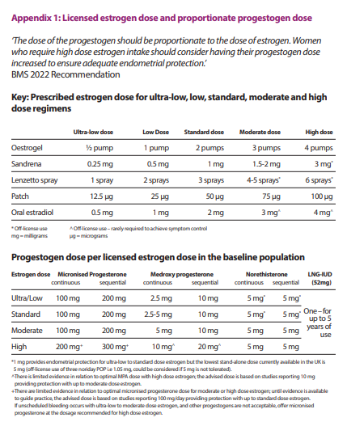

Appendix 2 - British Menopause Society Management of Unscheduled Bleeding on HRT – Flow Chart


