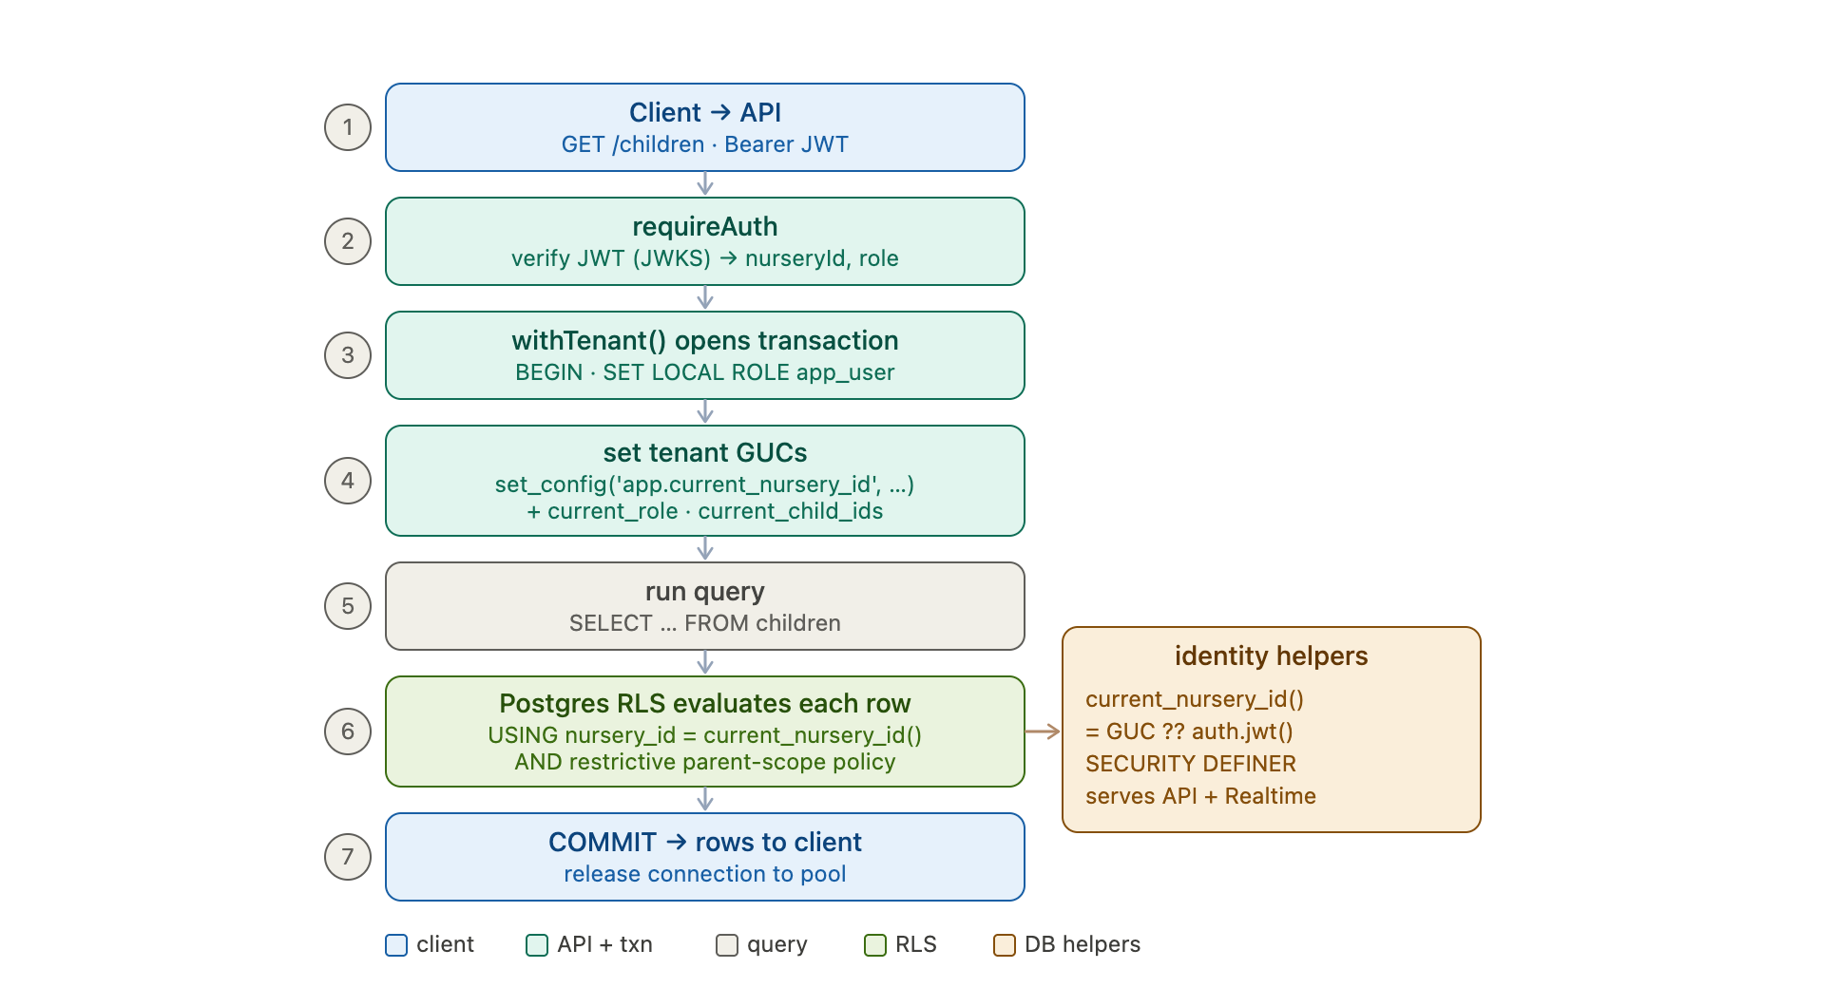

The model: defence in depth, enforced in the database
The API never relies on WHERE nursery_id = ? alone. Tenant isolation is enforced by Postgres Row-Level Security, so even a query that forgets its filter (or an injection) cannot return another nursery's rows. The application's job is just to tell the database who the caller is; the database decides what they can see.
There are two moving parts: a per-request identity carried on the connection, and policies + helper functions in the database that read that identity.

Step by step (matching the diagram)
1. Client → API. The staff app sends GET /children with the Supabase JWT as Authorization: Bearer ….
2. requireAuth. auth.ts verifies the token against the Supabase JWKS (ES256) and extracts the custom claims into the request context: nurseryId, role, childIds. A token missing those claims is rejected here, before any DB access.
3. withTenant() opens a transaction. The route handler wraps its work in withTenant(nurseryId, fn, claims?) (pool.ts:27). It checks out a pooled connection, runs BEGIN, then SET LOCAL ROLE app_user — dropping from the powerful owner role to a restricted role that only has SELECT/INSERT/UPDATE/DELETE on public tables and is subject to RLS. SET LOCAL means the role and settings are scoped to this transaction only, so they can't leak to the next request that reuses the pooled connection.
4. Set tenant GUCs. Inside the transaction it calls set_config('app.current_nursery_id', …, true) and, for parent requests, app.current_role and app.current_child_ids. These are connection-local settings (GUCs) that exist only for the life of the transaction.
5. Run the query. The handler runs ordinary SQL — SELECT … FROM children — with no special tenant filter.
6. Postgres RLS evaluates every row. Because the query runs as app_user, each tenant table's policy applies. The policies (generated in 013_rls_policies.sql) are uniform:
CREATE POLICY <tbl>_tenant_isolation ON <tbl>
USING (nursery_id = public.current_nursery_id());
The nurseries table itself keys on its own id (id = current_nursery_id(), 022). Parent-facing tables additionally carry a RESTRICTIVE policy that AND-combines with tenant isolation, so a parent only sees rows for their own child_ids while staff/managers see the whole nursery.
7. COMMIT and return. Rows that satisfy the policies are returned, the transaction commits, and the connection is released back to the pool.

The clever bit: one set of policies, two identity sources
The policies call SECURITY DEFINER helper functions (000_auth_helpers.sql) — current_nursery_id(), jwt_role(), jwt_child_ids() — and each helper resolves identity from the GUC first, then falls back to the JWT:
SELECT COALESCE(
NULLIF(current_setting('app.current_nursery_id', true), '')::int,
(auth.jwt() -> 'user_metadata' ->> 'nursery_id')::int
);
This is what lets the same policy serve two completely different access paths:
- The Hono API (pg pool, app_user) supplies identity via the GUCs that withTenant sets.
- Supabase PostgREST / Realtime (the authenticated role) carries identity in the JWT, read via auth.jwt().
SECURITY DEFINER is essential here: the functions are owned by a role with USAGE on the auth schema, so app_user can resolve auth.jwt() indirectly without ever being granted access to the auth schema. SET search_path = '' hardens them (every reference is schema-qualified, so they can't be hijacked by a malicious search path).

Why it's built this way — and the traps avoided
- Pooled connections are safe because role + GUCs are SET LOCAL (transaction-scoped), never sticky across requests.
- Policies use helper functions, not inline cross-table subqueries — an inline subquery inside a policy that re-reads a policy-protected table causes 42P17 infinite-recursion. The STABLE SECURITY DEFINER helpers sidestep that.
- The parent policy is RESTRICTIVE on purpose — permissive policies OR together, so a plain permissive parent policy would be widened (bypassed) by tenant-isolation; RESTRICTIVE makes it "nursery match AND child is mine."
- app_user has table privileges but is still under RLS — privileges (from 014) say which tables; RLS says which rows. New tenant tables need both a grant and a policy, or they're invisible (that exact gap is what broke Settings until 022 added the nurseries policy + grant).

The deliberate exception
The platform-admin routes (/api/admin/*) run on the raw pool without withTenant — no app_user, no GUCs — so they can read across all tenants. That's safe precisely because they're gated by a different door: a real login plus the ADMIN_EMAILS allowlist (requirePlatformAdmin), never the per-nursery JWT.
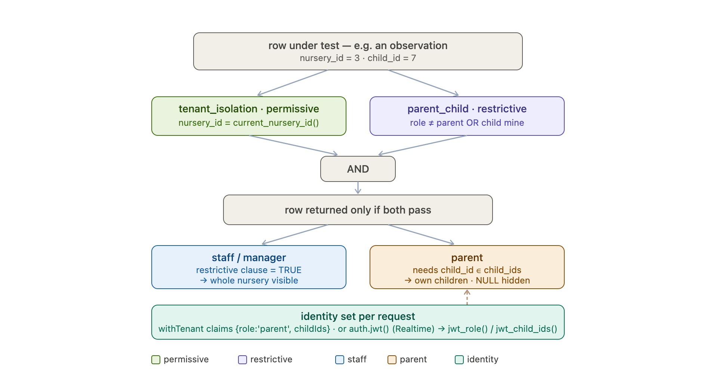
Here's how the same machinery narrows a parent down to only their own children's rows.

The idea: a second, stricter gate layered on tenant isolation
Tenant isolation alone (nursery_id = current_nursery_id()) keeps nurseries apart, but within a nursery a parent must see only their own children's data — not every child's. Sprout does this by adding a second policy to the child-scoped tables that AND-combines with tenant isolation, defined in 013_rls_policies.sql:46.

The two policies
On the 13 child-scoped tables — observations, assessments, consent_forms, invoices, attendance, medications, incidents, child_sessions, booking_requests, holiday_credit_requests, daily_logs, messages, child_documents — every row is checked against both:
-- permissive: keeps tenants apart
USING (nursery_id = public.current_nursery_id())

-- RESTRICTIVE: keeps parents to their own children
AS RESTRICTIVE USING (
COALESCE(public.jwt_role(), '') <> 'parent'
OR public.jwt_child_ids() @> to_jsonb(child_id)
)
Net effect: nursery match AND (caller is not a parent OR the row's child is mine).

Why RESTRICTIVE matters
Postgres combines multiple permissive policies with OR. If the parent policy were permissive, a row would be visible if it matched either tenant-isolation or the parent rule — so tenant-isolation would effectively widen (bypass) the parent restriction. Declaring it AS RESTRICTIVE makes Postgres AND it with the permissive set, which is exactly the "both must hold" semantics we need.

How each caller resolves
- Staff / manager: jwt_role() is not 'parent', so the restrictive clause short-circuits to TRUE. They keep full nursery scope — the parent rule never constrains them.
- Parent: the clause requires jwt_child_ids() @> to_jsonb(child_id) — the row's child_id must be contained in the parent's child_ids. Rows for other children are filtered out, and rows with a NULL child_id (nursery-wide broadcasts, unassigned invoices) are hidden from parents automatically, since @> against NULL isn't true.
Two implementation details worth noting: the check uses JSONB containment @> to_jsonb(child_id) rather than an ::int[] cast (which fails on JSONB arrays), and jwt_child_ids() (000_auth_helpers.sql:36) normalises every element through text→int, so a JWT that mints child_ids as strings (["1","2"]) still matches numeric child_ids.

Where the identity comes from (two paths, one policy)
The restrictive policy calls the same SECURITY DEFINER helpers, each reading the GUC first, then the JWT:
- Via the API: a parent request opts into parent scoping — the handler calls withTenant(nurseryId, fn, { role: 'parent', childIds }), which sets app.current_role and app.current_child_ids. (Note the safety default: an unset role is treated as non-parent, so a trusted server call that omits the role gets full nursery scope, never accidental over-restriction — and tenant isolation still confines it.)
- Via Supabase directly: the parent mobile app's PostgREST/Realtime queries run as the authenticated role, carrying role and child_ids in the JWT; jwt_role() / jwt_child_ids() fall back to auth.jwt(). The mobile app reads its own children's live data (e.g. daily logs, messages) over Realtime, and the same policy enforces ownership without any app-side filter.

Why this is robust
- A forgotten WHERE child_id = … in any query over those 13 tables can't leak siblings' or other families' data — the database refuses the rows.
- Adding a new child-scoped table means adding it to both loops in 013 (tenant + parent). Miss the parent loop and the table is nursery-isolated but not child-isolated; miss tenant isolation/grant and it's invisible — the policies are the single source of truth, so this is the one place to get right.

