
Course Code: CSE 412
Course Title: Programming with JAVA
Project
Project Name: Billing System Software
Submission date: 24-12-2022
Submitted by:  Md. Mizanur Rahman  Id: 201014061  Sec: 1 | Submitted to:  Dr. Mohammed Ashikur Rahman Assistant Professor  Department of Computer Science and Engineering of ULAB



Experiment No. Project Programming with JAVA (Theory)
1. Task/Problem/Project
Implement a Java program like Billing System Software.
2. Aim/Objective:
To implement a program that can be used as bill management system or Billing System Software.
3. Modern tools: Netbeans, MS Word
4. Understanding the requirements:
To complete the Project I will use modern tools (netbeans). In modern age we all must have a good experience in using different types of modern tools. Otherwise we cannot go a long way in life. So, here I will use netbeans. Netbeans has some beautiful features like GUI (Graphical User Interface). User can develop any software in netbeans using GUI easily. It is a very useful IDE. I will demonstrate my project using GUI of netbeans and I will connect different types of connections in source code for accomplishing my desire project.
NetBeans IDE is a free and open source integrated development environment for application development on Windows, Mac, Linux, and Solaris operating systems.
In order to complete the experiment I need to use the fundamental process of JAVA. As it is a modern age, we all use modern technology. My software is a part of modern technology. In every shop, inventory, and everywhere bill management is needed. We all often need a calculation system for calculating our daily necessity. Otherwise we cannot keep the records of our daily necessities. I will add print option in my software so that user can print the records depending on user needs.
For implementing the whole project I will use JAVA Programming Language and its attractive feature (like class and object, GUI including swing)
Java is a general-purpose, class-based, object-oriented programming language designed for having lesser implementation dependencies. It is a computing platform for application development. Java is fast, secure, and reliable, therefore. It is widely used for developing Java applications in laptops, data centers, game consoles, scientific supercomputers, cell phones, etc.
Java Platform is a collection of programs that help programmers to develop and run Java programming applications efficiently. It includes an execution engine, a compiler, and a set of libraries in it. It is a set of computer software and specifications. James Gosling developed the Java platform at Sun Microsystems, and the Oracle Corporation later

acquired it. Java is a multi-platform, object-oriented, and network-centric language. It is among the most used programming language. Java is also used as a computing platform. It is considered as one of the fast, secure, and reliable programming languages preferred by most organizations to build their projects.
I will add some method for returning or non-returning for establishing a good connection between different attributes of GUI and netbeans. For giving input I will use couple of text fields and buttons. And for getting output I will use a text area which will act like an output screen.
Here are some important Java applications:
- It is used for developing Android Apps
- Helps you to create Enterprise Software
- Wide range of Mobile java Applications
- Scientific Computing Applications
- Use for Big Data Analytics
- Java Programming of Hardware devices
- Used for Server-Side Technologies like Apache, JBoss, GlassFish, etc.
Here are important landmarks from the history of the Java language:
- The Java language was initially called OAK.
- Originally, it was developed for handling portable devices and set-top boxes. Oak was a massive failure.
- In 1995, Sun changed the name to “Java” and modified the language to take advantage of the burgeoning www (World Wide Web) development business.
- Later, in 2009, Oracle Corporation acquired Sun Microsystems and took ownership of three key Sun software assets: Java, MySQL, and Solaris.
Class: In object-oriented programming, a class is a basic building block. It can be defined as template that describes the data and behavior associated with the class instantiation. Instantiating is a class is to create an object (variable) of that class that can be used to access the member variables and methods of the class. A class can also be called a logical template to create the objects that share common properties and methods.
Syntax of Class in Java:
<access specifier> class class_name
{

// member variables
// class methods
}
Object: A Java object is a member (also called an instance) of a Java class. Each object has an identity, a behavior and a state. The state of an object is stored in fields (variables), while methods (functions) display the object's behavior. Objects are created at runtime from templates, which are also known as classes.
Object Syntax in Java:
ClassName ReferenceVariable = new ClassName();
A method is a block of code which only runs when it is called. You can pass data, known as parameters, into a method. Methods are used to perform certain actions, and they are also known as functions.
public class Main {
static void myMethod() {
// code to be executed
}
}

myMethod() is the name of the method

static means that the method belongs to the Main class and not an object of the Main class. You will learn more about objects and how to access methods through objects later in this tutorial. void means that this method does not have a return value.
public class Main {
static void myMethod() {
System.out.println("I just got executed!");
}

public static void main(String[] args) {

myMethod();
}
}

// Outputs "I just got executed!"
I will use GUI(jFrame, jLabel, jTextField, jButton)
GUI, which stands for Graphical User Interface, is a user-friendly visual experience builder for Java applications. It comprises graphical units like buttons, labels, windows, etc. via which users can connect with an application. Swing and JavaFX are two commonly used applications to create GUIs in Java.
Elements of GUI:
A GUI comprises an array of user interface elements. All these elements are displayed when a user is interacting with an application and they are as follows:
1. Input commands such as buttons, check boxes, dropdown lists and text fields.
2. Informational components like banners, icons, labels or notification dialogs.
3. Navigational units like menus, sidebars and breadcrumbs.
GUI in JAVA: Swing and JavaFX
As mentioned above, to create a GUI in Java, Swing and JavaFX are the most commonly used applications. Swing was designed with a flexible architecture to make the elements customizable and easy to plug-and-play which is why it is the first choice for java developers while creating GUIs.
Swing is a Java Foundation Classes [JFC] library and an extension of the Abstract Window Toolkit [AWT]. Swing offers much-improved functionality over AWT, new components, expanded components features, and excellent event handling with drag-and-drop support.
As far as JavaFX is concerned, it consists of a totally different set of graphic components along with new features and terminologies.
jFrame: The javax.swing.JFrame class is a type of container which inherits the java.awt.Frame class. JFrame works like the main window where components like labels, buttons, textfields are added to create a GUI.

jLabel: The object of JLabel class is a component for placing text in a container. It is used to display a single line of read only text. The text can be changed by an application but a user cannot edit it directly. It inherits JComponent class.
jTextField: The object of a JTextField class is a text component that allows the editing of a single line text. It inherits JTextComponent class. Unlike Frame, JFrame has the option to hide or close the window with the help of setDefaultCloseOperation(int) method.
jButton: The JButton class is used to create a labeled button that has platform independent implementation. The application result in some action when the button is pushed. It inherits AbstractButton class.
jPanel: JPanel, a part of the Java Swing package, is a container that can store a group of components. The main task of JPanel is to organize components, various layouts can be set in JPanel which provide better organization of components, and however, it does not have a title bar.
jSeparator: JSeparator is a part of Java Swing framework. It is used to create a dividing line between two components. More specifically, it is mainly used to create dividing lines between menu items in a JMenu. In JMenu or JPopupMenu addSeparartor function can also be used to create a separator.
JScrollPane: A JscrollPane is used to make scrollable view of a component. When screen size is limited, we use a scroll pane to display a large component or a component whose size can change dynamically.
jTable: The JTable class is a part of Java Swing Package and is generally used to display or edit two-dimensional data that is having both rows and columns. It is similar to a spreadsheet. This arranges data in a tabular form.
jTextArea: The object of a JTextArea class is a multi line region that displays text. It allows the editing of multiple line text. It inherits JTextComponent class;

5. Design and Development:
Before developing the software I must draw or sketch the design of the software. Without drawing or sketching I will not get the proper way how to complete the software. Every software or developer does a drawing of sketching before starting his/her software so that they can get a proper view of the software that can help him/her to demonstrate the project properly. Then they start coding of developing his software. My software is a real world based software and it is very useful for a user. For developing my coding concept I have drawn a design of my project so that I can get a proper flow about the whole software.

Class Diagram:
billInterface
proname;
rate;
qty;
total;
subtotal;
billInterface();
billhead();
billtotable();
DefaultTableModel();
getText();
setText();
bill();
clear();
print();

For completing the project I have declare some methods and variables of GUI.
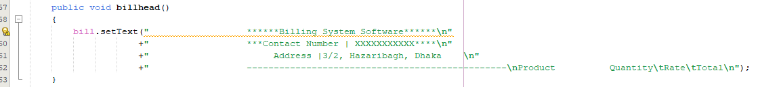
I have used a method name billhead that will show the name of the software and will display the contact number of the owner of the software and address of the office or shop or inventory where the software is being used.

I have used another method to create a table and store the names, rates and quantities of the products that is able to store the information after getting the inputs from user and will show after taking input as a table. After giving inputs in the input section user must add these information to store and calculate the bill. So, I have taken button for adding the information. By clicking add button user can store the information in a table.

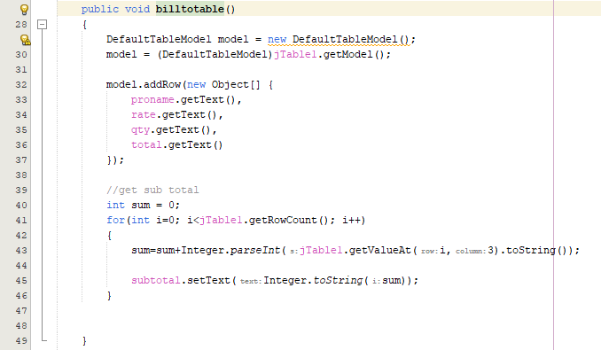

bill method will work for displaying the information in the display section that user will give as input.

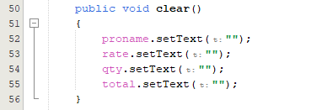
Clear method is used to keep the input section clear so that user can take more inputs from the user and can store in the table.

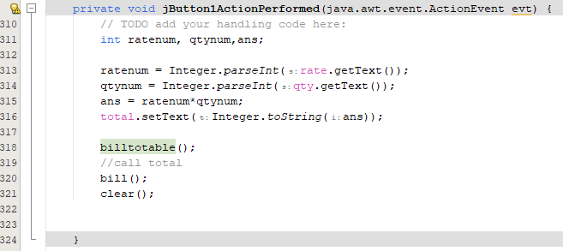
After taking the information of on product and keeping clear for taking next product’s information I have used another button.
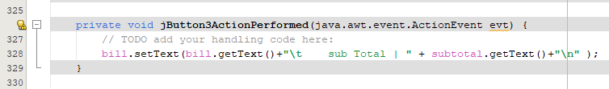
I have used another button to display the sub total of the bill. User can see his/her current amount of bill any time before buying more products using the software.

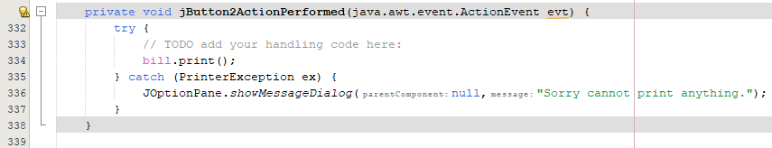
For printing the bill I have used a print button to print the bill of customers.

For keeping the output display I have used a clear button. After printing or calculating customers’ bill user can clear the bill screen.
Most importantly I have used some feature of GUI(like jFrame, jLabel, jButton etc.). I have established proper connection between these jFrames, jLabels, jButtons and jTextFields.

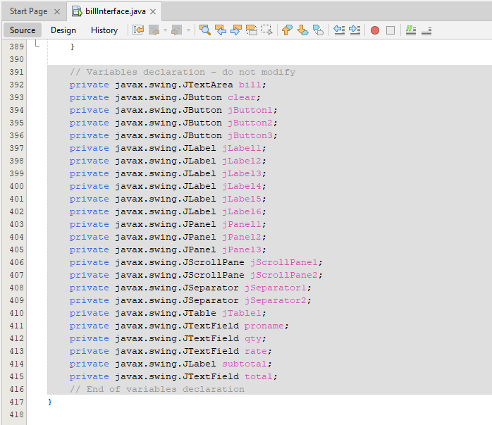

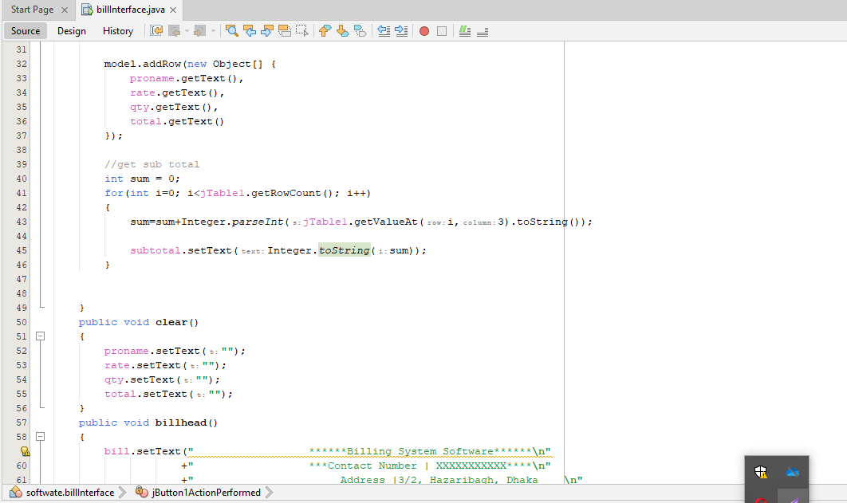
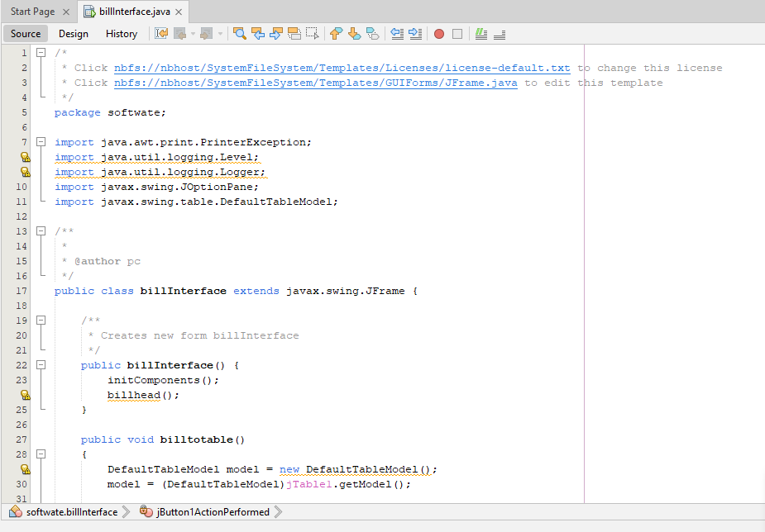
Code of the project:

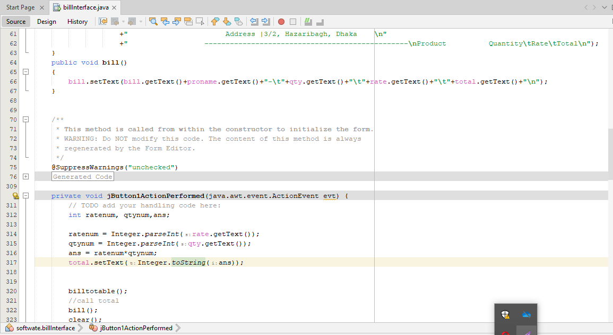
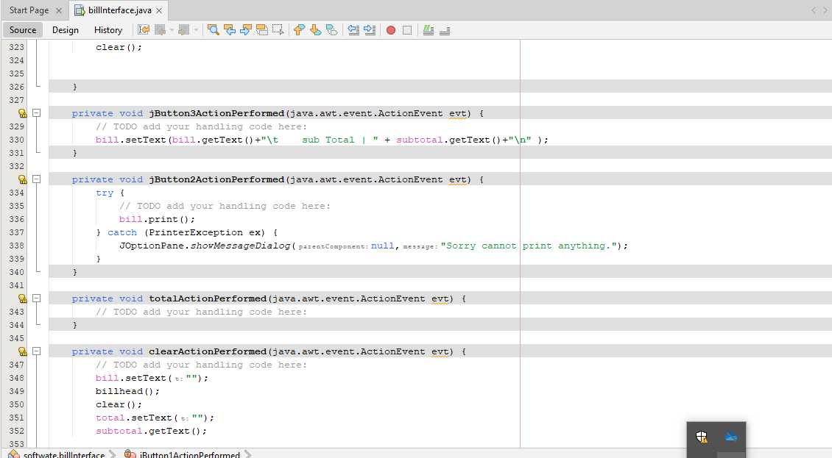

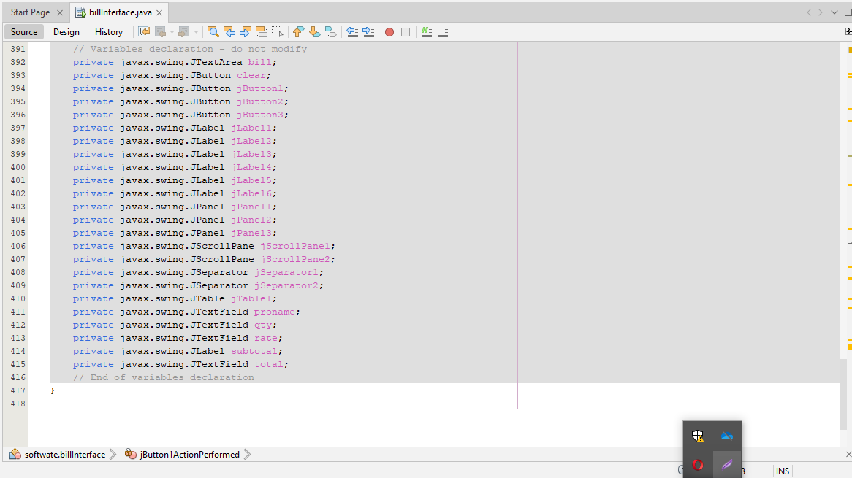
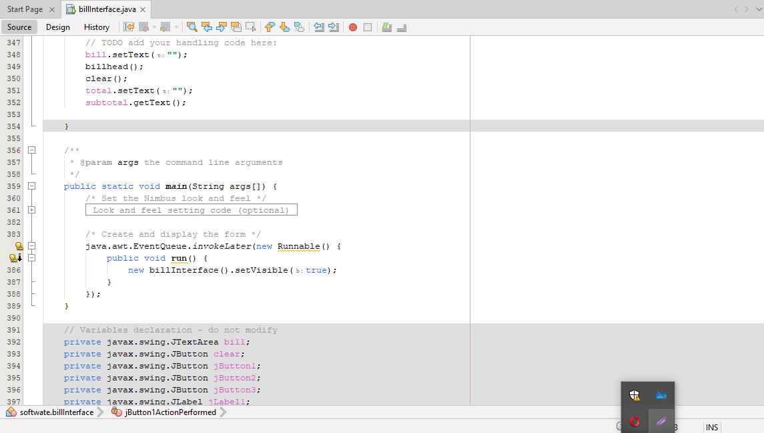

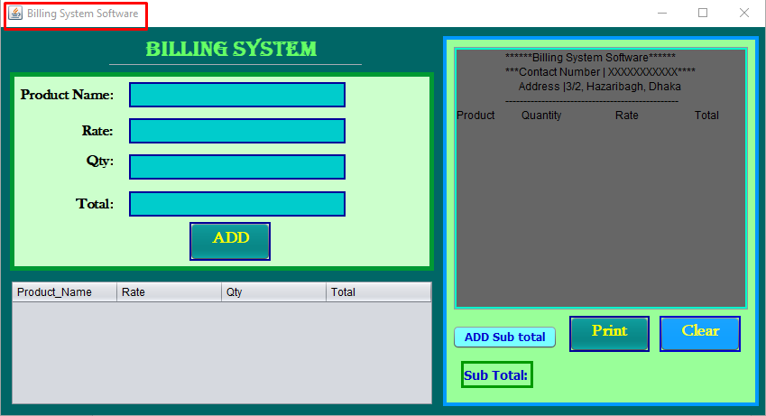
6. Result / Analysis: As I have used the basic of java and I have developed my software with very careful no error is found here. It is completely an error free software. It is working well. Its performance is also well. When user will enter in the software, user will see the main interface of the software. From where user can take inputs and can show the outputs. Where I have set the name of the software. I have taken a jFrame and set its name “Billing System Software”.
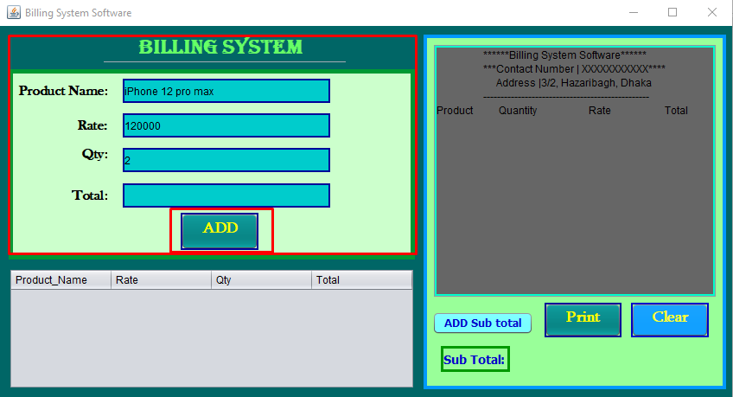
From the first entrance user can see some gaps where user must take inputs for adding the information of the product. User will see an add button. For adding the information user must click on add button.

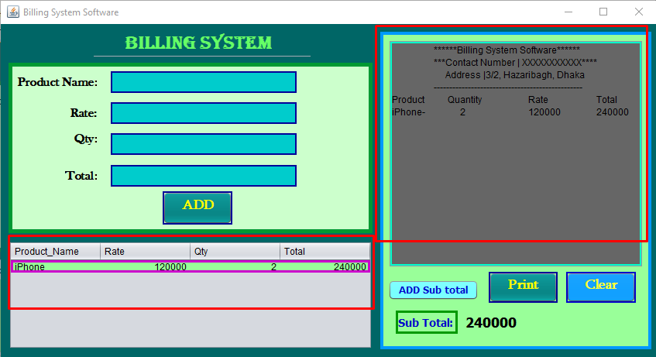
If the user just click on add button, the information will be saved in jTable and will display in the output section of the software. And the input section will be cleared for inputs again

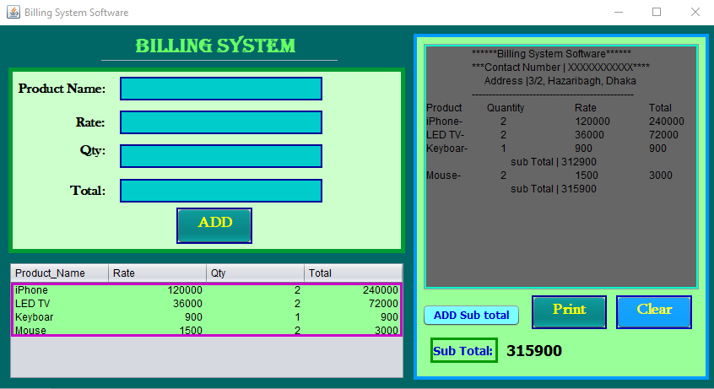
Then user can take multiple product’s information which will be stored in the table and will be displayed in the output section. User can see the subtotal also by clicking “Add Sub total” button.

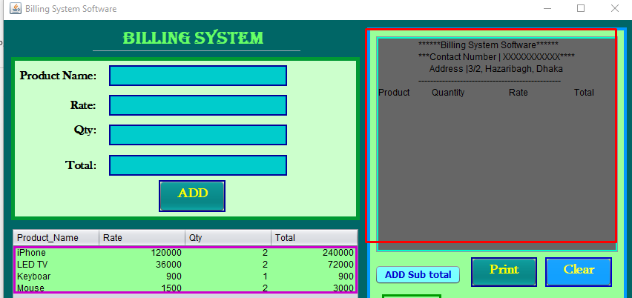
User can clear the screen by clicking clear button. Then the output section will be cleared.

User can print the bill by clicking print button.
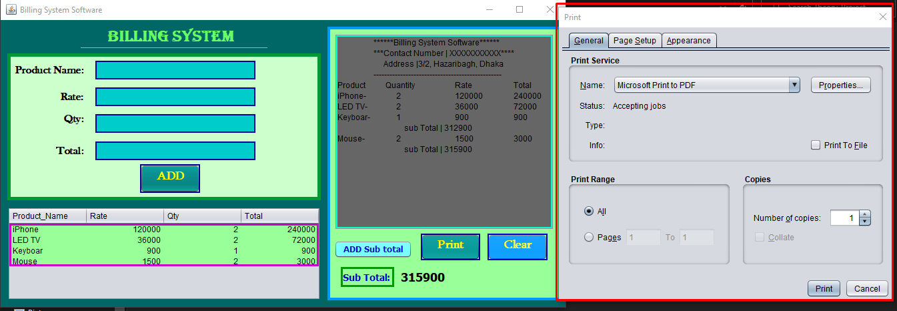

So, I can say my software is working properly. No error is found here.
7. Conclusion:
This report presents an introduction to Java and how Java is used to build graphics and what are the tools that can be used to develop graphics and drawing required shapes. This is an introduction to the main goal of my report that presented that is design and development a simple project. It is real world based calculation software. Where is needed to calculate anything user can use it. I have developed the software carefully. I have kept the project very simple. It is a very simple project. There is nothing extra ordinary things. It just a calculation based software for doing calculation tasks. I have just implemented the graphical user interface attractively. I have run the project multiple times. No error is found here. So, undoubtly I can say it is an error free software and it is very user friendly software. User can use it easily.

