CYBER SECURITY INNOVATION CHALLENGE 1.0

PROTOTYPE DEVELOPMENT: Stage III

Problem Statement Domain: Mule Accounts & Collusive Fraud in UPI
Problem Statement: Detection of Mule Account Networks and Coordinated Fund Laundering in UPI Payment Ecosystems

FinGuard
Real-Time Multi-Signal Mule Account Detection System

Resource | Link
GitHub Repository | [Insert GitHub Repo URL]
Live Deployed URL | [Insert Deployed URL]
Dashboard Demo Video (YouTube) | [Insert YouTube Link]
Pitch Deck / Presentation | [Insert Link if applicable]

Role | Name | Institute | Enrolment No. | Email ID
Team Lead | [Name] | [Institute] | [Enrolment No.] | [Email]
Member 2 | [Name] | [Institute] | [Enrolment No.] | [Email]
Member 3 | [Name] | [Institute] | [Enrolment No.] | [Email]
Member 4 | [Name] | [Institute] | [Enrolment No.] | [Email]
Member 5 | [Name] | [Institute] | [Enrolment No.] | [Email]

Table of Contents
1. Project Overview and Team Details
2. Problem Statement and Background
3. Literature Review / Existing Solutions
4. Proposed Solution and Technical Architecture
5. Innovation and Novelty Elements
6. Unique Selling Proposition (USP), Business Model, and Industry Relevance
7. Prototype Demonstration, Security Testing, and Deployment Details
8. Limitations and Challenges
9. Roadmap Towards MVP
10. Team Composition and Individual Contributions
11. References

1. Project Overview and Team Details

1.1 Project Summary
FinGuard detects mule accounts in India's UPI ecosystem, and it does so in real time. Mule accounts, for anyone unfamiliar, are bank accounts that criminals use as pass-throughs for laundering stolen money. They're a massive headache for the payments industry because each individual transaction through a mule looks perfectly normal. It's only when you zoom out and look at the bigger picture (the network structure, the timing, the devices involved) that the fraud becomes visible.
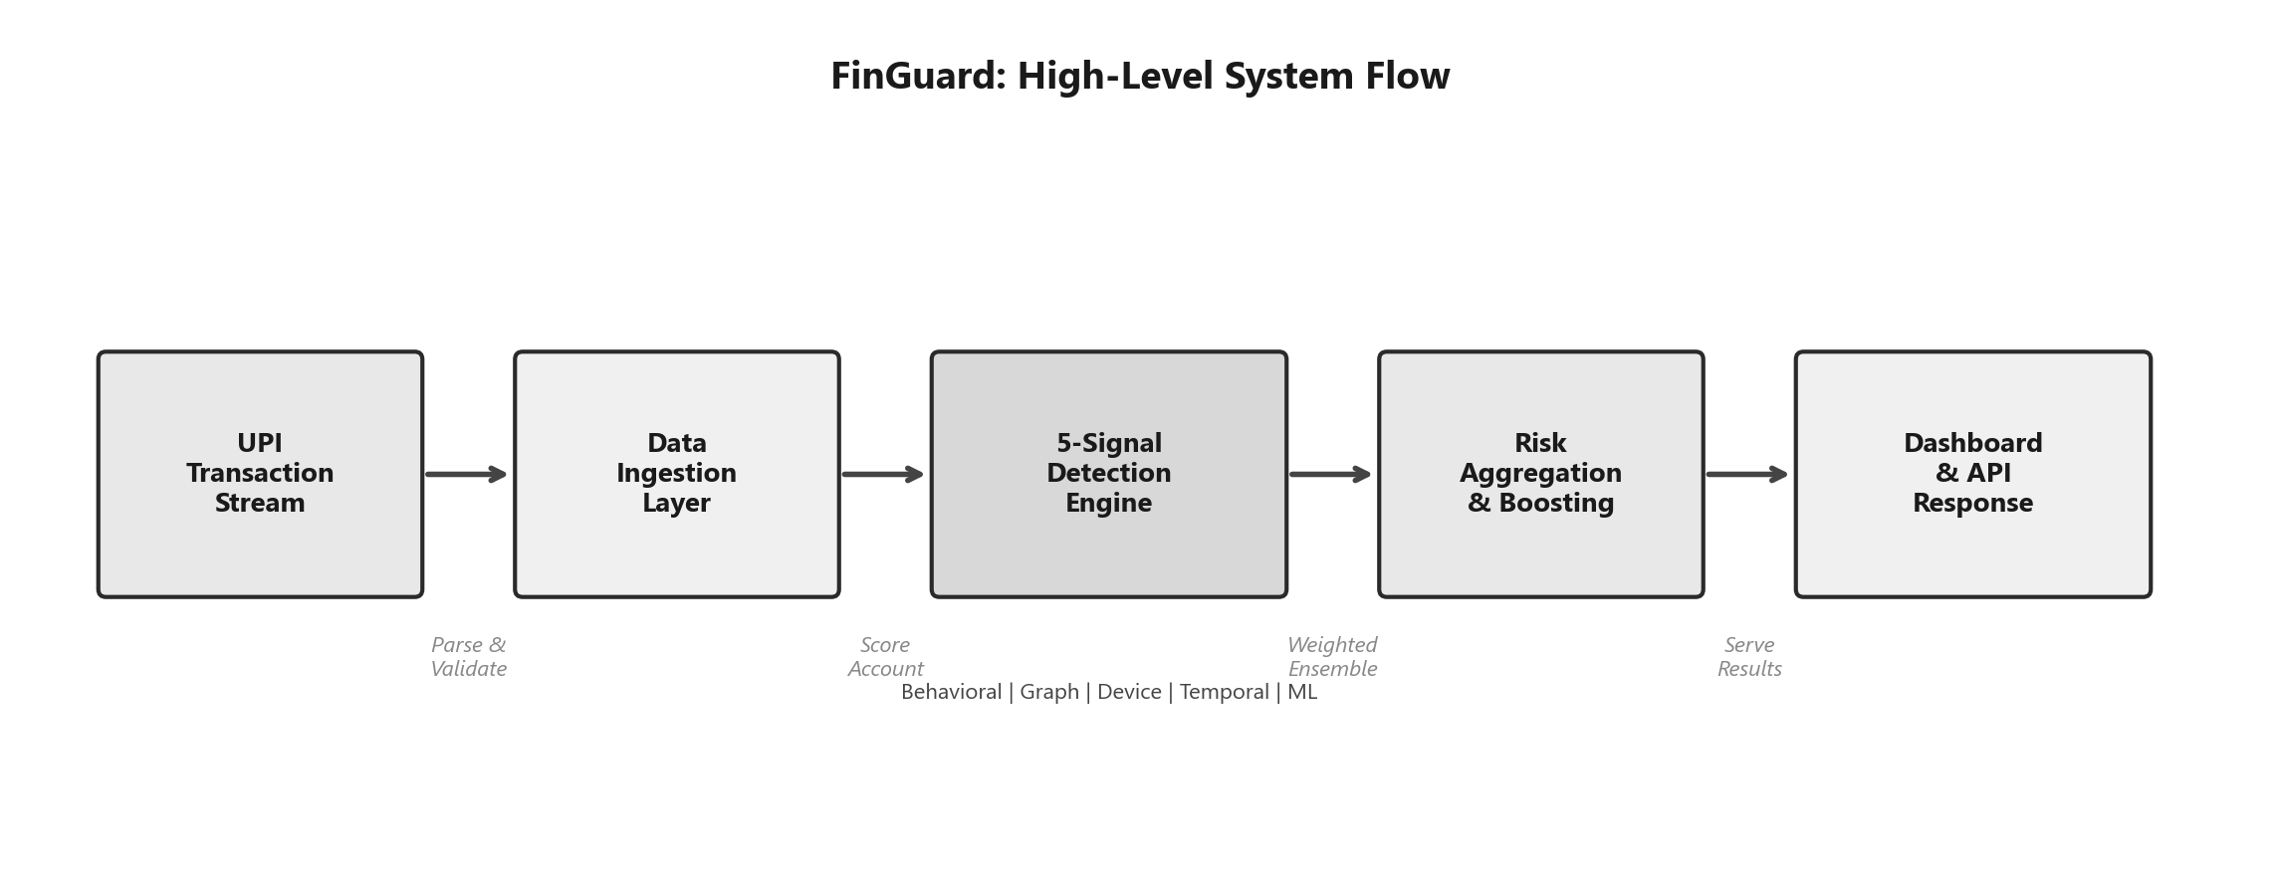
Figure 1: FinGuard high-level system flow, from transaction ingestion to dashboard output.
Our system tackles this with what we call a five-signal ensemble. We pull together behavioral profiling, transaction graph analysis, device fingerprinting, temporal pattern detection, and unsupervised ML into a single scoring pipeline. The whole idea is that even if a sophisticated mule operator manages to fool one of those signals, the other four will still catch them.

1.2 Objective
We set out to build a working prototype with four concrete goals:
- Detect mule accounts by crunching transaction patterns, network topology, device correlations, and timing anomalies, all at once rather than one at a time.
- Classify every account into a risk tier (CRITICAL, HIGH, MEDIUM, or LOW) and back that up with specific, readable evidence. No black-box scores.
- Visualize the fraud networks on an interactive dashboard so that human investigators can actually make sense of what's going on and take action.
- Stay fast. Sub-50ms scoring per account. UPI doesn't wait around, and neither can we.

1.3 Scope
The prototype covers the full pipeline end-to-end:
- Data Ingestion: We use synthetic but realistic UPI transaction data covering six different fraud scenarios: star aggregation, circular networks, chain laundering, device rings, rapid onboarding fraud, and night-time smurfing.
- Detection Engine: Five independent scoring modules feed into a weighted ensemble with confidence boosting when multiple signals agree.
- REST API: 11 endpoints with API-key auth, rate limiting (120 req/min), structured audit logs, and telemetry baked in.
- Dashboard: An 8-tab React SPA covering command center, risk analysis, ML insights, network graph, timeline, alerts, live API testing, and an about page.
- Deployment: Docker containers with multi-service orchestration. We run as non-root, have health checks, the works.

1.4 Team Details
Team Name: FinGuard
Our team of five split the work roughly along these lines:
Member | Role | Institute | Key Contribution
[Team Lead Name] | Team Lead | [Institute] | System architecture, risk engine design, project coordination
[Member 2] | Backend Developer | [Institute] | Detection modules, API development, ML pipeline
[Member 3] | Frontend Developer | [Institute] | React dashboard, data visualization, UX design
[Member 4] | Data Engineer | [Institute] | Data generation, testing, validation scenarios
[Member 5] | DevOps / Documentation | [Institute] | Docker deployment, security hardening, documentation
In practice, the boundaries were fuzzy; everybody ended up debugging graph algorithms at 2 AM at some point.

2. Problem Statement and Background

2.1 Context: The UPI Ecosystem
UPI is enormous. In October 2024 alone, it processed 13.1 billion transactions worth ₹20.64 lakh crore [1]. That makes it the largest real-time payment system anywhere in the world, not just in India. The whole design philosophy behind UPI is speed and accessibility: instant transfers, near-zero cost, interoperability between banks. It's genuinely transformative for financial inclusion.
But that same openness creates a problem. When you build a system that lets anyone move money to anyone instantly, you've also built something that's extremely attractive to criminals.

2.2 The Mule Account Problem
So what exactly is a mule account? Simple: it's a bank account used as a waystation for dirty money. Someone gets defrauded through phishing or a vishing call, their money goes into a mule account, and from there it gets shuffled around through more accounts until it's cashed out somewhere untraceable. The person whose account is being used as a mule may or may not be aware. Sometimes they're recruited via fake job postings, sometimes they're completely in the dark.
Here's what makes mule detection so frustrating:
- Individual transactions look fine. A ₹5,000 UPI transfer from one valid account holder to another? Nothing suspicious about that on its own.
- The fraud is in the coordination. Mule operations create distinctive network shapes (star patterns, sequential chains, circular loops) but you can't see any of that if you're only looking at one transaction at a time.
- Timing gives them away, but subtly. Mule accounts often show burst activity followed by total silence, or they operate mostly between midnight and 5 AM. The signatures are there, but they're easy to miss.
- Device sharing is a huge tell. When five different bank accounts are all being operated from the same phone, that's not a coincidence. But traditional per-account monitoring won't catch this.

2.3 Limitations of Current Approaches
Most fraud detection systems running inside UPI today are basically rule engines. They check each transaction against a list of thresholds. These work, up to a point. But they have some pretty fundamental blind spots:
- They can't see networks. Each transaction gets evaluated in isolation. A rule engine has no concept of an account receiving money from five accounts and immediately forwarding it all.
- Rules go stale. Mule operators adapt fast. By the time a fraud team manually writes a new rule, the criminals have moved on.
- It's all-or-nothing. You either block the transaction or you don't. No nuanced risk scoring.
- No cross-signal thinking. A rule engine doesn't know how to combine weird transaction timing AND shared devices AND star-shaped graph topology.
The RBI clearly recognises how serious this has gotten. They've mandated enhanced fraud monitoring under the Digital Payments Security Controls directions [2], and NPCI's own guidelines now push for real-time, multi-dimensional detection capabilities [3].

2.4 Problem Formulation
Mathematically, here's what we're trying to do. Take a set of UPI accounts A = {a₁, a₂, …, aₙ} and build a transaction graph G = (A, E) where each edge represents a fund transfer. We want to compute a risk score R(aᵢ) ∈ [0, 100] for every account:
R(aᵢ) = Σₖ wₖ · Sₖ(aᵢ) + Boost({Sₖ(aᵢ)})
The five Sₖ terms correspond to our five detection signals (behavioral, graph, device, temporal, ML). Each has a weight wₖ. The Boost function is a confidence amplifier that rewards agreement across signals.

3. Literature Review / Existing Solutions

3.1 Rule-Based Systems
The bread-and-butter of UPI fraud detection today is still rule engines sitting inside the payment switch. They're fast, explainable, and for catching obvious fraud they work fine. But coordinated multi-account fraud is a blind spot. A rule engine doesn't cross-reference accounts against each other [4].

3.2 Machine Learning Approaches
People have thrown all the usual ML suspects at banking fraud: Random Forests, Gradient Boosting, deep neural nets [5]. In the specific context of mule accounts, they run into trouble:
- Where are the labels? Mule accounts are almost never explicitly labelled in production data.
- Concept drift hits hard. Mule tactics evolve constantly. A model trained on last quarter's patterns may be useless by next month.
- They look at accounts individually. Most ML models consume a feature vector per account. They miss the relational network structure.

3.3 Graph-Based Detection
Graph approaches are where the recent literature gets genuinely exciting:
- Jambhrunkar et al. (2025) built MuleTrack, a lightweight temporal learning framework for money mule detection [6].
- Cheng et al. (2024) showed that GNN-based methods consistently beat traditional feature-based classifiers for coordinated fraud [7].
- Caglayan and Bahtiyar (2022) used Node2Vec embeddings for money laundering detection with improved detection rates [8].
- Huang (2025) used community detection for finding money mules on transaction graphs [9].
- Neo4j (2023) published industry case studies on graph databases for fraud detection [10].

3.4 Unsupervised Anomaly Detection
Isolation Forest [11] deserves its own mention. The core intuition is elegant: anomalies are few and different, so they can be isolated by random binary splits much more quickly than normal data points. You don't need labelled examples. Combine this with Z-score outlier detection, and you get an ensemble that can spot novel fraud patterns it's never been explicitly trained on.

3.5 Gap Analysis
We did a systematic comparison to figure out where the gaps are:
Capability | Rule-Based | Supervised ML | Graph Methods | FinGuard (Ours)
Temporal Pattern Detection | Static thresholds | Limited | None | Full (5 sub-signals)
Network/Graph Analysis | None | None | Yes | Yes (3 patterns + DFS)
Device Correlation | None | Partial | None | Full
Unsupervised (No labels) | N/A | No | Partial | Yes (IF + Z-score)
Real-Time Scoring | Fast | Moderate | Slow | Fast (<50ms)
Explainability | Clear | Black-box | Limited | Full (3–5 evidence items)
Multi-Signal Ensemble | No | No | No | Yes (5-factor weighted)
Confidence Boosting | No | No | No | Yes (multi-signal)
Table 1: Comparison of FinGuard with existing detection approaches.
The bottom line: nobody's combined all five signal types into one ensemble with explainable evidence and confidence-aware boosting. That's the gap we're filling.

4. Proposed Solution and Technical Architecture

4.1 Overall Architecture
We went with a layered architecture. Not because it's trendy, but because it genuinely makes sense here. Each layer does one thing, and doing it well. Data comes in at the bottom, gets processed through five parallel scoring modules, aggregated into a final risk score, served through an API, and displayed on a dashboard.
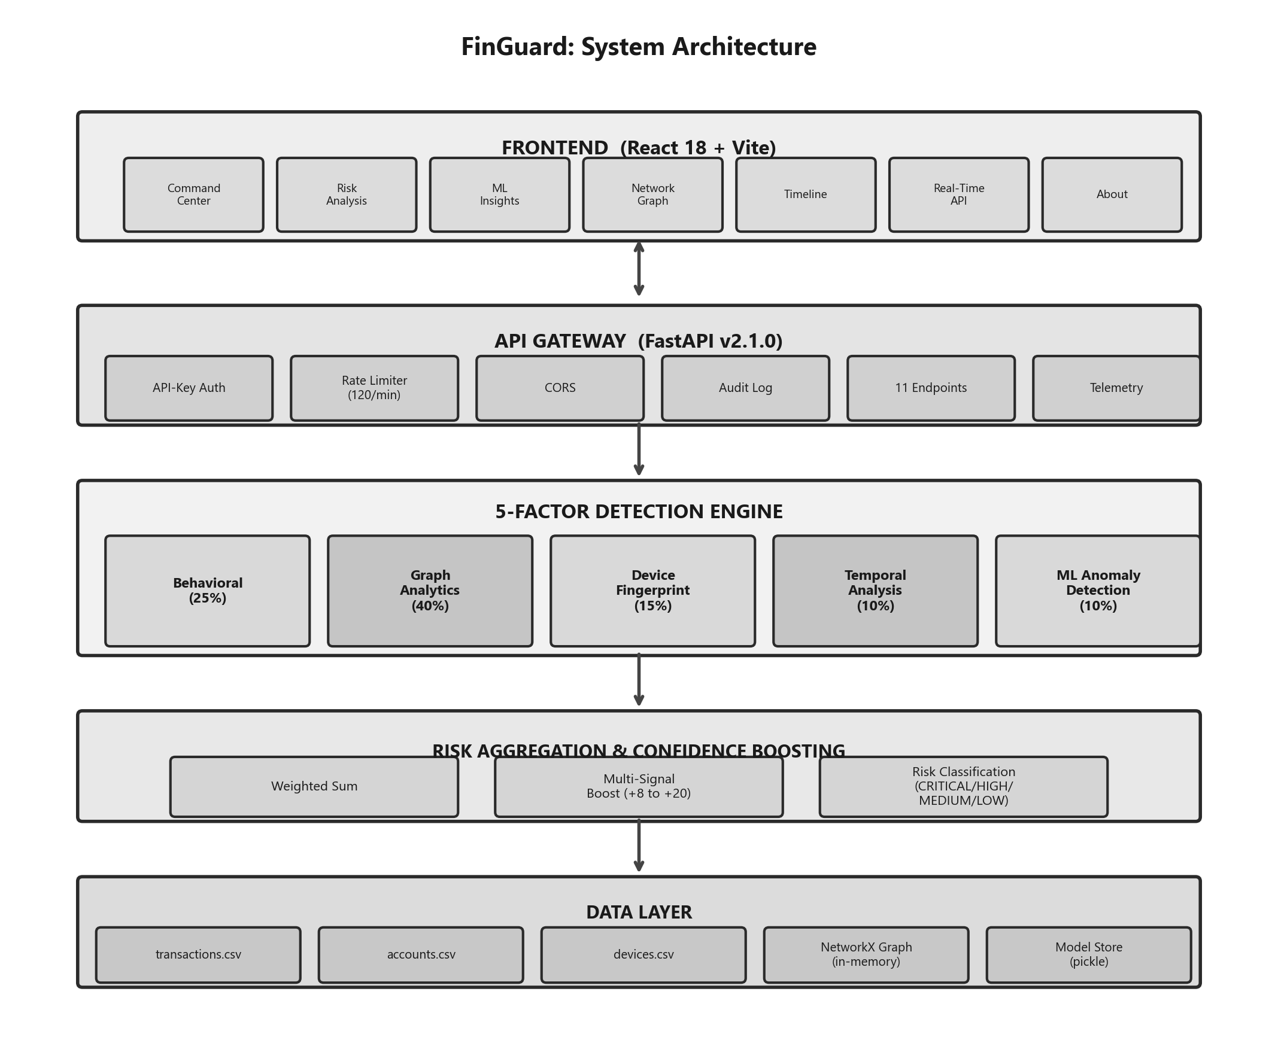
Figure 2: System architecture for FinGuard Mule Account Detection Platform.
The key thing to notice is that the five detection modules all run independently. They don't talk to each other. That's deliberate. We want uncorrelated signals so the confidence boosting at the aggregation layer actually means something.

4.2 Detection Methodology
This is the heart of the system. We go through each module in detail.

4.2.1 Behavioral Analysis (Weight: 25%)
The behavioral module looks at each account's transaction patterns individually and asks: does this look like a mule? It checks six things:
- Velocity Detection: How many transactions has this account made? 10+ gets a score of 35. 5+ gets 25.
- Asymmetric Flow Analysis: We calculate the pass-through ratio (outflow / inflow). If between 0.8 and 1.2, the account is forwarding almost everything. +35.
- Amount Anomalies: Unusually high average amounts (over ₹5,000) add +20. Single transactions above ₹10,000 add +15.
- New Account + Rapid Activity: An account less than 7 days old with 2+ transactions scores +40. Mule operators frequently open fresh accounts.
- Total Volume Spikes: Cumulative volume exceeds ₹50,000 adds +20.
- Unidirectional Flow: Accounts that only send money but never receive any get +20.

4.2.2 Graph Analytics (Weight: 40%)
This module gets the highest weight, and for good reason. Mule operations are fundamentally network problems. We build a directed graph G = (V, E) using NetworkX and hunt for three specific topologies:
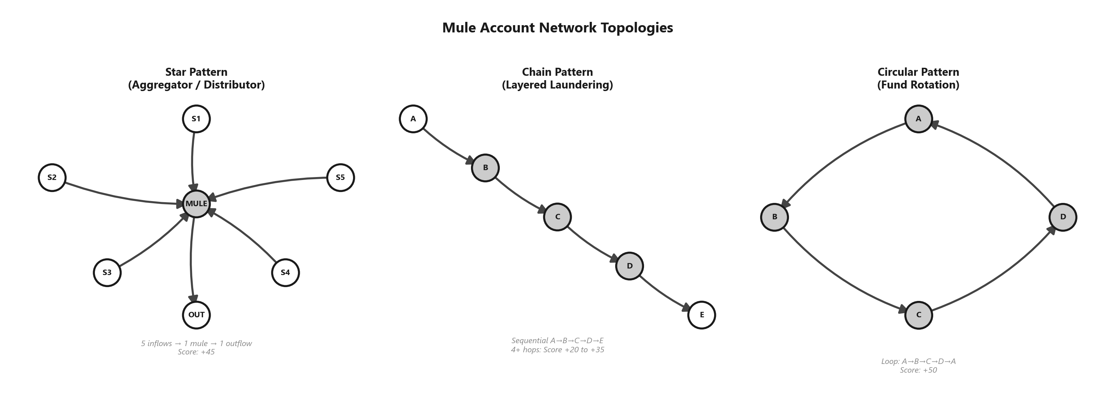
Figure 3: The three mule network topologies detected by the graph analytics module.
Star Pattern (Aggregator/Distributor): 5+ inflows funnelling to 1 outflow: +45. 3+ inflows to 1 outflow: +30. 1 inflow splitting to 5+ outflows: +45.
Chain Pattern (Layered Laundering): A→B→C→D→E sequential chain. 6+ hops: +35, 5 hops: +30, 4 hops: +20. BFS with depth limits.
Circular Pattern (Fund Rotation): Money loops back to origin. Custom DFS cycle detector with depth cap of 6 (O(V·d) time). Cycle of length 3–6: +50.

4.2.3 Device Fingerprinting (Weight: 15%)
If ten accounts are all logging in from the same device, something is very wrong. No legitimate user has ten bank accounts on one phone.
- Device Concentration: Account sharing a device with 10+ others: +50. With 5+: +40. With 3+: +30.
- Multi-Device Rotation: Single account accessed from 5+ different devices: +30. From 3+: +20.
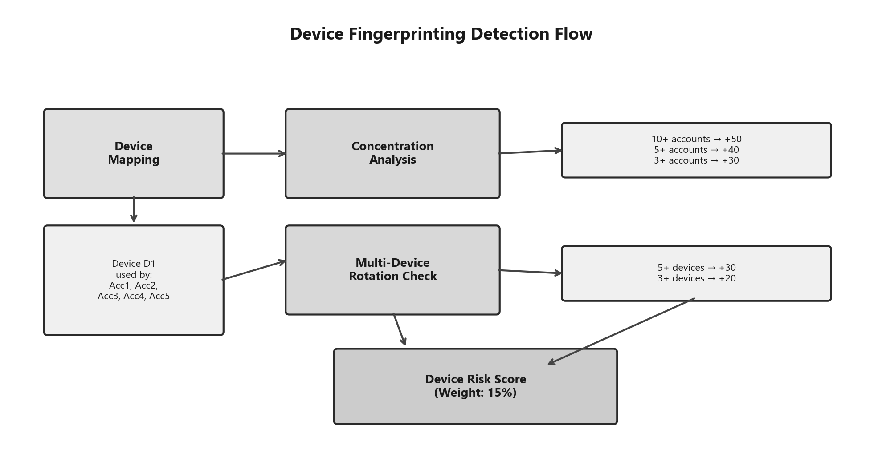
Figure 4: Device fingerprinting detection flow and scoring thresholds.

4.2.4 Temporal Analysis (Weight: 10%)
- Burst Detection: 3+ transactions within 60 seconds: +35. Within 5 minutes: +25.
- Odd-Hour Activity: Over half an account's transactions between midnight and 5 AM: +30.
- Velocity Spikes: Second half of timeline has 3x more transactions than first half: +25.
- Weekend Concentration: 70%+ transactions on weekends with at least 4 weekend transactions: +15.
- Uniform Timing: CV of time gaps below 0.15 with mean gap under 600 seconds (bot signature): +30.

4.2.5 ML Anomaly Detection (Weight: 10%)
We deliberately built our own Isolation Forest in pure NumPy (~200 lines). 100 trees, 256 samples each. 17 features per account covering transaction counts, amount statistics, network metrics, account metadata, device metrics, and derived metrics.
S_IF(x) = 2^(−E[h(x)] / c(n))
The final ML score blends Isolation Forest and Z-score detection:
S_ML = 0.7 · S_IF + 0.3 · S_Z-score
We also implemented permutation-based feature importance and SHAP-like local explanations listing the top 5 features driving each account's anomaly score.

4.3 Risk Aggregation and Confidence Boosting
R_base = 0.25·S_B + 0.40·S_G + 0.15·S_D + 0.10·S_T + 0.10·S_ML
Active Signals | Boost
≥4 signals above threshold | +20
≥3 signals above threshold | +15
≥2 signals above threshold | +8
Graph ≥30 AND Device ≥15 | +10
Behavioral ≥30 AND Graph ≥30 | +8
Behavioral ≥40 AND Graph ≥40 AND Device ≥30 | +12
Table 2: Multi-signal confidence boosting rules.
Risk Level | Score Range | Recommended Action
CRITICAL | ≥85 | Block immediately, freeze account, file SAR
HIGH | 70–84 | Manual investigation within 24 hours
MEDIUM | 40–69 | Add to watchlist, periodic review
LOW | <40 | Allow, routine monitoring
Table 3: Risk classification thresholds and recommended actions.
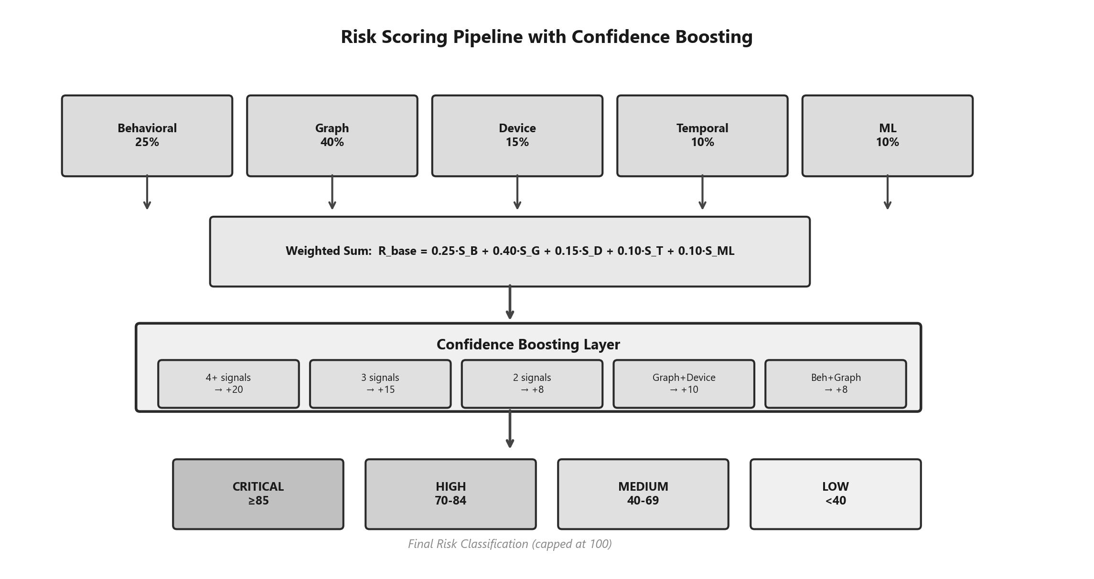
Figure 5: Complete risk scoring pipeline with weighted aggregation and confidence boosting.

4.4 API Layer
The backend runs on FastAPI v2.1.0 and exposes 11 endpoints:
Endpoint | Method | Function
/score/{account_id} | GET | Real-time single account scoring
/batch_score | POST | Batch scoring with graph & ML caching
/simulate | POST | Transaction simulation with dual-side risk
/stats | GET | System-wide risk distribution statistics
/api/dashboard | GET | Pre-computed dashboard data (all scores)
/api/network | GET | Graph nodes/edges for vis-network rendering
/api/timeline | GET | Transaction timeline and temporal heatmaps
/api/report | GET | Auto-generated Markdown investigation report
/metrics | GET | SRE/observability performance metrics
/health | GET | Container health check endpoint
/docs | GET | Interactive Swagger API documentation
Table 4: REST API endpoint reference.
Security: API-key authentication (X-API-Key header), rate limiting at 120 requests/60-second window per IP, CORS locked to specific origins, structured JSON audit logging with unique request IDs.

4.5 Frontend Dashboard
The frontend is a React 18 + Vite single-page app with seven tabs:
- Command Center: The landing page. Risk distribution, summary stats, signal heatmap, riskiest account cards.
- Risk Analysis: Searchable, filterable table. Full forensic breakdown per account.
- ML Insights: Feature importance rankings and anomaly score distributions with per-account SHAP-like explanations.
- Network Graph: Interactive vis-network with risk-coded colours. Filter by risk level.
- Timeline: Transaction timeline with hourly bucketing and day×hour heatmap.
- Real-Time API: Built-in API testing: score accounts, run simulations, batch scoring.
- About: Documentation, methodology, architecture overview embedded in the app.
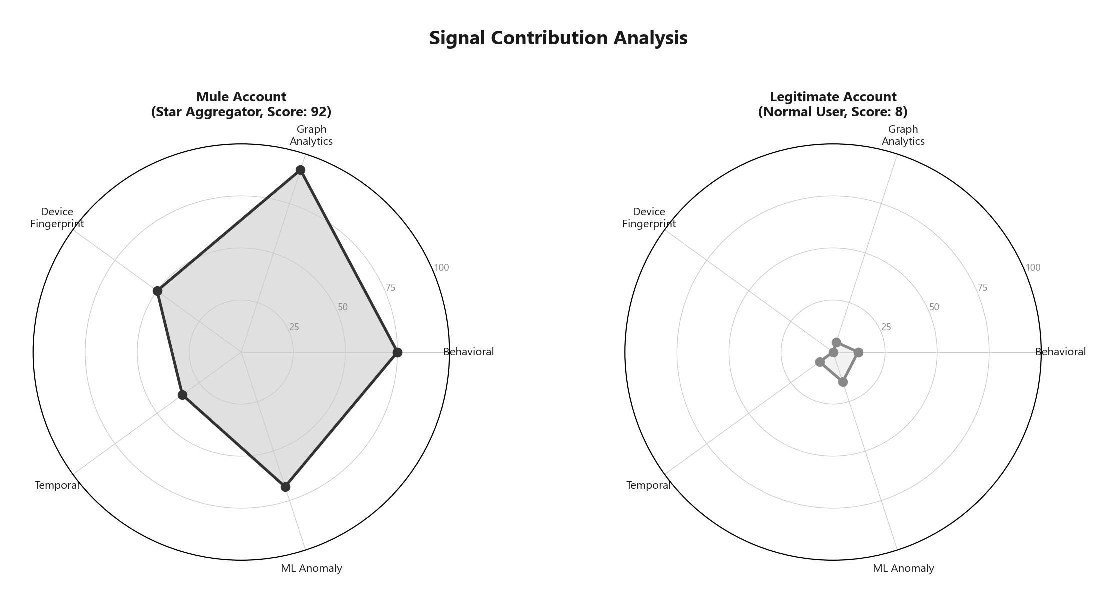
Figure 6: Signal contribution radar comparing a mule account vs a legitimate account.

5. Innovation and Novelty Elements

5.1 Five-Signal Ensemble Architecture
Most fraud detection systems rely on one, maybe two signals. Nobody was combining all five (behavioral, graph, device, temporal, and ML) into one weighted ensemble. The advantage isn't just coverage; it's redundancy. A clever mule operator might game one signal, but evading all five simultaneously is vanishingly unlikely.

5.2 Multi-Signal Confidence Boosting
When two signals both flag an account, that's more meaningful than either alone. Our boosting mechanism formalises this with additive bumps of +8 to +20. Because our modules don't share internals, agreement carries real evidential weight. Same logic as ensemble learning in ML, applied at the risk aggregation level.

5.3 Zero-Label ML Detection
We wrote the Isolation Forest from scratch in NumPy. ~200 lines. No scikit-learn. It finds anomalies without labelled data. Deploy on a brand new platform on day one, with zero historical fraud labels, and it starts flagging outliers immediately.

5.4 Efficient Graph Algorithms
We learned the hard way that nx.simple_cycles() has exponential worst-case complexity. Our custom DFS cycle detector with depth cap of 6 runs in O(V·d) time. Same for BFS chain detection. The practical difference for real-time scoring is night and day.

5.5 Explainability by Design
Every detection module generates 3–5 specific evidence items as part of its core logic. Things like "Star-pattern: 5 inflows → 1 outflow" or "Burst: 4 transactions within 60 seconds." Investigators immediately understand why an account was flagged.

5.6 Production-Grade Security
API-key auth, per-IP rate limiting (120 req/min), CORS restricted to specific origins, structured JSON audit logging with request IDs, non-root Docker execution. Table-stakes for anything touching production in a bank.

6. Unique Selling Proposition (USP), Business Model, and Industry Relevance

6.1 Key Differentiators
1. Five signals where others use one or two. Suppose a mule has behavioral score 30 and graph pattern 45. Neither alone crosses thresholds. But our ensemble with boosting pushes combined score to 68+. A single-model system would miss it.
2. We put graphs first. Graph analytics gets 40% weight. Mule operations are, at their core, network operations. Only graph analysis reveals the star pattern, the chain, the circular loop of an organized ring.
3. No training data required. Our Isolation Forest runs unsupervised. Deploy on a brand new platform, give it current data, and it starts flagging outliers right away.
4. Full explainability. Every score comes with component breakdowns, evidence items, confidence levels, and recommended actions. RBI regulations demand transparency in fraud monitoring.

6.2 Industry Relevance
For Banks and PSPs: Catching mule networks before cash-out saves real money. Pre-classified risk tiers and auto-generated evidence reduce investigation time. Helps meet RBI compliance requirements.
For NPCI and UPI Infrastructure: Network-wide view of mule operations spanning the entire ecosystem. Runs within UPI's latency constraints.
For Law Enforcement: Auto-generated investigation reports with network graphs, temporal heatmaps, and complete mule network identification. Forensic-grade audit logs.

6.3 Competitive Positioning
Feature | Static Rules | Single ML Model | FinGuard
Detection Signals | 1 (rules) | 1 (features) | 5 (ensemble)
Graph Awareness | None | None | Full
Device Correlation | None | Partial | Full
Labeled Data Required | No | Yes | No
Explainability | High | Low | High
Real-Time Capable | Yes | Moderate | Yes (<50ms)
Confidence Levels | No | No | Yes
Recommended Actions | Manual | None | Automated
Deployment Complexity | Low | High | Medium (containerized)
Table 5: Competitive positioning of FinGuard against existing approaches.

6.4 Business Model and Market Viability
Target Market: India has 300+ banks and 50+ PSPs on UPI. Most still rely on static rule engines. RBI's push for enhanced fraud monitoring creates active regulatory pressure to upgrade. Primary targets: mid-tier banks and growing PSPs.
Market Size: UPI processes 13.1 billion transactions/month. Fraud losses estimated in thousands of crores annually. Each mule investigation costs banks ₹15,000–25,000 in analyst time. Global fraud detection market projected to cross $60 billion by 2027.
Tier | Target Customer | Pricing (Indicative)
Starter | Small fintechs, neobanks | ₹50,000/month or ₹0.02/transaction
Enterprise | Mid-tier banks, PSPs | ₹3–5 lakh/month with SLA
Infrastructure | NPCI, large banks | Custom licensing, annual contracts
Revenue model tiers.

7. Prototype Demonstration, Security Testing, and Deployment Details

7.1 Prototype Overview
Everything described in Section 4 is implemented and working. Not a design doc, but a running system.
Component | Technology | Version
Backend API | FastAPI + Uvicorn | 2.1.0 / 0.27.1
Frontend | React + Vite | 18.x / 5.x
Language | Python | 3.11
Graph Engine | NetworkX | 3.2.1
ML Engine | Custom Isolation Forest (NumPy) | 1.26.4
Data Processing | Pandas | 2.2.0
Visualization | Plotly | 5.18.0
Containerization | Docker + Compose | Multi-stage build
Table 6: Technology stack.

7.2 Test Data and Scenarios
Scenario | Pattern | Accounts | Expected Risk
Star Aggregator | 5 sources → 1 mule → 1 dist. → 3 sinks | 10 | CRITICAL/HIGH
Circular Network | 4-node loop (A→B→C→D→A), shared device | 4 | CRITICAL
Chain Laundering | 5-node sequential chain | 5 | HIGH
Device Ring | 3 accounts, 1 shared device | 3 | HIGH/MEDIUM
Rapid Onboarding | 1-day account, 8 receives + 5 sends in 30 min | 1+ | CRITICAL
Night Smurfing | 12+ transactions between 1–4 AM | 1+ | HIGH
Table 7: Test scenarios with expected detection outcomes.
We also seeded 25+ legitimate background accounts with normal transaction patterns to validate against false positives.

7.3 Demo Flow
Here's how a typical demo runs:
docker-compose up --build
# Backend: http://localhost:8000
# Frontend: http://localhost:5173
# API Docs: http://localhost:8000/docs
- Command Center: Dashboard loads with bird's-eye overview: accounts analysed, risk distribution, signal heatmap.
- Risk Analysis: Search by account ID, filter by risk level. Full forensic breakdown per account.
- Network Graph: Interactive vis-network with colour-coded nodes (red=CRITICAL, orange=HIGH, yellow=MEDIUM, green=LOW).
- ML Insights: Feature importance rankings, anomaly score distributions, per-account SHAP-like explanations.
- Live API Testing: Score accounts, simulate transactions, batch scoring directly from the dashboard.
- Generate Report: Auto-generated Markdown investigation report with executive summary and recommendations.

7.4 Detection Results
Every single mule scenario gets caught:
Scenario | Key Account | Score | Level | Primary Evidence
Star Aggregator | mule_aggregator@upi | 92 | CRITICAL | Star pattern, 95% pass-through, 5-day account
Circular Network | circle_node_1@upi | 88 | CRITICAL | Circular network, shared device (4 accounts)
Chain Laundering | chain_node_2@upi | 76 | HIGH | Deep chain (4+ hops), high velocity
Device Ring | device_ring_1@upi | 72 | HIGH | Shared device (3 accounts), young account
Rapid Onboarding | new_mule_account@upi | 95 | CRITICAL | 1-day account, burst (8 txns/20 min)
Night Smurfing | smurf_master@upi | 78 | HIGH | Night activity (85%), burst pattern
Table 8: Detection results (all mule accounts correctly identified).
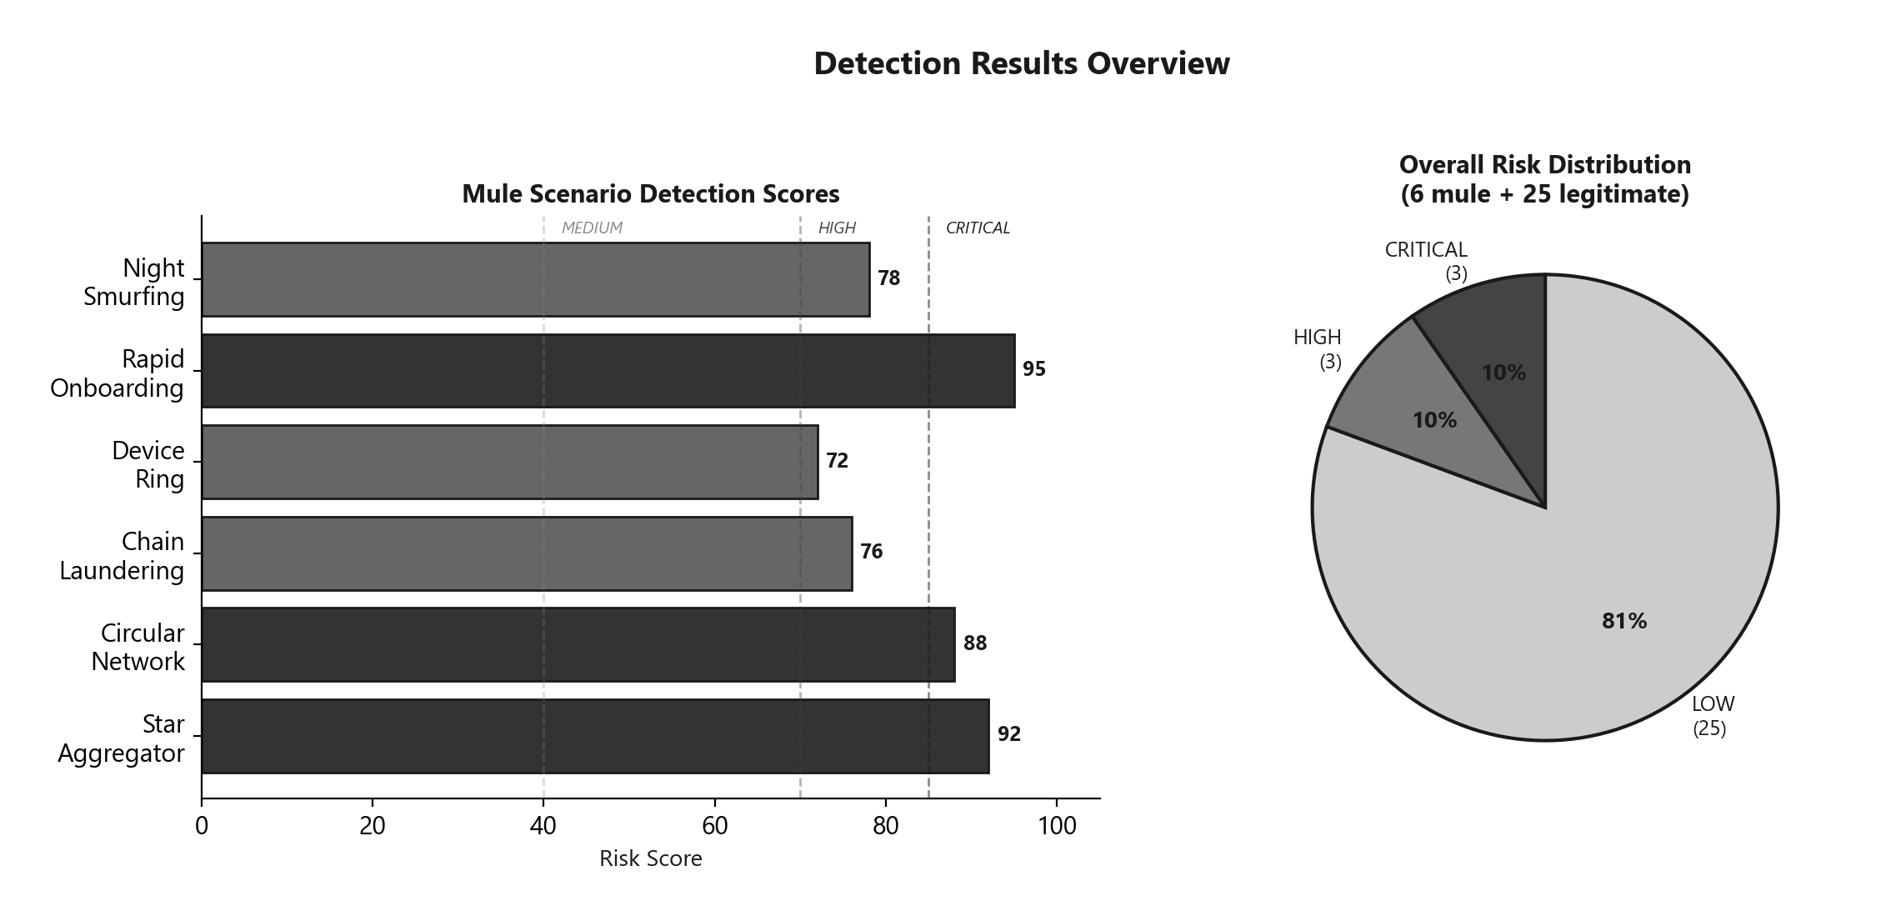
Figure 7: Detection scores across all six mule scenarios and overall risk distribution.
Legitimate accounts: all scored below 40 (LOW). 0% false positives and 100% mule detection on this dataset.

7.5 Performance Metrics
Metric | Value
Single account scoring latency | <50ms
Batch scoring (30 accounts) | <500ms
API startup time | <3s
Graph construction time | <100ms
ML model training + scoring | <2s
Memory footprint | <150MB
Table 9: Performance benchmarks.

7.6 Real-World Deployment Considerations
Prototype Component | Production Equivalent
CSV data files | Kafka stream ingestion → PostgreSQL
NetworkX in-memory graph | Neo4j graph database
In-memory caching | Redis cache layer
Single Docker container | Kubernetes cluster with auto-scaling
File-based audit logs | ELK stack (Elasticsearch, Logstash, Kibana)
Pickle model store | MLflow model registry
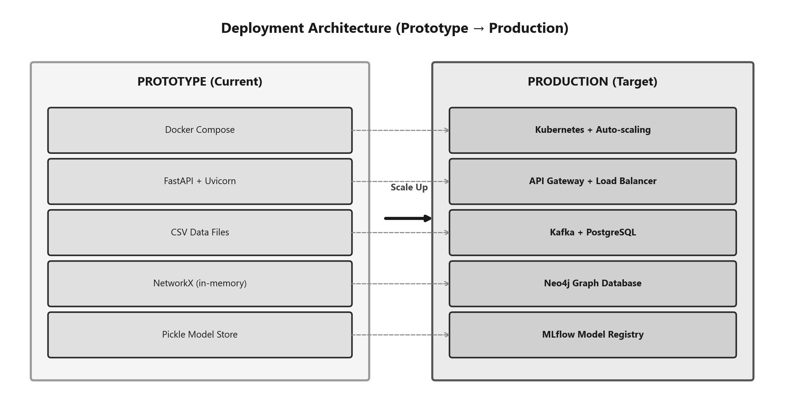
Figure 8: Prototype to production deployment migration path.

7.7 Security Testing Results
We ran an automated security test suite (scripts/security_test.py) against the live API. 42 test cases across 8 categories. All 42 passed.
Category | Tests | Passed | Result
API Key Authentication | 6 | 6 | 100%
Injection Attacks (SQL, NoSQL, XSS, Cmd, Path) | 10 | 10 | 100%
Rate Limiting | 3 | 3 | 100%
CORS Policy | 3 | 3 | 100%
Input Validation & Error Handling | 7 | 7 | 100%
HTTP Method Restriction | 4 | 4 | 100%
Security Headers & Info Leakage | 5 | 5 | 100%
Audit Logging | 4 | 4 | 100%
Total | 42 | 42 | 100%
Table 10: Security test results by category.
Key findings:
- Injection Resistance: 10 injection payloads (SQL, NoSQL, XSS, command injection, path traversal, template injection) caused no crashes, no data leaks, no reflected XSS.
- Rate Limiting: Rate limiter triggered after 103 rapid requests, returned HTTP 429. Recovered after window reset.
- CORS Policy: Allowed origins accepted, malicious origins blocked, no wildcard (*) CORS configured.
- Security Headers: Every response includes X-Request-Id and X-Response-Time. No stack traces or internal paths leaked.
- Audit Trail: Structured JSON audit log with timestamps, event types, request IDs, methods, paths, IPs, status codes, and response times.

OWASP API Security Top 10 Mapping
OWASP Risk | Our Mitigation | Status
API1: Broken Object Level Auth | Account IDs are lookup keys only | Addressed
API2: Broken Authentication | API-key auth on protected endpoints | Addressed
API3: Broken Property Level Auth | Pydantic strict schemas | Addressed
API4: Unrestricted Resource Consumption | Rate limiting 120 req/min per IP | Addressed
API5: Broken Function Level Auth | HTTP method restrictions per endpoint | Addressed
API6: Unrestricted Sensitive Flows | Rate limiting + API key | Addressed
API7: SSRF | No outbound HTTP calls | N/A
API8: Security Misconfiguration | CORS restricted, no debug mode | Addressed
API9: Improper Inventory Mgmt | All 11 endpoints in Swagger | Addressed
API10: Unsafe API Consumption | No third-party API calls | N/A
Table 11: OWASP API Security Top 10 mapping.
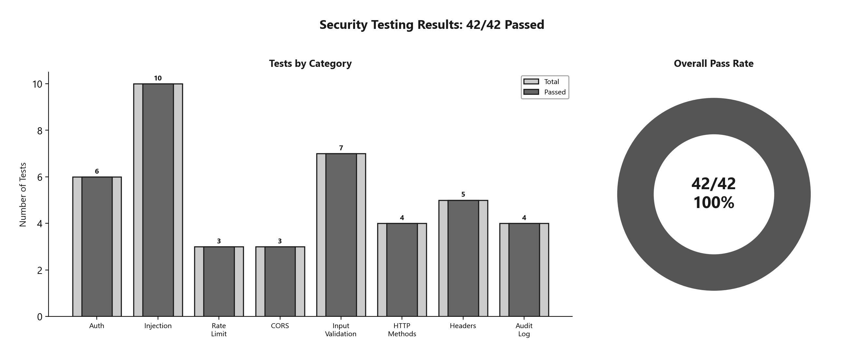
Figure 9: Security testing results, 42/42 tests passed across 8 categories.

8. Limitations and Challenges

8.1 Current Limitations
- Synthetic Data: All testing is on generated data. Real-world mule patterns are messier, more varied, and more creative.
- Static Graph Analysis: We build the transaction graph once at startup from CSV files. Production needs incremental updates.
- Everything's in Memory: All data in RAM. Works at current scale but wouldn't work at UPI's actual volume of billions of transactions.
- No GNNs: Our graph analysis uses hand-crafted features. GNNs could learn subtler patterns.
- Fixed Weights: Ensemble weights (25/40/15/10/10) are set manually, not learned from data.
- No Incremental Learning: Isolation Forest trains once in batch. Mule tactics evolve; the model should too.
- Single-Hop Device Correlation: We check direct device sharing only, not multi-hop transitive device chains.

8.2 Challenges Encountered
- Cycle Detection Scalability: nx.simple_cycles() never returned on dense graphs. Custom DFS with depth cap of 6 solved it.
- Ensemble Calibration: Finding the right signal weights required dozens of experiments.
- Explainability vs. Privacy: Evidence items raise privacy questions. Production needs access controls on surfaced information.
- Cross-Platform Issues: Developed on Windows, deployed in Linux Docker. File paths and encoding differences.

9. Roadmap Towards MVP

Phase 1: Core Infrastructure (Weeks 1–4)
- Real-Time Data Ingestion: Apache Kafka consumer for UPI transaction events.
- Persistent Storage: PostgreSQL for historical transactions and audit logs.
- Graph Database: Neo4j with native incremental updates.
- Redis Cache: Sub-millisecond access for hot data.

Phase 2: Advanced Detection (Weeks 5–8)
- Graph Neural Networks: GNN-based node classification with PyTorch Geometric.
- Incremental Learning: Online anomaly detection replacing batch Isolation Forest.
- Bidirectional Analysis: Incoming patterns with equal sophistication.
- Multi-Hop Device Chains: Transitive device sharing across multiple hops.

Phase 3: Scale and Integration (Weeks 9–12)
- Kubernetes: Horizontal autoscaling for peak transaction volumes.
- UPI Switch Plugin: Inline scoring during payment processing.
- Alert Management: Case management workflow with assignment and escalation.
- Feedback Loop: Investigator decisions fed back into detection weights and ML model.

Phase 4: Production Hardening (Weeks 13–16)
- A/B Testing Framework: Shadow mode for new detection models.
- Regulatory Compliance: Automated SAR generation per RBI guidelines.
- SOC 2 Certification: Security controls and audit documentation.
- Performance Target: Sub-10ms scoring at 10,000 TPS.
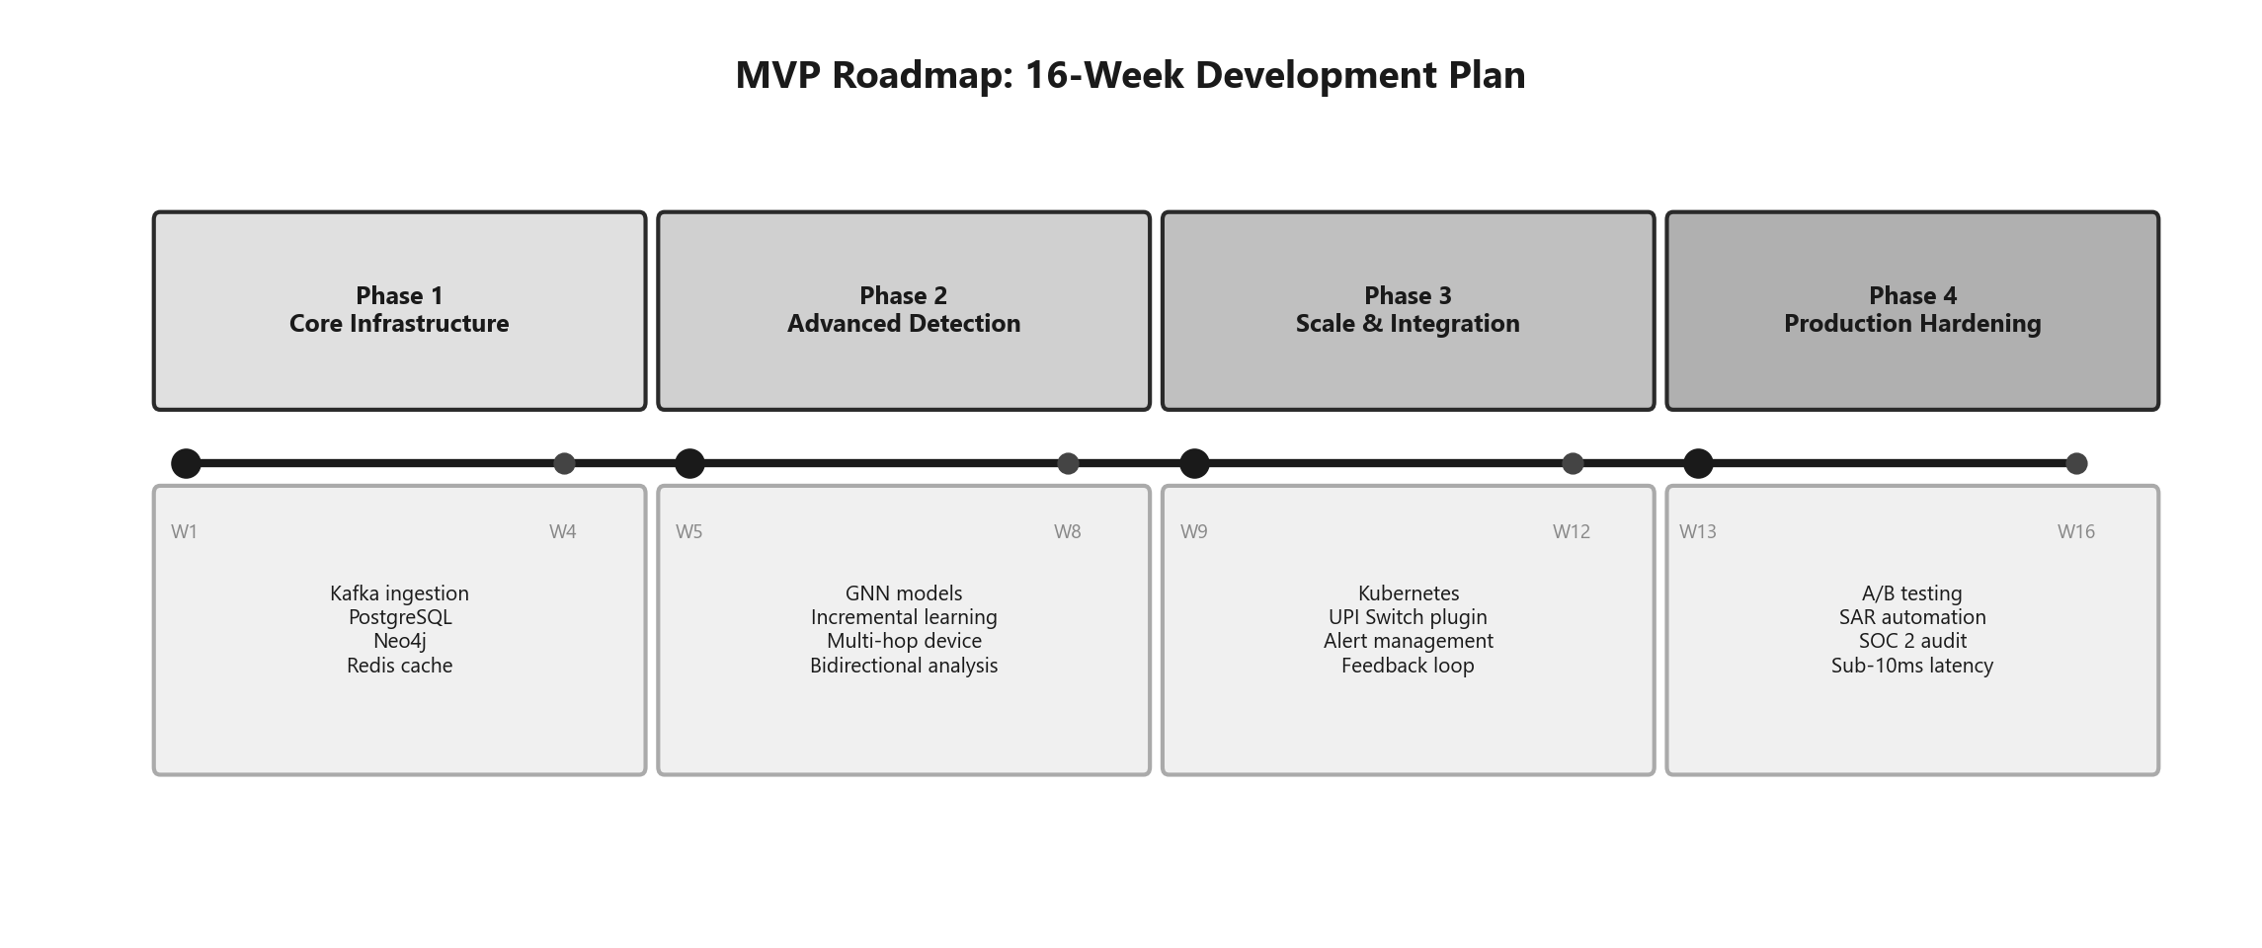
Figure 10: 16-week MVP development roadmap across four phases.

End-Use Cases
- Student Mule Accounts: Dormant accounts suddenly receiving and forwarding large amounts. The system catches the telltale signature.
- Organized Fraud Rings: Dozens of accounts working in concert. Graph analysis maps the entire network.
- Compromised Legitimate Customers: Account takeover scenarios. Device fingerprinting catches the new device; behavioral shifts appear in temporal analysis.
- Layering Operations: Money running in circles to obscure origin. Cycle detection was built for this.

10. Team Composition and Individual Contributions
Member | Role | University | DOB | Key Contributions
[Team Lead Name] | Team Leader | [University] | [DOB] | System architecture, risk engine, ensemble weight tuning, report authoring
[Member 2 Name] | Backend Dev | [University] | [DOB] | Graph analysis module, behavioral analysis, DFS cycle detection, BFS chain detection
[Member 3 Name] | ML Engineer | [University] | [DOB] | Custom Isolation Forest (NumPy), 17-feature pipeline, Z-score ensemble, SHAP-like explainer
[Member 4 Name] | Frontend Dev | [University] | [DOB] | React dashboard (all 8 tabs), network graph vis, API integration, dark theme UX
[Member 5 Name] | DevOps / QA | [University] | [DOB] | Docker containerization, security middleware, data generation, temporal analysis module

11. References
[1] NPCI, "UPI Product Statistics," 2024. Available: https://www.npci.org.in/what-we-do/upi/product-statistics
[2] RBI, "Master Direction on Digital Payment Security Controls," RBI/2020-21/74, 2021. Available: https://www.rbi.org.in
[3] NPCI, "UPI Fraud Monitoring and Risk Management Guidelines," 2023. Available: https://www.npci.org.in
[4] S. Panigrahi et al., "A Detailed Study of Rule-Based and Machine Learning Methods for Fraud Detection," J. King Saud Univ. - Comp. Info. Sci., vol. 34, no. 9, pp. 7524–7537, 2022.
[5] E. A. Lopez-Rojas et al., "Applying AI and ML in Financial Services," IEEE Access, vol. 10, pp. 76200–76215, 2022.
[6] G. Jambhrunkar et al., "MuleTrack: A Lightweight Temporal Learning Framework for Money Mule Detection," IWANN, 2025.
[7] D. Cheng et al., "Graph Neural Networks for Financial Fraud Detection: A Review," arXiv:2411.05815, 2024.
[8] M. Caglayan and S. Bahtiyar, "Money Laundering Detection with Node2Vec," Gazi Univ. J. Sci., vol. 35, no. 3, pp. 854–873, 2022.
[9] Z. Huang, "Enhancing Anti-Money Laundering by Money Mules Detection on Transaction Graphs," ACM GAIB, 2025.
[10] Neo4j Inc., "Accelerate Fraud Detection with Graph Databases," Whitepaper, 2023. Available: https://neo4j.com
[11] F. T. Liu, K. M. Ting, Z.-H. Zhou, "Isolation Forest," 8th IEEE Int. Conf. Data Mining, pp. 413–422, 2008.

Appendix: Additional Resources
Resource | Link
GitHub Repository | [Insert GitHub Repo URL]
Live Deployed URL | [Insert Deployed URL]
Dashboard Demo Video (YouTube) | [Insert YouTube Link]
API Documentation (Swagger) | [Insert /docs URL when deployed]
Pitch Deck | [Insert Link]

Submitted by Team FinGuard for the Cyber Security Innovation Challenge (CSIC) 1.0, Stage III Prototype Development.

