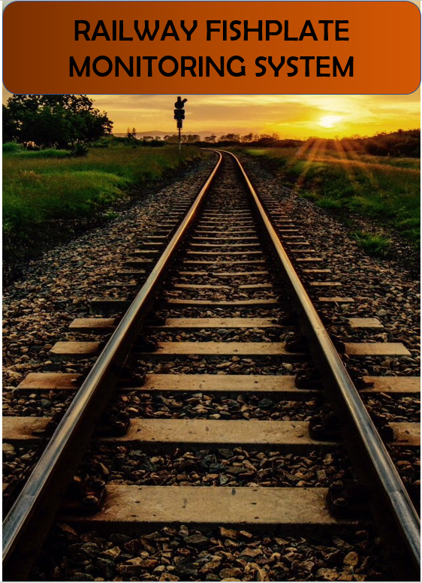



**BANGLADESH UNIVERSITY OF ENGINEERING AND TECHNOLOGY**

**Department of Electrical and Electronic Engineering**

**Course No. :** EEE 310

**Course Title:** Communication Laboratory **Section :** B1

**Project Name:** Railway Fish Plate Monitoring System

**Submitted To:**

*Dr. Md. Farhad Hossain*

Professor, Dept of EEE, BUET.

*Munia Ferdoushi*

Lecturer, Dept. of EEE, BUET

**Submitted By:**

SUAIB AL SUFI (1606070)

MIZANUR RAHMAN (1606073)

RIZWAN AHAMED (1606074)

ABIR KALLAYAN ABEDIN (1606091)

**Date of Submission: 18 September,2019.**

**Abstract:**

The project is about designing a system to provide additional safety in railway transportation. In [rail terminology](https://en.wikipedia.org/wiki/Rail_terminology), a fishplate, splice bar or joint bar is a metal bar that is bolted to the ends of two rails to join them together in a [track](https://en.wikipedia.org/wiki/Rail_tracks). Our Aim of the project is to detect whether the bolts are loosened or not, if bolts are loosen then a warning message will be sent to the main control room and a nearest station.

**Introduction:**

Rail fish plate, also called rail joint bars, is one of the most common kinds of rail fasteners. The name is derived from fish, a wooden bar with a curved profile used to strengthen a ship's mast. The top and bottom edges are tapered inwards so the device wedges itself between the top and bottom of the rail when it is bolted into place. In [rail transport modelling](https://en.wikipedia.org/wiki/Rail_transport_modelling), a fishplate is often a small [copper](https://en.wikipedia.org/wiki/Copper) or [nickel silver](https://en.wikipedia.org/wiki/Nickel_silver) plate that slips onto both rails to provide the functions of maintaining alignment and electrical continuity.

Detachment of fishplate in railway can cause severe accident and huge amount of people can loss their valuable lives. So the railway authorities are very much concerned how to avoid the detachment of fishplates. But it is very difficult for them to check manually every fishplates condition of the railway system. So an automated system that can check the condition of fishplate’s bolts can solve this problem. This automated system also send this information to the control room or the nearest station so that the concerned authority can make rapid and appropriate decision to avoid severe accident.

**Components Required:**

1.Mechanical Pulse Detector

2.GSM Module SIM900A

3.Arduino UNO

4.Breadboard

5.Connecting wires

6.Resistors

7.Power Bank

**Methodology:**

We have designed our project in 4 basic hardware portion. The individual performance of each portion will generate complete system performance. The four portions of the project are as follows:

1. Mechanical Pulse Detector
2. Integrated Environment (Arduino UNO)
3. GSM module (SIM900A)
4. Receiver

**Project Setup:**

The setup of the completed project is shown below with all the mechanical and software based parts.

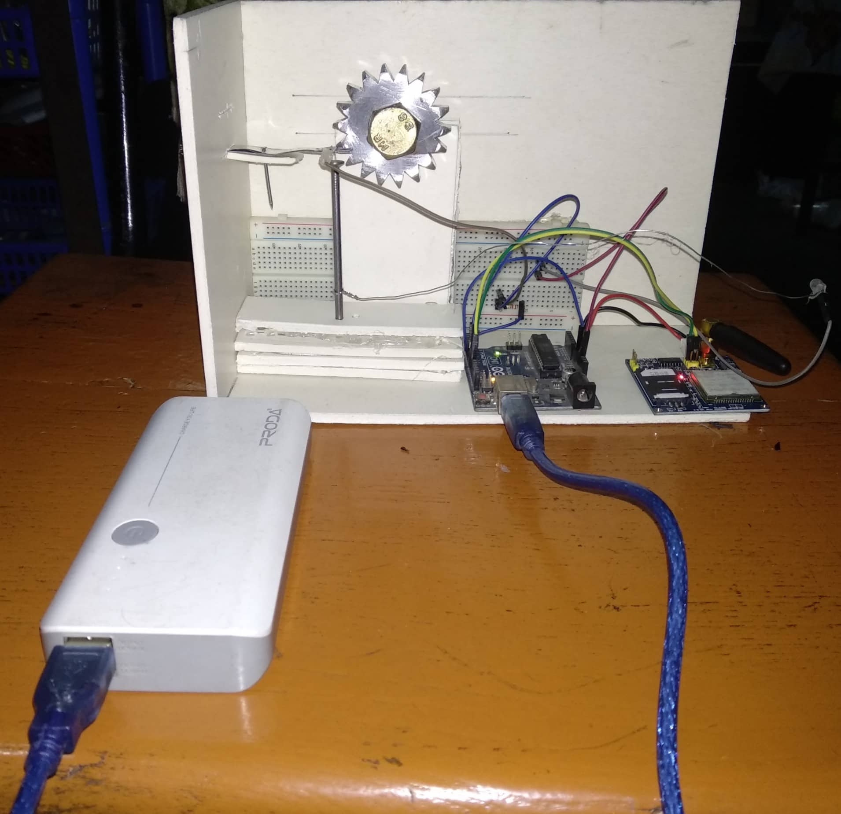

**Figure: Experimental Setup**

**Working Principle:**

**1. Mechanical Pulse Detector:**

It is completely a new system which can create a electrical pulse from the rotation of a bolt. It actually works as a rotating switch. A specially designed gear is connected at the head of the bolt; so when the bolt is rotated, it also rotates the gear. The teeth of the gear moves a metal sheet which acts as a switch to generate a voltage in the desired node of the system. This pulse will tell us if the bolt is rotated and this is the main trigger to set off the transmission that sends a warning message to the substation.

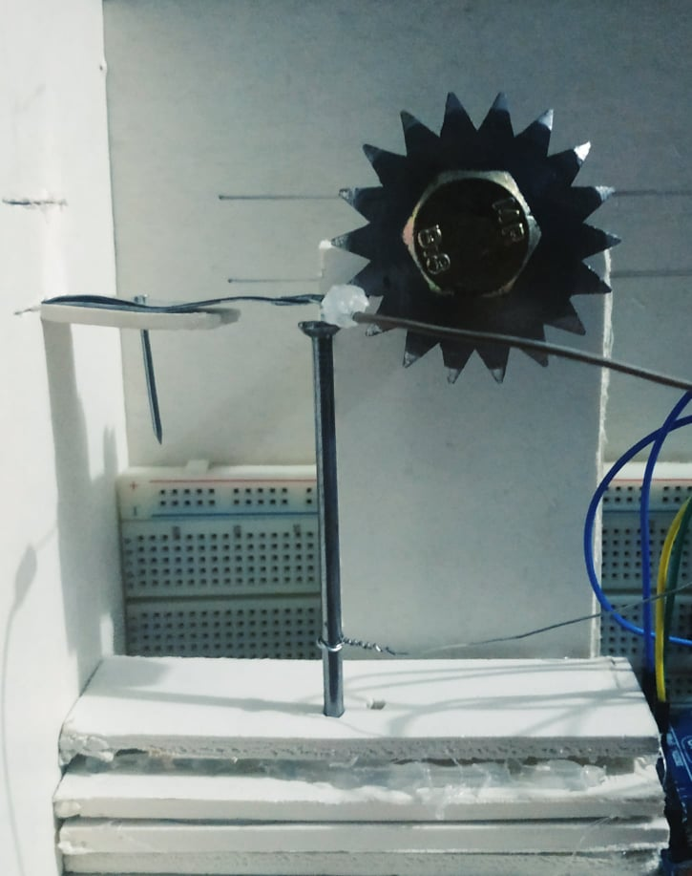 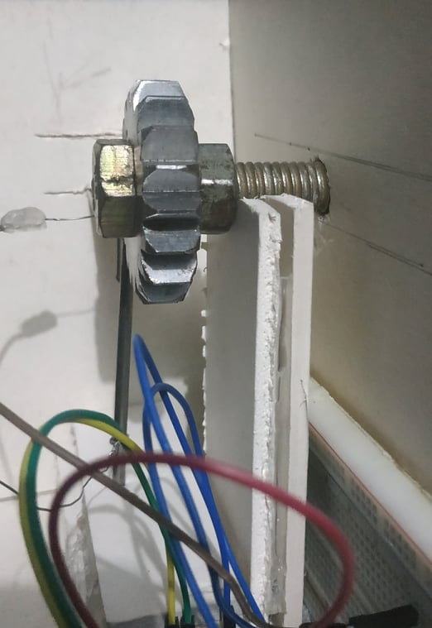

**Figure: Mechanical Pulse Detector**

**2.** **Integrated Environment (Arduino UNO):**

Arduino UNO is a commonly used microprocessor. It is basically the brain of this project. It works as the medium between the “Mechanical Pulse Detector” and the “GSM Module”. USB 5V Input is used for power supply of this part.When the “Mechanical Pulse Detector” detects a pulse, signal is sent to the Digital Pin 7 and the state of the Pin is then changed from “low” to “high”. A code is previously uploaded in the Arduino UNO. This code is set to trigger the GSM Module to start wireless transmission when it reads a “High” state in the digital Pin.

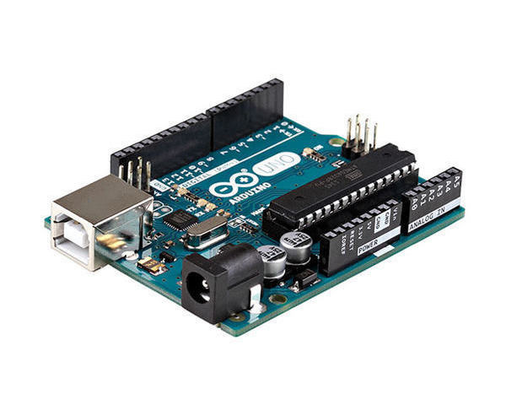

**Figure: Integrated Environment (Arduino UNO)**

**3. GSM module (SIM900A):**

This part is the part which does the part of wireless transmission. Wireless transmission is the part where the message is sent to the control room. When the Pin in the Arduino UNO shifts to the state high from the state low, the GSM module is activated by the command of the code uploaded in the microprocessor.

There is an activated sim card inserted in the GSM Module. When the module is activated, a previously typed text message is sent in a previously set phone number. The text and phone number can be changed from the code. Thus, for every time the mechanical switch is short, the GSM Module will send a message to the control room and let them know that the bolt is loosened.

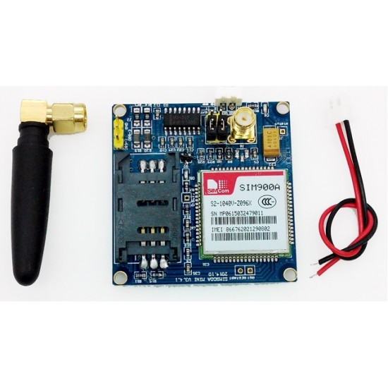

**Figure: GSM module (SIM900A)**

**4. Receiver:**

In this project, we used a mobile phone containing the receiver sim card. This sim card number is set in the code as the receiver station. So, when there is pulse in the Mechanical Pulse Detector, we automatically get a message saying,

“Warning. Fishplate Bolt is rotated”

In practical Cases, a computer connected to another GSM module that contains the receiver sim can be used. And the faulty fishplate position or number can be sent with the message.

**Thus, with the collaboration of all these four parts, the system works perfectly.**

**Limitations:**

Like other project this project also has some limitations. Those are explained below:

**Deliberate detachment**:

If someone deliberately removes wires or damages the components then the system will be damaged and actual output will not be found. This can be prevented by proper monitoring.

**False alarm:**

In case of natural calamities like earthquake or tornedo the circuit can be shorted and may cause a false alarm.

**Expense:**

A large number of fishplates are attached with the railways. To check this huge number of fishplates condition, huge number of components are used that increase the expense of the project.

**Rusting:**

The main component of this project is the gear which is made of iron-based metal. As the percentage of relative humidity in our country is significantly high that may cause rusting the metals. As a result, the lifetime of the components will not be very satisfactory. Stainless steel can be used to prevent this from happening.

**Future Prospects:**

**Sensor Based Alternative Approach:**

In future, load sensor can be used which can measure the force applied to it. From this measurement, we will be able to make decision whether the bolts are loosened or not. Other sensor like laser sensor can also be used in this case for more accuracy.

**Cost Effective Design:**

Rust proof metals can be used to increase the lifetime of the component to reduce the cost. Scrap metals from the railway industries can also be used here to reduce the cost.

**Alignment Detection:**

In this project the alignment of fishplates cannot be detected. But in future, by using sonar/IR sensor this alignment can be detected.