AZURE ENTERPRISE INFRASTRUCTURE LAB
11 — Azure CLI
CLI Administration & Resource Discovery
Portfolio documentation prepared from the completed Azure Cloud Shell evidence.

1. Objective
Automate common Azure administration tasks with Azure CLI, including account selection, resource-group discovery, resource discovery, networking and storage inspection, and safe cleanup.

2. Lab Environment
- Subscription: My Test Azure subscription 1
- Subscription ID: 14acea1d-b340-466e-82a5-3ae59a77c51b
- Resource group: rg-azure-enterprise_MM
- Region: Central India
- VNet: vnet-azure-enterprise-MM
- Subnet(s) observed: DatabaseSubnet_MM, ManagementSubnet_MM, WebSubnet_MM
- Storage account: stazureenterprisemm001

3. Login and Subscription Selection
Azure Cloud Shell was used with Azure CLI. The initial session selected a different subscription by default, so the lab subscription was explicitly selected before querying the lab resource group.
- az login
- az account show --output table
- az account list --output table
- az account set --subscription "My Test Azure subscription 1"
- az account show --output table

4. Resource Group Discovery
The lab resource group was successfully queried after selecting the correct subscription.
az group show --name "rg-azure-enterprise_MM" --output table
Observed result: provisioningState = Succeeded; location = centralindia.

5. Resource Discovery
- az resource list --resource-group "rg-azure-enterprise_MM" --output table
- az resource list --resource-group "rg-azure-enterprise_MM" --output json

6. Networking Discovery
- az network vnet list --resource-group "rg-azure-enterprise_MM" --output table
- az network vnet show --resource-group "rg-azure-enterprise_MM" --name "vnet-azure-enterprise-MM" --output table
- az network vnet subnet list --resource-group "rg-azure-enterprise_MM" --vnet-name "vnet-azure-enterprise-MM" --output table
- az network nsg list --resource-group "rg-azure-enterprise_MM" --output table
- az network nsg show --resource-group "rg-azure-enterprise_MM" --name "vm-web-MM-nsg" --output table
- az network nsg rule list --resource-group "rg-azure-enterprise_MM" --nsg-name "vm-web-MM-nsg" --output table

7. Storage Discovery
The completed Cloud Shell evidence shows the storage account query returning the lab storage account and confirms the storage account is provisioned successfully.
az storage account list --resource-group "rg-azure-enterprise_MM" --output table
Observed storage account: stazureenterprisemm001; location: centralindia; provisioning state: Succeeded; HTTPS traffic required: True.

8. Subnet Discovery Evidence
The captured CLI evidence shows three subnets in vnet-azure-enterprise-MM:
- DatabaseSubnet_MM
- ManagementSubnet_MM
- WebSubnet_MM

9. Current Screenshot Evidence
This screenshot captures successful storage-account and subnet discovery from Azure Cloud Shell.
Figure 1 — Storage account and subnet CLI output
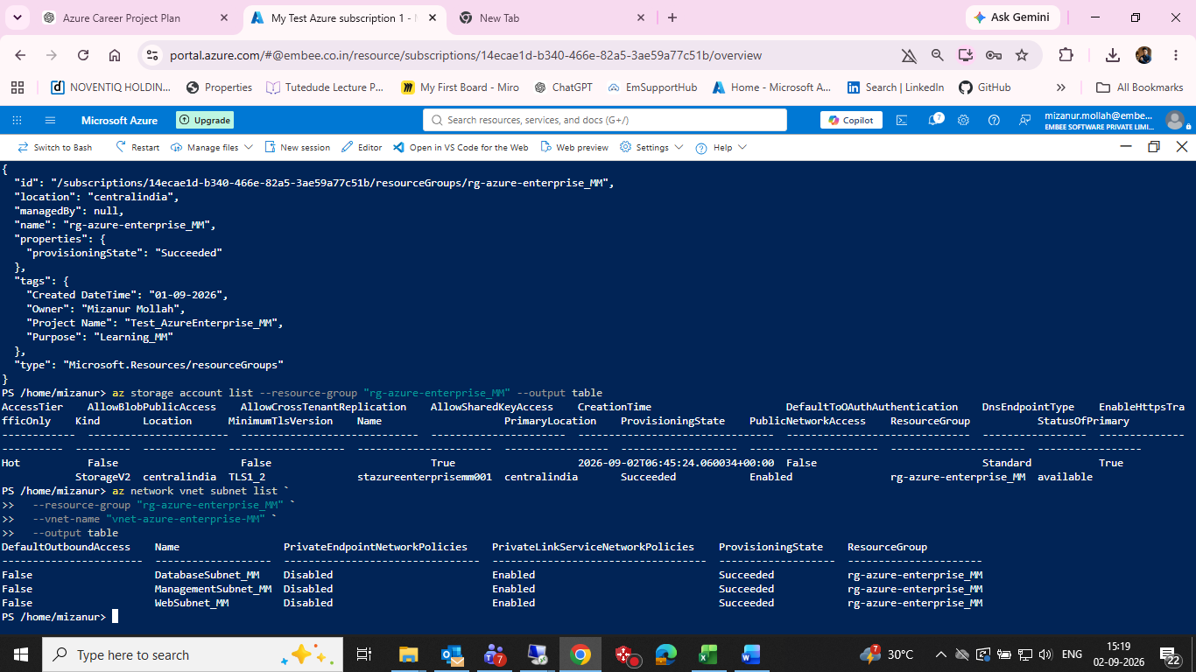
Azure Cloud Shell output showing stazureenterprisemm001 and the DatabaseSubnet_MM, ManagementSubnet_MM and WebSubnet_MM entries.

10. Cleanup Safety
The lab resource group contains active project resources, so destructive cleanup must not be executed without first verifying that the entire resource group is disposable.
az group delete --name "rg-azure-enterprise_MM"
Status: DOCUMENT ONLY — not executed.

11. Evidence Checklist
☑ Azure CLI login/account verification
☑ Correct subscription selected
☑ Resource-group discovery succeeded
☐ Resource discovery commands prepared
☑ VNet/subnet discovery captured
☑ Storage account discovery captured
☐ NSG discovery commands prepared
☑ Cleanup command documented but not executed

12. GitHub Structure
- 11-azure-cli/README.md
- 11-azure-cli/commands.ps1
- 11-azure-cli/screenshots/

13. Suggested commands.ps1
# Azure Enterprise Infrastructure Lab — Task 11
$subscription = "My Test Azure subscription 1"
$resourceGroup = "rg-azure-enterprise_MM"
az version
az account show --output table
az account list --output table
az account set --subscription $subscription
az account show --output table
az group list --output table
az group show --name $resourceGroup --output table
az resource list --resource-group $resourceGroup --output table
az network vnet list --resource-group $resourceGroup --output table
az network vnet subnet list --resource-group $resourceGroup --vnet-name "vnet-azure-enterprise-MM" --output table
az network nsg list --resource-group $resourceGroup --output table
az storage account list --resource-group $resourceGroup --output table
az vm list --resource-group $resourceGroup --output table
# Cleanup — do not run unless the entire resource group is disposable
# az group delete --name $resourceGroup

14. Interview Talking Points
Azure CLI vs Azure PowerShell?
Azure CLI is cross-platform and concise for automation; Azure PowerShell provides PowerShell-native objects and scripting patterns.
Why automate infrastructure operations?
Automation improves repeatability, reduces manual error, supports auditability and enables Infrastructure-as-Code workflows.

