AZURE ENTERPRISE INFRASTRUCTURE LAB
Task 01 — Resource Management
Azure Portal Evidence & Implementation Documentation

1. Objective
Create the foundational Azure resource group for the enterprise infrastructure lab, configure project metadata through tags, and capture Azure Portal evidence for the GitHub portfolio.

2. Azure Resource Group — Portal Evidence
The first screenshot documents the Resource Group creation screen. The portal shows the selected subscription, resource group name, and Central India region.
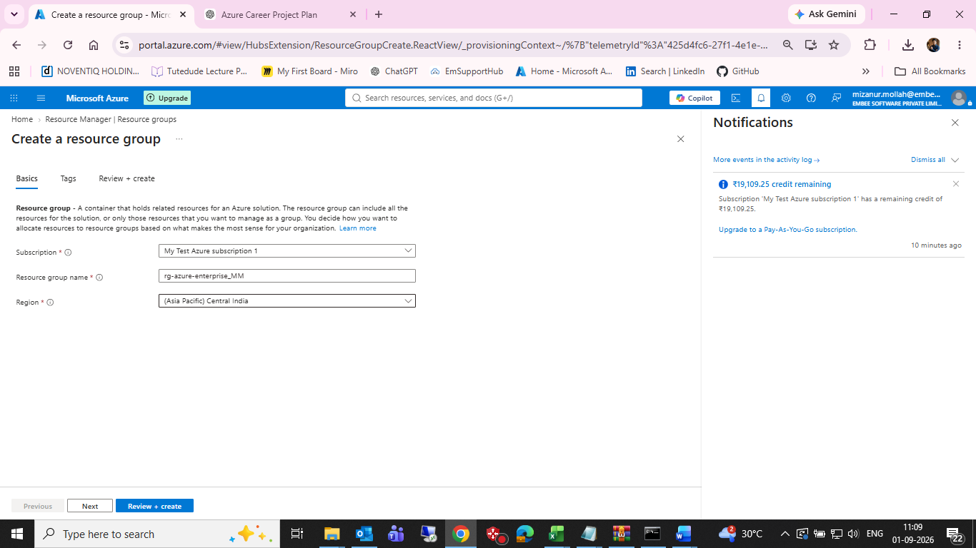
Figure 1 — Azure Portal: Create a resource group (Basics)
Property | Value shown in screenshot
Subscription | My Test Azure subscription 1
Resource group | rg-azure-enterprise_MM
Region | (Asia Pacific) Central India
Note: The screenshot is the evidence source for these values. Keep the resource-group name exactly as created in the Azure Portal when updating the final GitHub documentation.

3. Resource Group Tags — Portal Evidence
The second screenshot documents the Tags step of the resource-group creation workflow. The portal shows four configured tag rows and an additional empty row.
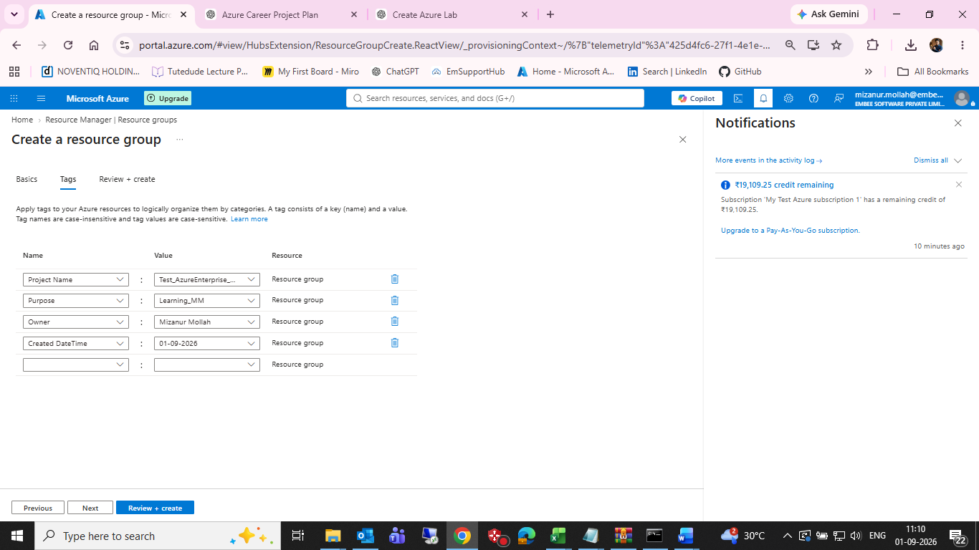
Figure 2 — Azure Portal: Resource group Tags
Tag name | Value visible in screenshot
Project Name | Test_AzureEnterprise_… (truncated in screenshot)
Purpose | Learning_MM
Owner | Mizanur Mollah
Created DateTime | 01-09-2026
Important: The Project Name value is visually truncated in the supplied screenshot, so this document does not guess the hidden characters. Use the exact value from the Azure Portal if a complete value is required.

4. Implementation Record
- Opened Azure Portal → Resource groups → Create a resource group.
- Selected the subscription shown in the Azure Portal.
- Entered the resource group name shown in Figure 1.
- Selected (Asia Pacific) Central India.
- Added project tags in the Tags step.
- Captured screenshots as implementation evidence.

5. Evidence Files for GitHub
Save the supplied screenshots in the repository as:
- screenshots/01-resource-group.png
- screenshots/02-tags.png

6. GitHub Documentation Snippet
Use the following concise section in 01-resource-management/resource-management.md after the Azure resource group has been created:
# 01 - Azure Resource Management
## Resource Group
| Property | Value |
|---|---|
| Subscription | My Test Azure subscription 1 |
| Resource Group | rg-azure-enterprise_MM |
| Region | (Asia Pacific) Central India |
## Tags
| Tag | Value |
|---|---|
| Project Name | Test_AzureEnterprise_… |
| Purpose | Learning_MM |
| Owner | Mizanur Mollah |
| Created DateTime | 01-09-2026 |
## Evidence
![Resource Group](../screenshots/01-resource-group.png)
![Resource Group Tags](../screenshots/02-tags.png)
- Remaining Task 01 Work

Yes. Complete Review + create and confirm the resource group was successfully created.
Yes. Capture the final Resource Group overview after deployment.
Yes. Configure the budget and capture the budget evidence screenshot.
Yes. Update the Markdown file with the final confirmed values.
Yes. Commit and push the evidence to GitHub.

