AZURE ENTERPRISE INFRASTRUCTURE LAB
Task 01 — Resource Management
Final Azure Portal Evidence

1. Objective
Create the foundational resource group for the Azure Enterprise Infrastructure Lab, apply project tags, and verify successful deployment in Azure Portal.

2. Resource Group Configuration
Property | Confirmed value
Subscription | My Test Azure subscription 1
Resource Group | rg-azure-enterprise_MM
Region | Central India

3. Tags Configuration
Tag | Value
Project Name | Test_AzureEnterprise_MM
Purpose | Learning_MM
Owner | Mizanur Mollah
Created DateTime | 01-09-2026

4. Review + Create Evidence
The Azure Portal review screen confirms the subscription, resource group name, Central India region, and the four configured tags before deployment.
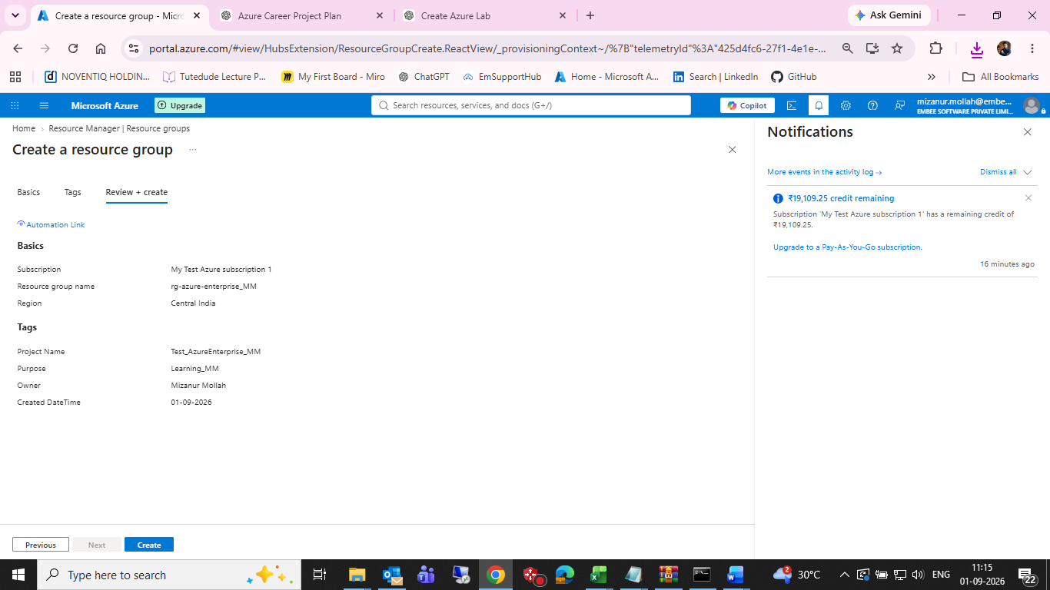
Figure 1 — Azure Portal Review + create screen

5. Deployment Confirmation
The Azure Portal notification confirms that creation of resource group rg-azure-enterprise_MM in subscription My Test Azure subscription 1 succeeded.
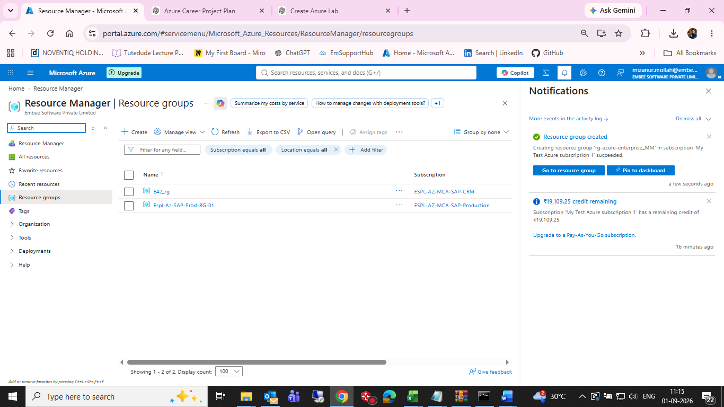
Figure 2 — Azure Portal Resource groups page with successful creation notification

6. Implementation Summary
- Selected the Azure subscription used for the lab.
- Created resource group rg-azure-enterprise_MM.
- Selected Central India as the resource-group region.
- Configured Project Name, Purpose, Owner, and Created DateTime tags.
- Reviewed the configuration before deployment.
- Verified the successful resource-group creation notification.

7. GitHub Evidence Files
Recommended repository evidence:
- screenshots/01-resource-group-review.png
- screenshots/02-resource-group-created.png
- 01-resource-management/resource-management.md

8. Git Commit
After copying the screenshots and updating the Markdown documentation, run:
cd /d C:\azure-enterprise-infrastructure-lab
git add .
git commit -m "Complete Azure resource management task"
git push

9. Completion Checklist
☐ Resource group created successfully
☐ Central India region selected
☐ Project tags configured
☐ Review screen captured
☐ Successful creation evidence captured
☐ Markdown documentation updated
☐ Screenshots copied to GitHub project
☐ Git commit created
☐ Changes pushed to GitHub

10. Next Lab Task
Next: Task 02 — Azure Networking. Build the Virtual Network, subnet and Network Security Group using the same documentation-and-evidence approach.

