Task 01 — Azure Resource Protection & Cost Management
Enterprise Azure Infrastructure, Security & Monitoring Lab

Objective
Set up the initial Azure governance and cost-protection controls before deploying other Azure resources.

1. Azure Resource Group
Resource Group: rg-azure-enterprise_MM
This Resource Group is the main container for the Azure portfolio project.

2. Azure Resource Lock
Lock name: PortfolioResourceLock
Lock type: Delete (CanNotDelete)
Scope: rg-azure-enterprise_MM
Notes: CanNotDelete
The lock protects the Resource Group from accidental deletion while still allowing normal resource management.

3. Azure Budget
Budget name: Budget_19000_RS
Scope: rg-azure-enterprise_MM
Reset period: Monthly
Budget amount: ₹18,700
Expiration date shown in Azure: 22 September 2026
The portal screenshot also shows approximately ₹19,109.25 remaining credit at the time of capture.

4. Cost Protection Strategy
Azure Free Credit / Spending Limit → Azure Budget → Cost Thresholds → Email Alerts → Manual Investigation → Stop / Deallocate / Delete unused resources when appropriate.

5. Email Alerting
Recommended thresholds: 50%, 70%, 90%, and 98%, with email notifications. Budget alerts monitor spending; they do not automatically stop all Azure resources.

6. Interview Questions
Q: What is an Azure Resource Group?
A: A logical container used to manage related Azure resources together.
Q: What is an Azure Resource Lock?
A: A control that prevents accidental deletion or modification of Azure resources.
Q: CanNotDelete vs ReadOnly?
A: CanNotDelete allows modification but prevents deletion. ReadOnly prevents modification and deletion.
Q: Does an Azure Budget automatically stop resources?
A: No. A budget primarily provides cost monitoring and notifications; additional automation is required for resource actions.

7. Result
Task 01 completed successfully. The environment has a dedicated Resource Group, Delete/CanNotDelete protection, an Azure Budget, and a cost-monitoring foundation.

8. Next Task — Azure Virtual Network
VNet: vnet-azure-enterprise-MM
Address space: 10.0.0.0/16
WebSubnet: 10.0.1.0/24
DatabaseSubnet: 10.0.2.0/24
ManagementSubnet: 10.0.3.0/24

Evidence — Azure Budget
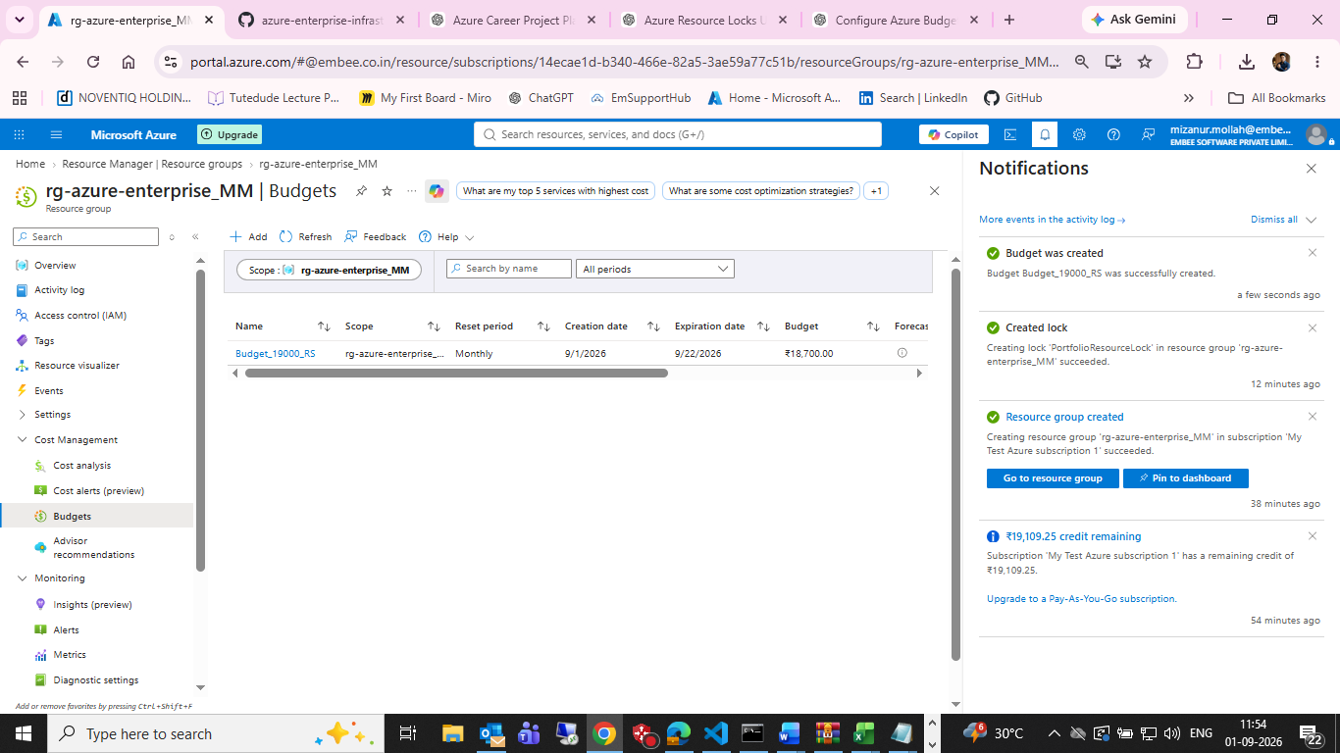
Figure 1: Azure Budget successfully created for rg-azure-enterprise_MM.

Evidence — Resource Lock
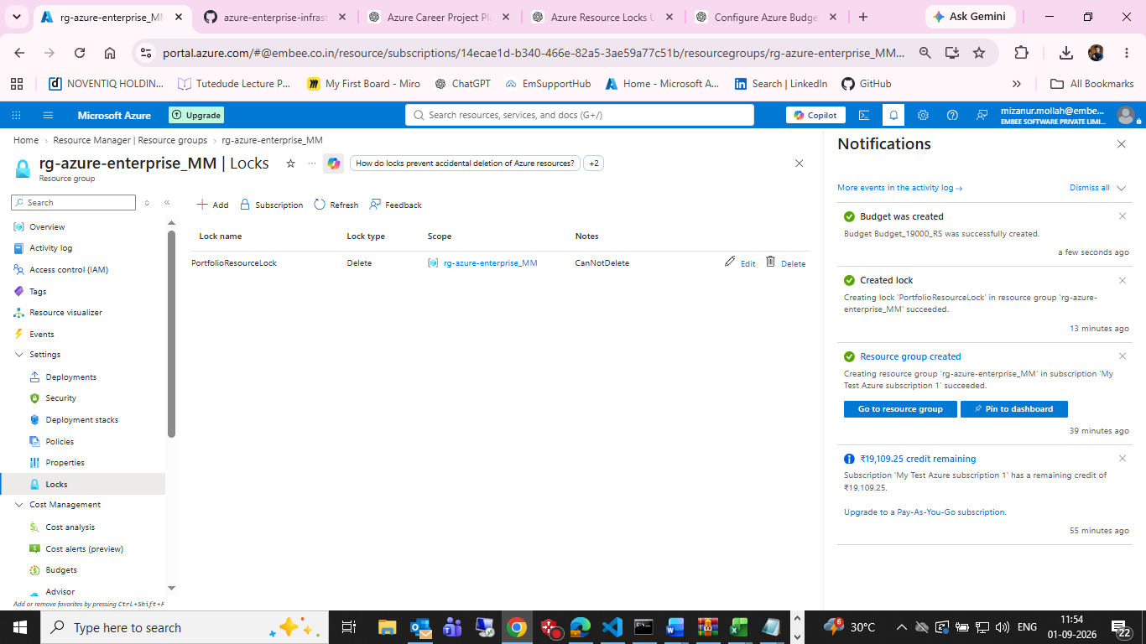
Figure 2: PortfolioResourceLock configured with Delete/CanNotDelete protection.

