Task 02 — Azure Virtual Network (VNet)
Enterprise Azure Infrastructure, Security & Monitoring Lab

Objective
Create a segmented Azure Virtual Network for future web, database, and management workloads.

Azure Configuration
Subscription: My Test Azure subscription 1
Resource Group: rg-azure-enterprise_MM
Region: Central India
VNet Name: vnet-azure-enterprise-MM
Address Space: 10.0.0.0/16

Subnet Design
WebSubnet_MM — 10.0.1.0/24 — Web/application workload
DatabaseSubnet_MM — 10.0.2.0/24 — Database workload
ManagementSubnet_MM — 10.0.3.0/24 — Administration/management

Design Rationale
The VNet is the overall network boundary. Separate subnets provide logical segmentation so different workloads can later receive different security and routing controls. Bastion, Firewall, and DDoS Network Protection were left disabled for this learning lab. No NAT Gateway or NSG was attached during initial subnet creation; NSG configuration is the next dedicated task.

What I Learned
A VNet provides private networking for Azure resources. A subnet is a logical subdivision of a VNet address space. The VNet uses 10.0.0.0/16 and the three subnets use non-overlapping /24 ranges. Network segmentation helps separate workloads and apply different security controls.

Interview Questions
Q: What is an Azure VNet?
A: A private network boundary in Azure for IP-based communication.
Q: What is a subnet?
A: A logical subdivision of a VNet's IP address space.
Q: Why use multiple subnets?
A: To separate workloads and apply different security, routing, and access controls.
Q: Can two VNets communicate automatically?
A: No. VNets are isolated by default; connectivity requires an appropriate mechanism such as VNet peering or VPN connectivity.

Result
Task 02 completed successfully. The Azure portfolio now has a segmented VNet ready for network security configuration.

Next Task
Task 03 — Network Security Groups (NSG): inbound/outbound rules, ports, source/destination, priority, Allow/Deny behavior, and subnet-level security.

Evidence — VNet Deployment
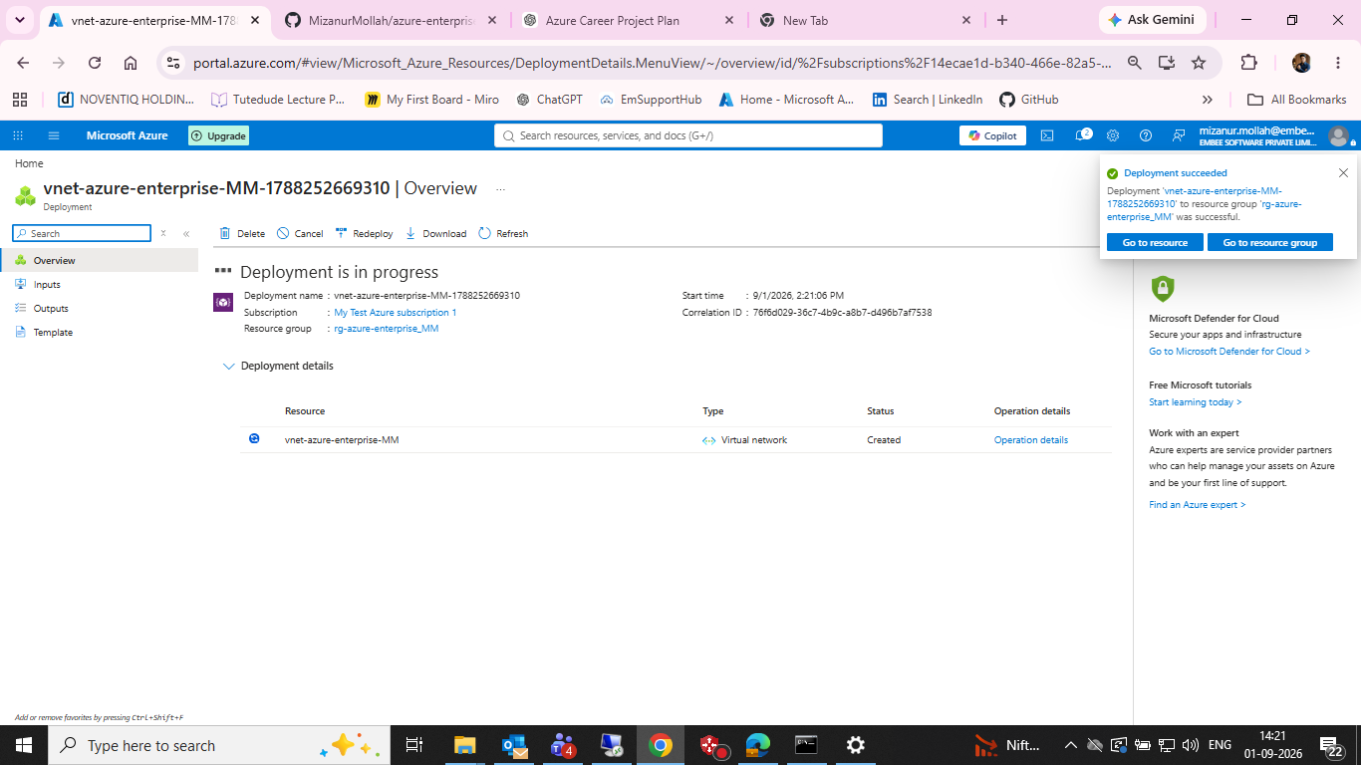
Figure 1: Azure deployment succeeded for vnet-azure-enterprise-MM in rg-azure-enterprise_MM.

