Task 03 — Azure Network Security Group (NSG)
Enterprise Azure Infrastructure, Security & Monitoring Lab

Objective
Create and configure an Azure Network Security Group for the web tier, add controlled HTTP/HTTPS inbound access, and associate the NSG with the web subnet.

Environment
- Subscription: My Test Azure subscription 1
- Resource Group: rg-azure-enterprise_MM
- Region: Central India
- NSG: nsg-web-MM
- VNet: vnet-azure-enterprise-MM
- Web Subnet: WebSubnet_MM (10.0.1.0/24)

Configuration Completed
- Created nsg-web-MM.
- Added inbound HTTP: priority 100, TCP 80, Allow.
- Added inbound HTTPS: priority 110, TCP 443, Allow. The rule is functionally correct; its current name appears as Allow-HTTP1 and should be renamed to Allow-HTTPS during cleanup.
- Associated nsg-web-MM with WebSubnet_MM.
- Verified the subnet association.

Security Rules
Direction | Priority | Name | Protocol | Port | Action
Inbound | 100 | Allow-HTTP | TCP | 80 | Allow
Inbound | 110 | Allow-HTTP1 (rename to Allow-HTTPS) | TCP | 443 | Allow
Inbound | 65000 | AllowVNetInBound | Any | Any | Allow
Inbound | 65001 | AllowAzureLoadBalancerInBound | Any | Any | Allow
Inbound | 65500 | DenyAllInBound | Any | Any | Deny

Resource Lock Observation
An accidental outbound HTTP rule was created during the exercise. Its deletion was blocked because the resource group has a CanNotDelete lock (PortfolioResourceLock). This demonstrates how Azure Resource Locks prevent protected resources from being deleted. The lock should be temporarily removed only when cleanup is required, then re-enabled.

Interview Points
- What is an NSG? A collection of rules that allow or deny network traffic to Azure subnets and/or network interfaces.
- Why priority? Lower numeric priority is evaluated before higher numeric priority.
- Why TCP 80? HTTP web traffic normally uses TCP port 80.
- Why TCP 443? HTTPS web traffic normally uses TCP port 443.
- Why associate the NSG with a subnet? Creating the NSG alone does not apply its rules to the subnet; association makes the NSG part of the subnet traffic-control configuration.
- Should SSH/RDP be open to Any? Normally no; management access should be restricted to trusted sources or controlled management services.

Evidence Screenshots

01 — Create NSG: Basics
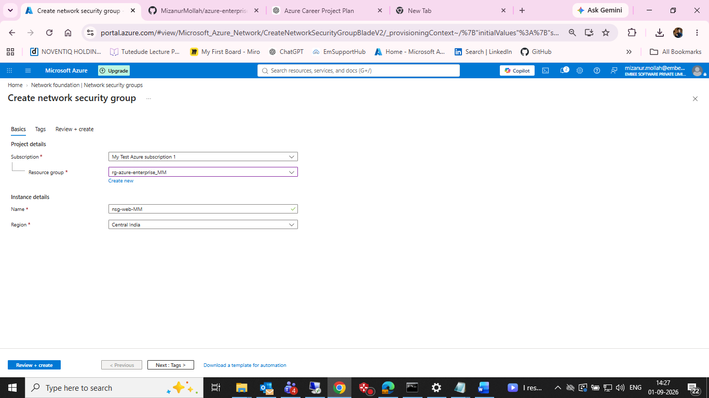
Evidence: 01 — Create NSG: Basics

02 — NSG deployment succeeded
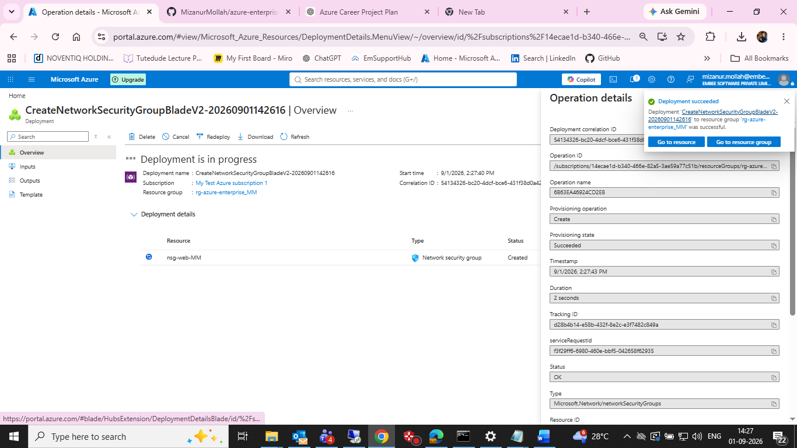
Evidence: 02 — NSG deployment succeeded

03 — Add inbound security rule
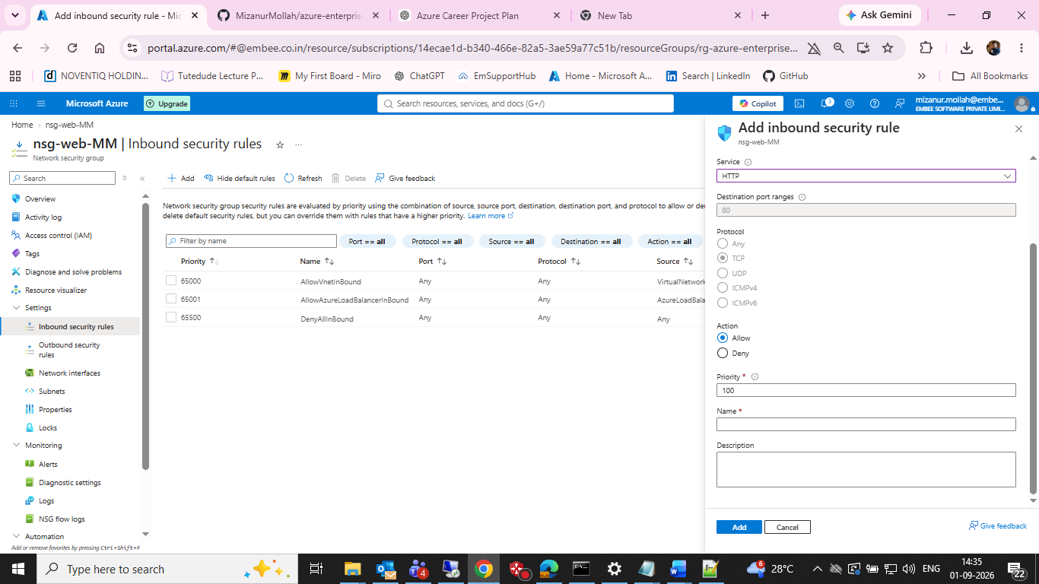
Evidence: 03 — Add inbound security rule

04 — NSG rules after configuration
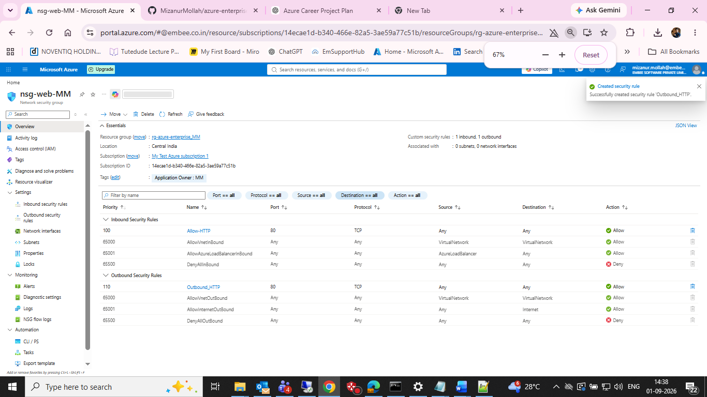
Evidence: 04 — NSG rules after configuration

05 — Outbound rule deletion blocked by CanNotDelete lock
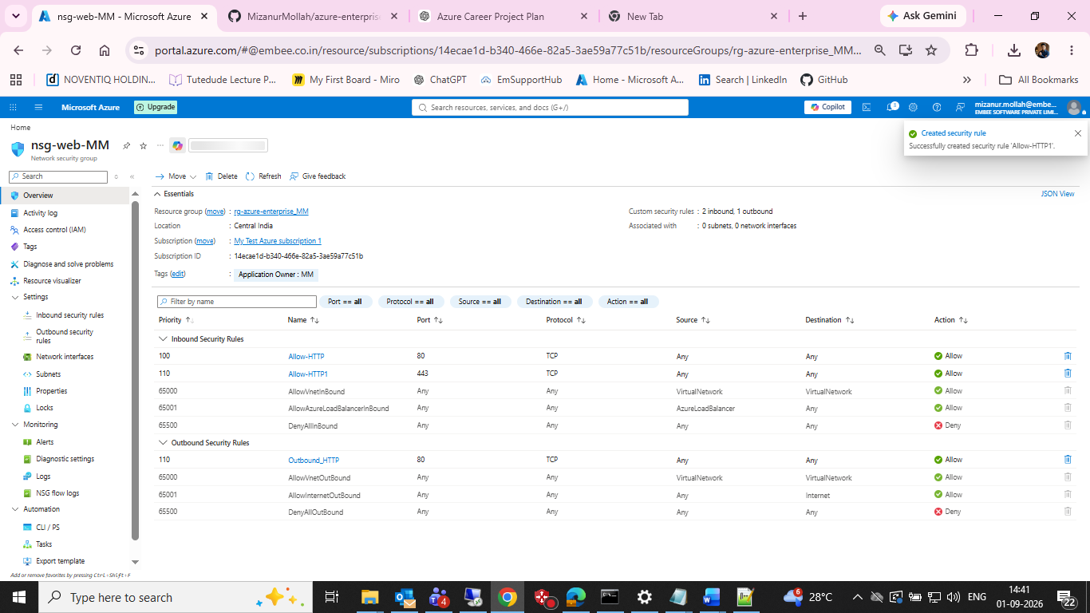
Evidence: 05 — Outbound rule deletion blocked by CanNotDelete lock

06 — Associate subnet dialog
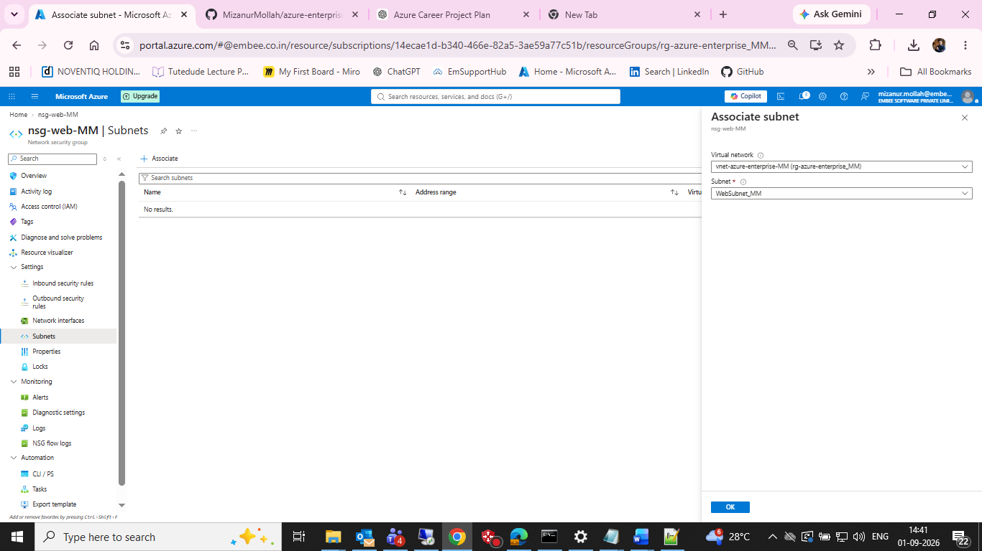
Evidence: 06 — Associate subnet dialog

07 — Final NSG-to-WebSubnet association
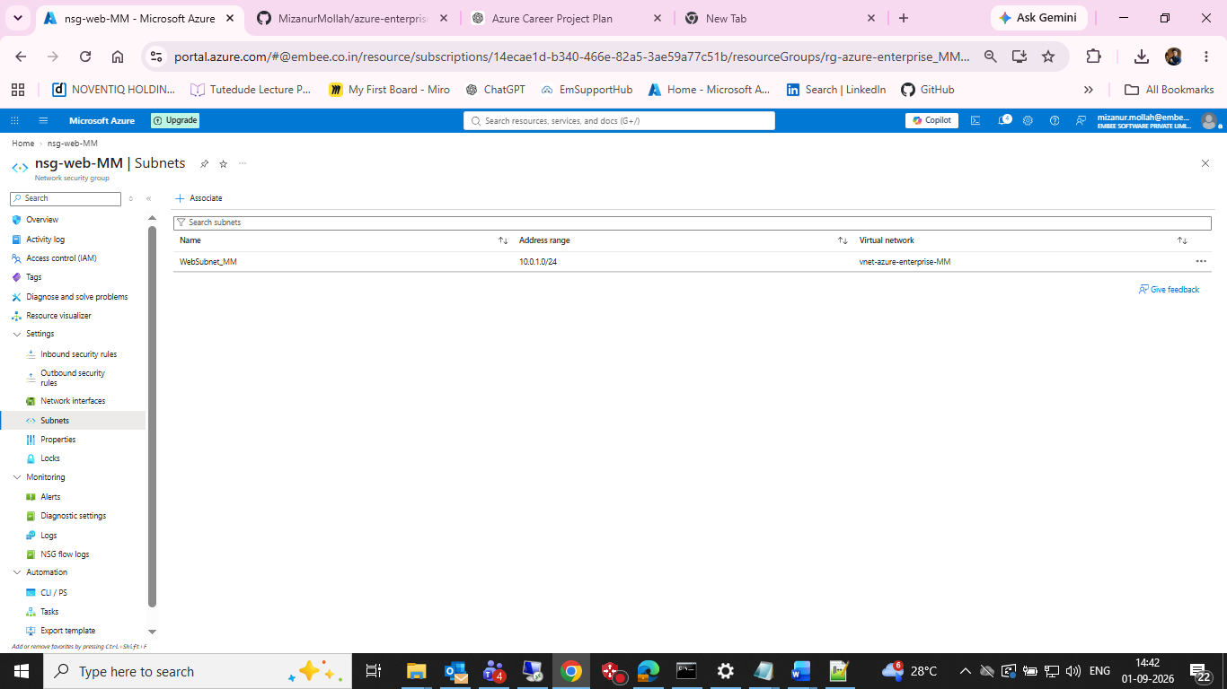
Evidence: 07 — Final NSG-to-WebSubnet association

Result
Task 03 completed: NSG created, web traffic rules configured, and nsg-web-MM associated with WebSubnet_MM.

Next Step
Build the web compute layer using an Azure VM and connect it to WebSubnet_MM, while keeping costs controlled within the Azure free credit.

