Task 03 — Azure Network Security Group (NSG)
Enterprise Azure Infrastructure, Security & Monitoring Lab

Objective
Create an Azure Network Security Group for the web tier as the security-control component of the VNet design.

Configuration
Subscription: My Test Azure subscription 1
Resource Group: rg-azure-enterprise_MM
Region: Central India
NSG Name: nsg-web-MM
Resource Type: Network Security Group

Deployment Evidence
The Azure Portal screenshot confirms that deployment succeeded, resource nsg-web-MM was created, the resource type is Network security group, provisioning state is Succeeded, and status is OK.

Security Design
The NSG will protect the web subnet.
Planned inbound rules:
Priority 100 — Allow-HTTP — TCP 80 — Allow
Priority 110 — Allow-HTTPS — TCP 443 — Allow
Azure default inbound rules remain in place. Administrative ports such as SSH (22) and RDP (3389) should not be exposed broadly to the internet.

Important Concept
An NSG filters network traffic using security rules based on source, destination, protocol, port, priority, and action. Lower priority numbers are evaluated before higher priority numbers. An NSG can be associated with a subnet and/or network interface. In this project, the web NSG will be associated with WebSubnet_MM.

What I Learned
An NSG is a network traffic filtering control in Azure. Inbound rules control traffic entering a protected resource/subnet. Outbound rules control traffic leaving it. Rule priority determines evaluation order. Security should follow least-privilege principles. Web traffic normally uses TCP ports 80 and 443.

Interview Questions
Q: What is an NSG?
A: An Azure Network Security Group is a collection of security rules used to allow or deny network traffic.
Q: Inbound vs outbound?
A: Inbound controls traffic entering; outbound controls traffic leaving.
Q: Why is priority important?
A: Lower numeric priority has higher precedence.
Q: Can an NSG be associated with a subnet?
A: Yes, and it can also be associated with a network interface.
Q: Should SSH/RDP be open to Any?
A: Normally no; administrative access should be restricted.

Result
NSG resource creation completed successfully. The next step is to configure inbound rules and associate nsg-web-MM with WebSubnet_MM.

Next Task Step
Open nsg-web-MM → Inbound security rules → add Allow-HTTP (TCP/80, priority 100) and Allow-HTTPS (TCP/443, priority 110) → associate the NSG with WebSubnet_MM → capture evidence screenshots.

Evidence — NSG Deployment
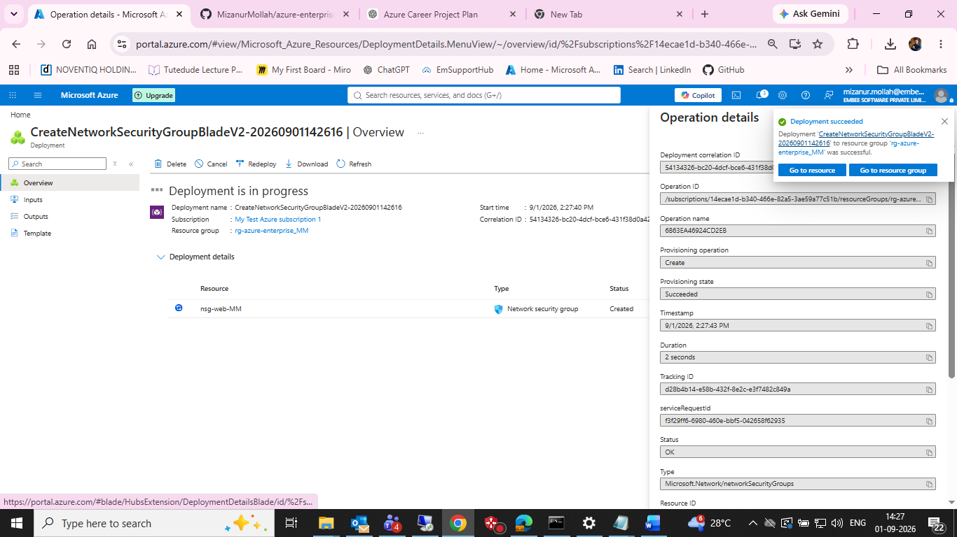
Figure 1: Azure Portal deployment evidence showing successful creation of nsg-web-MM.

