AZURE ENTERPRISE INFRASTRUCTURE LAB
Task 04 — Windows Virtual Machine
Final Azure Portal Evidence

1. Objective
Deploy and validate a Windows Server virtual machine as the web/compute workload for the Azure Enterprise Infrastructure Lab. The task demonstrates Azure compute, networking, security controls, remote administration, monitoring evidence, troubleshooting, and cost-aware resource selection.

2. Final VM Configuration
Property | Confirmed value
Subscription | My Test Azure subscription 1
Resource Group | rg-azure-enterprise_MM
Virtual Machine | vm-web-MM
Region | Central India
Availability Zone | Zone 2
Status | Running
Operating System | Windows Server 2025 Datacenter
Architecture | x64
VM Size | Standard B2ts_v2
vCPUs | 2
RAM | 1 GiB
VNet | vnet-azure-enterprise-MM
Subnet | WebSubnet_MM
Subnet range | 10.0.1.0/24
Private IP | 10.0.1.4
Public IP | 20.244.97.131
Primary NIC | vm-web-mm993
VM-level NSG shown in final Network settings | vm-web-MM-nsg
Subnet-level NSG | nsg-web-MM
Tag | Application Owner = MM
Public GitHub safety: the original evidence screenshots contain live public IP/account information. Sanitize or blur sensitive/current infrastructure identifiers before publishing screenshots in a public repository.

3. Azure Skills Demonstrated
- Azure Virtual Machine deployment
- Windows Server administration
- VM sizing and cost awareness
- Availability Zone selection
- Azure VNet and subnet integration
- Private/public IP identification
- Network Security Group usage
- RDP remote administration
- VM disk configuration
- Boot diagnostics
- Activity Log investigation
- Deployment verification
- Troubleshooting and configuration correction
- Resource lifecycle and cleanup awareness

4. VM Size Selection and Cost Control
The creation flow showed several availability and sizing constraints. An NC-series GPU VM was rejected as unnecessary for this learning lab because its displayed price was much higher. A D-series option was constrained by availability zone. A B-series option was then selected.
Final deployed size: Standard B2ts_v2.
The Azure Portal showed an estimated 0.0204 USD/hour during the VM creation flow. The VM should be stopped/deallocated when not in use, and unnecessary public-IP/compute resources should be removed after the lab.

5. Disk Configuration
- OS disk size: Image default
- OS disk type: Premium SSD / Premium_LRS
- Managed disks: Yes
- Delete OS disk with VM: Yes
- Ephemeral OS disk: None
- Data disks: None
- Key management: Platform-managed key
- Ultra Disk compatibility: Off
- Encryption at host: Not enabled

6. Networking Configuration
Final network path:
- Internet → Public IP 20.244.97.131
- Public IP → NIC vm-web-mm993
- NIC → VM-level NSG vm-web-MM-nsg
- NIC → WebSubnet_MM (10.0.1.0/24)
- WebSubnet_MM → subnet-level NSG nsg-web-MM
- WebSubnet_MM → VNet vnet-azure-enterprise-MM
The final Network settings screenshot confirms the NIC, VNet/subnet, public IP, private IP, accelerated networking, and both NSG layers.
Security observation: the final environment shows both a subnet-level NSG and a NIC-level NSG. The project should document why both are required or review whether one layer is redundant.

7. NSG Rules Observed
Priority | Rule / Name shown | Port | Protocol | Action
100 | Allow-HTTP | 80 | TCP | Allow
110 | Allow-HTTP1 | 443 | TCP | Allow
120 | NEWACC | 3389 | TCP | Allow
Azure default inbound rules are also present, including the final deny-all behavior.
For clean portfolio documentation, rename the HTTPS rule to Allow-HTTPS and give the RDP rule a descriptive name. RDP should be restricted to a trusted source IP rather than broadly exposed.

8. RDP Validation
A successful Native RDP session was established to vm-web-MM. This demonstrates public-IP connectivity, TCP 3389 access, and successful Windows remote administration.
RDP should not remain broadly exposed to the internet in a production-style environment. Restrict the source IP or use a controlled management service.

9. Activity Log and Troubleshooting Evidence
- Create or Update Virtual Machine — Succeeded
- Health Event Resolved
- Health Event Updated
The Activity Log evidence demonstrates Azure resource-operation review and basic health-event investigation.

10. Management Configuration
- System-assigned managed identity: Off
- Microsoft Entra ID login: Off
- Backup: Off
- Site Recovery: Off
- Periodic assessment: Off
- Hotpatch: Off
- Patch orchestration: Automatic by OS
- Auto-shutdown: Off at creation
For this learning environment, configure auto-shutdown after validating the lab workflow to reduce unnecessary VM runtime.

11. Monitoring Configuration
- Boot diagnostics: On
- Recommended alert rules: Off
- OS guest diagnostics: Off
- Application health monitoring: Off
Dedicated Azure Monitor and Log Analytics configuration will be completed in the monitoring task.

12. Implementation Summary
- Started Windows VM creation in Central India.
- Evaluated VM sizes and rejected oversized/GPU options for cost control.
- Selected Standard B2ts_v2.
- Selected Windows Server 2025 Datacenter.
- Used vnet-azure-enterprise-MM.
- Used WebSubnet_MM (10.0.1.0/24).
- Configured a public IP for lab RDP access.
- Preserved subnet-level nsg-web-MM.
- Completed VM deployment successfully.
- Verified Running state.
- Verified public/private IP configuration.
- Verified NSGs in Network settings.
- Established successful RDP connectivity.
- Reviewed Activity Log for deployment and health events.

13. GitHub Evidence Structure
- 04-virtual-machine/Task-04-Azure-Windows-VM-Final-Documentation.md
- 04-virtual-machine/screenshots/ (17 evidence screenshots)
- Root README linking to Task 04 and summarizing Azure skills

14. Git Commit
cd /d C:\azure-enterprise-infrastructure-lab
git add .
git commit -m "Complete Azure Windows VM deployment and validation"
git push

15. Completion Checklist
☑ Windows Server VM created
☑ Central India selected
☑ Zone 2 deployment completed
☑ Low-cost B-series size selected
☑ Project VNet selected
☑ Web subnet selected
☑ Public IP created
☑ VM deployment succeeded
☑ VM running state verified
☑ Network settings verified
☑ NSG evidence captured
☑ RDP connectivity verified
☑ Activity Log reviewed
☑ Complete screenshot evidence collected
☑ Documentation prepared
☐ Rename 443 rule to Allow-HTTPS
☐ Rename/restrict RDP rule
☐ Review whether both subnet and NIC NSGs are required
☐ Configure auto-shutdown
☐ Create Git commit
☐ Push to GitHub
☐ Sanitize public screenshots before public upload

16. Evidence Screenshots
Figure 1 — Windows VM creation basics checkpoint.
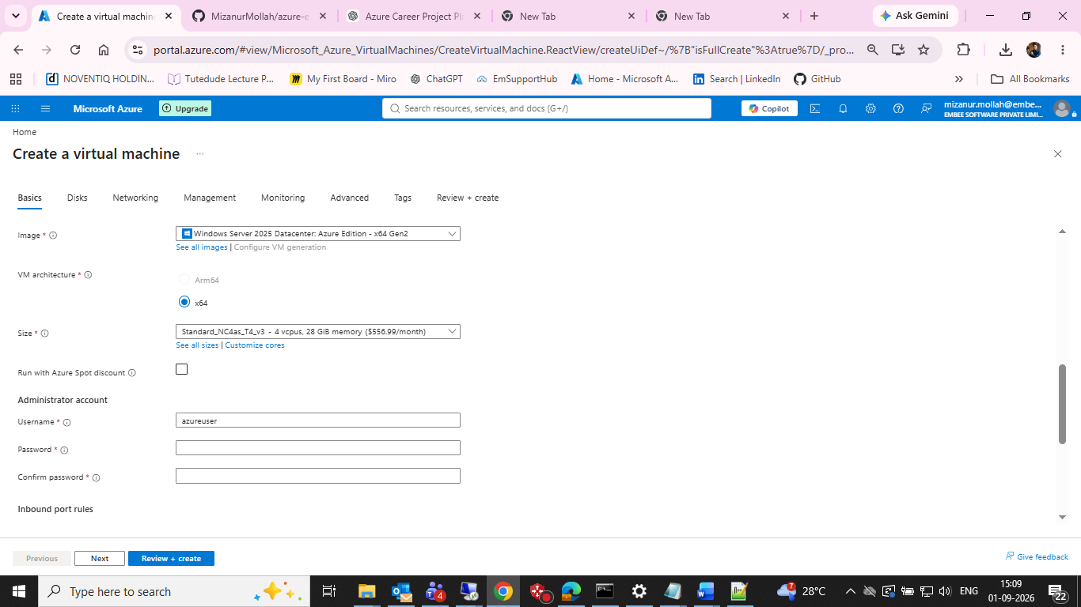
Windows VM creation basics checkpoint.

Figure 2 — VM size selection showing availability-zone constraints.
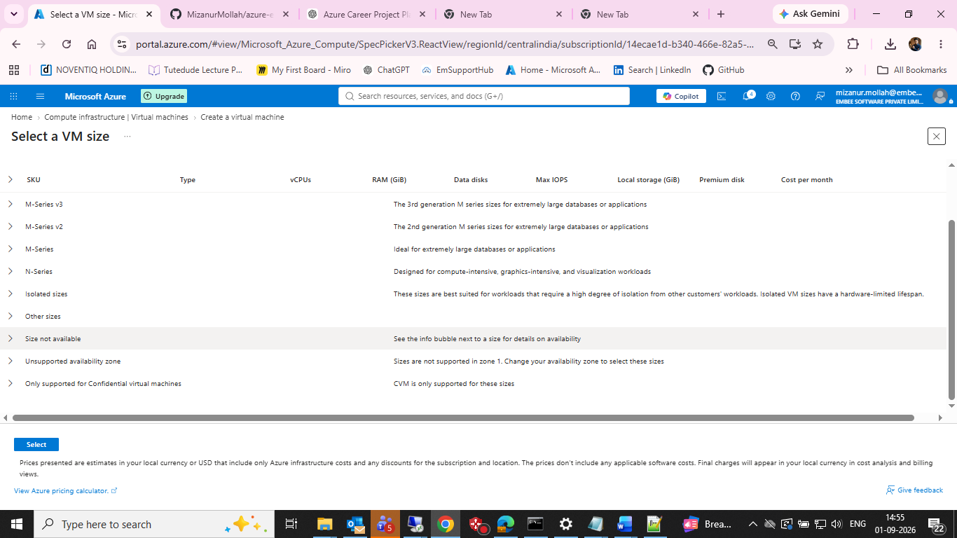
VM size selection showing availability-zone constraints.

Figure 3 — B-series VM size options available in the subscription.
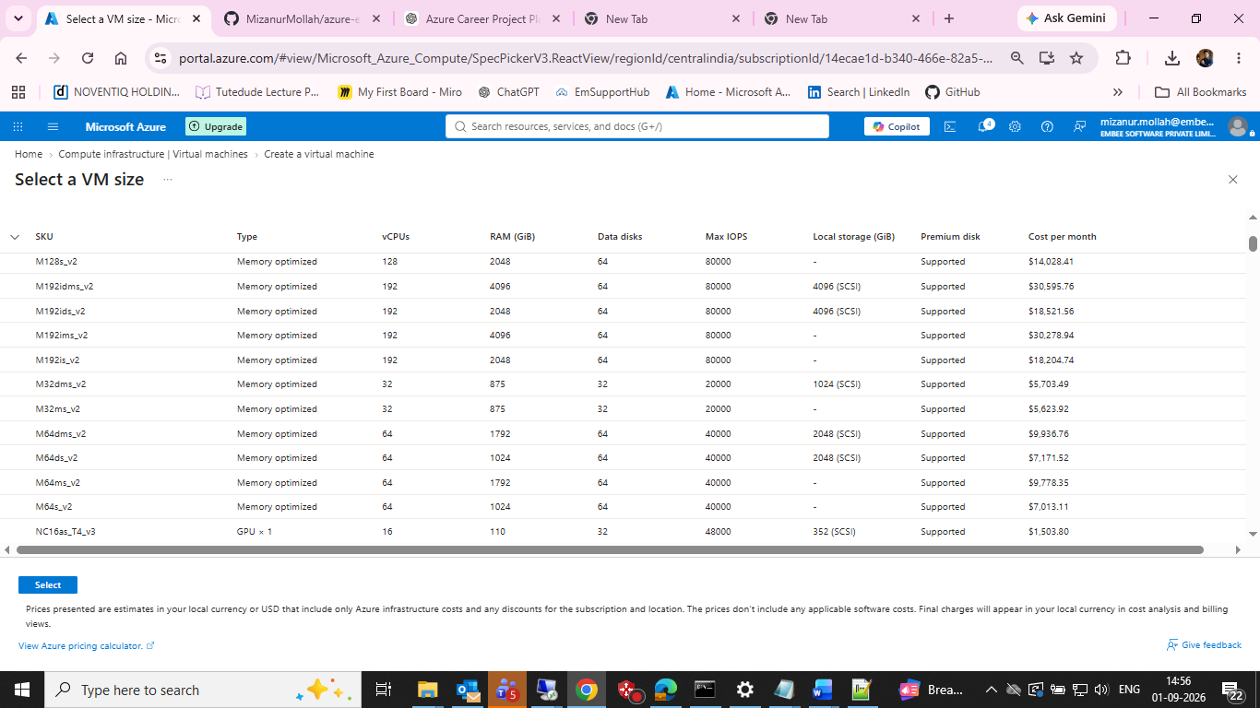
B-series VM size options available in the subscription.

Figure 4 — Inbound-port selection during VM creation.
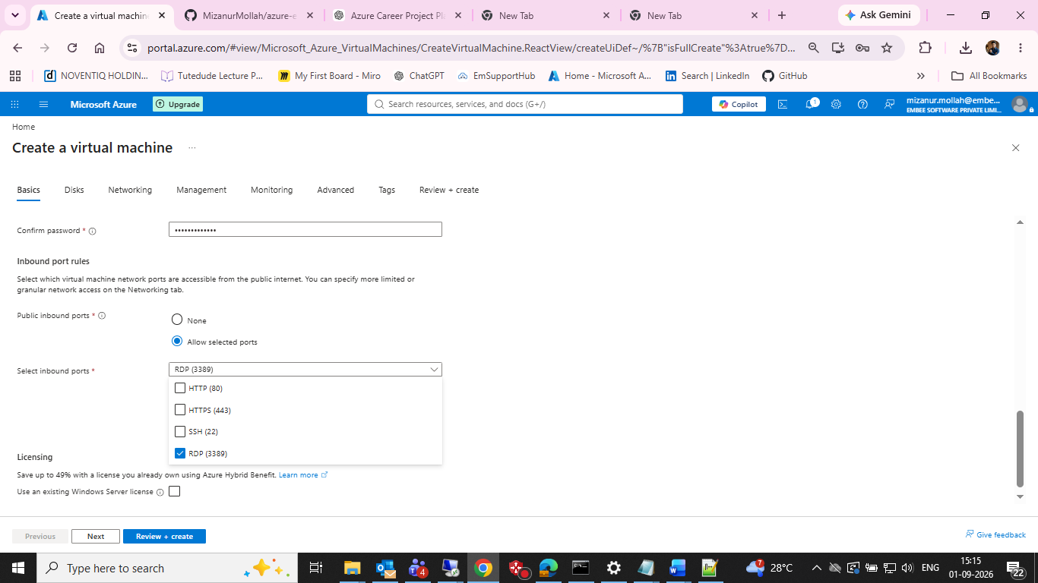
Inbound-port selection during VM creation.

Figure 5 — VM disk configuration.
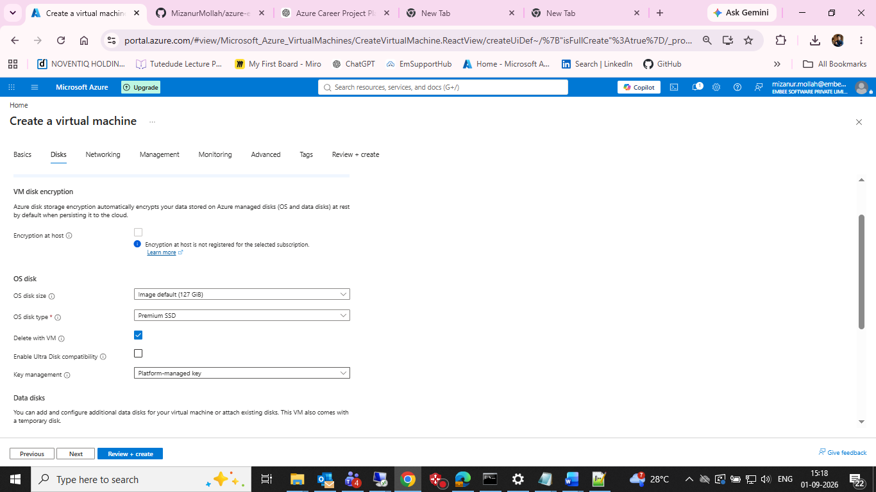
VM disk configuration.

Figure 6 — Initial networking checkpoint showing a generated VNet/subnet before correction.
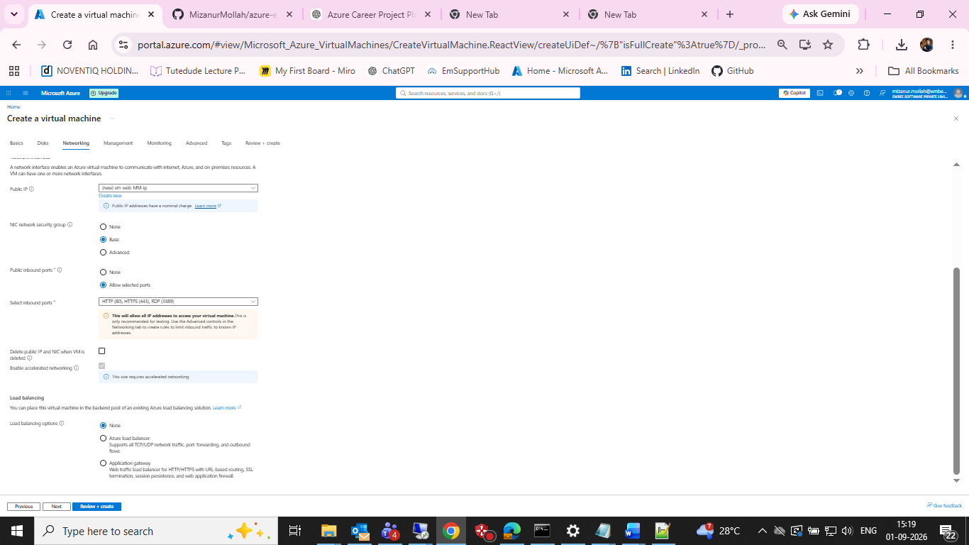
Initial networking checkpoint showing a generated VNet/subnet before correction.

Figure 7 — Networking checkpoint after selecting the project VNet and Web subnet.
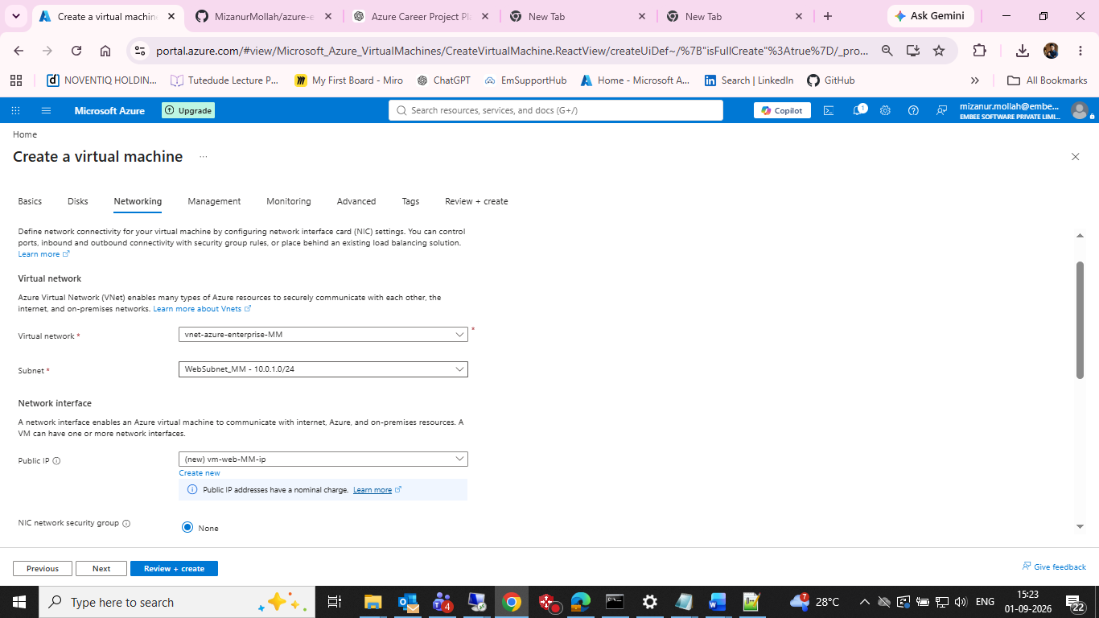
Networking checkpoint after selecting the project VNet and Web subnet.

Figure 8 — Networking checkpoint showing the existing subnet NSG association.
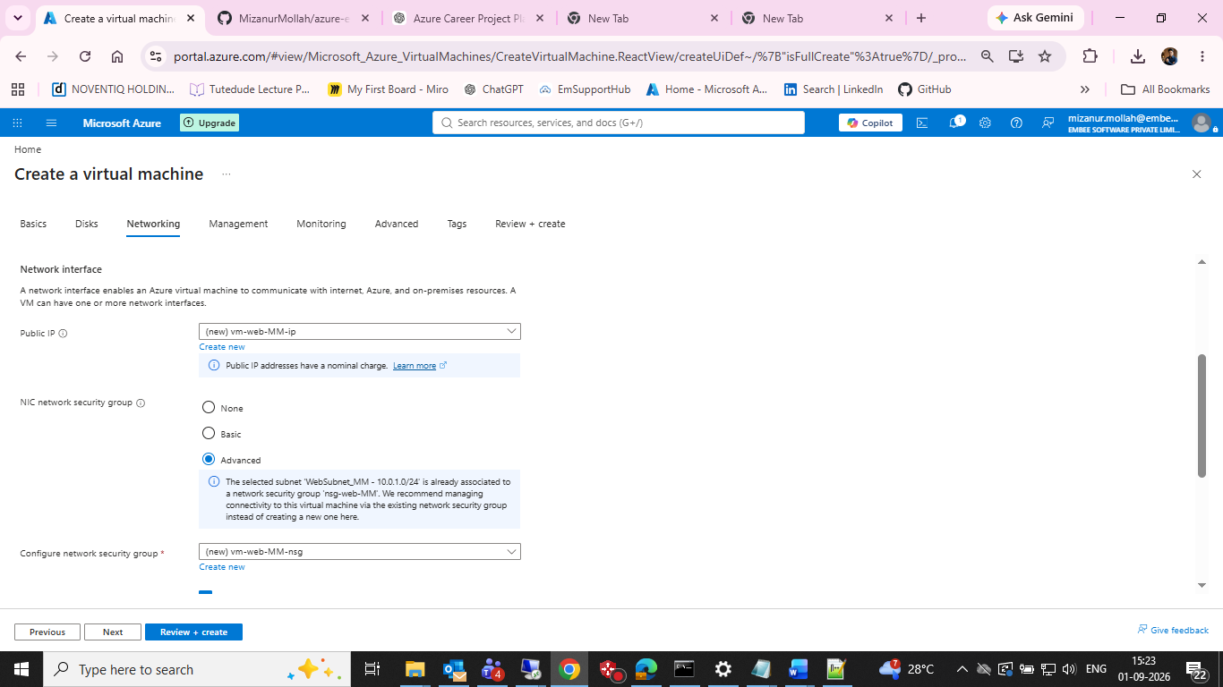
Networking checkpoint showing the existing subnet NSG association.

Figure 9 — VM management configuration.
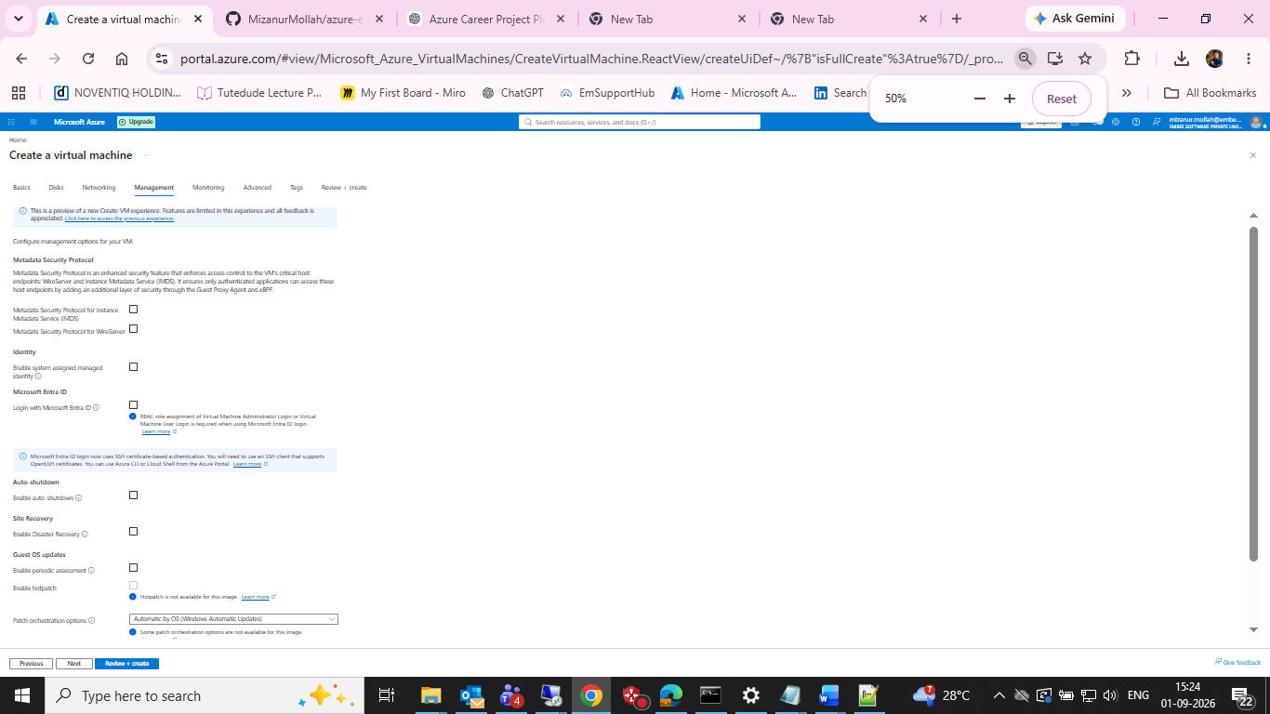
VM management configuration.

Figure 10 — VM monitoring configuration.
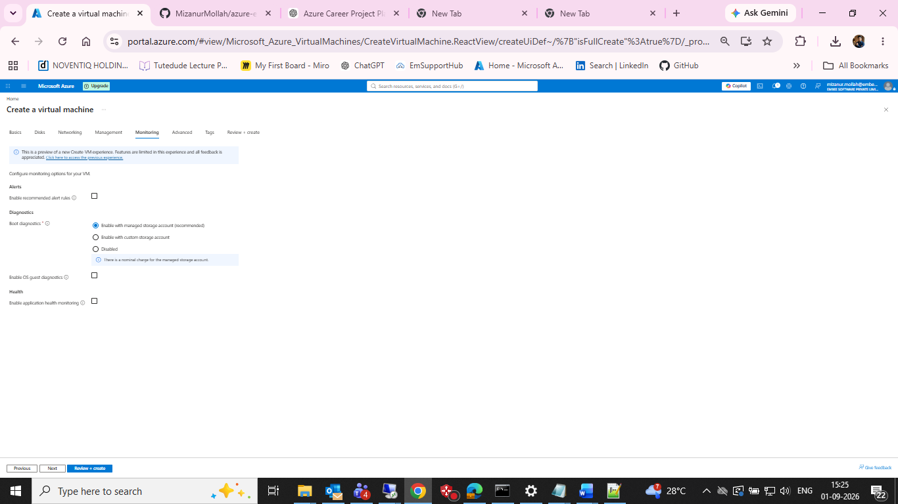
VM monitoring configuration.

Figure 11 — VM advanced configuration.
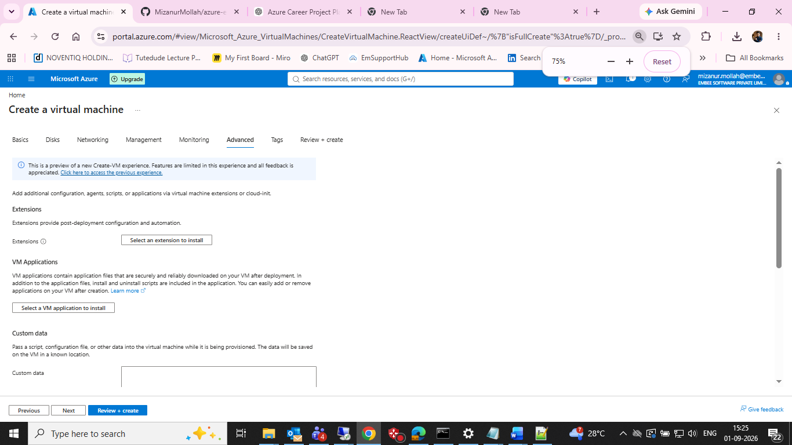
VM advanced configuration.

Figure 12 — Deployment checkpoint showing VM, NIC, NSG and Public IP resources.
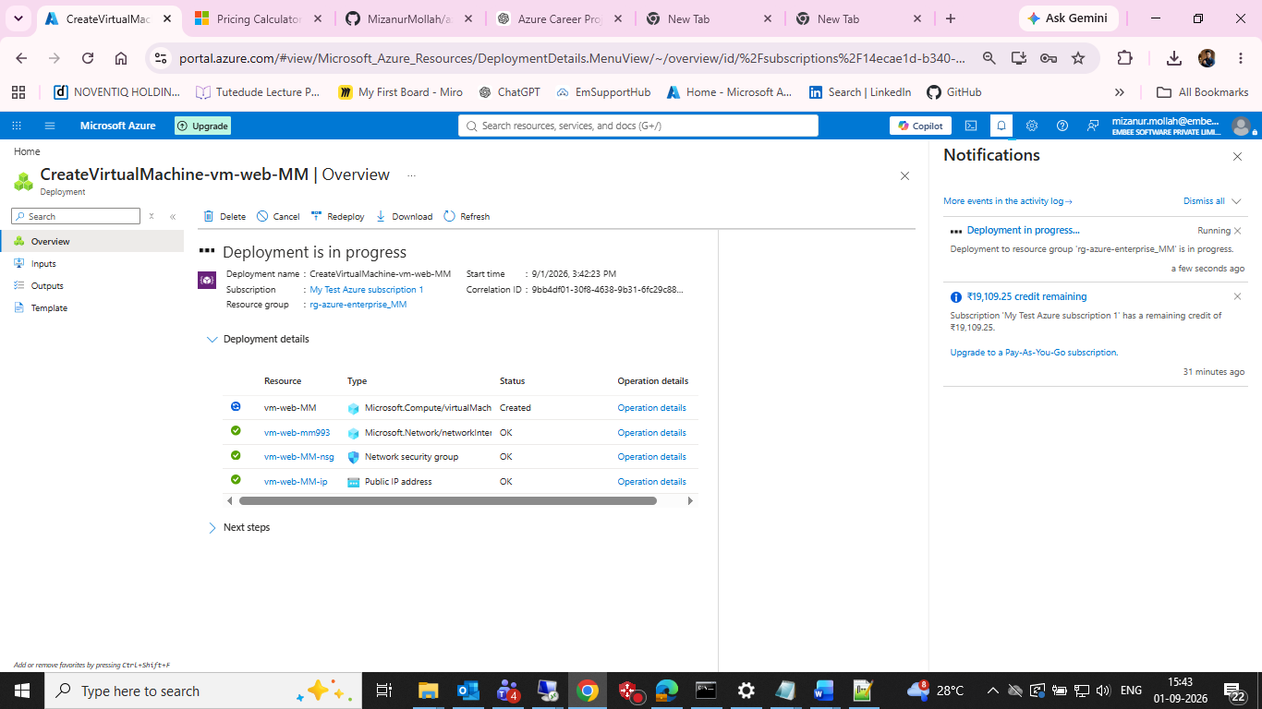
Deployment checkpoint showing VM, NIC, NSG and Public IP resources.

Figure 13 — Final VM Overview after successful deployment.
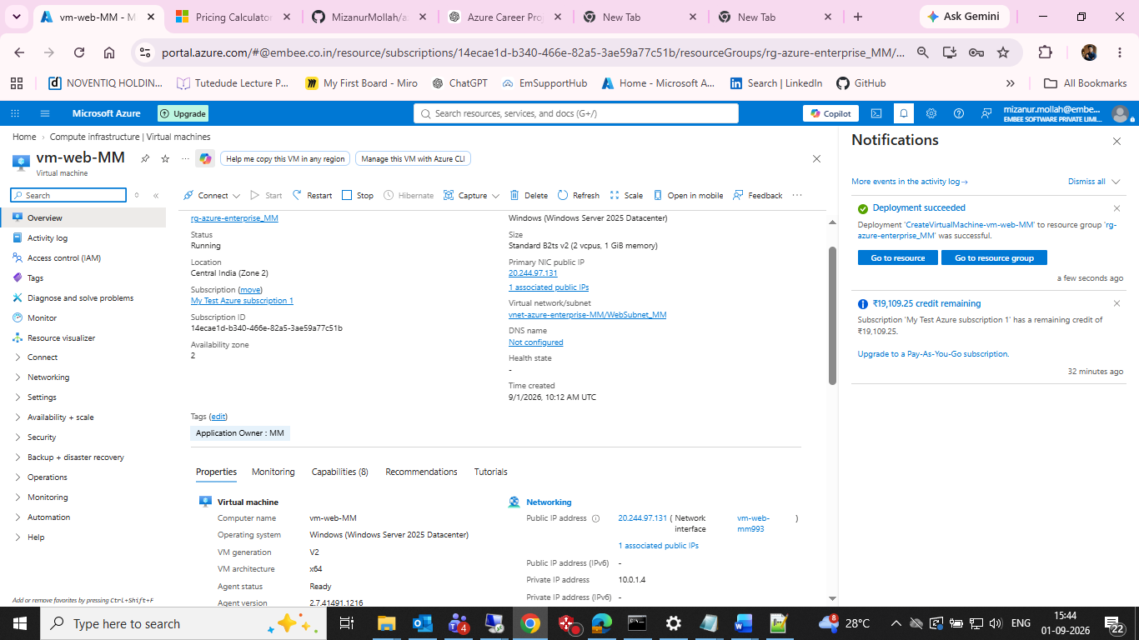
Final VM Overview after successful deployment.

Figure 14 — Final VM Network settings, including IPs, subnet and security groups.
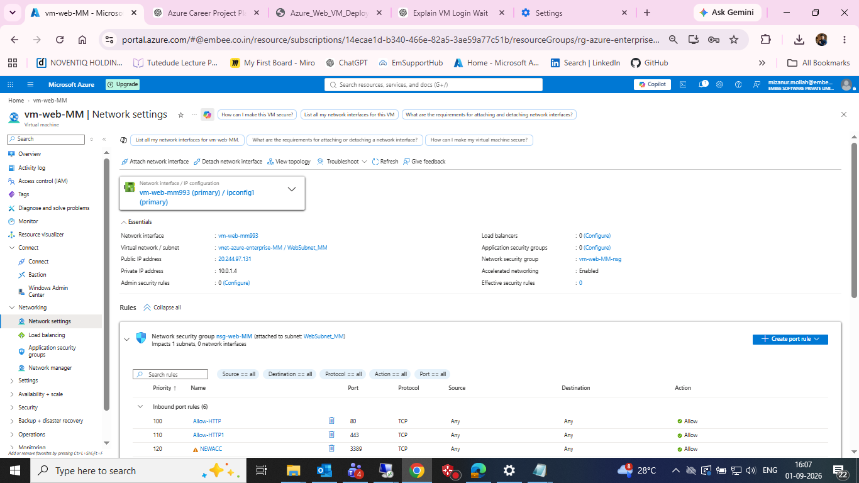
Final VM Network settings, including IPs, subnet and security groups.

Figure 15 — Final VM Overview showing the VM running.
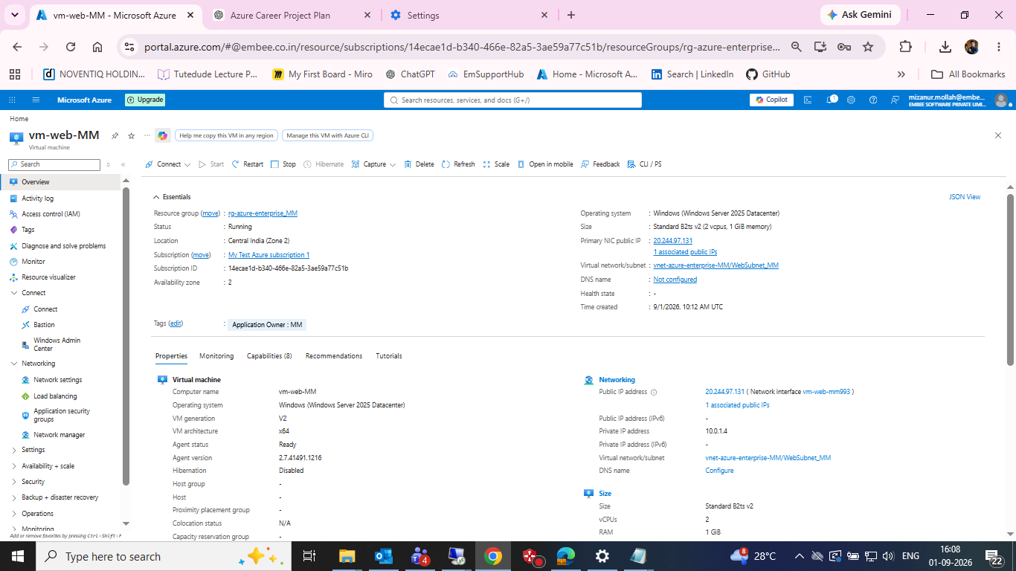
Final VM Overview showing the VM running.

Figure 16 — Successful Native RDP connection to the Windows VM.
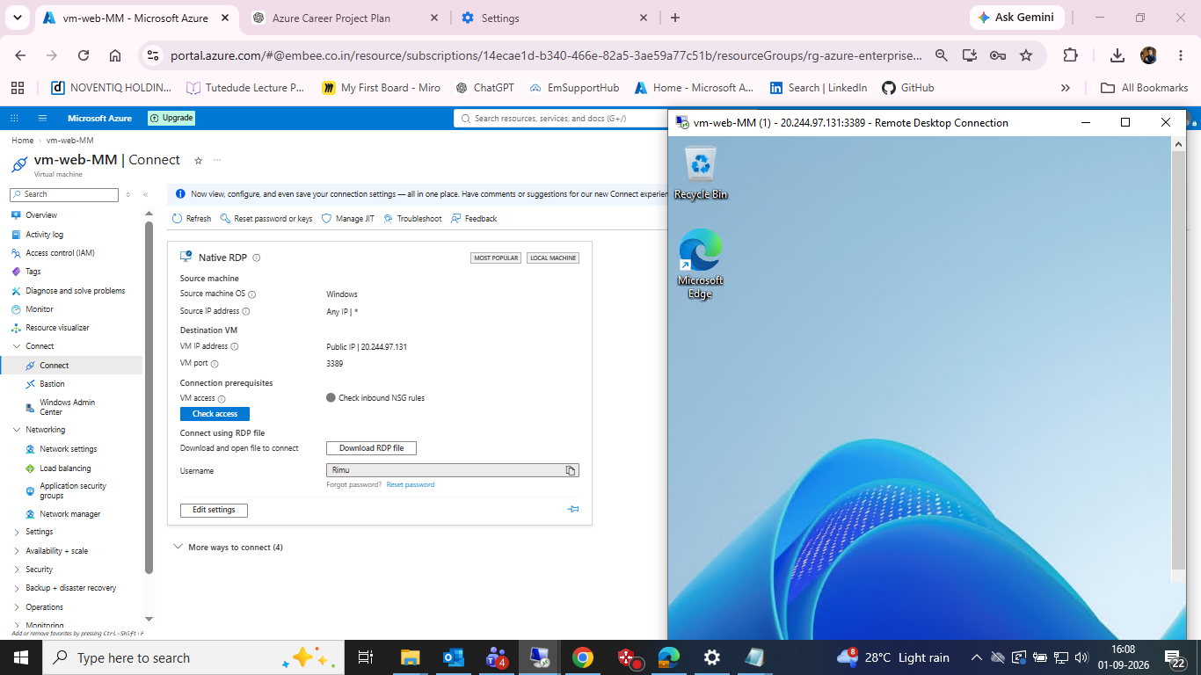
Successful Native RDP connection to the Windows VM.

Figure 17 — VM Activity Log showing successful create/update and health events.
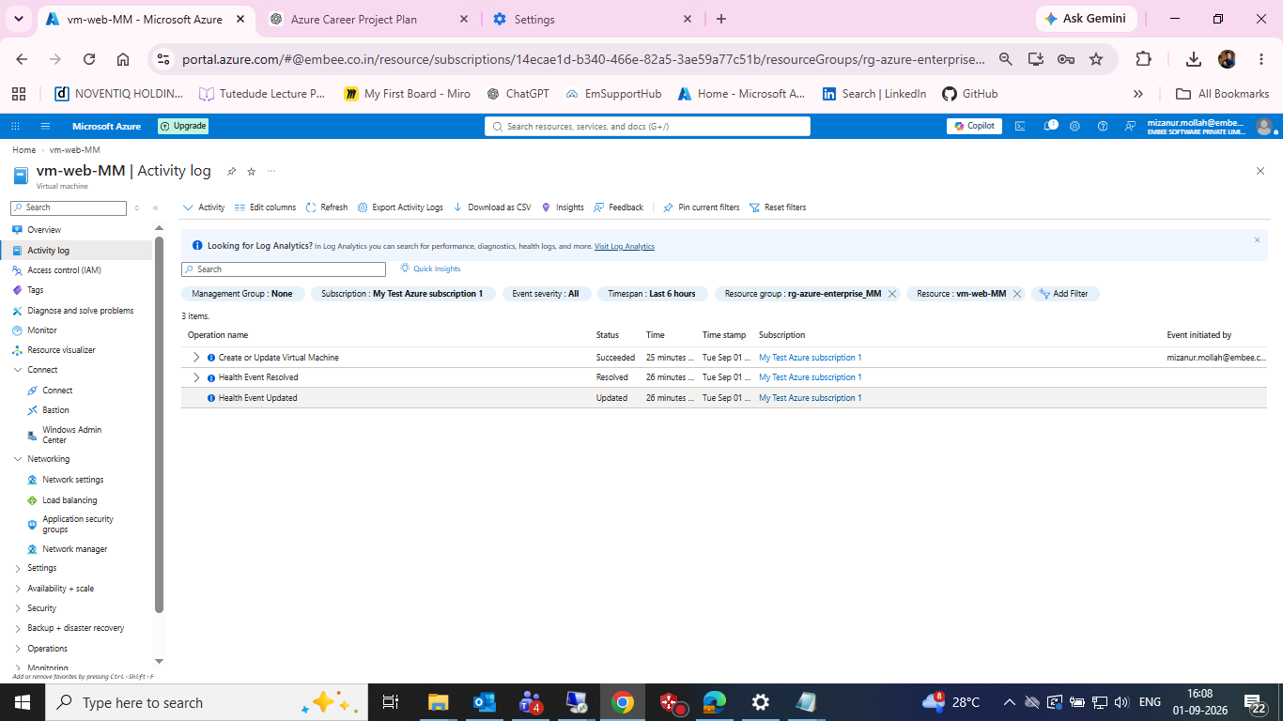
VM Activity Log showing successful create/update and health events.

17. Next Azure Task
Task 05 — Windows VM hardening, IIS, RDP source restriction and cost control. Planned evidence includes secure RDP access, IIS installation, HTTP/HTTPS tests, auto-shutdown, cost analysis, and Azure Monitor / Log Analytics.

