AZURE ENTERPRISE INFRASTRUCTURE LAB
Task 05 — Windows VM Security Hardening & Cost Control
Current State + Hardening Plan

1. Objective
Review the deployed Windows VM from a security, networking, remote-access, and cost-control perspective and document the hardening actions to be completed.
Status: This document records the current verified state and planned hardening work. Pending changes are not claimed as completed.

2. Current Environment
Property | Current value
Subscription | My Test Azure subscription 1
Resource Group | rg-azure-enterprise_MM
VM | vm-web-MM
Region | Central India (Zone 2)
Operating System | Windows Server 2025 Datacenter
VM Size | Standard B2ts_v2
VNet | vnet-azure-enterprise-MM
Subnet | WebSubnet_MM
Private IP | 10.0.1.4
Public IP | 20.244.97.131

3. Evidence Confirmed
- VM Network Settings show NIC vm-web-mm993, VNet/subnet vnet-azure-enterprise-MM / WebSubnet_MM, public IP 20.244.97.131, private IP 10.0.1.4, accelerated networking enabled, subnet NSG nsg-web-MM, and VM/NIC-level NSG vm-web-MM-nsg.
- VM Overview confirms vm-web-MM is Running.
- A Native RDP session was successfully established.
- Activity Log shows Create or Update Virtual Machine — Succeeded, Health Event Resolved, and Health Event Updated.

4. Security Review
Current configuration exposes TCP 3389 for RDP. For a production-style configuration, RDP should be restricted to a trusted administrator source rather than broadly exposed.
The project currently shows both nsg-web-MM at the subnet level and vm-web-MM-nsg at the NIC/VM level. This should be intentionally documented or simplified to avoid unclear or redundant security policy.

5. Planned Hardening Actions
- Restrict RDP to the administrator public IP using a /32 source; recommended name: Allow-RDP-Admin-IP.
- Rename the existing 443 rule from Allow-HTTP1 to Allow-HTTPS while retaining priority 110, TCP 443 and Allow.
- Review whether both subnet-level and NIC-level NSGs are intentionally required.
- Configure VM auto-shutdown or deliberate stop/deallocate procedures for cost control.

6. Why These Changes Matter
Area | Why it matters
RDP restriction | Reduces unnecessary exposure of Windows administration
HTTPS naming | Makes security policy readable and auditable
NSG review | Prevents unclear or redundant security controls
Auto-shutdown | Reduces unnecessary compute consumption
Activity Log | Provides an audit trail for resource operations

7. Interview Questions
Q1. Why should RDP not normally be open to Any?
RDP is an administrative service. Broad internet exposure increases the attack surface; access should be restricted to trusted sources or secure management services.
Q2. Can a subnet and NIC both have NSGs?
Yes. Azure supports NSGs at both levels. Effective traffic rules must be considered together.
Q3. Why use a /32 source for RDP?
A /32 represents one IPv4 address, allowing access to be limited to one known public source.
Q4. What is the difference between Stop and Deallocate?
Deallocation releases Azure compute resources. A guest-OS shutdown is not the same as Azure deallocation for billing purposes.
Q5. How did you troubleshoot RDP?
I verified VM state, Network settings, NSG rules, the public IP and port 3389 path, then validated access using Native RDP.

8. Completion Checklist
☑ VM Network Settings captured
☑ VM Running state captured
☑ Successful RDP session captured
☑ Activity Log reviewed
☐ Restrict RDP to trusted administrator IP
☐ Rename 443 rule to Allow-HTTPS
☐ Review subnet/NIC NSG layering
☐ Configure VM auto-shutdown
☐ Re-test RDP after hardening
☐ Capture post-hardening screenshots
☐ Update GitHub README
☐ Commit and push changes
☐ Sanitize public-IP/account details before public upload

9. Evidence Screenshots
Figure 1 — Current VM Network Settings evidence
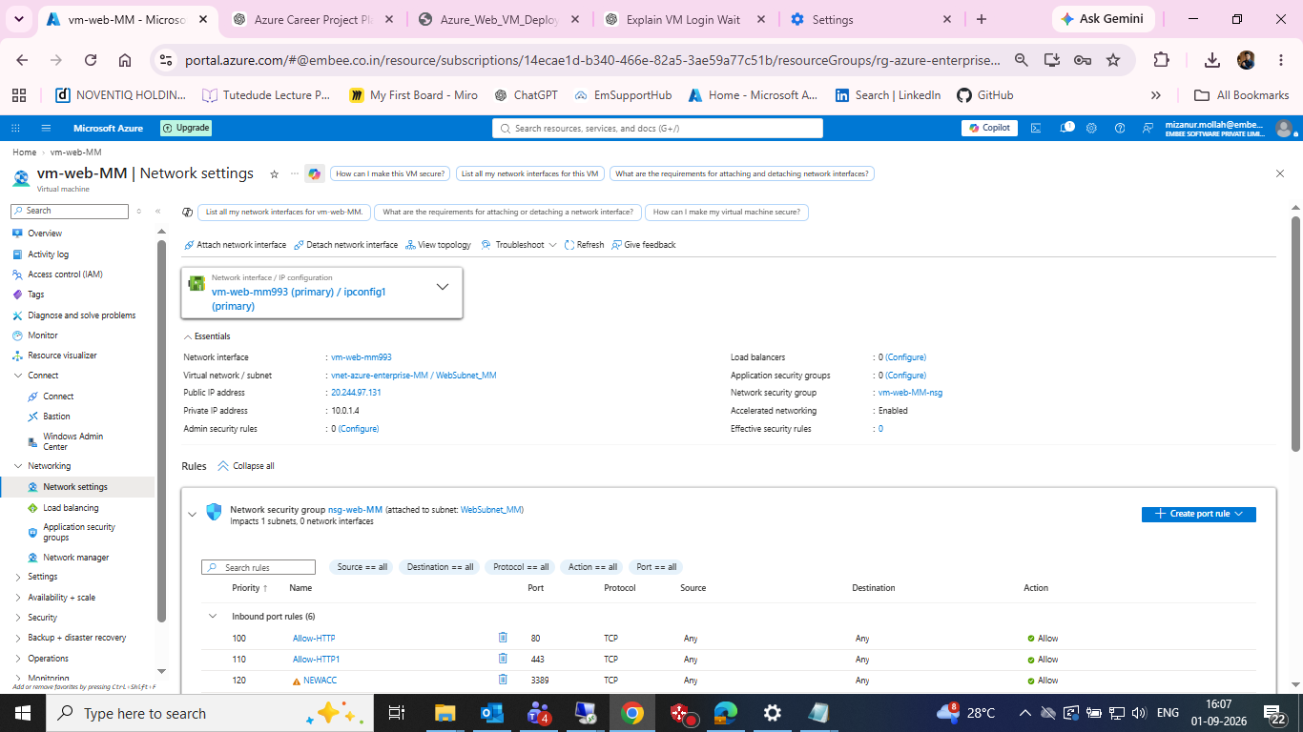
Current VM Network Settings evidence

Figure 2 — VM Overview showing Running status
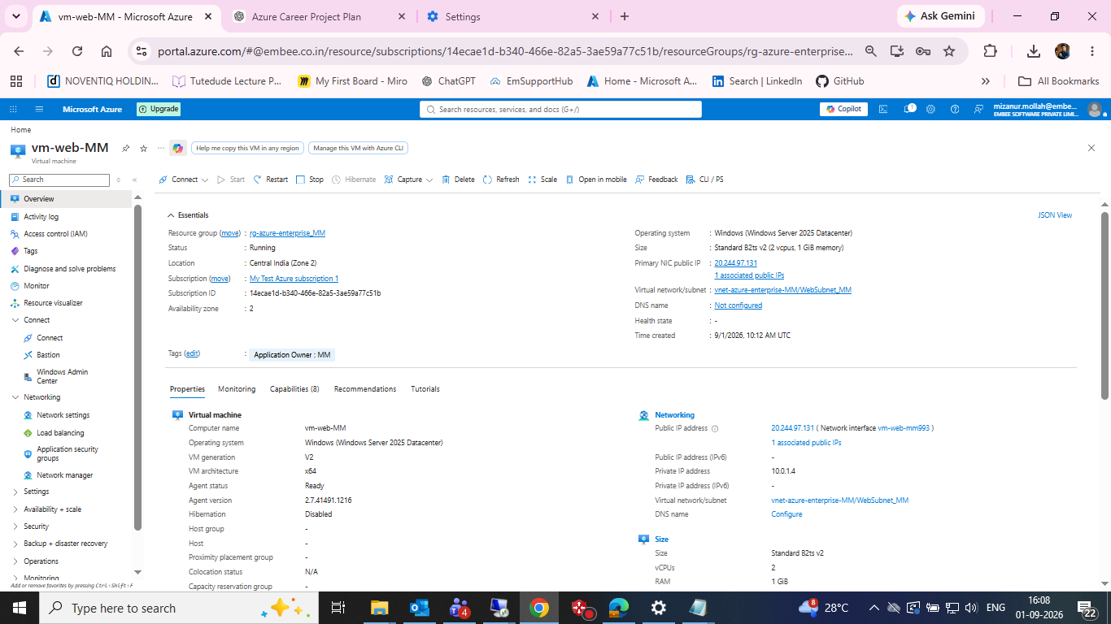
VM Overview showing Running status

Figure 3 — Successful Native RDP connection
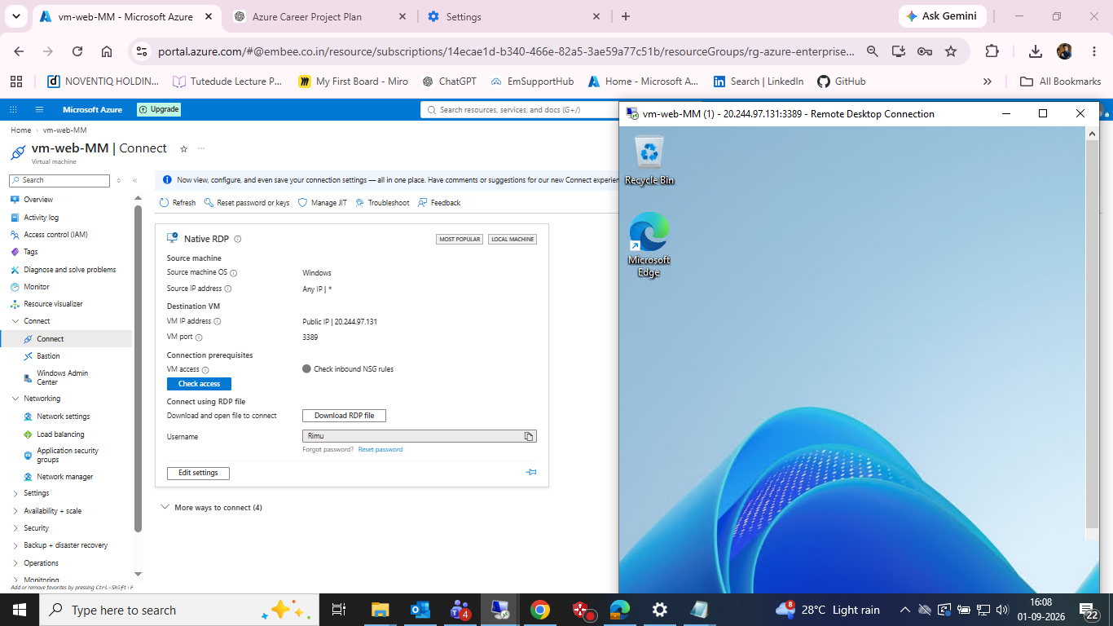
Successful Native RDP connection

Figure 4 — VM Activity Log evidence
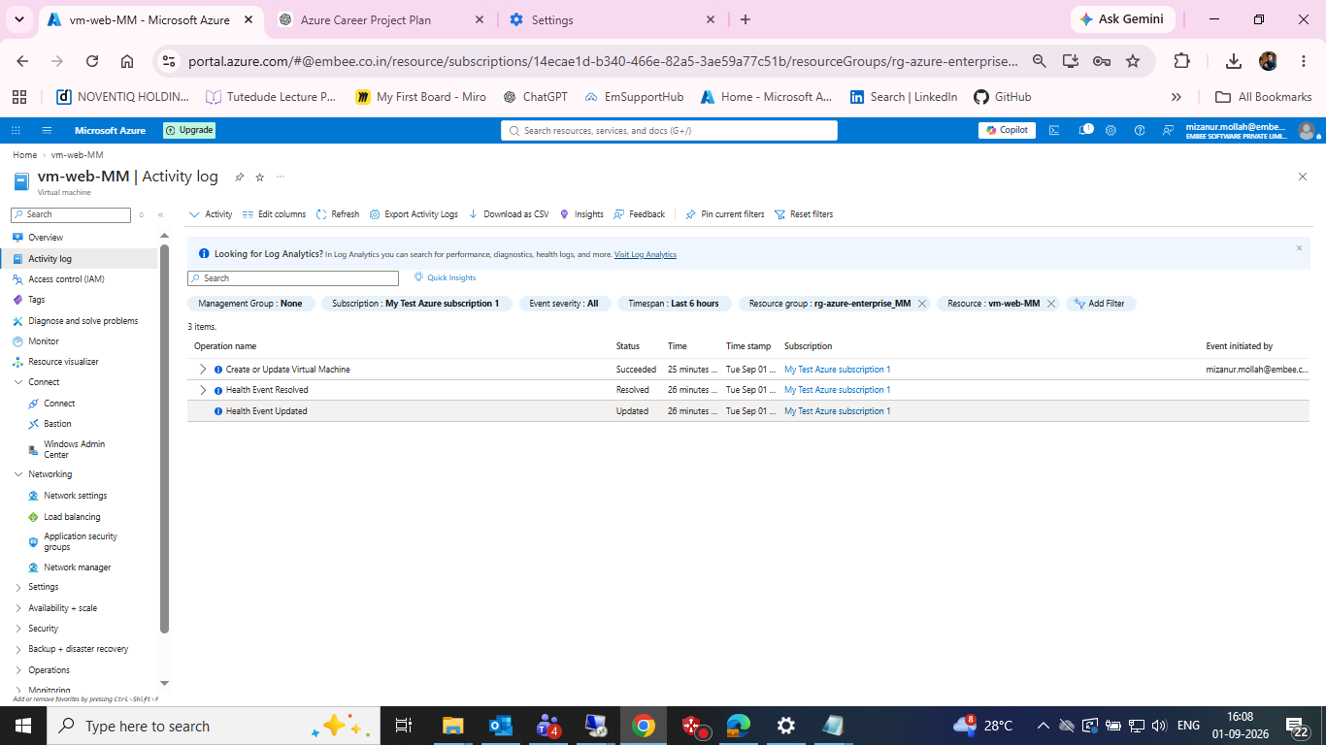
VM Activity Log evidence

10. Result
The VM's current operational state has been verified. The next phase is security hardening and cost control, followed by post-change validation.

11. Next Step
Complete the RDP source restriction first. Then review the VM-level NSG before making any deletion or structural change.

