AZURE ENTERPRISE INFRASTRUCTURE LAB
Task 04 — Azure Storage Account
Final Azure Portal Evidence

1. Objective
Create an Azure Storage Account for the lab, configure baseline security and data protection, and capture Azure Portal evidence for the GitHub portfolio.
Evidence status: The supplied final screenshot shows deployment in progress with the storage resource operation accepted. Add a post-deployment Overview screenshot after the account is fully provisioned.

2. Storage Account Configuration
Property | Selected value
Subscription | My Test Azure subscription 1
Resource Group | rg-azure-enterprise_MM
Storage Account Name | stazureenterprisemm001
Region | Central India
Primary Service | Azure Blob Storage / Azure Data Lake Storage
Performance | Standard
Redundancy | LRS
Access Tier | Hot
Minimum TLS | 1.2
Secure transfer required | Enabled
Anonymous container access | Disabled
Encryption | Microsoft-managed keys

3. Advanced Configuration
- Hierarchical namespace: Disabled
- SFTP: Disabled
- NFS v3: Disabled
- Cross-tenant replication: Disabled
- Access tier: Hot
- Managed identity for SMB: Disabled
- Encryption in transit for SMB: Enabled

4. Networking Configuration
- Public network access: Enabled
- Public network access scope: All networks
- Private endpoint: None
- Routing preference: Microsoft network routing
A private endpoint dialog was opened during the workflow but was not intended for this initial deployment. Private Endpoint will be treated as a separate advanced networking exercise.

5. Data Protection
- Point-in-time restore: Disabled
- Blob soft delete: Enabled — 7 days
- Container soft delete: Enabled — 7 days
- Blob versioning: Disabled
- Blob change feed: Disabled
- Version-level immutability: Disabled
- Azure Files soft delete: Enabled

6. Security
- Secure transfer required: Enabled
- Anonymous container access: Disabled
- Storage account key access: Enabled
- Default Microsoft Entra authorization in portal: Disabled
- Minimum TLS: 1.2
- Microsoft Defender for Storage: Disabled for this learning account

7. Encryption
- Encryption type: Microsoft-managed keys (MMK)
- Customer-managed key support: Blobs and files only
- Infrastructure encryption: Disabled

8. Deployment Evidence
The final Azure Portal screenshot records the deployment for stazureenterprisemm001 in rg-azure-enterprise_MM. The Storage account resource is shown with the operation state accepted while deployment is in progress.

9. Storage Architecture
- Azure Subscription → rg-azure-enterprise_MM → stazureenterprisemm001
- Storage Account → Blob Storage → project-files (planned, Private)
- Data Protection → Blob/Container soft delete (7 days)
- Security → Secure transfer + TLS 1.2 + no anonymous containers

10. Planned Blob Exercise
- Create container project-files
- Set access level to Private
- Upload azure-storage-test.txt
- Verify through Azure Portal
- Capture container and blob screenshots

11. Interview Skills Demonstrated
- Storage Account deployment
- Blob Storage fundamentals
- Standard performance
- LRS redundancy
- Hot tier
- Storage networking
- Secure transfer/TLS
- Soft delete
- Storage encryption
- Microsoft-managed keys
- Anonymous-access controls
- Private Endpoint concept
- Deployment verification
- Cost-aware cloud design

12. Interview Questions
Q1. What is an Azure Storage Account?
The Azure resource boundary that provides services such as Blob Storage, Azure Files, queues and tables.
Q2. What is Blob Storage?
Azure object storage for unstructured data such as files, images, documents and backups.
Q3. What is LRS?
Locally redundant storage designed for redundancy within the local Azure storage scope and commonly used for low-cost development and learning workloads.
Q4. Why use Hot?
For data expected to be accessed frequently.
Q5. Why enable soft delete?
To provide a recovery window for accidental deletions.
Q6. Why disable anonymous container access?
To prevent containers from being publicly readable without authentication.
Q7. Why require TLS 1.2?
To require modern secure transport for supported storage requests.
Q8. Microsoft-managed vs customer-managed keys?
Microsoft-managed keys are managed by Microsoft; customer-managed keys provide customer control over the key lifecycle and can be integrated with Azure Key Vault.
Q9. Public network access vs Private Endpoint?
Public network access uses the public endpoint/network path; Private Endpoint provides private connectivity from an Azure virtual network.

13. Implementation Summary
- Selected the subscription.
- Reused rg-azure-enterprise_MM.
- Configured stazureenterprisemm001.
- Selected Central India.
- Selected Blob Storage.
- Selected Standard + LRS.
- Selected Hot tier.
- Enabled seven-day Blob/container soft delete.
- Disabled anonymous container access.
- Required secure transfer and TLS 1.2.
- Selected Microsoft-managed keys.
- Did not add a private endpoint.
- Started the storage deployment.
- Captured deployment evidence.

14. GitHub Evidence Structure
- 04-storage/storage.md
- 04-storage/screenshots/ (8 evidence screenshots)

15. Git Commit
cd /d C:\azure-enterprise-infrastructure-lab
git add .
git commit -m "Complete Azure storage account task"
git push

16. Completion Checklist
☑ Storage Account configuration completed
☑ Standard performance selected
☑ LRS redundancy selected
☑ Hot tier selected
☑ Secure transfer enabled
☑ TLS 1.2 selected
☑ Anonymous container access disabled
☑ Blob soft delete enabled
☑ Container soft delete enabled
☑ Microsoft-managed encryption selected
☑ Deployment initiated
☑ Screenshots collected
☐ Confirm deployment completed
☐ Capture Storage Account Overview
☐ Create private project-files container
☐ Upload test blob
☐ Verify blob access
☐ Capture container/blob screenshots
☐ Update documentation
☐ Commit and push to GitHub

17. Evidence Screenshots
Figure 1 — Storage Account — Basics
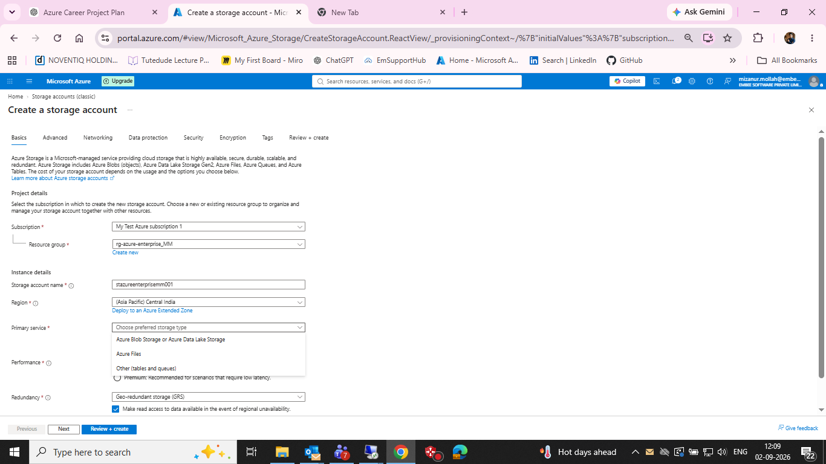
Storage Account — Basics

Figure 2 — Storage Account — Advanced
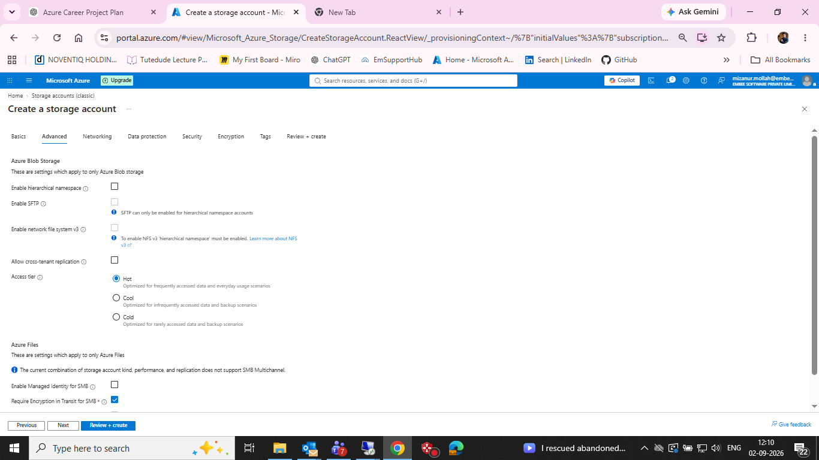
Storage Account — Advanced

Figure 3 — Storage Account — Networking
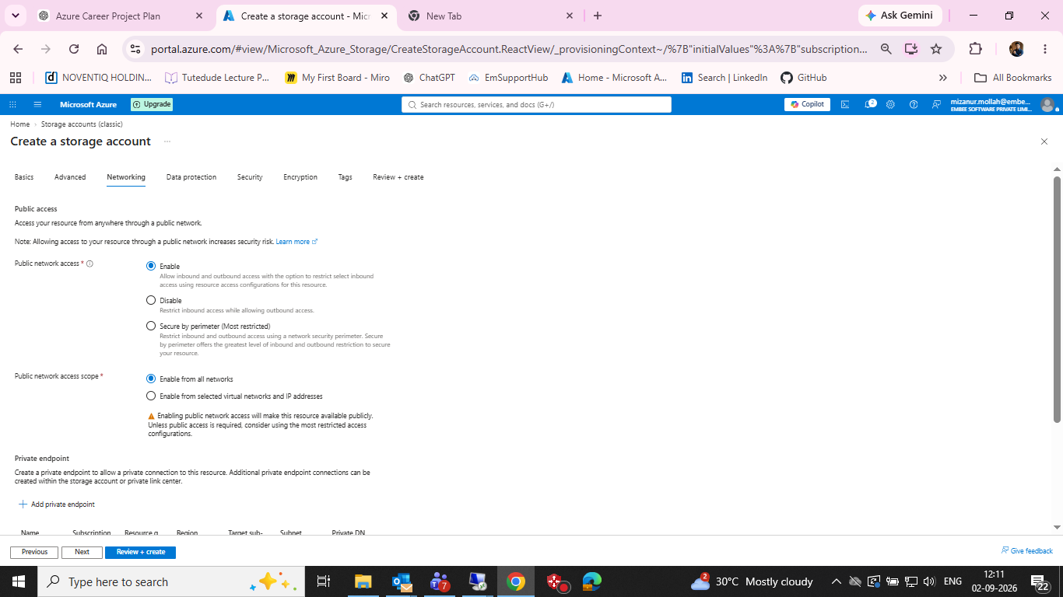
Storage Account — Networking

Figure 4 — Private endpoint dialog opened during workflow
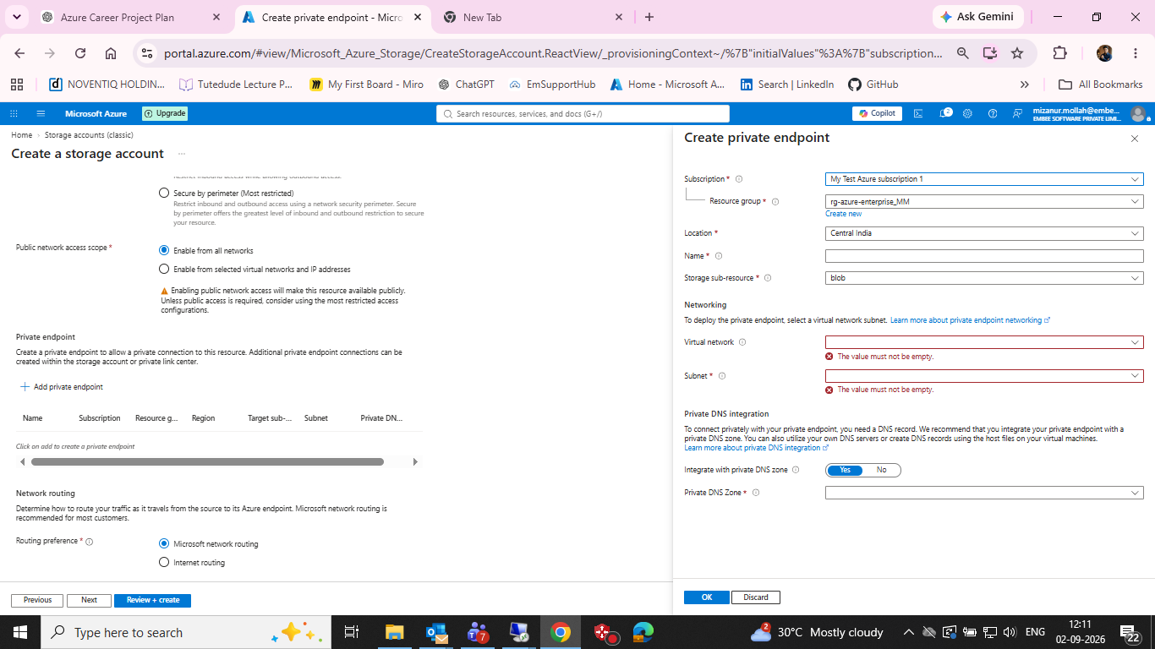
Private endpoint dialog opened during workflow

Figure 5 — Storage Account — Data protection
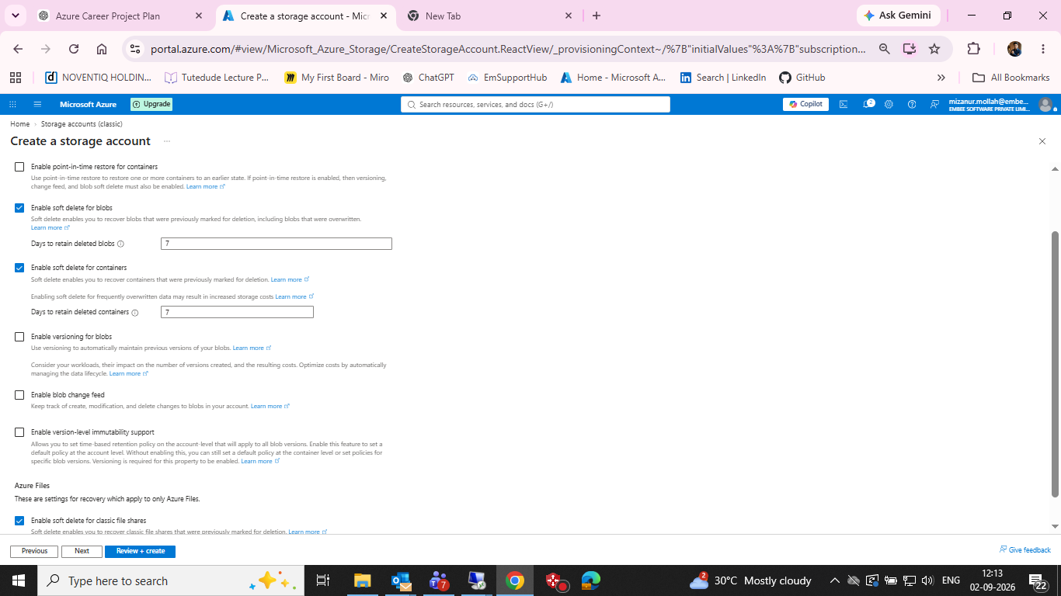
Storage Account — Data protection

Figure 6 — Storage Account — Security
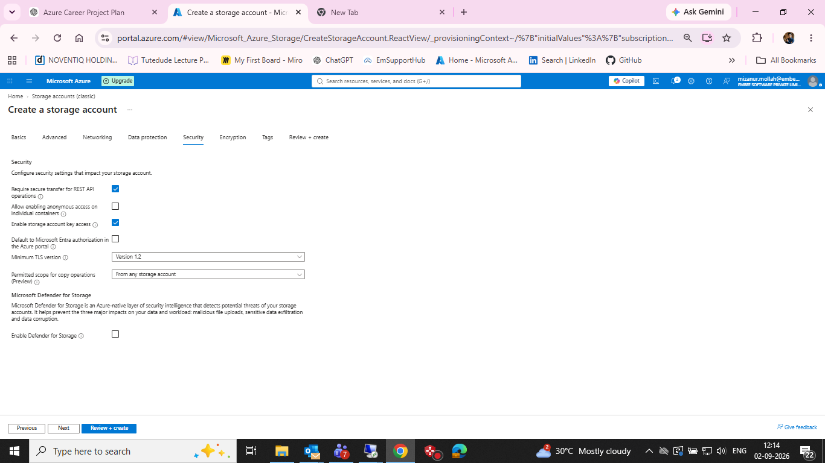
Storage Account — Security

Figure 7 — Storage Account — Encryption
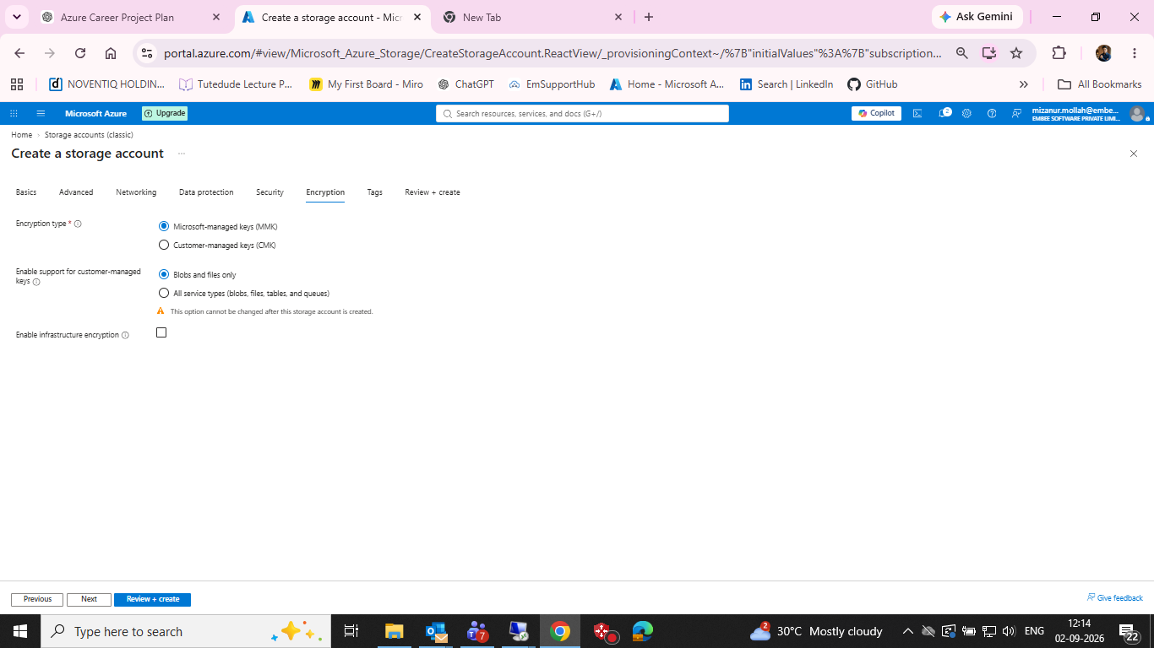
Storage Account — Encryption

Figure 8 — Storage Account — Deployment evidence
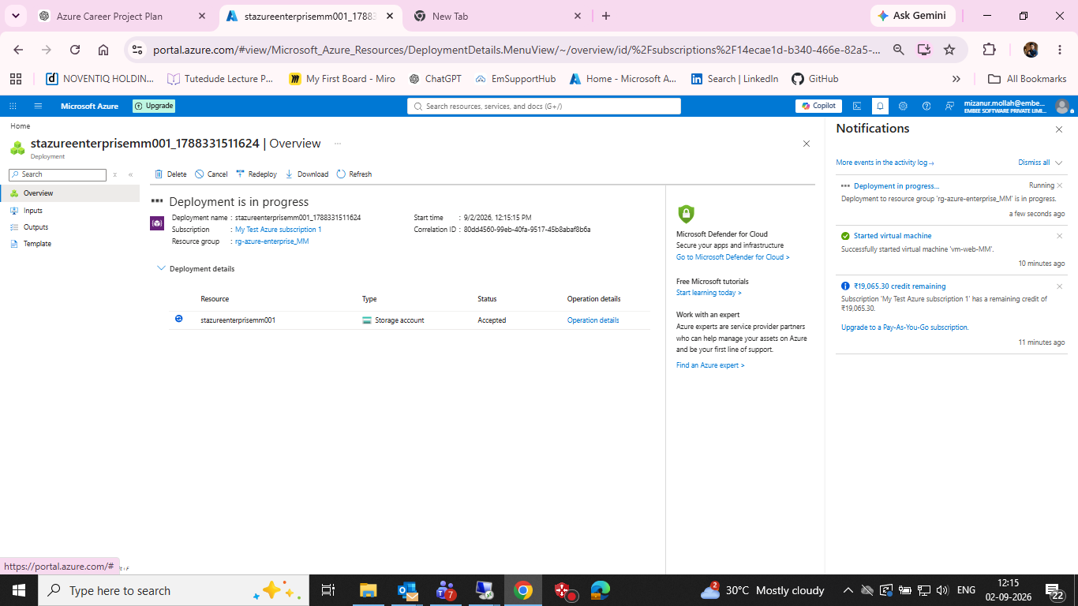
Storage Account — Deployment evidence

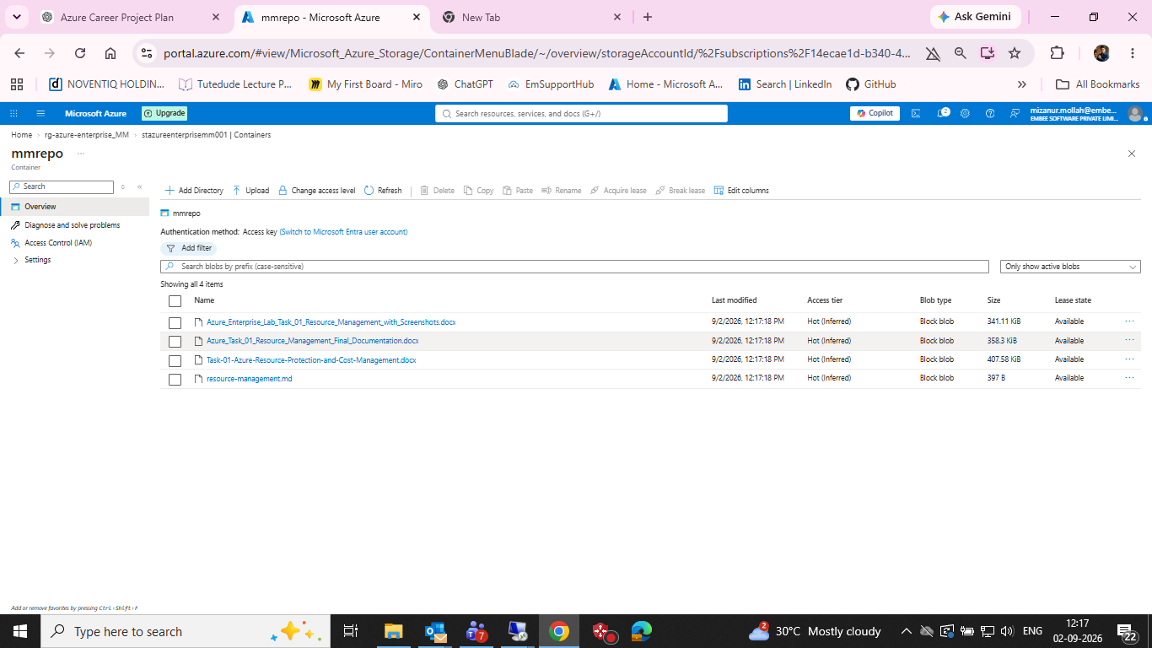

18. Next Azure Task
Task 04A — Blob Container, Upload, Access Control and Lifecycle. First verify deployment completion, then create the private project-files container, upload a test blob, and capture final storage evidence.

