AZURE ENTERPRISE INFRASTRUCTURE LAB
05 — Azure SQL / SQL Server on Azure VM
Complete Portfolio Documentation

1. Project Scope
This portfolio entry documents two related Microsoft SQL deployment patterns used in the Azure Enterprise Lab: Azure SQL Database (PaaS) and the planned installation of Microsoft SQL Server directly inside the existing Windows VM vm-web-MM (IaaS).
Important status note: The attached evidence proves the Azure SQL deployment, VM/RDP connectivity, and supporting Azure configuration. The actual SQL Server installer/service/SSMS installation inside the VM has not yet been captured in this conversation, so that portion is documented as a planned implementation.

2. Architecture
- Azure Subscription → rg-azure-enterprise_MM
- rg-azure-enterprise_MM → vm-web-MM → Windows Server 2025
- vm-web-MM → planned SQL Server 2022 Developer Edition
- rg-azure-enterprise_MM → sqlserver-enterprise-mm-2026 → sqldb-enterprise-MM

3. Existing Azure VM
Property | Value
VM | vm-web-MM
OS | Windows Server 2025 Datacenter
Size | Standard B2ts_v2
Region | Central India
Availability Zone | 2
VNet | vnet-azure-enterprise-MM
Subnet | WebSubnet_MM
Private IP | 10.0.1.4
Public IP | 20.244.97.131
NIC | vm-web-mm993

4. Existing Azure SQL Database
Property | Value
Database | sqldb-enterprise-MM
Logical Server | sqlserver-enterprise-mm-2026
Server FQDN | sqlserver-enterprise-mm-2026.database.windows.net
Region | Central India
Port | TCP 1433
Free offer | Applied during creation flow

5. SQL Server on VM — Planned Implementation
- RDP into vm-web-MM.
- Download Microsoft SQL Server Developer Edition inside the VM.
- Start SQL Server Installation Center.
- Choose New SQL Server stand-alone installation.
- Select Developer edition.
- Select Database Engine Services.
- Use the Default instance / MSSQLSERVER.
- Use installer-default service configuration for the learning lab.
- Select Mixed Mode authentication.
- Set a strong SQL administrative password and add the current Windows administrator.
- Install and verify completion.
Never store SQL credentials in GitHub or screenshots.

6. Verify SQL Server Service
Run in the Windows VM:
Get-Service MSSQLSERVER
Expected state: Status = Running, Name = MSSQLSERVER

7. Install SSMS and Connect
- Install SQL Server Management Studio separately.
- Server type: Database Engine.
- Server name: localhost.
- Authentication: Windows Authentication.
- Connect and verify the Databases node.

8. Create Local SQL Database
Run in SSMS:
CREATE DATABASE EnterpriseLabDB;
GO
USE EnterpriseLabDB;
GO
CREATE TABLE Customers
(
CustomerID INT PRIMARY KEY,
CustomerName VARCHAR(100),
City VARCHAR(100)
);
GO
INSERT INTO Customers (CustomerID, CustomerName, City)
VALUES
(1, 'Customer One', 'Kolkata'),
(2, 'Customer Two', 'Delhi'),
(3, 'Customer Three', 'Mumbai');
GO
SELECT * FROM Customers;
GO

9. VM-to-Azure SQL Connectivity
The VM outbound public IP was verified from PowerShell as 20.244.97.131. For a basic connectivity test, the Azure SQL logical server firewall can allow this specific client address.
Test command:
Test-NetConnection sqlserver-enterprise-mm-2026.database.windows.net -Port 1433
Expected result: TcpTestSucceeded : True

10. Azure SQL Firewall
Field | Recommended lab value
Rule name | Allow-VM-Web-MM
Start IP | 20.244.97.131
End IP | 20.244.97.131
Port | 1433
Protocol | TCP
Avoid broad 0.0.0.0/0-style exposure for the portfolio lab.

11. Cost Control
The SQL creation workflow initially displayed an expensive Hyperscale estimate. The Free offer was then applied and the portal showed zero displayed compute and storage cost with overage billing disabled. This demonstrates cost-aware deployment selection.

12. Security Considerations
- Patch Windows Server and SQL Server.
- Restrict inbound TCP 1433.
- Avoid exposing SQL Server directly to the public internet unless required.
- Prefer private networking for production-style SQL deployments.
- Use least-privilege access.
- Never publish passwords or connection secrets.

13. Interview Skills
- PaaS vs IaaS for SQL
- Windows Server administration
- SQL Server installation
- Database Engine configuration
- Mixed Mode authentication
- SQL Server service management
- SSMS
- T-SQL
- TCP 1433
- Azure SQL firewall
- Cost management
- RDP troubleshooting

14. Interview Questions
Q1. Azure SQL Database vs SQL Server on Azure VM?
Azure SQL Database is PaaS; Microsoft manages most underlying infrastructure. SQL Server on a VM is IaaS; you manage the operating system and SQL Server.
Q2. Why install SQL Server on the VM?
To gain full SQL Server administration experience, including instance configuration, services, patching, backups and OS/SQL integration.
Q3. What is the default SQL Server instance?
MSSQLSERVER.
Q4. What port does SQL Server commonly use?
TCP 1433 for the default Database Engine instance.
Q5. Why use Mixed Mode?
It supports Windows authentication and SQL Server authentication.
Q6. Why not expose 1433 to Any?
It increases the attack surface; restrict to trusted sources or use private networking.
Q7. Why use Developer Edition?
For development/testing and learning; it is not a production licensing choice.

15. Evidence Collected
The current documentation package includes 13 attached screenshots covering the Azure SQL lifecycle, VM connectivity and Azure configuration. The actual SQL Server-on-VM installer/service/SSMS screenshots remain to be captured.

16. Required SQL Server-on-VM Screenshots
- SQL Server installer landing page
- Feature Selection
- Instance Configuration
- Mixed Mode Authentication
- Installation success
- SQL Server (MSSQLSERVER) service running
- SSMS connected to localhost
- EnterpriseLabDB created
- T-SQL result

17. GitHub Structure
- 05-azure-sql/README.md
- 05-azure-sql/screenshots/
- 05-azure-sql/sql-server-on-vm/screenshots/
- 05-azure-sql/azure-sql-database/

18. Git Commit
cd /d C:\azure-enterprise-infrastructure-lab
git add 05-azure-sql
git commit -m "Document Azure SQL and SQL Server on VM lab"
git push

19. Completion Checklist
☑ Azure SQL Database deployed
☑ SQL logical server deployed
☑ Free SQL offer applied
☑ Cost checked before deployment
☑ VM deployed and running
☑ RDP verified
☑ VM outbound IP verified
☑ Azure SQL Query Editor accessed
☑ Resource-group evidence captured
☐ Install SQL Server Developer Edition on VM
☐ Configure Database Engine
☐ Configure default instance
☐ Configure Mixed Mode
☐ Add Windows administrator
☐ Verify MSSQLSERVER service
☐ Install SSMS
☐ Connect to localhost
☐ Create EnterpriseLabDB
☐ Execute T-SQL
☐ Capture SQL Server installer screenshots
☐ Review SQL port 1433 security
☐ Commit and push

20. Attached Evidence Screenshots
Figure 1 — Azure SQL databases resource page before creation
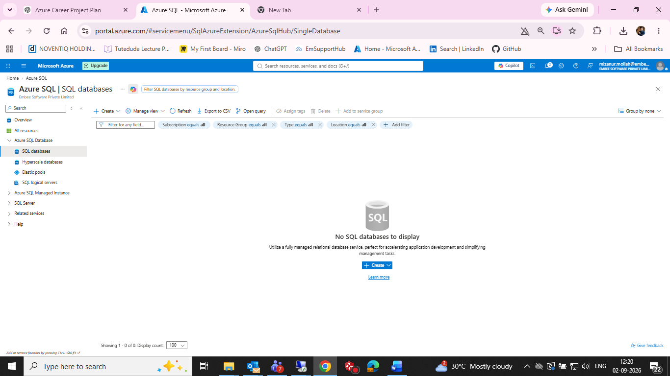
Azure SQL databases resource page before creation

Figure 2 — Create SQL Database Server form
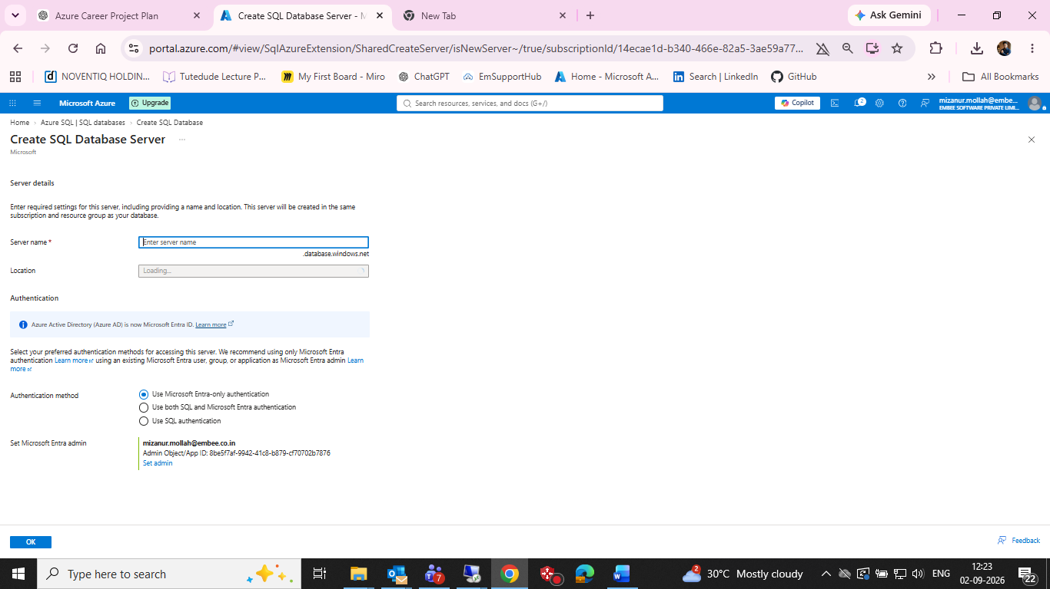
Create SQL Database Server form

Figure 3 — SQL logical server authentication configured
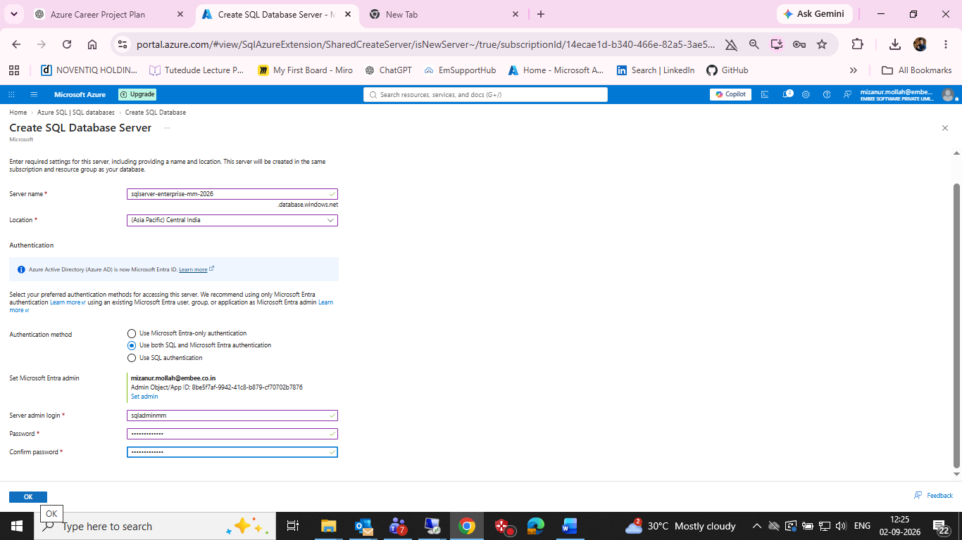
SQL logical server authentication configured

Figure 4 — SQL deployment started
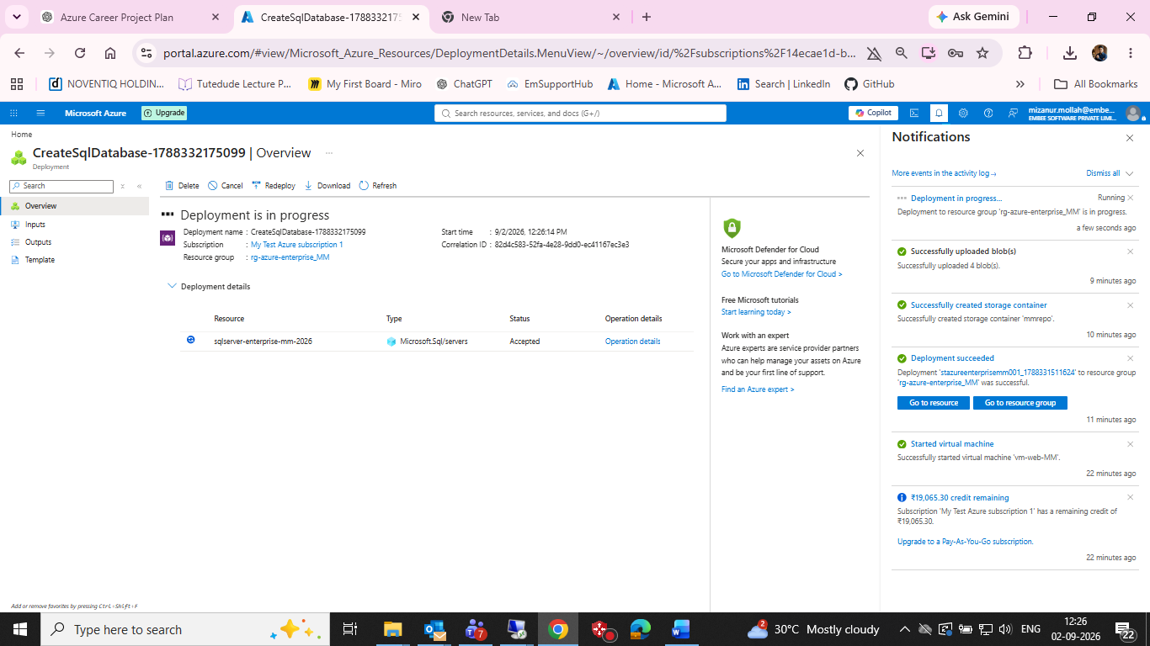
SQL deployment started

Figure 5 — SQL server operation details while running
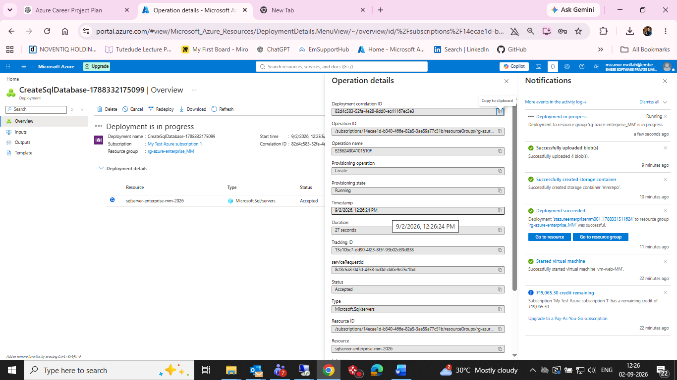
SQL server operation details while running

Figure 6 — Resource group showing SQL database and SQL server
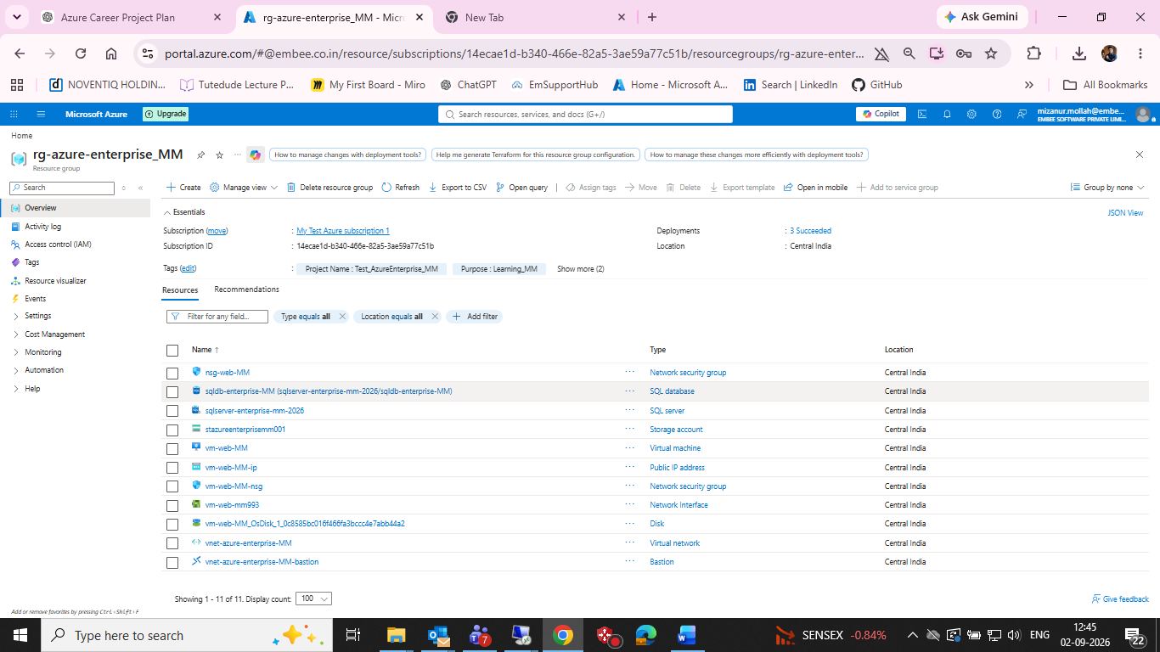
Resource group showing SQL database and SQL server

Figure 7 — Azure SQL Query Editor
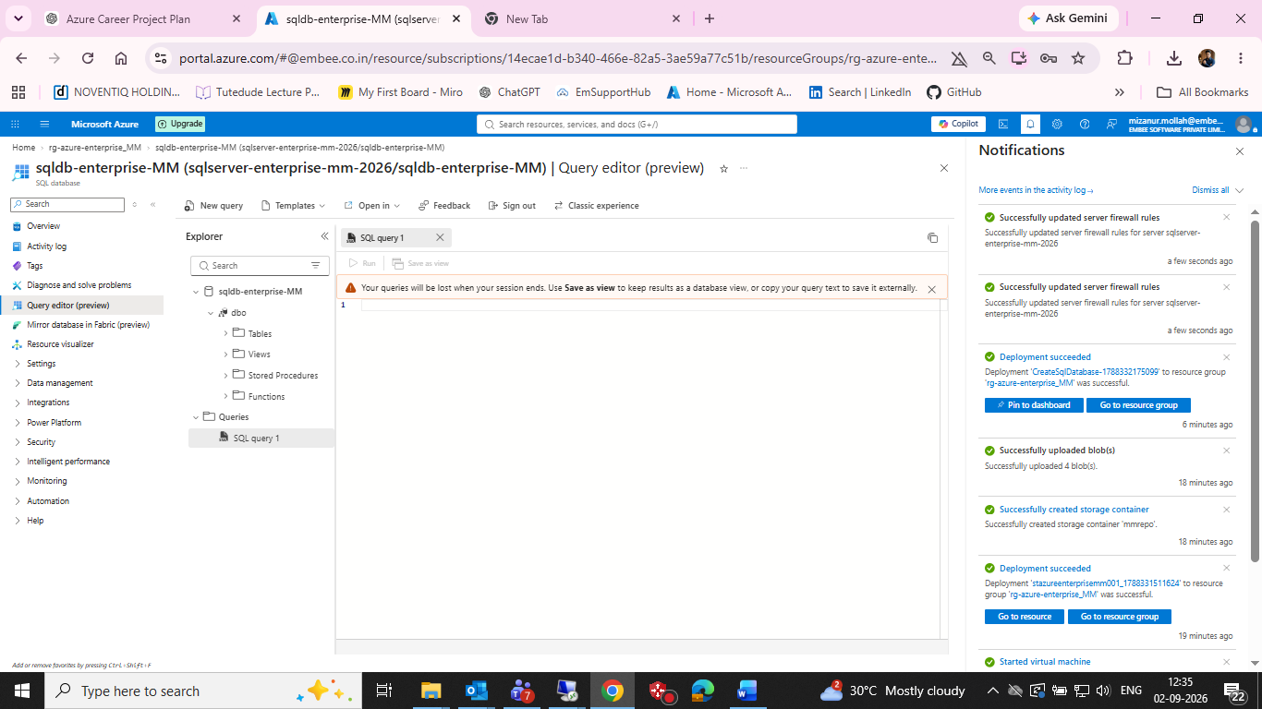
Azure SQL Query Editor

Figure 8 — SQL database creation screen showing an expensive Hyperscale estimate
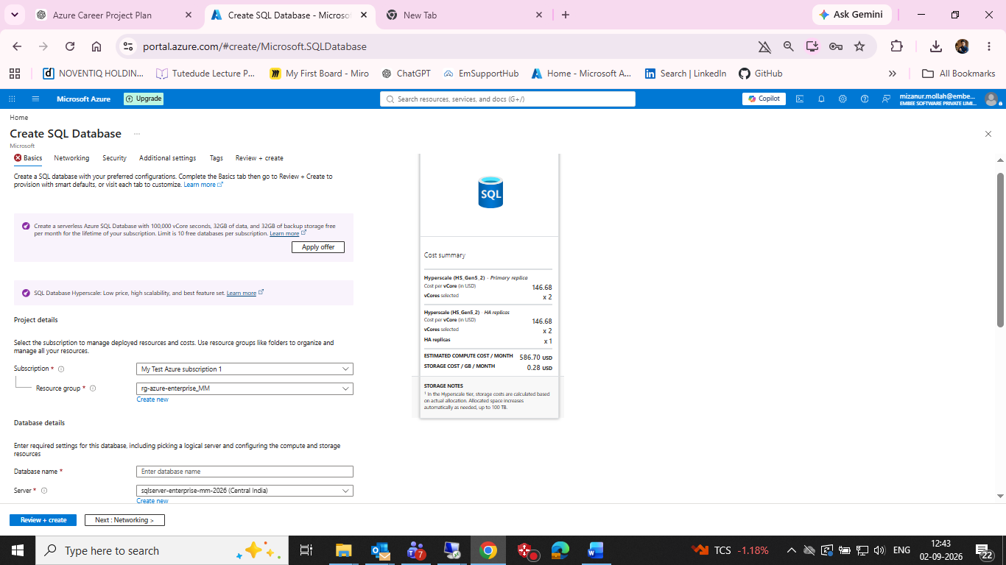
SQL database creation screen showing an expensive Hyperscale estimate

Figure 9 — SQL Free offer applied with zero displayed compute/storage cost
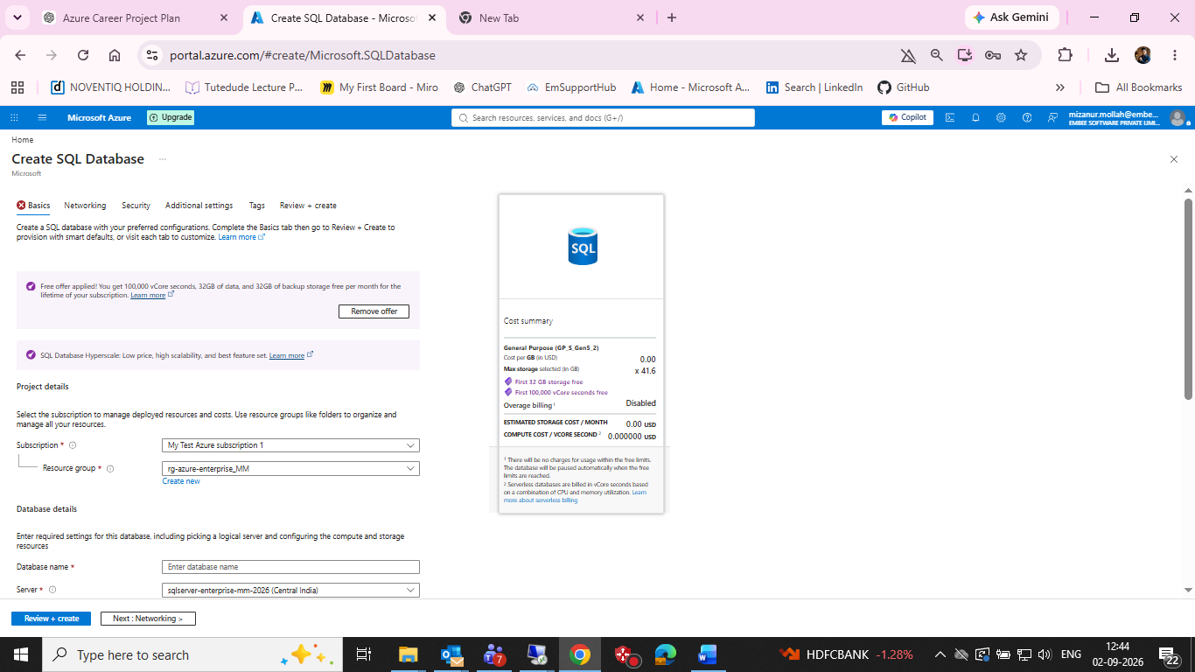
SQL Free offer applied with zero displayed compute/storage cost

Figure 10 — Successful RDP session to vm-web-MM
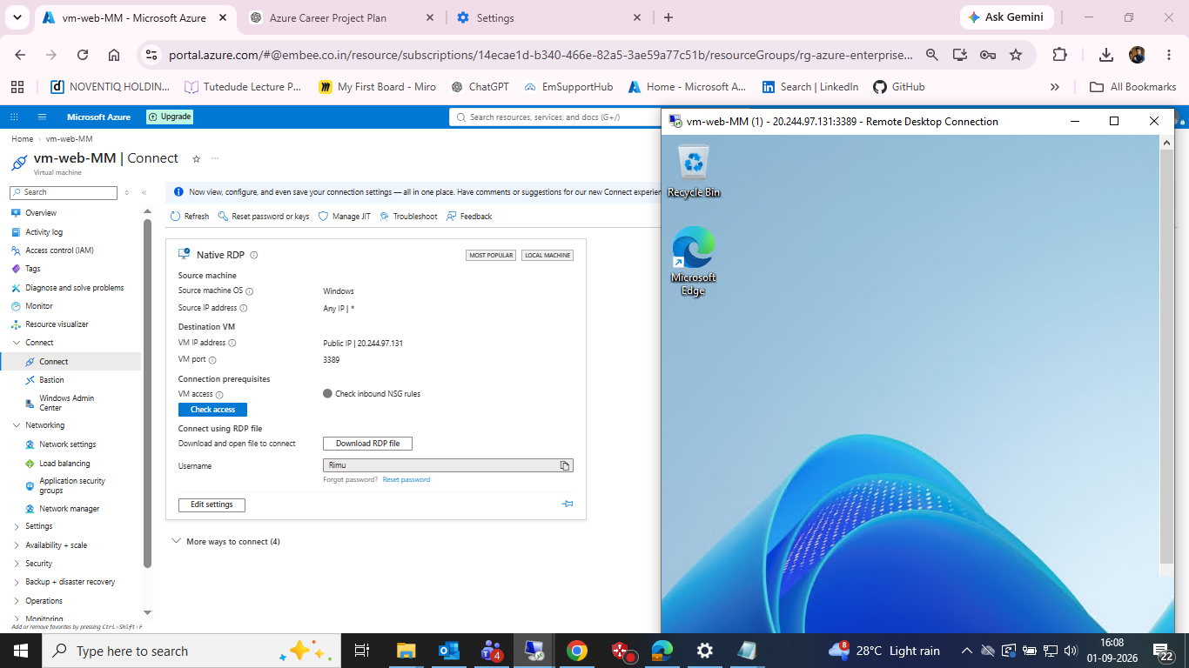
Successful RDP session to vm-web-MM

Figure 11 — Outbound public IP verified from Windows VM
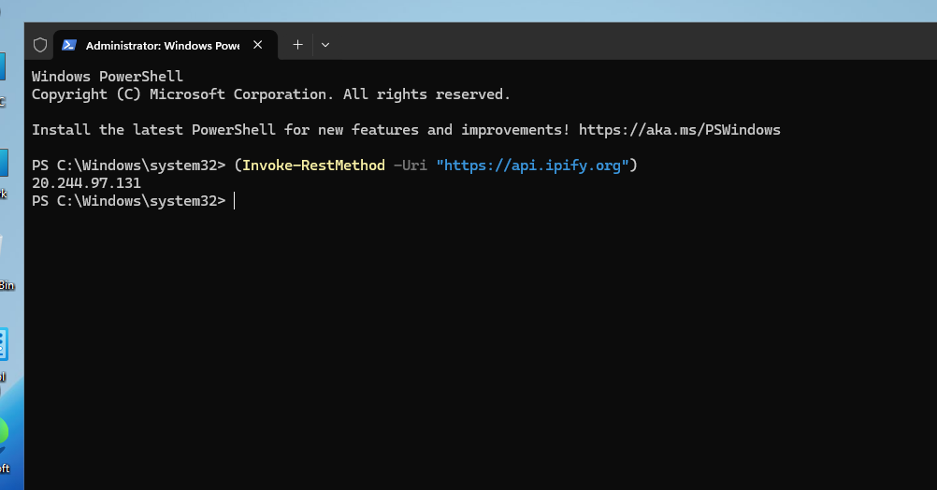
Outbound public IP verified from Windows VM

Figure 12 — VM Overview after deployment
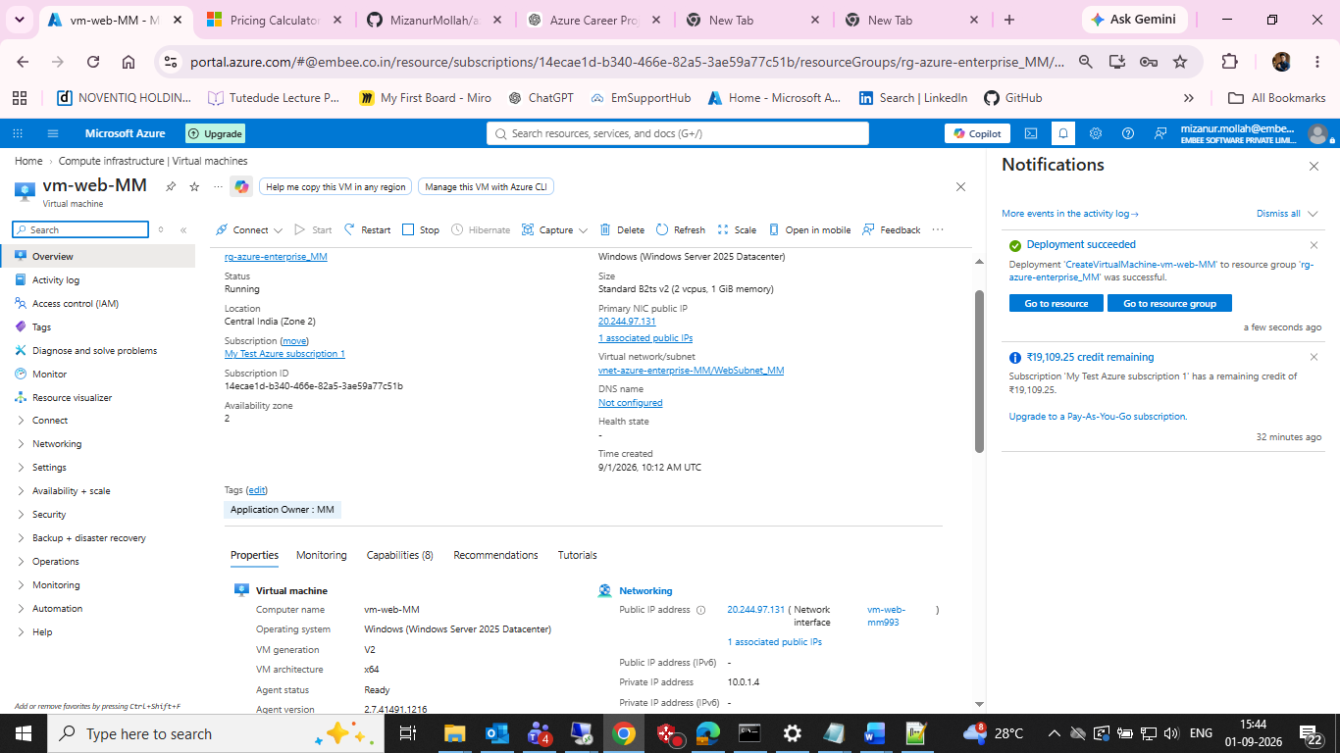
VM Overview after deployment

Figure 13 — VM Network Settings
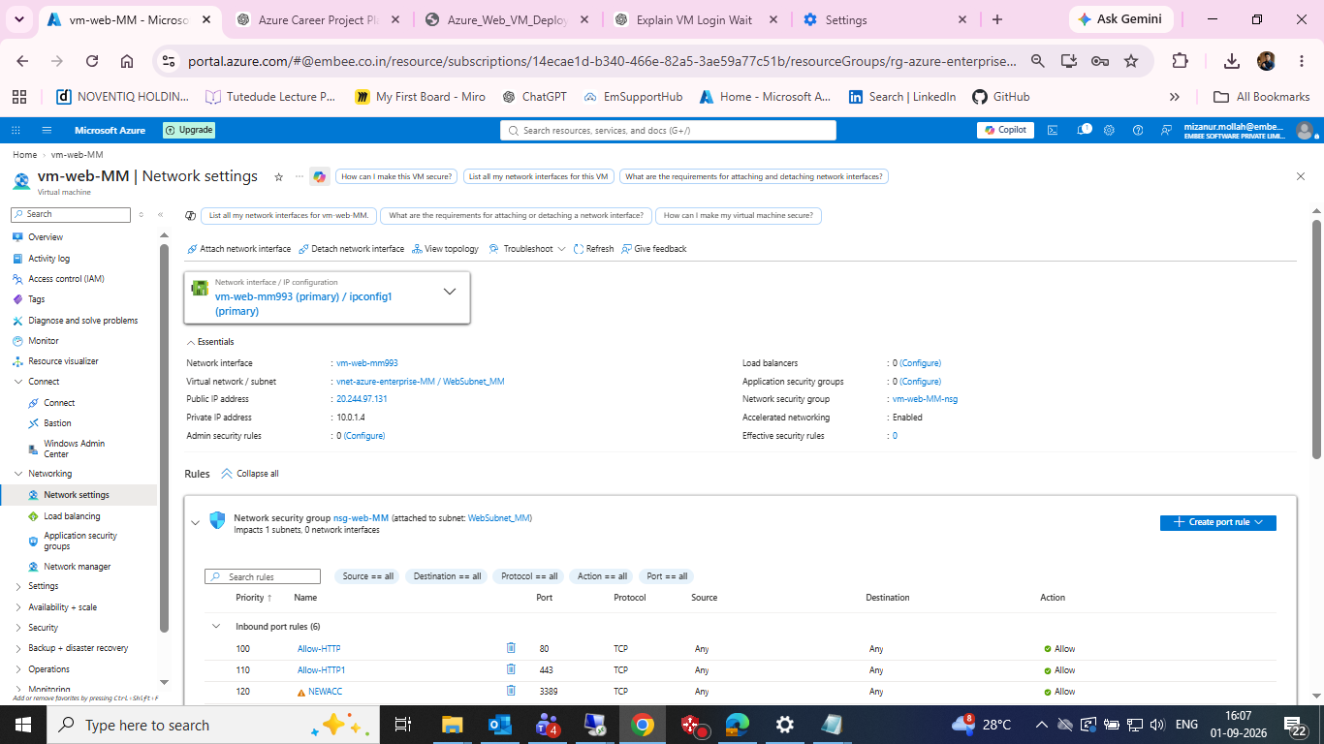
VM Network Settings

21. Next Step
Continue inside vm-web-MM with the Microsoft SQL Server Developer Edition installation. Capture each installer stage and the final SSMS/T-SQL evidence. After those screenshots are available, this document can be upgraded from a combined Azure SQL + planned SQL Server-on-VM record into a fully verified SQL Server-on-VM implementation document.

